NAME…………………………………………………ADM NO………………..CLASS:……………
SIGNATURE:………………………………………………

451/2
COMPUTER STUDIES
Paper 2
(PRACTICAL)
JULY 2019
2 ½ hours

MOKASA II EVALUATION EXAMINATION
Kenya Certificate of Secondary Education

Instructions to Candidates
- Type your name and index number at the top right hand corner of each printout.
- Sign and write the date of the examination below the name and index number on each printout.
- Write your name and index number on the compact disks.
- Write the name and version of the software used for each question attempted in the answer sheet.
- Passwords should not be used while saving in the compact disks.
- Answer all the questions.
- All questions carry equal marks.
- All answers must be saved in your compact disks.
- Make a printout of the answers on the answer sheets provided.
- Hand in all the printouts and the compact disks.
- This paper consists of 4 printed pages.
- Candidates should check the question paper to ascertain that all pages are printed as indicated and that no questions are missing.

- (a) (i) Using a database management system, create a database file named ANTIGUA_ENT_LTD to store the data below. (1 mark)

CommodityTable
Commodity_ID | Commodity_Name | Retail_Cost
C10 | Apple Vinegar Super | 400
C20 | Assorted Sandwich | 300
C30 | Sweetener Max | 130
C40 | Soda 1L | 120
C50 | UPS APC 2 | 5000
C60 | Persil Detergent | 130
C70 | Minute maid | 120
C80 | Pizza XL | 1000
C90 | Sacho Springs water 5L | 650
C100 | UPS APC 1 | 3000

SuppliersTable
Supplier_ID | Supplier_Name | Town
S-11 | Antigua Foods | Nakuru
S-12 | Prime Fast Food | Nairobi
S-13 | Gilanis Mart | Nakuru
S-14 | Power Dynamics Ltd | Eldoret
S-15 | Panda Energy | Nakuru
S-16 | SAHICO | Kabarnet
S-17 | Rio Beverages | Nakuru

OrderTable
Order_ID | Commodity_ID | Supplier_ID | Order_Date
101 | C10 | S-11 | 12/04/19
102 | C20 | S-12 | 22/04/19
103 | C30 | S-11 | 12/04/19
104 | C40 | S-11 | 02/05/19
105 | C50 | S-14 | 12/04/19
106 | C60 | S-16 | 22/08/18
107 | C70 | S-17 | 19/08/18
108 | C80 | S-12 | 12/04/18
109 | C90 | S-13 | 11/05/18
110 | C100 | S-15 | 15/04/18

(ii) Create tables named: Commodity_Table, Suppliers_Table and Order_Table in the database created in (a) to store the information above assigning appropriate data types for each field. (14 marks)
(iii) Identify a field to be assigned as primary key for each table. (
(iv) Create relationships among the tables and enforce referential integrity. (3 marks)

- Capture the number of units for the Commodities as shown below in the Commodity Table. (3 marks)
Commodity_ID | No Of Units
C30 | 50
C10 | 20
C60 | 89
C40 | 18
C50 | 10
C20 | 16
C70 | 35
C80 | 5
C90 | 21
C100 | 17
- Create a query named RETAILCOST to display Commodity name, retail price, number of units, suppliers’ name and calculate the total retail price for each Commodity. (4 marks)
- Create a query named CUSTOM_QR to display name of each Commodity, retail price and number of units ordered. The query should contain Commodities whose suppliers name start with letter “P” and Total Retail Price is between Ksh.4000 and less than Ksh.50,000. (5 marks)
- Create a report named SUPPLIERS_RPT to display Commodity name, suppliers’ name, total retail price and date of order. (4 marks)
- Group records per suppliers’ town
- Title the report as “ANTIGUA SUPPLIERS DETAILS”
- Show the Total Retail Prices per supplier.
- Create a report named ORDERS_2019 to display Commodity name, retail price, suppliers’ name, town and items ordered in the year 2018 only. Show the number of suppliers. (
- Create a pie chart to display Total Retail Prices and their respective Commodities. (2 marks)
- Create a form named COMMODITIES_2018 used to enter data in the database to appear as shown below (5 marks)
CommodityName
No. of Units
Town
RetailPrice
SuppliersName
OrderDate
ANTIGUA LTD

- Print the following (4 marks)
- Tables: CommodityTable
- Queries: RETAIL_COST and CUSTOM_QR
- Reports: SUPPLIERS _RPT

Question 2
- Launch a Desktop publishing software and set the measurements to centimeters, margins 2cm all round and paper size A4 potrait. (1½ marks)
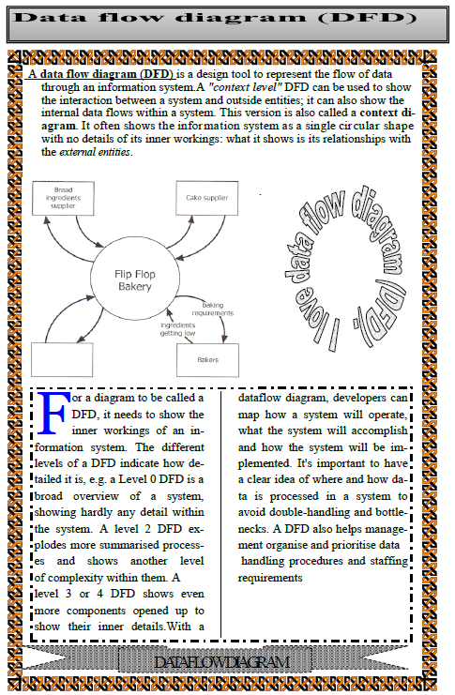

- Design the publication above (in page 4) as it appears and save it as MOKASA_2. (30 marks)
- Format the Title “ Data Flow Diagram (DFD)” as follows: (6 marks)
(i)
    - Character spacing: 300%
    - Font style: Times New Roman
    - Font size: 13.5
(ii) Modify the shape containing the title as follows:
- Background : Gradient with 17% transparency, Shading style Horizontal
- Border line : Double
- Apply a first line indent to the first paragraph of the document. (2 marks)
- Proofread your publication. (½ mark)
- Insert your full index number as a watermark of your publication. (2 marks)
- Insert your full name as the header, Class and admission number as the footer of your publication . (2 marks)
- Insert page number at the right bottom margin of your page. (2 marks)
- Insert the Date and time created for this document after the first paragraph. (2 marks)
- Print your publication (2 marks)

