NAME:…………………………………………………………ADMNO:……………INDEX NO:………………………..
CLASS:………………………SIGNATURE:……………………………………………..

312/1
GEOGRAPHY
Paper 1
July, 2019
Time 2 hours 45 min.

MOKASA II JOINT EXAMINATION
Kenya Certificate of Secondary Education
312/1
Paper 1
GEOGRAPHY

INSTRUCTIONS TO STUDENTS
- This paper has two sections A and B.
- Answer ALL the questions in section A. In section B answer questions 6 and any other TWO questions.
SECTION A: 25 MARKS
Answer ALL questions in this section

1. Describe the formation of planet earth according to the passing star theory.
(5 marks)

2. (a) Give two examples of sedimentary rocks. (2 marks)

(b) State three characteristics of sedimentary rocks. (3 marks)

3. (a) Differentiate between weathering and mass wasting. (2 marks)

(b) State three causes of landslides. (3 marks)

4. (a) The diagram below shows the hydrological cycle. Study and use it to answer
the question that follows.
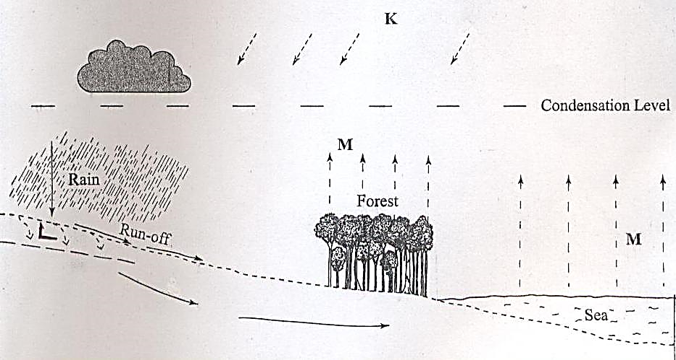
L

- Identify the processes marked K and L. (2 marks)

(b) State three characteristics of a flood plain. (3 marks)

5. (a) State two reasons why wind erosion is dominant in arid areas. (2 marks)

(b) Describe how a Bajada is formed. (3 marks)

SECTION B
Answer question 6 and any other TWO questions from this section.
6. Study the map of Taita hills, 1:50,000 sheet provided and answer the question that follow.

- (i) What is the latitudinal and longitudinal extent of Taita Hills map extract? (2 marks)
(ii) Convert the ratio scale of the map into statement. (2 marks)

(b) Citing evidence from the map, identify four social activities in the area covered by Taita Hills. (4 marks)

(c) (i) Draw a rectangle 20cm by 16cm from Easting 32 to 37 Northings 14
to 18. (2 marks)
(ii) On the rectangle mark and name; (4 marks)

- Taita sisal estate
- Hills
- Main track/motorable
- River

(iii) Calculate the new scale of the drawn rectangle. (2 marks)

(d) Citing evidence, explain three ways how relief has influenced the distribution of settlement in Taita Hills. (6 marks)

(e) Describe the vegetation in the area covered by the map. (3 marks)

7. (a) Name two instruments kept in a Stevenson screen. (2 marks)

(b) The diagram below shows a weather measuring instrument. Use it to answer the questions below.
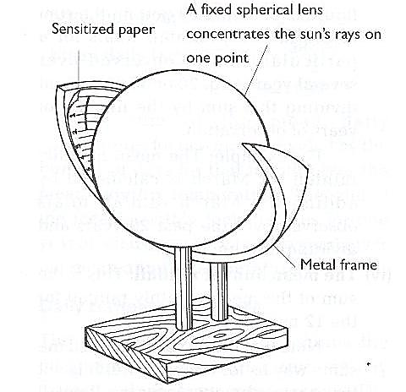

Metal frame
M
N

- Name the parts marked M and N. (2 marks)
- Describe how the instrument works. (4 marks)
(c) The table below shows climatic figure for station Q. Use it to answer the questions that follow.

Months | J | F | M | A | M | J | J | A | S | O | N | D
Temp in ⁰C | 30 | 31 | 31 | 29 | 27 | 27 | 28 | 29 | 28 | 28 | 27 | 30
Rainfall in mm | 257 | 246 | 231 | 234 | 207 | 201 | 218 | 227 | 234 | 240 | 235 | 230

(i) Calculate the annual range of temperature for station Q. (2 marks)

(ii) Give four characteristics of climate for station Q. (4 marks)

(d) With the aid of a well-labelled diagram, describe the formation of cyclonic rainfall. (6 marks)
(e) You intend to carry out a field study of a weather station in your school.

(i) Give two methods of recording data that you are likely to use.
(2 marks)
(ii) State three reasons why the recording of data at a school weather station may be inaccurate. (3 marks)

8. (a) (i) Distinguish between a fault and a fold. (2 marks)
(ii) Give three factors that influence folding. (3 marks)
(b) Describe how isostatic adjustment cause earth movement. (5 marks)
(c) Describe how plate tectonic movements cause fold mountain formation.
(5 marks)

(d) (i) Name two features resulting from faulting. (2 marks)
(ii) Explain how faulting influences drainage of an area. (8 marks)
9. (a) Distinguish between soil profile and soil catena. (2 marks)
(b) Explain how the following factors influence soil formation:
(i) The parent rock (4 marks)
(ii) Relief (2 marks)

(c) Describe laterization process of leaching. (4 marks)

(d) State three importance of soil structure. (3 marks)

(e) Give two characteristics of Azonal soils. (2 marks)

(f) Explain four causes of physical soil degeneration. (8 marks)

10. (a) (i) Define the term Moraine. (2 marks)
(ii) State three conditions necessary for the formation of ice. (3 marks)
(b) Describe how ice moves through the following:-

(i) Basal slip (3 marks)
(ii) Extrusion flow (3 marks)

(c) Describe how an arete is formed. (6 marks)
(d) Explain the four Significance of lowland glaciated features to human
activities. (8 marks)

