NAME: ………………………………………………..CLASS:….……ADMNO…..….….

DATE………………………………
232/1
Physics
Paper 1
JULY 2019

MOKASA II JOINT EXAMINATION
Kenya Certificate of Secondary Education (KCSE)
Physics Paper 1

Instructions to candidates

- This paper consists of two sections A and B.
- Answer all the questions in the two sections in the spaces provided after each question
- All working must be clearly shown.
- Electronic calculators and Mathematical tables may be used.
- All numerical answers should be expressed in the decimal notations.

For Examiner use only
SECTION | QUESTION | MAX MARKS | CANDIDATE’S SCORE
A | 1 – 14 | 25
B | 15 | 12
 | 16 | 10
 | 17 | 09
 | 18 | 14
 | 19 | 10
TOTAL |  | 80
This paper consists of 14 printed pages. Candidates should check to ascertain that all pages are printed as indicated and that no questions are missing.

SECTION A (25 MARKS)
Answer all the questions in this section in the spaces provided.
1. Figure 1. shows a micrometer screw gauge being used to measure the diameter of a ball bearing.
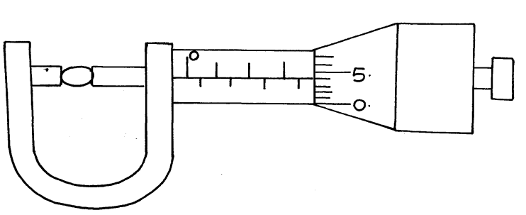
Fig.1

If the instrument has a negative zero error of 0.01mm, record the actual diameter of the ball bearing. (1 mark)
………………………………………………………………………………………………………
………………………………………………………………………………………………………
2. Figure 2. shows drops of mercury and water on a glass surface,
Mercury drop
Water drop
Fig. 2
Glass

Explain the difference in the shapes of the drops. (2 marks)
…………………………………………………………………………………………………………………………………………………………………………………………………………………………………………………………………………………………………
…………………………………………………………………………………………………
………………………………………………………………………………………………
3. State why diffusion is faster in gases than in liquids. (1 mark)
……………………………………………………………………………………………………………………………………………………………………………………………………
…………………………………………………………………………………………………
…………………………………………………………………………………………………

- When a Bunsen burner is lit above a wire gauze, it is observed that the flame initially burns above the gauze shown in figure 3 (i). After sometime, the flame burns below as well as above the gauze as shown in figure 3(ii).
Gauze
Fig. 3

(ii)
(i)

Explain the observation. (2 marks)
………………………………………………………………………………………………………………………………………………………………………………………………………………………………………………………………………………………………………
5. In an experiment to demonstrate Brownian motion, smoke was placed in a smoke cell and observed using a microscope. The smoke particles were seen moving randomly in the cell. Explain the observation. (1 mark)
……………………………………………………………………………………………………………………………………………………………………………………………………
6. A paper vane in a horizontal axis was placed above a Bunsen burner as shown in figure 4.
When the burner was lit, the paper vane begun to rotate. Explain the observation. (2 marks)
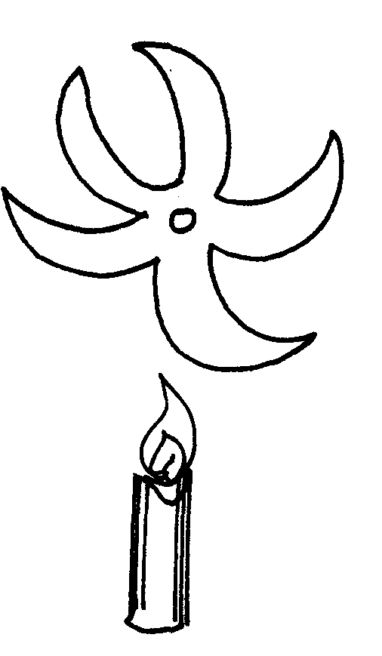
List Candle

Fig. 4

………………………………………………………………………………………………………………………………………………………………………………………………………………………………………………………………………………………………………
7. An electric kettle with shiny outer surface is more efficient than one with a dull outer surface, give a reason for this. (1 mark)
……………………………………………………………………………………………………………………………………………………………………………………………………
8. What is the reason why trailers carrying heavy loads have many wheels. (1mark)
……………………………………………………………………………………………………………………………………………………………………………………………………
9. Two flasks A and B were placed on a horizontal surface as shown in figure 5.

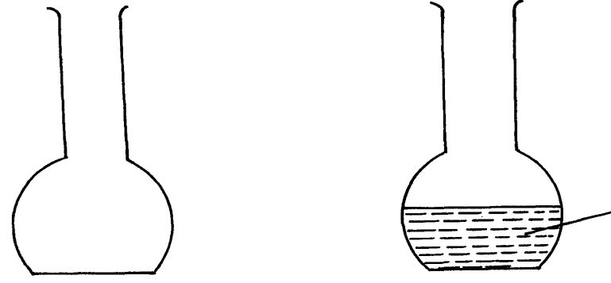

Fig. 5
A
B
Water

State and explain which flask is more stable. (2 marks)
……………………………………………………………………………………………………………………………………………………………………………………………………
10. Figure. 6 below shows a metre rule balancing when a mass of 200g is hung at one end.
Determine the tension, T in the string. (3 marks)
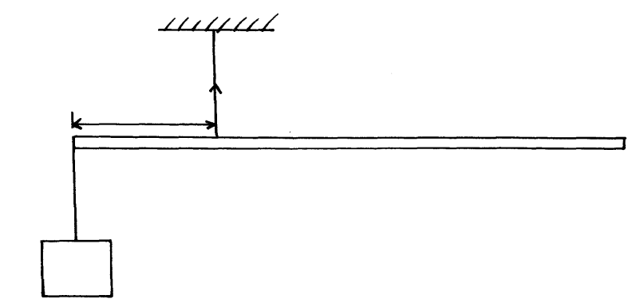
T
10cm
Fig. 6

200g

11. State Newton’s second law of motion. (1 mark)
……………………………………………………………………………………………………………………………………………………………………………………………………
…………………………………………………………………………………………………
12. A pipe of diameter 12mm is connected to another of diameter18mm. if water flows in the wider pipe at the speed of 2m/s, determine the speed of water in the narrow pipe. (3 marks)
…………………………………………………………………………………………………………………………………………………………………………………………………………………………………………………………………………………………………………………………………………………………………………………………………………
13. On the axes provided in the figure 7, sketch the graph showing variation in pressure with volume of a fixed mass of gas that obeys Boyle’s law. (1 mark)

Pressure (pa)

Volume ( cm³)

Fig. 7

14. An oil drop has a volume of 0.01mm³. When it is placed on the surface of water, it spreads out to form a circular patch of area 500cm².
(i) Calculate the size of the molecule of the oil. (3 marks)
……………………………………………………………………………………………… ……………………………………………………………………………………………… .……………..………………………………………………………………………………
.……………..………………………………………………………………………………
(ii) State one assumption made in (i) above. (1 mark)
…………………………………………………………………………………………………………………………………………………………………………………………………
SECTION B (55 marks)
15. (a)Define angular velocity (1 mark)
……………………………………………………………………………………………………………………………………………………………………………………………….……………..………………………………………………………………………………………………………
(b) the figure below shows an object of mass 0.2kg whirled in a vertical circle of radius 0.3m at uniform speed of 4m/s
D
A
B
c

(c) Determine the tension of the string at:
(i) Position A (2 marks)
……………………………………………………………………………………………………………………………………………………………………………………………….……………..………………………………………………………………………………………………………
(ii) Position B (2 marks)
……………………………………………………………………………………………………………………………………………………………………………………………….……………..………………………………………………………………………………………………………

(iii) Suggest the point where the string is likely to snap. (1 mark)
……………………………………………………………………………………………………………………………………………………………………………………………….……………..………………………………………………………………………………………………………
(d) The figure below shows the motion of a trolley on a ticker tape timer whose frequency is 100HZ
0.8cm
4cm
A
B
C
D

Determine:
(i) Initial velocity at points AB. (2 marks)
……………………………………………………………………………………………………………………………………………………………………………………………….……………..………………………………………………………………………………………………………
(ii) Velocity at points CD (2 marks)
……………………………………………………………………………………………………………………………………………………………………………………………….……………..………………………………………………………………………………………………………

(iii) Acceleration of the trolley during the motion. (2 marks)
……………………………………………………………………………………………………………………………………………………………………………………………….……………..………………………………………………………………………………………………………

16. (a)Give the reason why a density bottle is more accurate than a measuring cylinder when used to measure volume of liquids. (1 mark)
……………………………………………………………………………………………………………………………………………………………………………………………….……………..………………………………………………………………………………………………………
(b) State two precautions taken when using a density bottle. (2 marks)
……………………………………………………………………………………………………………………………………………………………………………………………….……………..………………………………………………………………………………………………………
(c) A form one student wanted to determine the density of copper. She wrote the following procedure: Study it and answer the questions that follow.
- Measure the mass x₁ (g) of a clean dry empty density bottle
- Fill the bottle partly with copper turnings and measure the mass x₂(g)
- Fill the bottle with water up to the neck and measure its mass x₃(g)
- Empty the bottle and rinse it.
- Fill it with water and replace the stopper. Measure the mass x₄(g) of the bottle filled with water.
Write an expression for:
(i) Volume of the bottle (2 marks)
……………………………………………………………………………………………………………………………………………………………………………………………….……………..………………………………………………………………………………………………………

(ii) Mass of copper turnings (1 mark)
……………………………………………………………………………………………………………………………………………………………………………………………….……………..………………………………………………………………………………………………………
(iii) Volume of copper turnings. (2 marks)
……………………………………………………………………………………………………………………………………………………………………………………………….……………..………………………………………………………………………………………………………
(iv) Density of copper. (2 marks)
……………………………………………………………………………………………………………………………………………………………………………………………….……………..………………………………………………………………………………………………………
17. (a) State the law of floatation (1 mark)
……………………………………………………………………………………………………………………………………………………………………………………………….……………..………………………………………………………………………………………………………

(b) A metal block weighs 0.8N is suspended by a string in water. If the block is completely immersed in water the tension in the string is 0.5N. Find
(i) The upthrust on the block (1 mark)
……………………………………………………………………………………………………………………………………………………………………………………………….……………..………………………………………………………………………………………………………

(ii) The density of the block. (3 marks)
……………………………………………………………………………………………………………………………………………………………………………………………….……………..………………………………………………………………………………………………………………………………………………………………………………………………………………
(c) The figure below shows a cork of mass 25g floating in water.

cork

Determine the minimum volume of copper that must be attached so that the two will just submerge.( Relative density of copper = 9.0, Relative density of cork= 0.25) ( 3marks)
Water
……………………………………………………………………………………………………………………………………………………………………………………………….……………..……………………………………………………………………………………………………………………………………………………………………………………………………………………………………………………………………………………………………….……………..………………………………………………………………………………………………………
(d) Explain how a submarine can be made to.
(i) Float on water (1 mark)
……………………………………………………………………………………………………………………………………………………………………………………………….……………..………………………………………………………………………………………………………

18. (a) You are provided with the following apparatus:
A filter funnel, a thermometer, a stop watch, ice at 0°C, an immersion heater rated P watts, a beaker, a stand, boss and clamp and a weighing machine.
Describe an experiment to determine the specific latent heat of fusion of ice. Clearly state the measurements to be made. (3 marks)
……………………………………………………………………………………………………………………………………………………………………………………………….……………………………………………………………………………………………………………………………………………………………………………………………….…………………………………………………………………………………………………………………………………………………………………………………………
(b) 200 g of ice at 0°C is added to 400g water in a well lagged calorimeter of mass 40g. The initial temperature of the water was 40°C. If the final temperature of the mixture is X°C,(Specific latent of fusion of ice L = 3.36 x 10⁵ Jkg⁻¹, specific heat capacity of water, c = 4200Jkg⁻¹K⁻¹, specific heat capacity of copper = 400 Jkg⁻¹K⁻¹.)

(i) Derive an expression for the amount of heat gained by ice to melt it and raise its temperature to X°C (2 marks)
……………………………………………………………………………………………………………………………………………………………………………………………….……………………………………………………………………………………………………………………………………………………………………………………………….…………………………………………………………………………………………………………………………………………………………………………………………………………………………………
(ii) Derive an expression for the amount of heat lost by the calorimeter and its content when their temperature falls to X°C. (2 marks)
……………………………………………………………………………………………………………………………………………………………………………………………….……………………………………………………………………………………………………………………………………………………………………………………………….…………………………………………………………………………………………………………………………………………………………………………………………………………………………………
(iii) Determine the value of X. (3 marks)
……………………………………………………………………………………………………………………………………………………………………………………………….……………………………………………………………………………………………………………………………………………………………………………………………….…………………………………………………………………………………………………………………………………………………………………………………………………………………………………
(c) A hydrogen balloon of volume 1.2 m³ is released at the ground level where the pressure is680 mmHg and a temperature of 20 °C. Determine the volume of the balloon at a height of2500m above the ground where the pressure drops to 500 mmHg and the temperature is 4°C. (4 marks)
……………………………………………………………………………………………………………………………………………………………………………………………….……………………………………………………………………………………………………………………………………………………………………………………………….………………………………………………………………………………………………………………………………………………………………………………………………………………………………………………………………………………………………………………………………………………………………………………………………………………
19. A balloon seller has a cylinder of helium gas which he uses to blow up his balloons. The volume of the cylinder is 0.10m³. It contains helium gas at a pressure of 1.0 x 10⁷Nm⁻². The balloon seller fills each balloon to a volume of 1.0 x 10⁻²m³ and a pressure of 2.0 x 10⁵N/m²
(a) Explain in terms of particles how the helium in the cylinder produces a pressure (1 mark)
…………………………………………………………………………………………………….………………………………………………………………………………………………………………………………………………………………………………………

(b) Calculate the total volume that the helium gases occupy at a pressure of 1.2 x 10⁵ N/m². Assume the temperature of the helium does not change (3 marks)
…………………………………………………………………………………………………….………………………………………………………………………………………………………….…………………………………………………………………………………………………….………………………………………………………………………………………………………….…………………………………………………………………………………………………….……………………………………………

(c) Calculate the number of balloons of volume 1.0 x 10⁻²m³ that the balloon seller can fill using the gas (2 marks)
…………………………………………………………………………………………………….………………………………………………………………………………………………………….…………………………………………………………………………………………………….…………………………………………………………………
(d) The graph below shows how the pressure of a gas trapped inside a sealed container changes with temperature. The pressure is caused by the gas particles continually hitting the sides of the container.
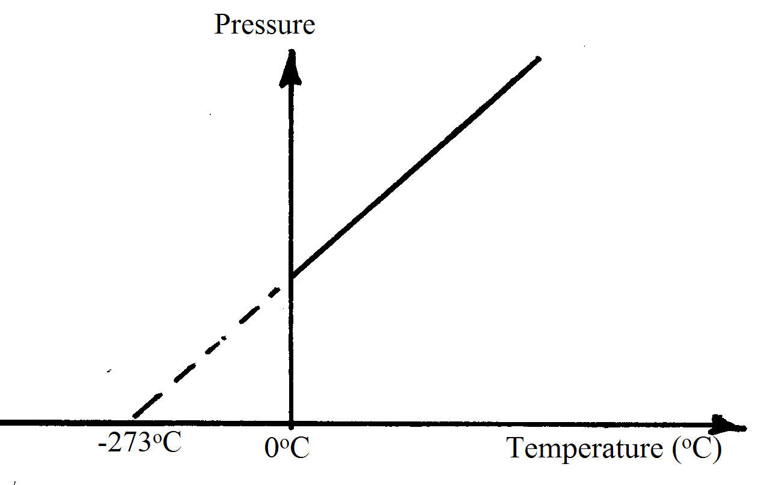
Figure 6
(i) Write down the name of the temperature at which the gas particles stop hitting the sides of the container (1 mark)
…………………………………………………………………………………………………….………………………………………………………………………………………
(ii) What is the momentum of the gas particles at this temperature? Give reason for the Answer (2 marks)
…………………………………………………………………………………………………….………………………………………………………………………………………………………….…………………………………………………………………………………………………….……………………………………………………………………………………………………………………………………………………………….
(iii) Give the value of the temperature in Kelvin (1 mark)
…………………………………………………………………………………………………….………………………………………………………………………………………..

END

