NAME: ………………………………………………..…CLASS:….…ADM NO:…………
SIGNATURE:…………………………………INDEX NO:…………………………………

232/2
PHYSICS
PAPER 2
JULY 2019

MOKASA II EXAMINATION - 2019
Kenya Certificate of Education
Physics Paper 2

Instructions to candidates

- This paper consists of two sections A and B.
- Answer all the questions in the two sections in the spaces provided after each question
- All working must be clearly shown.
- Electronic calculators, mathematical tables may be used.
- All numerical answers should be expressed in the decimal notations.

SECTION | QUESTION | MAX MARKS | CANDIDATE’S SCORE
A | 1 – 12 | 25
B | 13 | 14
 | 14 | 16
 | 15 | 09
 | 16 | 08
 | 17 | 08
TOTAL |  | 80

SECTION A (25 MARKS)
- The fig below shows the magnetization method
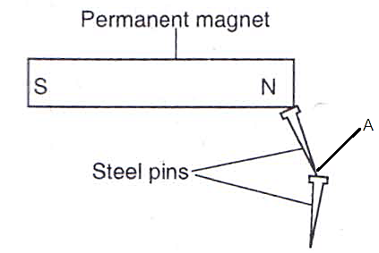

Figure 1
- State the method of magnetization shown above (1 mark)
……………………………………………………………………………………………………………………………………………………………………………………………………………………………………………………………………………………………………………………………………………………………………………………………………………………………………………………………………….
- State the polarity of point A in the pin attached to the magnet (1 mark)
……………………………………………………………………………………………………………………………………………………………………………………………………………………………………………………………………………………………………………………………………………………………………………………………………………………………………………………………………….
- The figure below shows two mirrors inclined at a certain angle x. A viewer counts a total of 7 images by looking directly into them from the object O. Determine the value of angle X (2 marks)
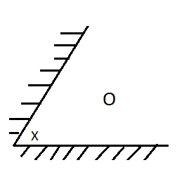Figure 2
………………………………………………………………………………………………………………………………………………………………………………………………………………………………………………………………………………………………………………………………………………………………………………………………………………………………………………………………………………………………………………………………………………………………………………………………………………………………………………………………………………………………………………………………………………………………………………………

- UV rays are made to fall on the cap of a negatively charged electroscope, state and explain the observation made. (2marks)
……………………………………………………………………………………………………………………………………………………………………………………………………………………………………………………………………………………………………………………………………………………………………………………………………………………………………………………………………………………………………................................................................................................................................
- The figure below shows a cross section of a dry cell.

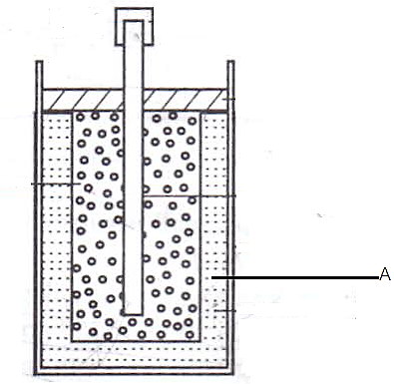Figure 3
- Name the part labeled A (1 mark)
……………………………………………………………………………………………………………………………………………………………………………………………………………………………………………………………………………………………………………
- State the use of manganese iv oxide in the cell (1 mark)
………………………………………………………………………………………………………………………………………………………………………………………………………………………………………………………………………………………………………………
- The figure below shows a ray incident on the boundary between two media 1 and 2 at an angle α.

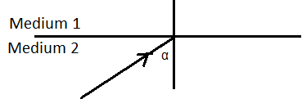Figure 4
Given that, the refractive index of medium 2 with respect to medium 1 is 1.5 and that the refracted ray forms an angle of 60º with the boundary. Calculate the angle of incidence α (3 marks)
…………………………………………………………………………………………………………………………………………………………………………………………………………………………………………………………………………………………………………………………………………………………………………………………………………………………………………………………………………………………………….............................................................................................................................................................................................................................................................................................................................................................................................................................................................
- Given the following resistor networks
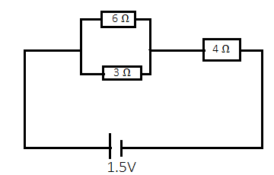Figure 5
- Calculate the effective resistance (2 marks)
……………………………………………………………………………………………………………………………………………………………………………………………………………………………………………………………………………………………………………………………………………………………………………………………………………………………………………………………………………………………………………………………………………………………………………………………………………………………….
- calculate the current through the 4 Ω resistor (1 mark)
……………………………………………………………………………………………………………………………………………………………………………………………………………………………………………………………………………………………………………………………………………………………………………………………………………………………………………………………………………………………………................................................................................................................................
- The table below shows part of the electromagnetic spectrum

A | B | Infrared | Visible light | C | D
- Name the radiation named A (1 mark)
………………………………………………………………………………………………………………………………………………………
……………………………………………………………………………………………………………………………………………………….

- State one method of production of C (1mark)
………………………………………………………………………………………………………………………………………………………………………………………………………………………………………………………………………………………………………………
- Give two reasons why the earth pin is usually longer than the neutral and live pin (2 marks)
……………………………………………………………………………………………………………………………………………………………………………………………………………………………………………………………………………………………………………………………………………………………………………………………………………………………………………………………………………………………………..............................................................................................................................
- (i) state the reason why tungsten is used as an anode target in an X- ray tube. (1 mark)
……………………………………………………………………………………………………………………………………………………………………………………………………………………………………………………………………………………………………………
- Distinguish between hard and soft X-rays (1mark)
……………………………………………………………………………………………………………………………………………………………………………………………………………………………………………………………………………………………………………………………………………………………………………………………………………………………………………………………………………………………………………………………………………………………………………………………………………………………………………………………………………………………………………………………………………………………………………………….
- State the reason as to why convex mirror is preferred over a plane mirror for use as a driving mirror (1mark)
………………………………………………………………………………………………………………………………………………………………………………………………………………………………………………………………………………………………………………………………………………………………………………………………………………………………………………………………………
- An iron box has a resistance of 30 Ω and takes a current of 5A. Calculate heat in kJ developed in 2 minutes. (2 marks)
……………………………………………………………………………………………………………………………………………………………………………………………………………………………………………………………………………………………………………………………………………………………………………………………………………………………………………………………………
- State two factors affecting speed of sound in air (2 marks)
………………………………………………………………………………………………………………………………………………………………………………………………………………………………………………………………………………………………………………

SECTION B (55 MARKS)
- (a) State Lenz’s law (1 mark)
……………………………………………………………………………………………………………………………………………………………………………………………………………………………………………………………………………………………………………………………………………………………………………………………………………………………………………………………………….(b) The diagram below shows two coils placed close to each other
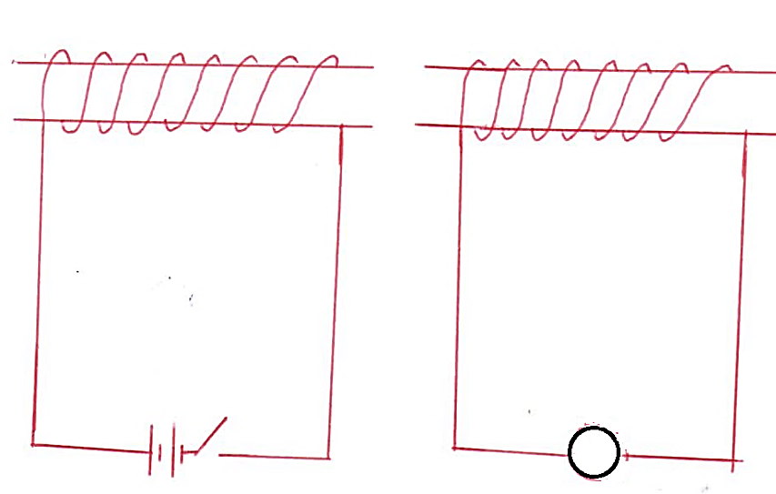Figure 6
- Indicate in the diagram the direction of the deflection of the galvanometer when switch S is closed (1 mark)
………………………………………………………………………………………………………………………………………………………
- Compare the difference noted in the deflection of the galvanometer on closing the switch and on opening the switch (1 mark)
……………………………………………………………………………………………………………………………………………………………………………………………………………………………………………………………………………………………………………………………………………………………………………………………………………………………………………………………………….
- Explain the difference noted in (ii) above (1mark)
……………………………………………………………………………………………………………………………………………………………………………………………………………………………………………………………………………………………………………………………………………………………………………………………………………………………………………………………………
- State any two ways that can be done to increase the deflection of the galvanometer (2marks)
………………………………………………………………………………………………………………………………………………………………………………………………………………………………………………………………………………………………………………………………………………………………………………………………………………………………………………………………………
(b) The generator at a power plant produces a voltage of 25KV for long distance transmission on overhead power lines. This is stepped up to 400KV. It is later stepped down to 240V for domestic use.
(i) State the reason why the voltage is stepped up to 400KV (1mark)
………………………………………………………………………………………………………………………………………………………………………………………………………………………………………………………………………………………………………………………………………………………………………………………………………………………………………………………………………
- A transformer is used to step up the voltage. Calculate the ratio of primary turns to secondary turns needed for this transformer (2marks)
……………………………………………………………………………………………………………………………………………………………………………………………………………………………………………………………………………………………………………………………………………………………………………………………………………………………………………………………………………………………………………………………………………………………………………………………………………………………………………………………………………………………………………………………………………………………………………………….
- Given that the step down transformer has a current output of 20A and it is 80% efficient. Calculate the current through the primary coil of the transformer (3marks)
……………………………………………………………………………………………………………………………………………………………………………………………………………………………………………………………………………………………………………………………………………………………………………………………………………………………………………………………………………………………………………………………………………………………………………………………………………………………………………………………………………………………………………………………………………………………………………………….
(c) State one energy loss in a transformer and how it is minimized (2marks)
………………………………………………………………………………………………………………………………………………………………………………………………………………………………………………………………………………………………………………………………………………………………………………………………………………………………………………………………………………………………………………………………………………………………………………………………………………………………
- (a) Define the term Threshold wavelength (1mark)
………………………………………………………………………………………………………………………………………………………………………………………………………………………………………………………………………………………………………………………………………………………………………………………………………………………………………………………………………………………………………………………………………………………………………………………………………………………………

(b) The figure below is a graph of the stopping potential Vs against frequency in an experiment on photoelectric effect.

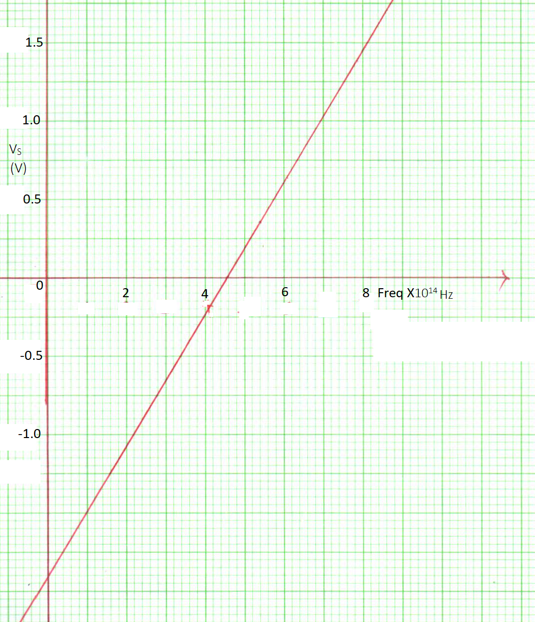
Figure 7
Given that the stopping potential Vs is related to the frequency by equation V_{S}e=hf-Wo, where e is the charge of an electron (e=1.6x10⁻¹⁹C), Determine;
- Planks constant, h (3 marks)
……………………………………………………………………………………………………………………………………………………………………………………………………………………………………………………………………………………………………………………………………………………………………………………………………………………………………………………………………………………………………...............................................................................................................................................................................................................................................................................................

- Find the threshold frequency (1 mark)
……………………………………………………………………………………………………………………………………………………………………………………………………………………………………………………………………………………………………………………………………………………………………………………………………………………………………………………………………….
- Work function, Wo of the metal in electron volts (2marks)
……………………………………………………………………………………………………………………………………………………………………………………………………………………………………………………………………………………………………………………………………………………………………………………………………………………………………………………………………………………………………………………………………………………………………………………………………………………………….
(b) The figure below shows a diagram of a cathode ray oscilloscope
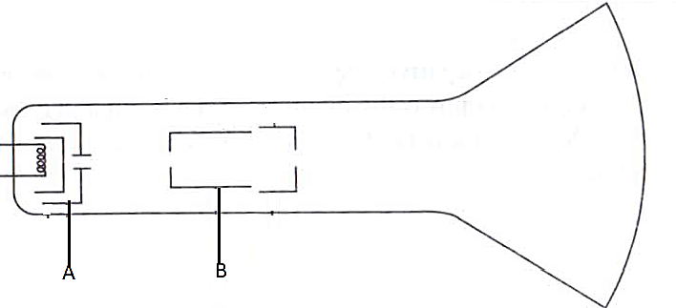
Figure 8
Name the parts labeled;
- A :……………………………………………………….. (1mark)
- B :………………………………………………………. (1 mark)
- State two functions of the electron gun (2marks)
………………………………………………………………………………………………………………………………………………………………………………………………………………………………………………………………………………………………………………………………………………………………………………………………………………………………………………………………………………………………………………………………………………………………………………………………………………………………
- Explain how the electrons are produced in the tube (2marks)
………………………………………………………………………………………………………………………………………………………………………………………………………………………………………………………………………………………………………………………………………………………………………………………………………………………………………………………………………………………………………………………………………………………………………………………………………………………………………………………………………………………………………………………………………………………………………………………
- The figure below represents a display of an ac signal on the CRO screen
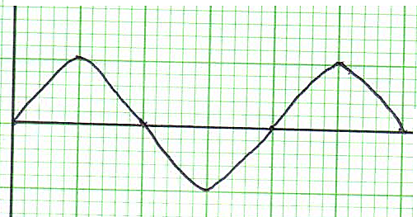
Figure 9
Determine the frequency of the signal given that the time base setting is 200ms per division (3marks)
……………………………………………………………………………………………………………………………………………………………………………………………………………………………………………………………………………………………………………………………………………………………………………………………………………………………………………………………………………………………………………………………………………………………………………………………………………………………………………………………………………………………………………………………………………………………………………………….
- (a) Distinguish between intrinsic and extrinsic semi-conductors (1 mark)
……………………………………………………………………………………………………………………………………………………………………………………………………………………………………………………………………………………………………………………………………………………………………………………………………………………………………………………………………………………………………………………………………………………………………………………………………………
(b) The diagram below show a p-n junction,

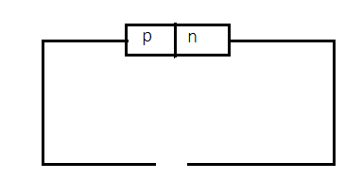
Figure 10

Complete the terminal of the external cell to show a reverse biased diode (1 mark)
………………………………………………………………………………………………………………………………………………………………………………………………………………………………………………………………………………………………………………

(c) The figure below shows an ac connected in series with a diode and CRO
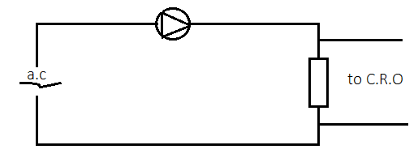Figure 11
- State the type of rectification shown above (1mark)
………………………………………………………………………………………………………………………………………………………………………………………………………………………………………………………………………………………………………………
- Sketch on the axes provided in the wave that is seen on the CRO screen from the circuit shown in (i) above (2marks)
Figure 12
(d) Describe how an n-type semi-conductor is formed (2marks)
………………………………………………………………………………………………………………………………………………………………………………………………………………………………………………………………………………………………………………………………………………………………………………………………………………………………………………………………………………………………………………………………………………………………………………………………………………………………
(e) Sketch a current- voltage characteristic of a junction diode with both forward and reverse bias (2marks)
………………………………………………………………………………………………………………………………………………………………………………………………………………………………………………………………………………………………………………………………………………………………………………………………………………………………………………………………………………………………………………………………………………………………………………………………………………………………
………………………………………………………………………………………………………………………………………………………………………………………………………………………………………………………………………………………………………………

- (a) The figure below shows plane waves incident on a curved reflecting surface, draw the reflected wave fronts (1mark)

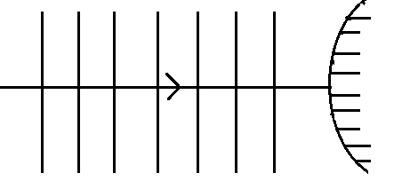Figure 13
………………………………………………………………………………………………………………………………………………………………………………………………………………………………………………………………………………………………………………
(b) The diagram below shows water waves moving from shallow water to deep water
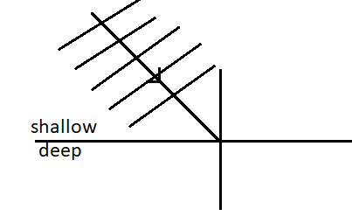
Figure 14
Sketch on the diagram the refracted wave fronts (2 marks)
………………………………………………………………………………………………………………………………………………………

(c) The figure below shows a wave profile.
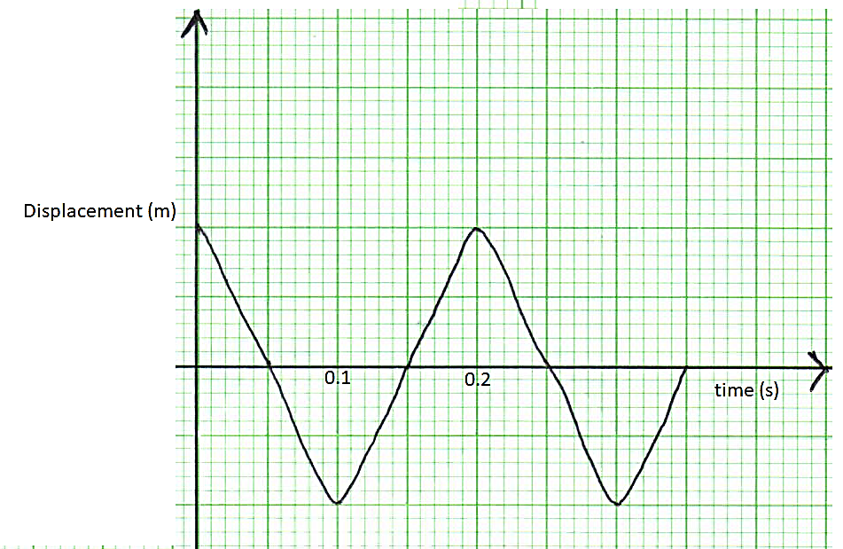Figure 15
. Determine the frequency of the wave (2marks)
…………………………………………………………………………………………………………………………………………………………………………………………………………………………………………………………………………………………………………………………………………………………………………………………………………………………………………………………………………………………………...............................................................................................................................................................................................................................................................................................
(d) An object is positioned 12cm from the Centre of a converging lens of focal length 18cm. Find the position and nature of image formed (3marks)
……………………………………………………………………………………………………………………………………………………………………………………………………………………………………………………………………………………………………………………………………………………………………………………………………………………………………………………………………………………………………...............................................................................................................................................................................................................................................................................................
- (a) Define the term half-life (1 mark)
………………………………………………………………………………………………………………………………………………………………………………………………………………………………………………………………………………………………………………………………………………………………………………………………………………………………………………………………………
(b) The following nuclear reaction is part of radioactive series
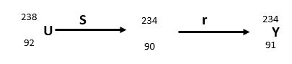
X
Name the radiations represented by r and s
r…………………………………………… (1mark)
s…………………………………………… (1mark)

(c) The figure below shows the features of a diffusion cloud chamber used for detecting radiations for radioactive source
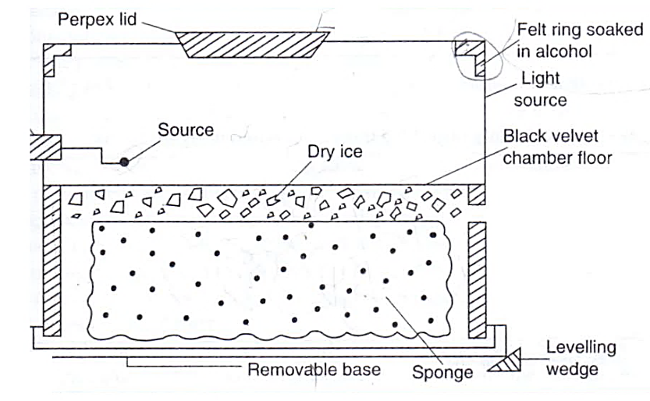
Figure 16
- Give a reason as to why Perspex lid is rubbed with a piece of cloth (1mark)
………………………………………………………………………………………………………………………………………………………………………………………………………………………………………………………………………………………………………………………………………………………………………………………………………………………………………………………………………
- Explain how radiations from the radioactive source is detected in the chamber (3marks)
……………………………………………………………………………………………………………………………………………………………………………………………………………………………………………………………………………………………………………………………………………………………………………………………………………………………………………………………………………………………………..............................................................................................................................................................................................................................................................................................................................................................................................................................................................
- State one advantage of cloud chamber over a charged electroscope when used as a detector of radiations (1mark)
………………………………………………………………………………………………………………………………………………………………………………………………………………………………………………………………………………………………………………………………………………………………………………………………………………………………………………………………………

