NAME: ……………………………… DATE: ………………..………
SCHOOL:……………………..…… CANDIDATE’S SIGN: ….....……

443/1
AGRICULTURE
PAPER 1
JULY/AUGUST 2018
TIME: 2 HOURS

LANET CLUSTER JOINT EXAMINATION (LANJET) -2018
443/1
AGRICULTURE
PAPER 1
JULY/AUGUST 2018
TIME: 2 HOURS

INSTRUCTIONS TO CANDIDATES
- Write your name, index number and class in the spaces provided above.
- This paper consists of THREE SECTIONS, A, B and C.
- Answer all questions in sections A and B and two questions in section C.
- All your answers must be written in the spaces provided in this question paper.
FOR EXAMINERS USE ONLY
SECTION | QUESTIONS | MAXIMUM SCORE | CANDIDATES SCORE
A | 1-18 | 30
B | 19-22 | 20
C | 23-25 | 20
 |  | 20
TOTAL |  | 90

This paper consists of 12 printed pages. Candidates should check the question paper to ascertain that all pages are printed as indicated and that no pages are missing.

SECTION A (30 MARKS)
Answer all questions in this section
1. Highlight two reasons for early land preparation. (1 mk)
……………………………………………………………………………………………………………………………………………………………………………………………………………………….
2. Give two examples of Variable costs in the production of beans. (1 ½ mks)
……………………………………………………………………………………………………………………………………………………………………………………………………………………….
3. What is the relationship between scarcity, preference and choice. (2 mks)
……………………………………………………………………………………………………………………………………………………………………………………………………………………….
4. State two conditions under which the opportunity cost is zero or does not exist. (1 mk)
……………………………………………………………………………………………………………………………………………………………………………………………………………………….
5. State four importance of raising tomato seedlings in a nursery bed. (2 mks)
………………………………………………………………………………………………………………………………………………………………………………………………………………………………………………………………………………………………………………………………………………………………………………………………………………………………………………….
6. Give four factors that affect the ensiling process. (2 mks)
………………………………………………………………………………………………………………………………………………………………………………………………………………………………………………………………………………………………………………………………………………………………………………………………………………………………………………….
7. Give two examples of Books of Accounts. (1 mk)
……………………………………………………………………………………………………………………………………………………………………………………………………………………….
8. Give two reasons for imposing quarantine on imported planting materials. (1 mk)
……………………………………………………………………………………………………………………………………………………………………………………………………………………….
9. Give three factors that may influence the price of an agricultural commodity. (1 ¹/₂mks)
…………………………………………………………………………………………………………………………………………………………………………………………………………………………………………………………………………………………………………………………………….

10. Name three examples of leguminous fodder crops. (1 ¹/2Mks)
……………………………………………………………………………………………………………………………………………………………………………………………………………………….……………………………………………………………………………………………………………
11. Give two factors that may determine the size of a pit for silage making. (1mk)
……………………………………………………………………………………………………………………………………………………………………………………………………………………….
12. Give three reasons for controlling weeds in pastures. (1 ½Mks)
……………………………………………………………………………………………………………………………………………………………………………………………………………………….………………………………………………………………………………………………………….
13. State six characteristics of a productive soil. (3 mks)
……………………………………………………………………………………………………………………………………………………………………………………………………………………….………………………………………………………………………………………………………….……………………………………………………………………………………………………………………………………………………………………………………………………………………….………………………………………………………………………………………………………….
14. A member of young farmers club was advised to apply a complete fertilizer 30:20:10 in a tomato
plot measuring 10m long by 5m wide at the rate of 300kg per hectare
- State the percentage of P₂0₅ in the complete fertilizer. ( 1mk)
……………………………………………………………………………………………………………………………………………………………………………………………………………………….……………………………………………………………………………………………………….
- Calculate the amount of fertilizer the member would require for the plot (2 mks)
(Show your working)

……………………………………………………………………………………………………………………………………………………………………………………………………………………….………………………………………………………………………………………………………….
……………………………………………………………………………………………………………………………………………………………………………………………………………………….………………………………………………………………………………………………………….
15. State four ways of controlling bean anthracnose disease (2mks)

16. Apart from training and extension services, state four other agricultural support services the
Kenyan government provides to a maize farmer. (2 mks)
……………………………………………………………………………………………………………………………………………………………………………………………………………………….………………………………………………………………………………………………………….…………………………………………………………………………………………………………………
17. List four sites on which agro forestry trees can be established on a farm (2 mks)
……………………………………………………………………………………………………………………………………………………………………………………………………………………….………………………………………………………………………………………………………………………………………………………………………………………………………………………….…
18. Give two forms in which nitrogen is absorbed from the soil by plants (1 mk)
……………………………………………………………………………………………………………………………………………………………………………………………………………………….…

SECTION B: (20 MARKS)
Answer all questions in this section
19. Study the weeds illustrated below and answer the questions that follow

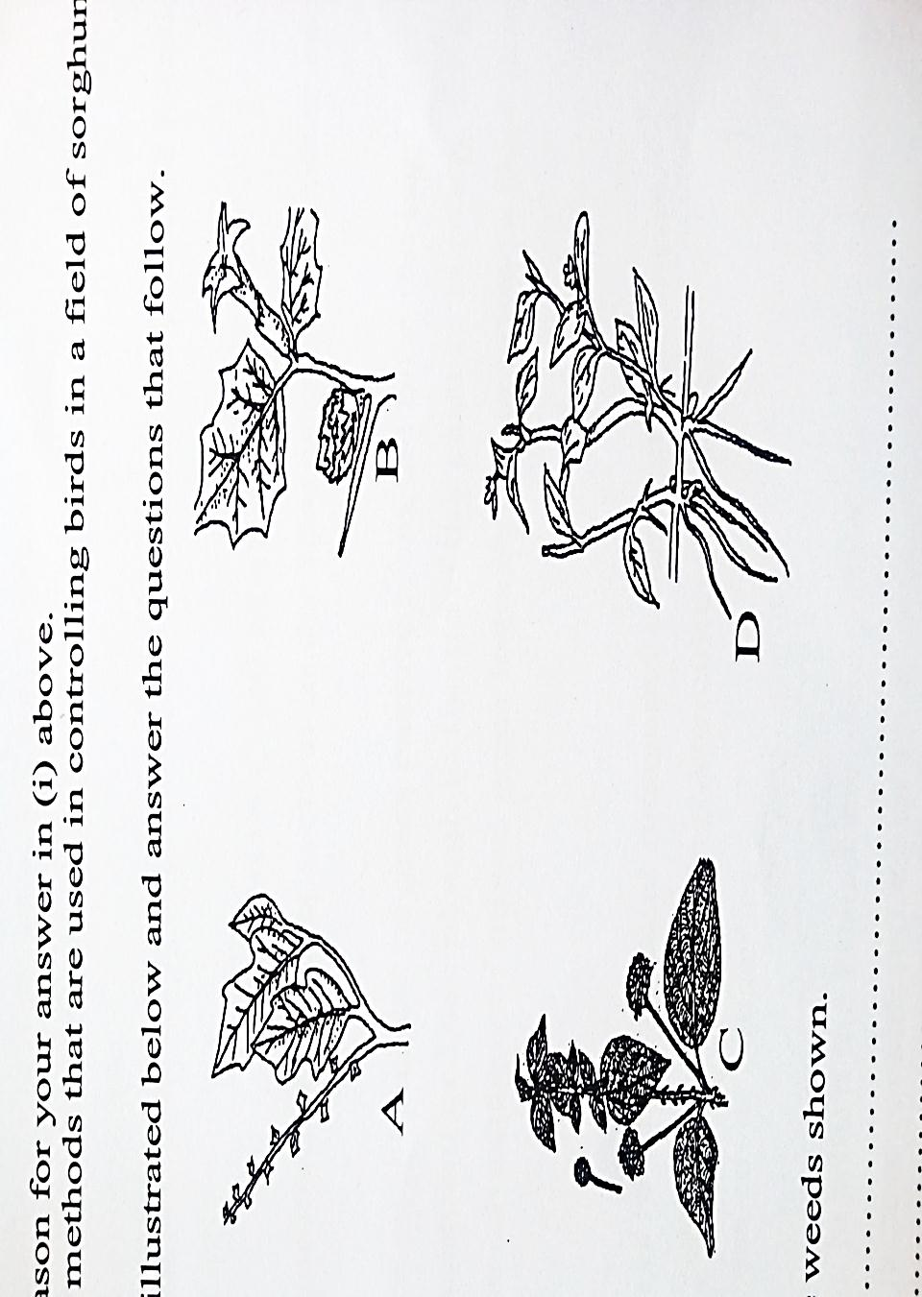

- Identify the weeds shown (4mks)
A……………………………..
B……………………………..
C…………………………......
D……………………………..
- Give one economic importance of each one of the weeds (2mks)
- ………………………………..
- ………………………………..
- State the advantage of weed C on the farm (1 mk)
- …………………………………………………………………………………………………………………………………………………………………………………………………………
- Why is weed D difficult to control (1mk)
…………………………………………………………………………………………………… ……………………………………………………………………………………………………

20. The diagrams below represent some pests. Study them and answer the questions that follow.

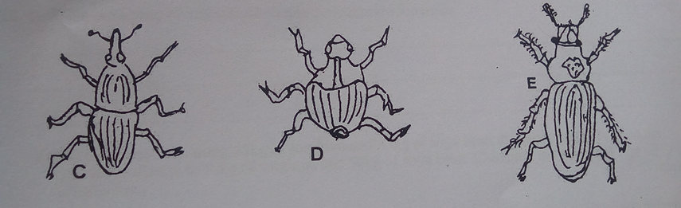

i) Identify the pest labeled C, D and E (3 mks)
C-……………………………………………………
D- …………………………………………………..
E- …………………………………………………..
ii) Give one reason why pest E is not controlled chemically (1 mk)
…………………………………………………………………………………………………………………………………………………………………………………………………………………….
iii) State two non-chemical methods of controlling pest C and D (1 mk)
……………………………………………………………………………………………………………………………………………………………………………………………………………………….…

21. The diagram below illustrates an experiment on soil. Study it carefully and answer the questions
that follow.

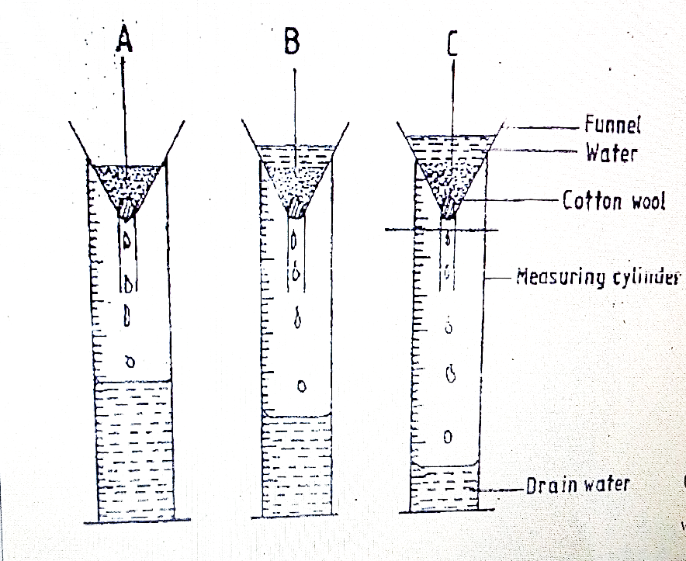
a) State the aim of the experiment (1 mk)
……………………………………………………………………………………………………………………………………………………………………………………………………………………….…
b) If the volume of water illustrated in the measuring cylinder was observed after one hour, identify the soil sample labeled A and B
i) Soil sample A (1 mk)
……………………………………………………………………………………………………………
ii) Soil sample B (1 mk)
……………………………………………………………………………………………………………
c) State one way in which the soil structure of the sample labeled C above can be improved (1 mk)
……………………………………………………………………………………………………………

22. Study the illustration below which illustrates a series of changes.

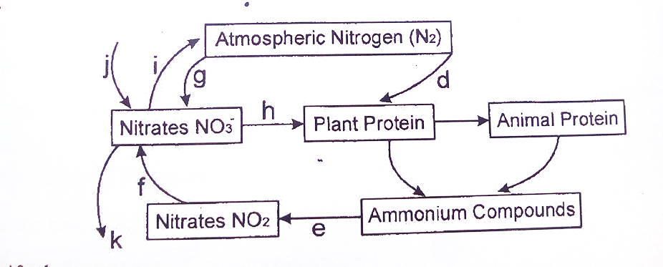
- Identify the process (1 mk)
…………………………………………………………………………………………………………
Name the organism involved in the series represented by d (1 mk)
D- ………………………………………………………

- Identify the processes represented by h and i ( 1mks)
H- ……………………………………………………….
I- ………………………………………………………..

SECTION C: (40MARKS)
Answer any two questions from this section
23 a).Describe the field production of dry beans under the following sub headings
i). Planting (5mks)
ii) Weed control (2mks)
iii) Harvesting (5mks)
b) Outline four problems associated with manure use in agricultural production (4 mks)
c) Give four characteristics of plants suitable for green manure (4 mks)

24 a) Explain ten factors that can encourage soil erosion. (10marks)
b) Describe the seven management practices that should be carried out on a vegetable nursery after sowing seeds until the seedlings are ready for transplanting. (7 marks)
c) Describe the precautions that should be observed during the harvesting of pyrethrum. (3 mks)

25 a). Explain eight factors that should be considered when planning to set up a farm business.
(8 mks)
b) The information below was extracted from the financial valuation of Uwezo Micro-farm at the end of the year 2017.
ITEM VALUE IN KSHS
Tools in store……………………………………………. 10,000
Cattle feed in store ……………………………………… 4,000
Office equipment ………………………………………. 1,400
Calves ………………………………………………….. 5,000
Machinery ……………………………………………… 4,000
Land …………………………………………………… 260,000
Seven Mature sheep…………………………………… 7,000
Buildings ……………………………………………… 126,000
Maize in store …………………………………………… 19,000
Daily cattle ……………………………………………… 55,000

On the same date, the farm had Kshs 50000 in the bank and owed KFS kshs 4500 for fertilizers and 5000 to Unga ltd for feeds delivered and 12000 for laborers’ wages. KCC owed the farm 5000 for fresh milk delivered.
Draw up a balance sheet for Uwezo Micro farm as at 31st December 2017. (12marks)

………………………………………………………………………………………………………………………………………………………………………………………………………………………………………………………………………………………………………………………………………………………………………………………………………………………………………………………………………………………………………………………………………………………………………………………………………………………………………………………………………………………………………………………………………………………………………………………………………………………………………………………………………………………………………….………………………………………………………………………………………………………………………………………………………………………………………………………………………………………………………………………………………………………………………………………………………………………………………………………………………………………………………………………………………………………………………………………………………………………………………………………………………………………………………………………………………………………………………………………………………………………………………………………………………………………………………………………………………………………….………………………………………………………………………………………………………………………………………………………………………………………………………………………………………………………………………………………………………………………………………………………………………………………………………………………………………………………………………………………………………………………………………………………………………………………………………………………………………………………………………………………………………………………………………………………………………………………………………………………………………………………………………………………………………….………………………………………………………………………………………………………………………………………………………………………………………………………………………………………………………………………………………………………………………………………………………………………………………………………………………………………………………………………………………………………………………………………………………………………………………………………………………………………………………………………………………………………………………………………………………………………………………………………………………………………………………………………………………………………….………………………………………………………………………………………………………………………………………………………………………………………………………………………………………………………………………………………………………………………………………………………………………………………………………………………………………………………………………………………………………………………………………………………………………………………………………………………………………………………………………………………………………………………………………………………………………………………………………………………………………………………………………………………………………….
………………………………………………………………………………………………………………………………………………………………………………………………………………………………………………………………………………………………………………………………………………………………………………………………………………………………………………………………………………………………………………………………………………………………………………………………………………………………………………………………………………………………………………………………………………………………………………………………………………………………………………………………………………………………………….………………………………………………………………………………………………………………………………………………………………………………………………………………………………………………………………………………………………………………………………………………………………………………………………………………………………………………………………………………………………………………………………………………………………………………………………………………………………………………………………………………………………………………………………………………………………………………………………………………………………………………………………………………………………………….………………………………………………………………………………………………………………………………………………………………………………………………………………………………………………………………………………………………………………………………………………………………………………………………………………………………………………………………………………………………………………………………………………………………………………………………………………………………………………………………………………………………………………………………………………………………………………………………………………………………………………………………………………………………………….………………………………………………………………………………………………………………………………………………………………………………………………………………………………………………………………………………………………………………………………………………………………………………………………………………………………………………………………………………………………………………………………………………………………………………………………………………………………………………………………………………………………………………………………………………………………………………………………………………………………………………………………………………………………………….………………………………………………………………………………………………………………………………………………………………………………………………………………………………………………………………………………………………………………………………………………………………………………………………………………………………………………………………………………………………………………………………………………………………………………………………………………………………………………………………………………………………………………………………………………………………………………………………………………………………………………………………………………………………………….………………………………………………………………………………………………………………………………………………………………………………………………………………………………………………………………………………………………………………………………………………………………………………………………………………………………………………………………………………………………………………………………………………………………………………………………………………………………………………………………………………………………………………………………………………………………………………………………………………………………………………………………………………………………………….
………………………………………………………………………………………………………………………………………………………………………………………………………………………………………………………………………………………………………………………………………………………………………………………………………………………………………………………………………………………………………………………………………………………………………………………………………………………………………………………………………………………………………………………………………………………………………………………………………………………………………………………………………………………………………….……………………………………………………………………………………………………………………………………………………………………………………………………………………………………………………………………………………………………………………………………………………………………………………………………………………………………………………………………………………………………………………………………………………………………………………………………………………………………………………………………………………………………………………………………………………………………………………………………………………………………………………………………………………………………….………………………………………………………………………………………………………………………………………………………………………………………………………………………………………………………………………………………………………………………………………………………………………………………………………………………………………………………………………………………………………………………………………………………………………………………………………………………………………………………………………………………………………………………………………………………………………………………………………………………………………………………………………………………………………….………………………………………………………………………………………………………………………………………………………………………………………………………………………………………………………………………………………………………………………………………………………………………………………………………………………………………………………………………………………………………………………………………………………………………………………………………………………………………………………………………………………………………………………………………………………………………………………………………………………………………………………………………………………………………….……………………………………………………………………………………………………………………………………………………………………………………………………………………………………………………………………………………………………………………………………………………………………………………………………………………………………………………………………………………………………………………………………………………………………………………………………………………………………………………………………………………………………………………………………………………………………………………………………………………………………………………………………………………………………………………………………………………………………………………………………………………….………………………………………………………………………………………………………………………………………………………………………………………………………………………….………………………………………………………………………………………………………….

