NAME …………………………..……………….. DATE …………………………

INDEX NO. ……….……….…………………...…..… SIGNATURE ……………..…………..

231/3
BIOLOGY
PAPER 3
(PRACTICAL)
TIME: 1¾ HOURS.

LANET JOINT EVALUATION TEST, 2018

Kenya Certificate of Secondary Education

231/3
BIOLOGY
PAPER 3
(PRACTICAL)
JULY/AUGUST 2018
TIME: 1¾ HOURS.

INSTRUCTIONS TO CANDIDATES
- Answer all the questions.
- You are required to spend the first 15 minutes of the 1¾ hours allowed for the paper reading the whole paper carefully before commencing your work.
- Answers must be written in the spaces provided in the question paper.
- Additional pages must not be inserted.
- This paper consists of 4 printed pages. Candidates should check to ensure that all pages are printed as indicated and no questions are missing

FOR EXAMINER’S USE ONLY
Questions | Maximum score | Candidate's score
Question 1 | 16
Question 2 | 12
Question 3 | 12
Total score | 40

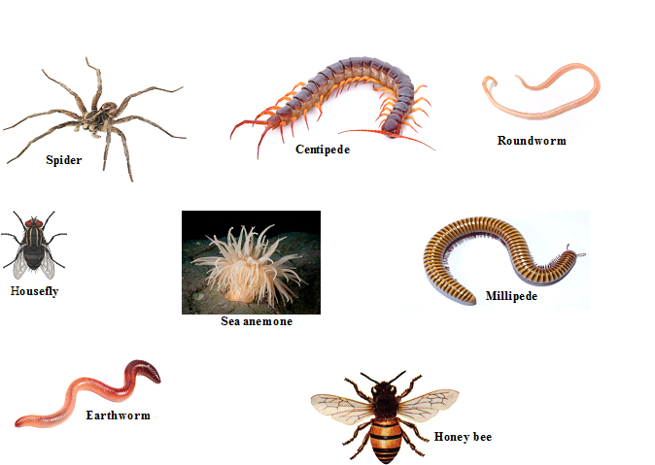
1. The photographs below show a variety of animals collected by a group of students during a field study.

a) Using the observable features only in the order given below, construct a dichotomous key that can be used to identify the animals (13marks)
- Body symmetry
- Limbs
- Six legs
- Wings
- Eight legs
- Pair of legs per segment
- Body segmentation
...................................................................................................................................................................................................................................................................................................................................................................................................................................................................................................................................................................................................................................................................................................................................................................................................................................................................................................................................................................................................................................................................................................................................................................................................................................................................................................................................................................................................................................................................……………………………………………...…………………………………………….........................................................................................................................................................................................................................................................................................................................................................................................................................................................................................................................................................................................................................................................................................................................................................................…………...................................................................................................................................................................................
b) (i) Name the phylum to which the housefly and the spider belong (1mark)
…………………………………………………………………………………………………….
…………………………………………………………………………………………………….
ii) Give a reason for your answer in b(i) above (1mark)
......................................................…………………………………………………………………...............................................................................................................................................................................................................................................................………………………………….

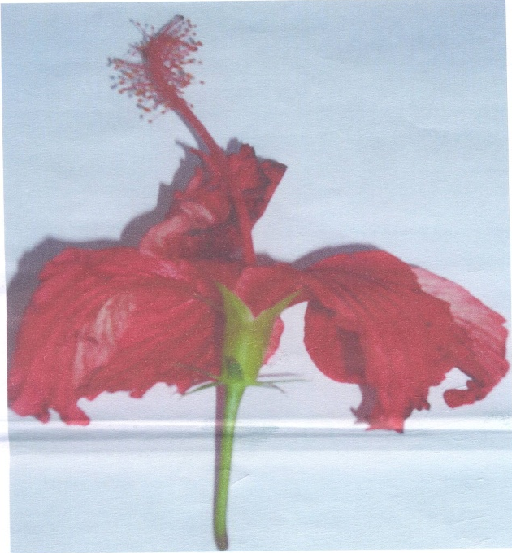
2. Study photograph P below and use it to answer the following questions.

a) On the photograph label a bract (1mark)
......................................................…………………………………………………………………..........................................................................................................................................................

b) Describe the arrangement of stamens and structure of corolla and calyx

i) Stamens (1mark)
......................................................…………………………………………………………………...............................................................................................................................................................................................................................................................………………………………….

ii) Corolla (1mark)
......................................................…………………………………………………………………...............................................................................................................................................................................................................................................................………………………………….

iii) Calyx (1mark)
......................................................…………………………………………………………………...............................................................................................................................................................................................................................................................………………………………….
c) i) Name the class of the plant from which the photograph was taken (1mark)
......................................................…………………………………………………………………...............................................................................................................................................................................................................................................................………………………………….

ii) Using only observable features on the photograph give one reason for your answer in c i) above (1mark)
......................................................…………………………………………………………………...............................................................................................................................................................................................................................................................………………………………….

d) i) Suggest the agent of pollination for the flower shown on the photograph (1mark)
......................................................…………………………………………………………………...............................................................................................................................................................................................................................................................………………………………….

ii) Give two reasons for your answer in d (i) above (2marks)
......................................................…………………………………………………………………...............................................................................................................................................................................................................................................................………………………………….

e) i) Which type of ovary is found in the flower on the photograph (1mark)
......................................................…………………………………………………………………...............................................................................................................................................................................................................................................................………………………………….

ii) Give a reason for your answer in e (i) above (1mark)
......................................................…………………………………………………………………...............................................................................................................................................................................................................................................................………………………………….

f) The actual length of the flower measured 14cm. Work out the magnification of the photograph (2marks)
......................................................…………………………………………………………………...............................................................................................................................................................................................................................................................………………………………….
......................................................…………………………………………………………………..........................................................................................................................................................
3. You are provided with two visking tubings, a solution labeled X, iodine solution, benedict’s solution and a piece of thread. Tie one end of the visking tubing tightly using the thread provided. With the help of a syringe, put 20ml of the solution labeled X into the visking tubings. Tie the other end of the visking tubing tightly. Ensure that there is no leakage at both ends of the visking tubing. Wash the outside of the visking tubing with water. Place the visking tubing upright in 100ml beaker. In set up A add the starch solution + solution X into the beaker to reach the level of starch solution in the visking tubing. In set up B add the starch solution + boiled solution X1 into the beaker to reach the level of starch solution in the visking tubing. Allow the set ups to stand for an hour in water bath maintained at 37⁰C. After an hour, the contents of the visking tubing and the beaker were tested using iodine solution and benedict’s solution. Arrange your set-up as shown below
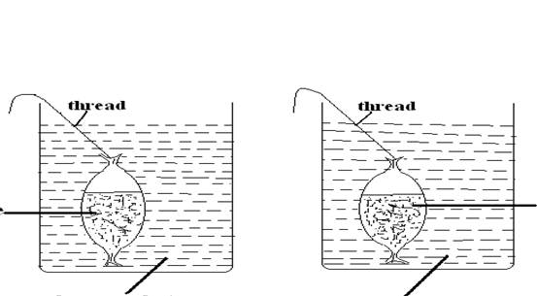
Set up A
Set up B
Visking tubing
containing starch solution
Visking tubing
containing starch solution + solution X
Visking tubing
containing starch solution + solution X
Visking tubing
containing starch solution + boiled solution X

Record in the table below the observations after the contents in set up A and B were tested using iodine solution and benedict’s solution. (8 marks)

 | VISKING TUBING |  | BEAKER
Set up | Iodine solution | Benedicts solution | Iodine solution | Benedict’s solution
A
B

