NAME: …………………………………………. INDEX NO: ………………

233/1
CHEMISTRY
PAPER 1
JULY/AUG 2018
TIME: 2 HOURS

LANET JOINT EVALUATION TEST – 2018
Kenya Certificate Of Secondary Education
233/1
CHEMISTRY
PAPER 1
JULY/AUG 2018
TIME: 2 HOURS

INSTRUCTIONS TO CANDIDATES

- Write your name and index number in the spaces provided.
- Answer all questions in the spaces provided
- Mathematical tables and silent electronic calculators may be used for calculations.
- All workings must be clearly shown where necessary.
- Candidates should check the question paper to ascertain all the pages are printed as indicated and no questions are missing.

For Examiners Use Only

MAXIMUM SCORE | STUDENTS SCORE
80

This paper consists of 10 printed pages. Candidates should check the question paper to ascertain that all pages are printed as indicated and that no pages are missing.

- a) What is meant by allotropy? (1 mark)
…………………………………………………………………………………………………………………………………………………………………………………………
b) Name the allotrope of Sulphur that is stable below 96 ºC. (1 mark)
…………………………………………………………………………..
c) Temperature of 96 ºC is the transition temperature of Sulphur allotropes. Define the term transitional temperature? (1 mark)
…………………………………………………………………………………………
……………………..……………………………………………………………………
…………………..………………………………………………………………………
- Define the following terms as used in Chemistry
  - Flame (1 mark)
……………………………………………………………………………………………
……………………..…………………………………………………………………..…
  - Optimum conditions (1 mark)
………………………………………………………………………………………….…
………………………………………………………………………………….…………
……………………………………………………………………………….……………

  - End point of a reaction (1 mark)
……………………………………………………………………………………….…
………………………………………………………………………………….…………
……………………………………………………………………………….……………
- Why is solid carbon (IV) Oxide (Dry ice) preferred in cool boxes than the normal ice (solid water)? (2mks)
………………………………………………………………………………………….…
………………………………………………………………………………….…………
……………………………………………………………………………….……………
- 30cm³ of ethene gas was exploded in 60cm³ of oxygen gas. Write a balanced chemical equation of the reaction that will take place and hence determine the volume of the residue gas at room temperature. (3mks)
…………………………………………………………………………………………………………………………………………………………………………………………………………………………………………………………………………………………………………………………………………………………………………………………………………………………………………………………………………………

- When solid M is dissolved in water, it dissolves and forms a blue solution. Addition of ammonia solution to this solution forms a blue precipitate which dissolves in excess to form a deep blue solution. Write the formula and name of the ion responsible for the deep blue solution. (2mks)
……………………………………………………………………………………
……………………………………………………………………………………
……………………………………………………………………………………
……………………………………………………………………………………

- The solubility of Iron (II) Sulphate crystals at 22ºC is 15.65g per 100g of water.
Calculate the mass of iron (II) sulphate crystals in 45g of saturated solution at the same temperature. (2mks)
…………………………………………………………………………………………………………………………………………………………………………………………………………………………………………………………………………………………………………………………………………………………………………………...
- The table below gives bond energies of some covalent compound
Bond | Bond energy KJ mol⁻¹
C – H | 413
O=O | 497
C=O | 804
H-O | 464
Calculate the enthalpy change for the combustion of methane in excess oxygen gas. (3mks)
……………………………………………………..….……………………………………..……………………………………………………..….……………………………………..……………………………………………………..….……………………………………..……………………………………………………..….……………………………
8 .Study the following equilibrium equation.

2X₂(g) + Y_{2(g)} 2X₂Y_{(g)}ΔH = -197kJ/mol

Suggest two ways of increasing the yield of X₂Y. (2mark)
………………………………………………..….……………………………………..……………………………………………………..….……………………………………..……………………………………………………..….……………………………….……………………………………………………………………………………………….

9. A student burnt magnesium ribbon in a gas jar full of Sulphur (IV) oxide gas.
(i) State two observations made in the gas jar. (2 marks)
……………………………………………………………………………………………………………….……………………………………………………………………………………………………………...................................................................
(ii) Write an equation for the reaction that took place. (1 mark)

……………………………………………………………………………………..

10. Iron is extracted from its ore by the blast furnace process.
a) Name the chief ore from which iron is extracted from. (1 mark)
…………………………………………………………………………………..
b) An ore is suspected to contain mainly iron. Describe a method that can be used to confirm the presence of iron in the ore. (2 marks)
…………………………………………………………………………………………………
…………………………………………………………………………………………………
…………………………………………………………………………………………………
…………………………………………………………………………………………………
...……………………………………………………………………………………..………
11. The diagram below shows a stove that uses charcoal as a fuel in a well-ventilated room. Study it and answer the questions that follow.

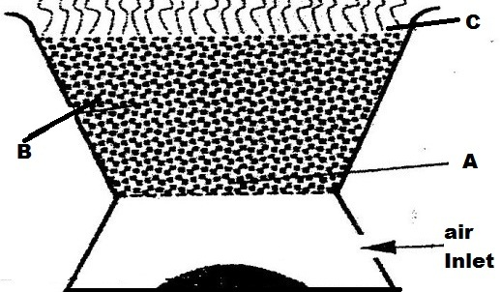

- Write the chemical equation for the reaction that takes place at
- Region A (1mark)
...................................................................................................................................
- Region C(1 mark)
...................................................................................................................................
- State the reason why the stove above should be used in a well ventilated room. (1 mk)
...................................................................................................................................

12. During electrolysis of dilute sulphuric (VI) acid, a current of 0.63 A was passed through the electrolyte for 74 minutes. Calculate the volume of gas produced at the anode.
(1 Faraday = 96500 coulombs; MGV 24dm³ at room temperature) (3marks)
...................................................................................................................................
...................................................................................................................................
...................................................................................................................................
...................................................................................................................................
......................................................................................................................................................................................................................................................................
13. The table below gives the rate of decay for a radioactive element K;

Number of days | Mass (g)
O | 12.8
280 | 0.8

Determine the half – life of the radioactive element K.(2mks)
……………………………………………………………………………………………………….……………………………………………………………………………………………………….……………………………………………………………………………………………………….……………………………………………………………………………………………………….…………………………………………………
14. The chromatogram below shows the constituents of ink sample M using methylated spirit as solvent.
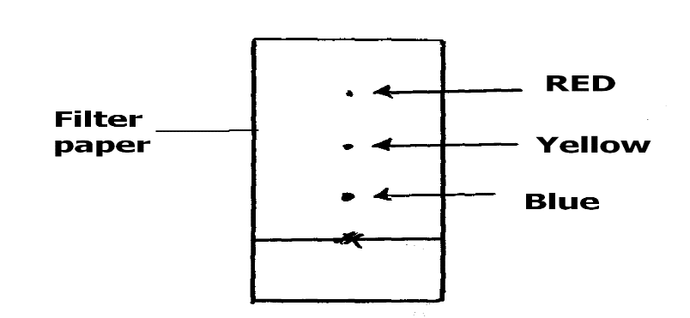
State two factors that allow separation of the pigment above.
……………………………………………………………………………………………………………………………………………………………………………………………………………………………………………………………………………………………………………………………………………………………………………………
15. Starting with magnesium sulphate solution, describe how a solid sample of magnesium oxide can be prepared in the laboratory. (3mks)
……………………………………………………………………………………………………….……………………………………………………………………………………………………….……………………………………………………………………………………………………….……………………………………………………………………………………………………….…………………………………………………………………………………………………………….…
……………………………………………………………….………………………

16. When solid F was added into a beaker containing distilled water, it dissolved to form a colourless solution F. When two drops ofacidified barium chloride solution was added to the sample solution F, a white precipitate was formed. There was effervescence when solid sodium carbonate was added to another sample of solution F.
    - Identify the cation and the anion present in solid F (1 mark)
Cation …………………………….
Anion …………………………….
    - Write ionic equation for formation of white precipitate formed upon adding acidified barium (ii) chloride (1 mark)
……………………………………………………………….………………………

17. The scheme below was used to prepare a cleansing agent. Study it and answer the questions that follow.
Fat
Solution of cleansing agent + alcohol
Solid cleansing agent
Step II
Boil
Step I
Step I

What name is given to the type of cleansing agent prepared by the method shown in the scheme? ………….…………………………………………… (1mk)

Name onechemical substance added in step II (1mk)
…………….…………………………………………………………………

(iii) What is the purpose of adding the chemical substance named in (ii) above.(1mk)
…………………………………………………………………………………
…………………………………………………………………………………

18 (a) Identify the acid and base in the forward reaction given by the equation
below:

${ HSO}_{4 (aq)}^{-} + H_{2}O_{(l)} ⇋ H_{2}{SO}_{4 (aq)} + {OH}_{(aq)}^{-}$(1mark)
Acid …………………………..………….….
Base ………………………………………..
- Using the above equation and your answer in (a) above, define the term acid.
……………………………………………………………………(1 marks)
19. i) Name the compound formed when chlorine gas reacts with hot concentrated sodium hydroxide solution. (1mk)
………………………………………………………………………………….
- Name use of the compound in (i) above other than bleaching.(1mk)
……………………………………………………………………………

20. Study the set- up below and answer the questions that follow that was used to prepare oxygen gas in the laboratory.
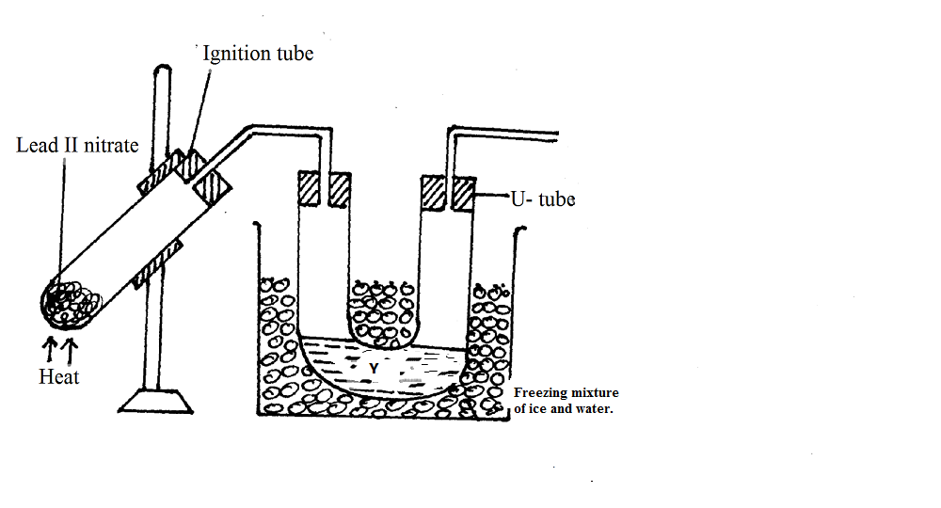
a) i) Identify:-
Liquid Y……………………………………... (½ mark)
ii) What colour is liquid Y (½ mark)
………………….…………………………………
b) Write the chemical equation for the reaction taking place in the
Ignition tube. (1mark)
…………………………………………………………………………….

- Complete the diagram to show how oxygen was collected ( 1mark)

21. Write the electronic configuration of Sulphur in;
  - SO₃²⁻ (1mark)
……………………………………………………………………………………………………………………………………………………………………
  - H₂S(1mark)
……………………………………………………………………………………………………………………………………….………………………………………
22. (a) State Graham’s law of diffusion. (1 mark)
……………………………………………………………………………………………………………………………………….……………………………………………………………………………………………………………………………………………………………………………….………………………………………
(b)60cm³ of oxygen gas diffused through a porous hole in 50 seconds. How long will it take 80cm³ of Sulphur (IV) oxide to diffuse through the same hole under the same conditions? (S = 32, O = 16). (2 marks)
……………………………………………….……………………………………………………………………………………………………………………………………………………………………………….………………………………………
……………………………………………….……………………………………………………………………………………………………………………………………………………………………………….………………………………………
23. A mixture of magnesium powder and copper powder was reacted with dilute hydrochloric acid. The solution was then filtered, name;
(a) (i) The residue (1mark)
……………………………………………………………..
(ii) The filtrate (1mark)
………………………………………………………………………………………
(b)Write an ionic equation for the reaction that takes place (1mk)
………………………………………………………………………………………
24. Name the following processes;
- When anhydrous calcium chloride is left in an open beaker overnight a solution was formed. (1mk)
……………………………………………………………………………………………………………………………………………….…………………………………..
- When sodium carbonate decahydrate crystals are left in an open beaker for some days it turned into a powder. (1mk)

25. Compare the atomic sizes of sodium and magnesium. Explain. (2mks)
………………………………………………………………………………………………………………………………………………………………………………………………………………………………………………………………………………………………………………………………………………………………………………………………………………………………………………………………………………………………………………………………………………………………………………
26. The graphs below were drawn when15 g of marble chips in different physical states were reacted with 50cm³ of 2M Hydrochloric acid. They are drawn by measuring the volume of carbon (iv) oxide produced with time.

a) Which curves corresponds to the reactions involving powdered calcium carbonate andlarge sized marble chips with the dilute acid?
i) Powdered calcium carbonate (1mark) ..............................................................................................................................
ii) Large sized calcium carbonate (1mark) .............................................................................................................................
b) All the graphs eventually flatten out at the same level but at different time. Why do the graphs flatten out at the same level? 1 mark
...........................................................................................................................................................
...........................................................................................................................................................

27. Draw a well labelled diagram to show the set-up that can be used to separate mixture of iodine and sodium chloride.( 2marks)

28. Give the structural formula and name the compound formed when methanol and ethanoic acid are reacted in presences of few drops of concentrated sulphuric (VI) acid. (2 marks)
………………………………………………………………………………………………………………………………………………………………………………………………………………………………………………………………………………………………………………………………………………………………………………………………………………………………………………………………………………………………………………………………………………………………………………………………………………………………………

