MARKING SCHEME

1. a) Different forms of the same elements that exists at the same physical state**✓**

b) Rhombic**✓**

c) Transition temperature is the temperatures at one allotrope of an element changes into another allotrope.**✓**

2. i) Flame is a mass of burning gases**✓**

ii) Optimum conditions –This are the conditions required in an industrial process to ensure maximum yield of the product within the minimum time possible at the least cost possible. **✓**

iii) End point of a reaction- It’s the point in a reaction where one of the reacting species becomes exhausted/completely used up hence forcing the reaction to stop**✓**

3. Dry ice sublimes leaving no any wetness**✓1**unlike ordinary ice that melts on heating to form water that causes wetness.**✓**

4. 50cm3

5.

*Cu (NH3)4+2***✓***tetra-ammine copper (II) ion***✓**

**6.** 115.65 of saturated solution contain 15.65 g of FeSO4 . 45 g of saturated solution will contain 45 x 15.65/115.65**✓**

= 4.5331g**✓**

7.) CH4 (g) +2O2 (g) CO2(g) + 2H2O(l)

Bonds broken 4 (C-H)+ 2( 0=0)

(4x413+2x497) = +2646kJ**✓**

Bond formed 2(C =0) +4(H-O)

(1608 + 1856)= -3464kJ**✓**

Enthalpy change =+2646+ (-3464)

= -818kJ**✓**

8.**(i) Lowering the temperature ✓**

**(ii) Increasing pressure ✓**

**9.**

(i) **- A yellow powder of sulphur was deposited ✓**

**-White solid of magnesium oxide is formed ✓**

(ii)**2Mg(s) + SO2(g) 2MgO(s) + S (s) ✓**

**10 a) Haematite✓**

**b)** -crush the ore into powder**✓½**.

-Add excess dilute nitric (V) acid or sulphuric (VI) acid and warm, filter to obtain

the filtrate.**✓½** To a portion of the filtrate add aqueous sodium hydroxide or ammonia solution till in excess**✓½**, formation of a green or brown precipitate insoluble in excess reagent**✓½** indicates Fe2+ or Fe3+, hence the ore contains iron.

**11. a) i)** Region A : C(s) + O2(g) CO2(g)**✓**

ii) Region C:CO (g) + O2 (g)CO2(g)**✓**

b) – To prevent accumulation of Carbon II oxide which is poisonous.

- Environmental effect

- Cost**✓ Any one correct answer.**

- Ease of storage

- Ease of transportation

- Ease of combustion

12. 4OH-(aq) 2H2O (l) + O2(g) +4e-

Q = It

0.63 X 74X60 = 2797C✓

24dm3 ……………… (4X96500) C

?? …………………2797C

24X2794/4X96500✓

0.17372 dm3 or 173.72cm3✓

13.



**14.** a) Solubility

Adsorbility

15. - Addsodium hydroxide/potassium hydroxide to a beaker containing magnesium

Sulphate solution, stir then filter to obtain magnesium hydroxide as the residue✓

* Place the residue in a boiling tube and heat strongly ✓
* Dry residue of magnesium oxide is left behind in the boiling tube✓

16. a) Cation ……Al3+/Aluminium ion✓ ½

Anion ……SO42-/ sulphate ions✓ ½

b) Ba2+ (aq) + SO42-(aq)  BaSO4 (s) ✓

17. i) Saponification✓

ii) Sodium chloride ✓

iii) Lowers the solubility of soap in the glycerol /alcohol✓

18. a) Acid ………………✓

Base ……✓

b) An acid is a proton donor.✓

19. i) Sodium chlorate (v)✓

ii) - Antiseptic for throat and mouth

- making weed killers **✓Anyone correctanswer**

- Making heads of safety matches

20. a) i) Dinitrogen tetraoxide ✓ ½

ii) Yellow✓ ½

c)

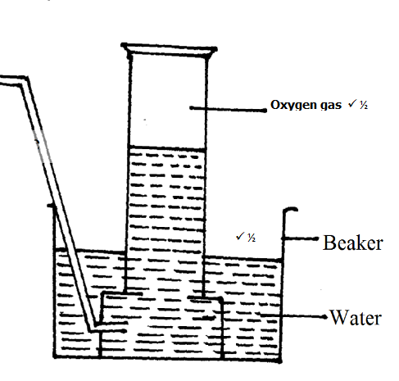

21. i) SO32-

X+ ( -2X3)= -2

X=+4✓ ½ hence Sulphur lost 4 electrons to 2:8:2✓ ½

ii) H2S

(1X2)+ X=0

X= -2 ✓ ½ hence Sulphur gained 2 electrons to 2:8:8✓ ½

22 (a) The volume of a fixed mass of a gas is inversely proportional to its

Pressure at constant temperature. 🗸¹

1. RO2= 60/50= 1.2cm3/sec.

RO2/ SO2=

🗸

= 0.849cm3/sec.🗸 time = 80/0.849 = 94.28sec

23.(a) (i) Copper powder✓

(ii) Magnesium chloride solution✓

(b) Mg(s) + 2H+ (aq) Mg2+ (aq) + H2(g)✓

24. a) Deliquescence✓

b) Efflorescence ✓

25. Sodium is larger than magnesium. ✓ Magnesium has a higher nuclear charge than sodium and its outer energy level is more attracted towards the nucleus compared to sodium. ✓

26. i. Curve A✓

Curve C ✓

ii. One of the reactants has been used up✓ ½in the reaction and the total amount of CO2 produced will be the same ✓ ½ since no more reaction takes place.

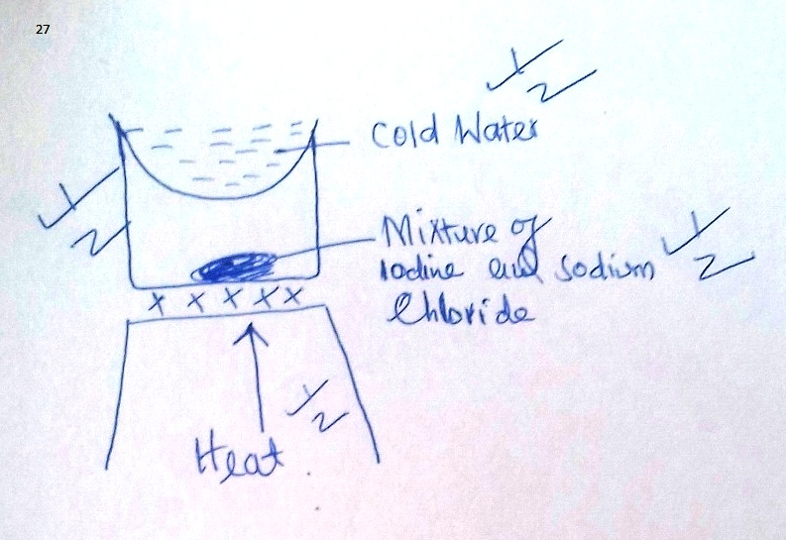

# C:\Users\fem b collections\Desktop\20180611_135910-1.jpg