**LANJET JOINT EVALUATION MOCK**

**GEOGRAPHY PAPER 1**

**TERM 2 -2018**

**FORM FOUR**

**MARKING SCHEME:**

1. (a) How does a land breeze occur? (2mks)

***This is the movement of cool air from the land to the sea.***

(b) (i) Name two ocean currents found on the coasts of West Africa. (2mks)

* ***Benguela***
* ***Guinea***
* ***Cannary***

(ii) State one effect of warm ocean current on the adjacent coastlands. (1mk)

* ***Warm up the adjacent land.***
* ***It increases the humidity of the adjacent land.***
* ***It may lead to rainfall on the adjacent land.***

1. (a) The diagram below represents a barchan. Use it to answer question (a)

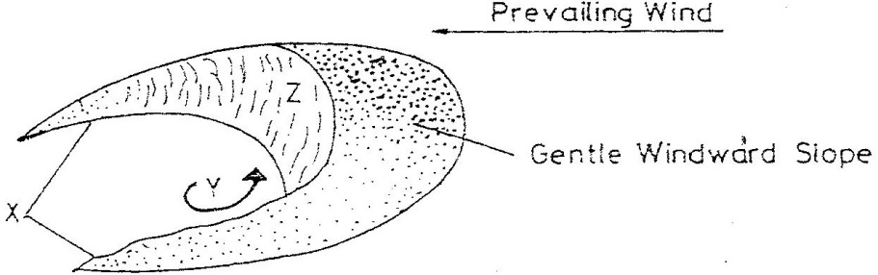

Name;

1. The feature marked X. (1mk)

***Horns***

1. The air current marked Y. (1mk)

***Eddy currents***

1. The slope marked Z. (1mk)

***The steep concave leeward slope.***

(b) Give two ways in which wind transports its load. (2mks)

* ***Suspension***
* ***Saltation***
* ***Surface creep***

1. The diagram below shows a composite volcano.

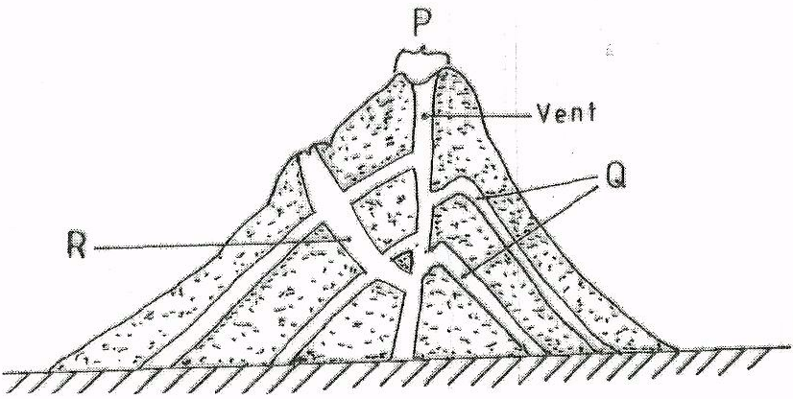

1. Name the features marked P, Q and R. (3mks)

P – ***crater***

Q – ***lava layers***

R – ***dyke/ side vent***

1. Give two ways in which vulcanicity influences human activities. (2mks)

* ***The lower slopes of volcanic mountains are suitable for agricultural activities.***
* ***Scenic beauty the mountains attract tourists.***
* ***Expose minerals which are mined.***
* ***Geothermal power is exploited for electricity.***
* ***Volcanic rocks are used for building and construction.***
* ***Pumice a volcanic rock is used by human as a scrubbing stone.***

1. (a) What is the difference between an ice sheet and an iceberg? (2mks)

***An ice sheet is a large continuous mass of ice covering vast areas of land while an ice berg is a large mass of ice floating in large water bodies.***

(b) Name three types of glacial moraines. (3mks)

* ***Lateral moraine***
* ***Medial moraine***
* ***Terminal moraine***
* ***Ground moraine***

1. (a) Give two components of the solar system. (2mks)

* ***the sun***
* ***the planets***
* ***asteroids***
* ***meteors***
* ***comets***

***(****any 2 x 1)*

(b) State three effects of the movement of the earth around the sun. (3mks)

* ***changes in the position of the midday sun at different times of the year.***
* ***Varying length of day and night.***
* ***Causes the four seasons.***
* ***Causes lunar eclipse.***

**(any 3 x 1)**

**SECTION B:**

**Answer question 6 and any TWO other questions from this section.**

1. Study the map of Oyugis 1:50,000 (sheet 130/1) provided and answer the following questions.
2. (i) What is the four figure grid reference of the Kokungu dam? (2mks)

***7134***

(ii) What is the magnetic variation of the map? (1mk)

***0’52’***

(iii) Calculate the area covered by Kodera Forest. Give your answer in square kilometers. (2mks)

***14 half squares = $\frac{14}{2} quares$***

***= 7.0 km $± {1km}^{2}$***

1. Draw a square 10cm by 10cm to represent the area enclosed by Eastings 84 and 94 and Northings 28 and 38. (1mk)

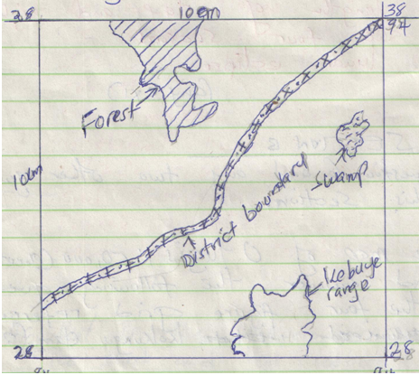

On the square, mark and name;

1. Forest. (1mk)
2. Swamp. (1mk)
3. District boundary (1mk)
4. Range. (1mk)
5. Describe the relief of the area covered by the map. (6mks)

* ***The highest point is approximately 6025feet (6001 – 6049) while the lowest point is slightly below 3750 feet.***
* ***There are many hills in the area.***
* ***There is a pass between Nyatworo and Nyandiere hills.***
* ***The eastern parts have many river valleys.***
* ***Several ridges/water sheds occur at Kibuye, Nyamonema and at Bomorenda.***
* ***The South West region is undulating due to widely spaced contours.***
* ***The South eastern parts are highly dissected due to many river valleys.***
* ***The general direction of slope is from eastern parts towards western part.***

1. Identify three social services of Kamagambo trading centre. (3mks)

* ***Educational services***
* ***Health services***
* ***Religious services***

1. Citing evidence from the map, explain three factors that favour coffee growing in the area covered by the map. (6mks)

* ***Transport evidence by many roads that facilitates transportation of the crop from the farms to the factory for processing.***
* ***Labour evidenced by dense settlements offering labour during coffee picking period.***
* ***High rainfall, evidenced by presence of many rivers that offer a suitable condition for growing coffee.***
* ***High altitude evidenced by trigonometrical station 5828 offering a cool condition for the growth of coffee.***
* ***Well drained soils, evidenced by absence of many swamps.***

1. (a)(i) Difference between a tributary and a confluence. (2mks)

***Tributaries are small rivers that flow into bigger ones while a confluence is a point where tributaries join the main stream.***

(ii) The diagram below shows the three stages of the long profile of a river.

*(i) Youthful stage*

*(ii) Mature stage*

*(iii) Old stage*

1. Give one activity that takes place in each stage. (3mks)

***Youthful stage***

* ***Erosion***

***Mature stage***

* ***Deposition***
* ***Erosion***

***Old stage***

* ***Deposition.***

1. State two features formed at the mature stage. (2mks)

* ***Gentler river gradient.***
* ***Wider valley floor.***
* ***Wider valley with an open cross section.***
* ***River bends begins to appear.***
* ***Concave banks stand out as river cliffs while convex banks become slip-off slopes.***
* ***Interlocking spurs becomes bluffs.***

1. Describe three processes by which a river transports its load. (6mks)

* ***Suspension – fine light materials transported in suspension form.***
* ***Saltation – The particles are moved in a series of short jumps or hops along the river-bed.***
* ***Traction – large particles and boulders are pushed and rolled along the stream bed by water force.***
* ***Solution – involves the transportation of materials dissolved in water.***

***(any 3 x 2)***

1. With the aid of a well labeled diagram, describe the process of a river capture. (7mks)

* ***The powerful river flow and misfit river must flow in adjacent valley.***
* ***The pirate river should have a wider valley than the misfit.***
* ***Pirate river must have more active head-ward erosion than the neighbouring river.***
* ***Pirate river ought to be flowing in a lower level.***
* ***Eventually the misfit river will be robbed of its headwaters forming a elbow of capture, wind gap, misfit stream and rejuvenated pirate river***

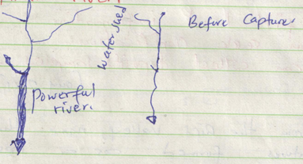

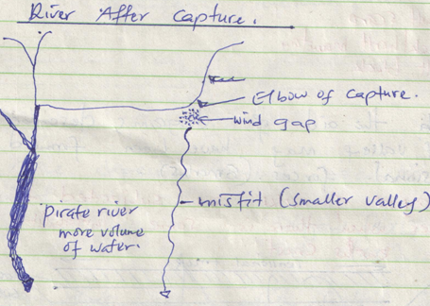

1. You are required to carry out a field study on the materials deposited by a river.
2. State three methods you would use to collect data. (1mk)

* ***Observation***
* ***Interviewing***
* ***Height measurement***
* ***Photograph taking.***

**(accept any relevant answer 3 x 1)**

1. State two advantages of studying the work of rivers through fieldwork. (2mks)

* ***Gives first hand information.***
* ***One can seek clarification.***
* ***One can collect deposit samples for study.***

1. (a)(i) Apart from the Rift Valley, name three other relief features formed as a result of faulting. (3mks)

* ***Fault scarp***
* ***Block/horst mountain***
* ***Tilt block.***

(ii) With the aid of diagrams, describe how the Rift Valley may have been formed by tensional forces. (8mks)

***Layers of rocks are subjected to tensional forces when there is some instability within the earth’s crust.***

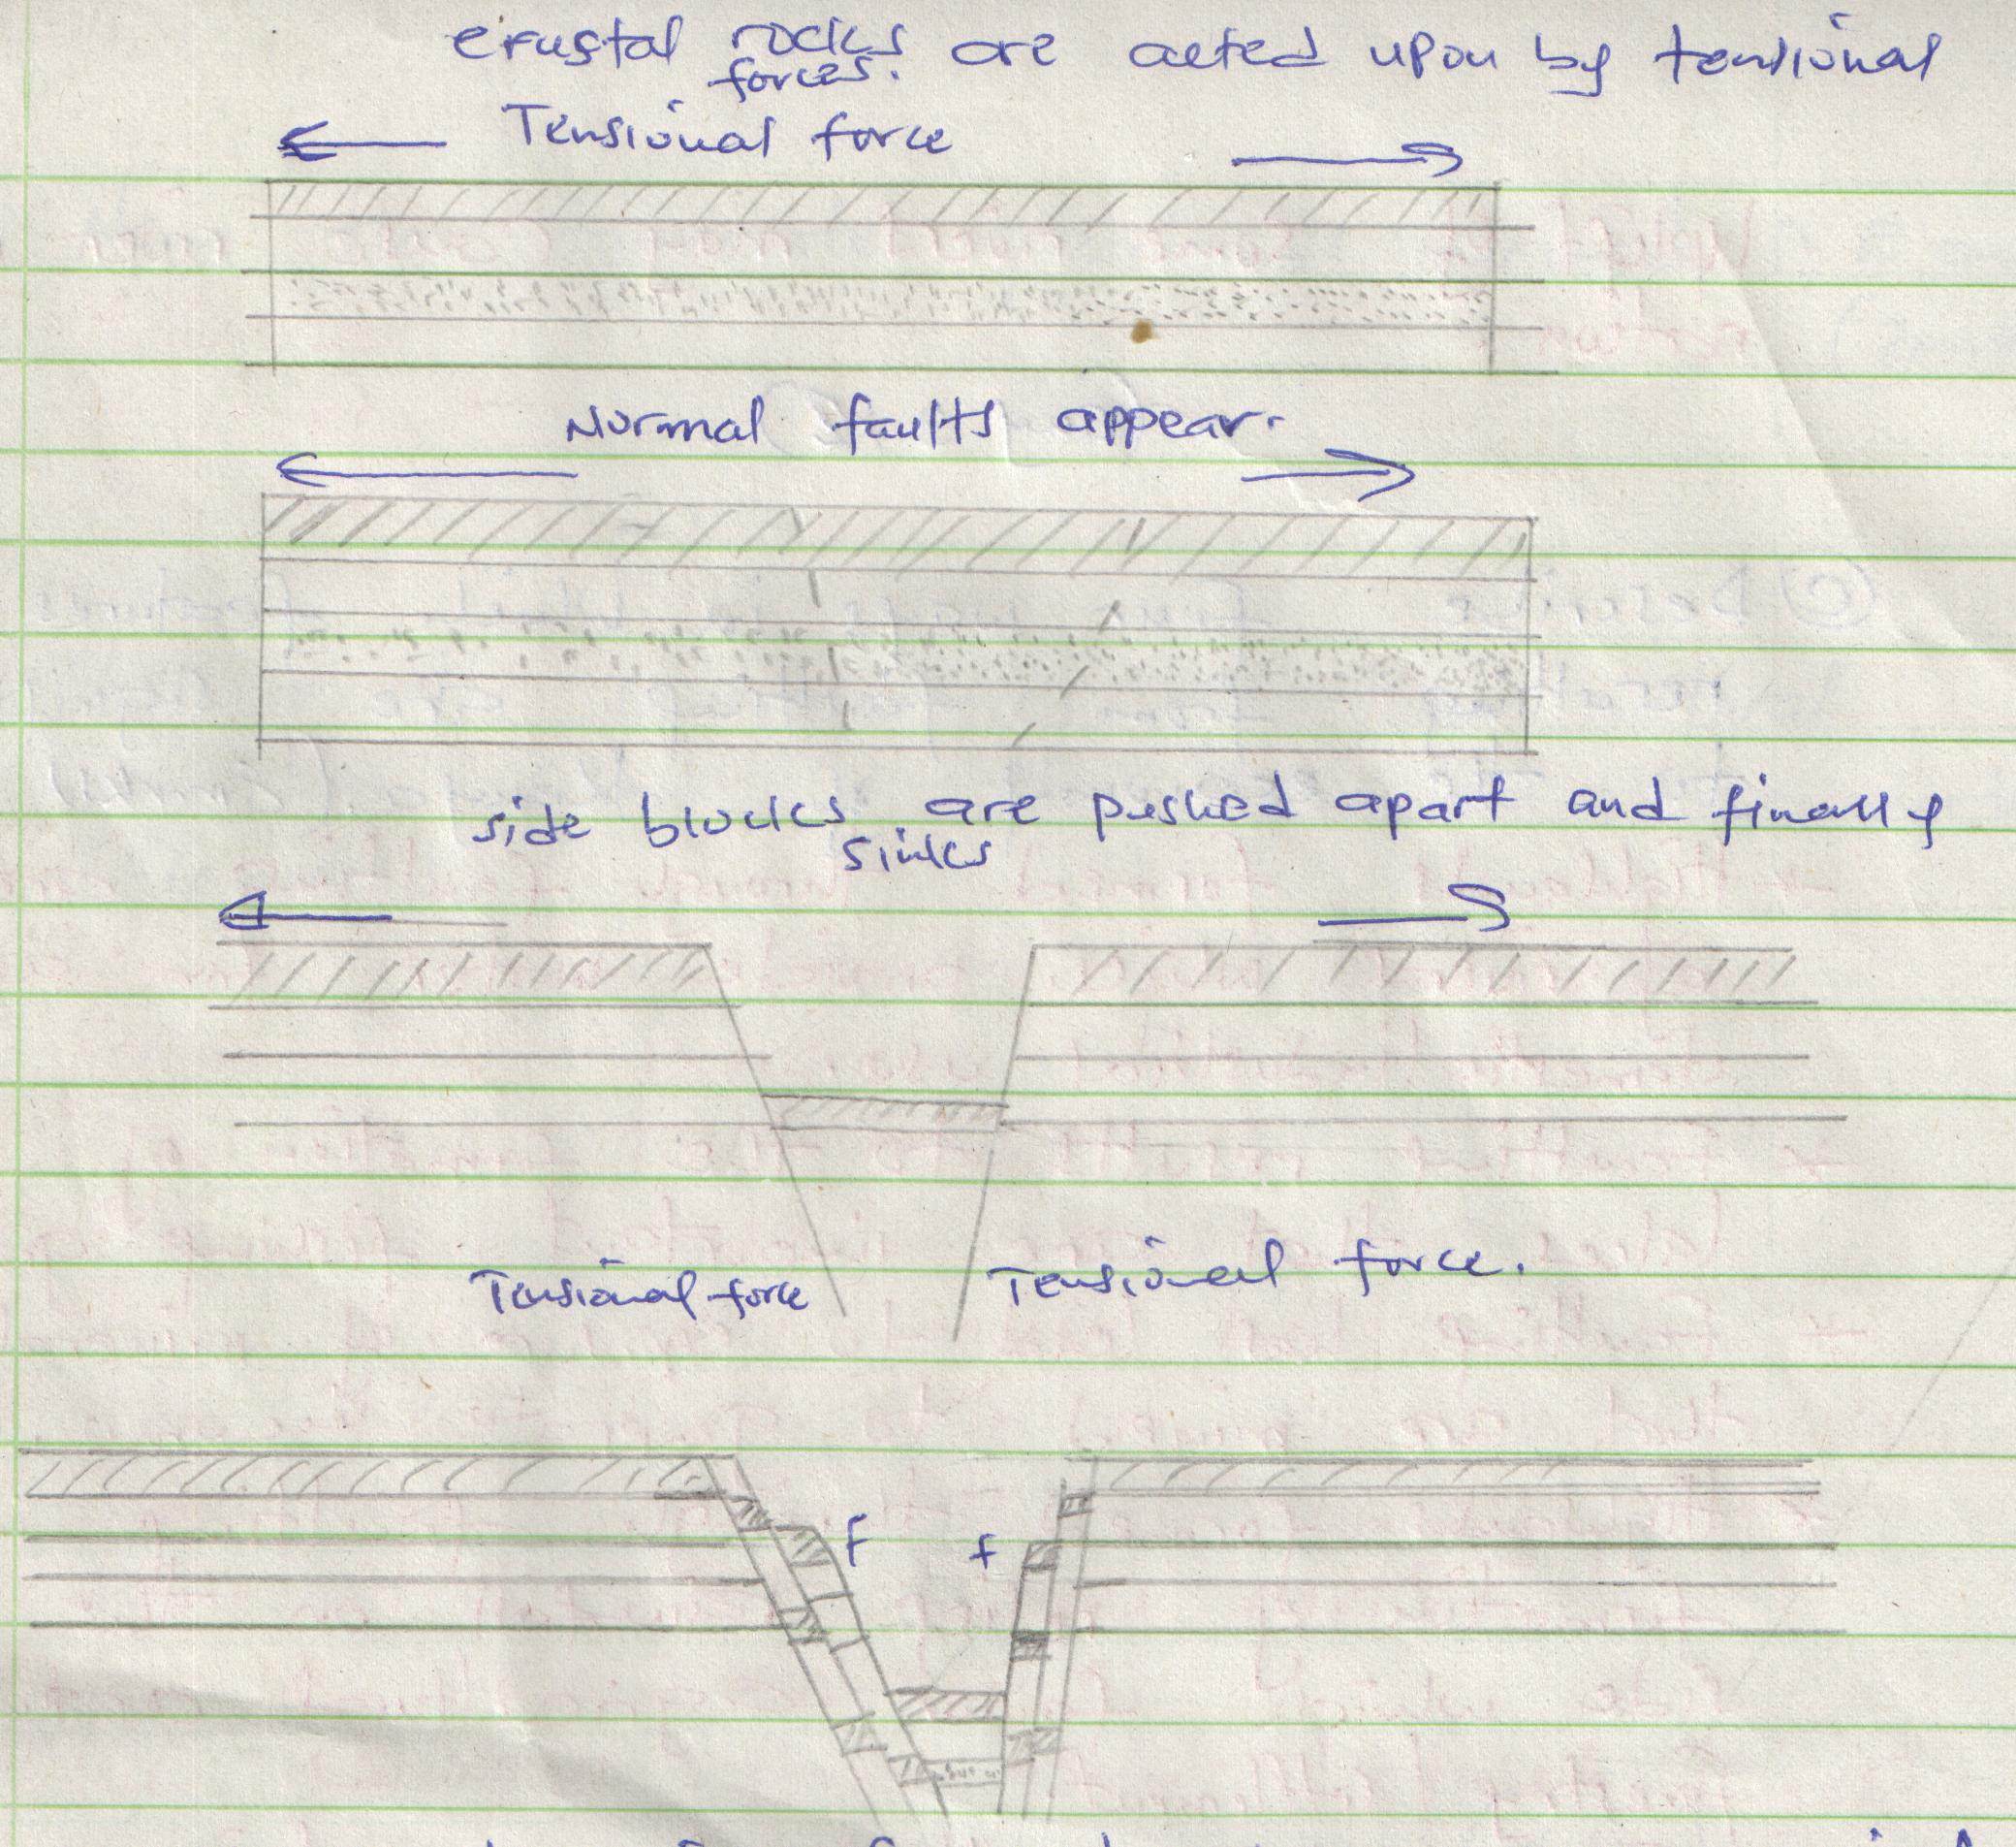

***The depression formed becomes a rift valley. (****Diagrams 4 x 1*

*Text 4 x 1)*

(b) Explain three ways in which faulting influences drainage systems. (6mks)

* ***Uplifting landscape which may cause a change of flow of a river.***
* ***Vertical faulting across a river may case chase of the base level resulting in the formation of waterfalls.***
* ***Some rivers may disappear into the ground through fault guided drainage patterns.***
* ***Some rivers may disappear into the ground through a fault forming underground stream.***
* ***Uplift of some rivers may cause river rejuvenation.***

*(any 3 x 2)*

(c) Explain four ways in which features resulting from faulting are of significance to the economy of Kenya. (8mks)

* ***Highlands formed through faulting are sources of rivers which provide water for agriculture domestic/ industrial use.***
* ***Faulting results to the formation of lakes that are important fishing grounds.***
* ***Faulting has lead to exposure of minerals that are mined to generate income.***
* ***Highlands formed through faulting influence formation of relief rainfall on the wind ward side which favour agricultural activities/ forestry/ settlement.***
* ***Faulting has resulted to formation of deep faults which are passage of stream jets that are harnessed to generate electricity.***
* ***Faults results to the formation of fault scarps that form attractive sites for tourism activity thus generating income.***

1. The map below shows some vegetation regions of the world. Use it to answer questions (a) and (b)
2. (i) Name the temperate grasslands marked D, E and F. (3mks)

* ***Prairies***
* ***Steppers***
* ***Downs***

(ii) Describe the characteristics of the natural vegetation found in the shaded area marked G. (6mks)

* ***Consists of mixed variety of tree species***
* ***Forests are evergreen***
* ***Trees have tall trunks***
* ***Trees have broad leaves***
* ***Tree species are mainly hardwood***
* ***Some trees have little or no undergrowth.***
* ***Some trees have epiphytes/ climbing plants.***
* ***Some trees have buttress roots.***
* ***Forest have canopies.***
* ***The canopies form three distinct layers.***

1. Explain how the following factors influences existence of various vegetation types.

Altitude:- (2mks)

***Altitude affect temperature and the rainfall which eventually affects vegetation for example mangrove forests are typical sea level vegetation while bamboo is typical in highlands and mountains.***

Aspect: - (2mks)

***Aspect influences vegetation upon increasing or decreasing exposure to sunlight and prevailing winds, alpine region in Europe, slopes facing south have thick vegetation as compared to slopes facing north which a colder.***

Precipitation :- (2mks)

***Rainfall influences germination, photosynthesis and flowering, areas with high rainfall has luxuriant vegetation while areas that has little unreliable rainfall have poor and scanty vegetation.***

Drainage: - (2mks)

***Steepness of land has indirect influence on how precipitation is drained from the surface. Steep slopes, runoff is rapid thus water does not remain available for a long time, such areas have scanty vegetation as compared to areas with gentle slopes where water is available for a long time thus luxurious vegetation.***

1. You are required to carry out a field study of the natural vegetation within your local environment.
2. State three activities that are necessary before undertaking the study. (3mks)

* ***Seek permission for the relevant authority.***
* ***State objectives and hypothesis clearly.***
* ***Choose suitable methods of collecting dat.***
* ***Assemble necessary tools.***
* ***Prepare a working schedule.***
* ***Divide the students into groups.***

***(3 x 1)***

***(Note reconnaissance should not earn a mark)***

1. State two methods that you would use to record the data collected. (2mks)

* ***Tabulation***
* ***Tallying***
* ***Maping***
* ***Field sketching***
* ***Photographs.***

***Note method chosen should be relevant to the area of study. (2 x 1)***

1. State three follow up activities you are likely to undertake. (3mks)

* ***Compare notes taken from the field***
* ***Discuss the findings.***
* ***Compile the notes to establish a reliable data.***
* ***Teacher comments on the points that require clarification.***
* ***Present the data after analyzing.***

***(3 x 1)***

1. (a)(i) Differentiate between weathering and mass wasting. (2mks)

* ***Weathering is the breaking, disintegration and decay of solid rocks at or near the surface of the earth in situ while mass wasting is the downward movement of weathered material on a slope under the influence of gravity.***

(ii) Give two processes of slow mass wasting. (2mks)

* ***Soil creep***
* ***Talus creep/ scree sceep***
* ***Sohifluction (2 x 1)***

(iii) State two physical conditions that may influence landslides. (2mks)

* ***steep slopes that allow soil to move down easily.***
* ***Occurrence of earthquakes that affect the stability of rocks.***
* ***Heavy rainfall that facilitates movement of materials down slope.***
* ***Presence of loose soil which may easily be moved down slope.***

(b) Explain the following processes of weathering.

1. Frost action. (2mks)

***High altitude areas, water may occupy cracks/ cavities during the day, at night temperature fall below freezing point causing it to expand thus exerting pressure on rocks. This alternate freeze and then weaken the rocks causing them to disintegrate.***

1. Oxidation. (2mks)

***Oxidation takes place in rocks that contain iron. The iron combine with oxygen to form ion oxides. Such rocks change colour and crumble easily.***

1. Hydration. (2mks)

***Certain rock minerals absorb water thus expanding. This causes internal stress in the rock and it eventually disintegrate.***

(c) Describe how an exfoliation dome is formed. (6mks)

* ***In arid areas there are large diurnal ranges of temperature.***
* ***During the day a homogenous rock is intensely heated while at night the rock loses heat rapidly.***
* ***The differential heating causes the outer layer to expand faster than the inner layer.***
* ***When expansion and contraction takes place repeatedly, stress develops in the outer layer of rocks.***
* ***Cracks appear on the surface of the rock layer.***
* ***Eventually, the outer layer peels off.***
* ***The peeling leaves behind a rounded mass of rock known as exfoliation dome.***

*(The last statement must be captured to score the maximum points) (6 x 1)*

(d) State four indicators of occurrence of soil creep in an area. (6mks)

* ***Inclined telephone poles down a slope.***
* ***Accumulated soil at the foot of slope.***
* ***Existence of bare rock upper slope.***
* ***Deposits of materials on infrastructure such as roads down slope.***

***(4 x 1)***

(e) Name three human activities influenced by weathering. (3mks)

* ***Tourism***
* ***Agriculture***
* ***Mining.***