Name……………………….………….… Index ……………………….ADM:…........................
School…………………………….…… Date ………………..………. Class: ………………….

312/2
GEOGRAPHY
Paper 2
KULY/AUG, 2018
Time: 2¾ hours

LANJET CLUSTER JOINT MOCK EXAMINATION
Kenya Certificate of Secondary Education
312/2
Paper 2
GEOGRAPHY
JULY/AUGUST 2018
TIME: 2 ¾ HOURS

INSTRUCTIONS
This paper has two sections: A & B.
- Answer all questions in section A.
- In section B, answer question 6 and any other two questions.
- Candidates should answer the questions in English.
- All answers to be written in foolscaps provided.

This paper consists of 5 printed pages. Candidates should check the question paper to ascertain that all pages are printed as indicated and that no pages are missing.

SECTION A
Answer all questions from this section.
1. a) Differentiate between indigenous forests and exotic forests. (2marks)
b) State three physical factors which favour the growth and distribution of softwood forests in Kenya. (3marks)
2. a) The table below shows Kenya’s domestic tangible exports and tangible imports by value in KSh million to and from major regions of the world in year 2016.
REGION | EXPORTS | IMPORTS
Africa | 234,673 | 140,241
Europe | 414,533 | 265,323
Asia | 140,536 | 956,679
Americas | 52,891 | 65,190
All other areas | 8,433 | 4,311
TOTAL | 578,066 | 1,431,744
Source: Kenya National Bureau of Statistics
- i) What is the difference in value of the exports to and imports from Asia? (1mark)
ii) Calculate Kenya’s balance of trade for year 2016 (2marks)
- Give two statistical methods that can be used to present the data in the table. (2marks)
3. a) Name two methods used in alluvial mining (2marks)
b) State three effects of limestone mining at Bamburi in Mombasa county (3marks)
4. The diagram below shows the Great lakes and St. Lawrence Seaway.
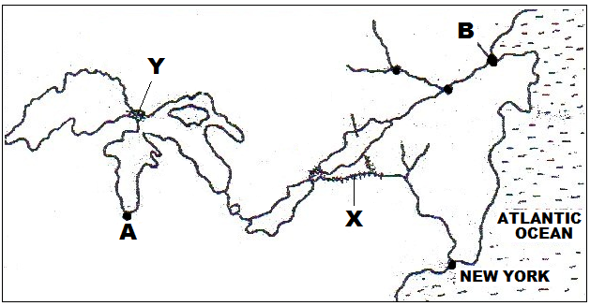

- Name (i) The canal marked X and Y (2marks)
ii) The ports marked A and B (2marks)
b) State two objectives of constructing the St. Lawrence Seaway (2marks)
5. State four causes of an energy crisis. (4marks)
SECTION B
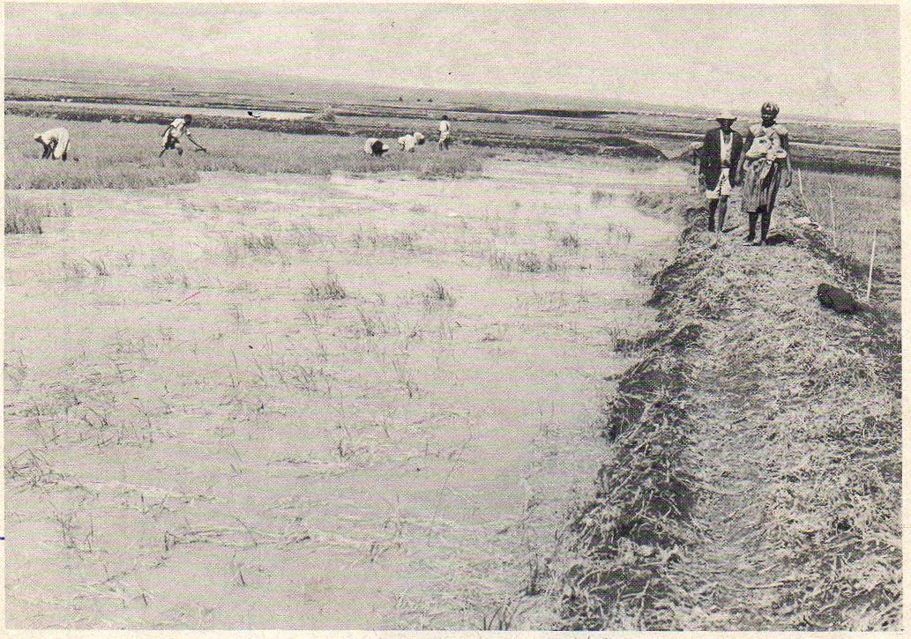
6. Study the photograph below and use it to answer questions (a) and (b)

a) i) Name the type of photograph shown above (1mark)
ii) What time of the day was the photograph taken? (1mark)
iii) Name three specific places in Kenya where the photograph is likely to have been taken. (3marks)
- i) Citing evidence from the photograph, explain three conditions necessary for the economic activity shown that can be observed from the photograph (6marks)
ii) Using evidence from the photograph, explain two health problems that the people practicing this economic activity would experience. (4marks)
c) Apart from the method shown on the photograph, give four other methods used to reclaim land in Kenya (4marks)
d) Give three differences between land reclamation in Kenya and land reclamation in Netherlands (6marks)
7. Study the sketch map of Ghana below and use it to answer the following questions
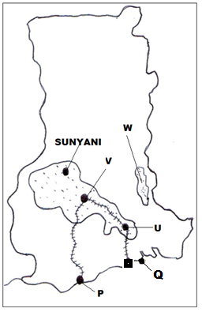
a) Name (i) The cocoa growing areas marked U, V and W (3marks)
ii) The port cities marked P and Q (2marks)
b) State five physical conditions favoring cocoa growing in Ghana (5marks)
c) Describe the stages involved in cocoa processing in Ghana. (7marks)
d) Explain four economic problems facing cocoa farmers in Ghana (8marks)

8. a) What is demersal fishing? (1mark)
b) The world map below shows some ocean currents and fishing grounds
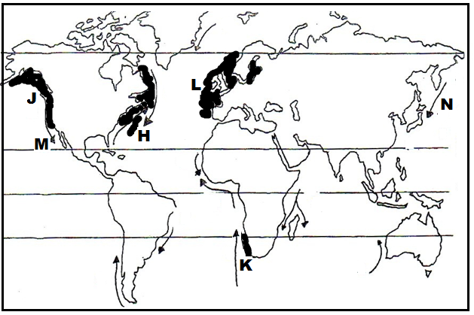
- Name the fishing grounds marked J,K and L (3marks)
- Identify the ocean currents marked M and N (2marks)
iii) Mention three main fish species caught in the fishing ground marked H (3marks)
c) Explain four physical factors that have made Japan a great fishing nation (8marks)
d) Explain four problems facing the fishing industry in Kenya (8marks)

9. a) i) Differentiate between industry and industrialization (2marks)
ii) State the benefits of industrialization to Kenya (5marks)
b) Explain three causes of the decline in the textile industry in Kenya (6marks)
c) State four ways in which the Kenyan government assists Jua kali industries. (4marks)
d) Explain four factors that have led to the growth of the iron and steel industry in the Ruhr region of Germany (8marks)
10. a) i) What is a Census? (2marks)
ii) State four reasons why a census is important to Kenya (4marks)
b) Explain four effects of migration at the place of origin (8marks)
c) Explain three causes of a reduced fertility rate in Kenya (6marks)
d) State five differences between Kenya’s population and that of Sweden (5marks)

