LANET JOINT EVALUATION EXAMINATION
GEOGRAPHY PAPER TWO
JULY 2018
TIME: 2 ¾ HOURS
MARKING SCHEME
SECTION A
1 a) Differentiate between indigenous forests and exotic forests. (2marks)
Indigenous forests have trees that are native to a region or country while exotic forests have trees that have been introduced from other regions of the world.
b) State three physical factors which favour the growth and distribution of softwood forests in Kenya (3marks)
- Moderate to low temperatures experienced in the Kenya highlands
- High rainfall and low evaporation rates in Kenya highlands
- Rugged terrain in some parts of the Kenya highlands
- Presence of deep and well drained volcanic soils rich in nutrients
- Well distributed rainfall in Kenya highlands
2. a) The table below shows Kenya’s domestic tangible exports and tangible imports by value in Ksh million to and from major regions of the world in year 2016. (2marks)
REGION | EXPORTS | IMPORTS
Africa | 234,673 | 140,241
Europe | 414,533 | 265,323
Asia | 140,536 | 956,679
Americas | 52,891 | 65,190
All other areas | 8,433 | 4,311
TOTAL | 578,066 | 1,431,744
Source: Kenya national bureau of statistics
- i) What is the difference in value of the exports to and imports from Asia (1mark)
Ksh 956,679 million – Ksh 140,536 million
=Ksh 816,143,000,000
Or Ksh 816.1Billion

ii) Calculate Kenya’s balance of trade for year 2016 (2marks)
Balances of trade = Value of tangible exports – Value of tangible imports
=Ksh 578,066million – Ksh 1,431,744 million
= - Ksh 853,678 million
Or- Ksh 853,678,000,000
Or - Ksh 853.7 Billion
b) Give two statistical methods that can be used to present the data in the table. (2marks)
- Comparative bar graph
- Comparative line graph
- Compound bar graph
- Proportional divided circles
3. a) Name two methods used in alluvial mining (2marks)
- Panning
- Dredging
b) State three effects of limestone mining at Bamburi in Mombasa county (3marks)
- Occurrence of derelict land
- Destruction of vegetation / clearing of vegetation
- Loss of biodiversity in the area
- Dust from limestone blasts pollutes the air
- Large open pits destroy the beauty of land
- Heaps of rock waste promotes soil erosion
4. The diagram below shows the great lakes and St. Lawrence Seaway.
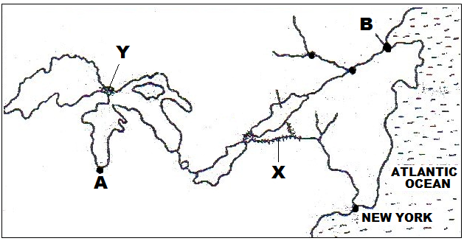
- Name (i) The canal marked X and Y (2marks)
X- New YorkState Barge Canal
Y-Soo Canal
ii)The ports marked A and B (2marks)
A- Chicago
B - Quebec
b) State two objectives of constructing the St. Lawrence Seaway (2marks)
- To promote trade and industrialization in U.S.A and Canada.
- To remove silt deposited between lakes Huron and Erie
- To regulate different water levels along the Seaway
- To smoothen river channels by removing outcrop rocks and Islands
- To regulate the flow of St. Lawrence river through locks and dams
5. State four causes of an energy crisis
- Rapid depletion of oil reserves from some oil fields
- Unequal pattern of crude oil distribution in the world
- Control of oil resources by a few petroleum producing countries
- Disruption of oil production due to war in a key producing country
- Sharp rise in oil prices due to sharp rise in demand
- Invention of many machines that consume a lot of energy
- Prolonged drought which lower electricity production thus more demand for petroleum
SECTION B
6. Study the photograph below and use it to answer questions (a) and (b)
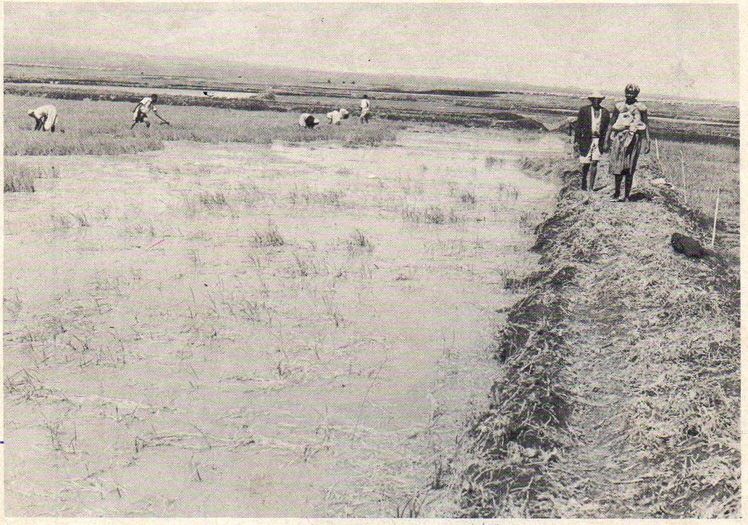

a) i) Name the type of photograph shown above (1mark)
Ground general view
ii) What time of the day was the photograph taken (1mark)
At around noon / mid-day
iii) Name the three specific places in Kenya where the photograph is likely to have been taken. (3marks)
- AtMweaTebere in Kirinyaga county
- AtAhero in Kisumu county
- AtBunyala in Busia county
- At West Kano in Kisumu county
b) i) Citing evidence from the photograph, explain three conditions necessary for the economic activity shown that can be observed from the photograph (6marks)
- Availabilityof gently sloping land which is evidenced by water logging and the plain on the photogragh
- Availability of a reliable water supply for wet paddy production evidenced by flooded plots
- Availability of labour during field practices such as land preparation, planting weeding and harvesting. This is evidenced by several people within the flooded plot
ii) Using evidence from the photograph, explain two health problems that the people practicing this economic activity would experience. (4marks)
- Presence of waterlogged plots creates stagnant water which is a breeding ground for mosquitoes that transmit malaria to the people
- Snails also breed in waterlogged plots thus transmitting bilhazia among the farmers / labourers.
- The people seen on the photograph work for long hours while in water logged plots thus likely to suffer from cold related diseases.
c) Apart from the method shown on the photograph, give four other methods used to reclaim land in Kenya (4marks)
- Tsetse fly control
- Draining swamps
- Planting of vegetation / afforestation
- Introduction of drought resistant crops
- Controlling soil erosion
- Improving soils by use of fertilizers and manure
d) Give three differences between land reclamation in Kenya and land reclamation in Netherlands (6marks)
- In Kenya land reclamation is done on a small scale while in Netherlands it is done on a large scale
- In Kenya irrigation is used as a means of reclaiming dry areas while in Netherlands, irrigation is used to lower salinity of soil in reclaimed areas
- In Kenya the methods land reclamation are simple while inNetherlands the methods of land reclamation are advanced
- In Kenya dykes are used to control river floods whereas in Netherlands dykes are used to protect reclaimed areas from sea invasion
- In Kenya land is mainly reclaimed from swamps and marginal areas while in the Netherlands land has been reclaimed mainly from the sea.
7. Study the sketch map of Ghana below and use it to answer the following questions
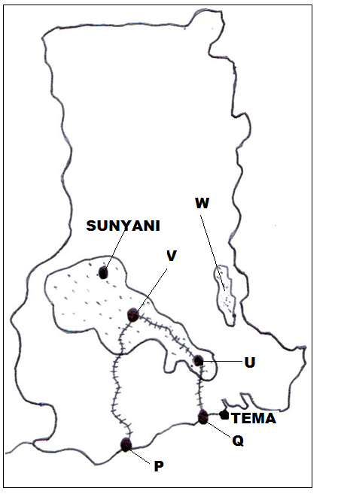
- Name (i) The cocoa growing areas marked U, V and W (3marks)
- U- Koforidua
- V- Kumasi
- W- Akwapim
ii) The port cities marked P and Q (2marks)
- P-Takoradi
- Q- Tema
b) State five physical conditions favoring cocoa growing in Ghana (5marks)
- Cocoa growing areas receive high rainfall annually (1300-1800mm)
- High temperatures (24⁰C- 30⁰C) in growing areas throughout the year.
- The rainfall in growing areas is well distributed throughout the year
- Occurrence of high relative humidity (70% to 80%) in growing areas
- Cocoa growing areas lie below 750m above sea level and have gently sloping land
- There is plenty of sunshine due to equatorial location of Ghana which favours maturing and ripening of cocoa pods
- Presence of deep well drained loam / volcanic soils that are rich in iron and potassium
c) Describe the stages involved in cocoa processing in Ghana. (7marks)
- Yellow ripe cocoa pods are cut using long sharp knives and piled at a central point
- The pods are split open with a sharp knife and cocoa beans scooped out by hand.
- The cocoa beans are put in heaps on mats and are covered with banana leaves to allow fermentation for upto six days
- Fermented beans are cleaned and washed
- After washing the beans are spread on racks / tables covered with mats to allow them to dry in the sun till they turn brown.
- Damaged or poor quality beans are sorted out / removed
- Dry beans are packed in bags and taken to buying centres
- Grade 1 are the unbroken clean and dry beans and fetch the best price

d) Explain four economic problems facing cocoa farmers in Ghana (8marks)
- Fluctuation of cocoa prices in the world market which at times lowers income to farmers thus lowering their morale
- Shortage of labour at times during harvesting leading to delays
- Smuggling of cocoa mainly from Ivory Coast into Ghana which threatens the quality of cocoa from Ghana
- Impassable feeder roads in some areas which delay the delivery of cocoa to buying areas
- Competition for land for other economic activities such as construction and for food crops which lowers the quantity of cocoa produced.

8. a) What is demersal fishing? (1mark)
Demersal fishing refers to catching of fish that live at or near the bottom of a continental shelf and the deep seas.
- The world map below shows some ocean currents and fishing grounds

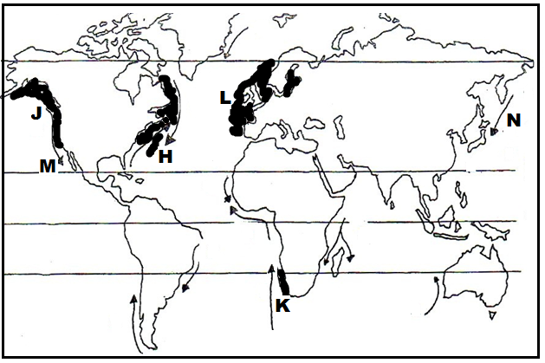
i) Name the fishing grounds marked J,K and L (3marks)
- J-North East pacific fishing ground
- K- South West Africa fishing ground
- L- North East Atlantic fishing ground
ii) Identify the ocean currents marked M and N (2marks)
- M- Cold California ocean current
- N-Cold OyaSiwo / Oyashio
iii) Mention three main fish species caught in the fishing ground marked H (3marks)

- Hake
- Herring
- Flounder
- Halibub
- Mackerel
- Sardine
- Cod
- Haddock
- Shell fish

c) Explain four physical factors that have made Japan a great fishing nation (8marks)
- Japan has a broad and shallow continental shelf which allows sunlight to reach the seabed hence growth of planktons which are food for fish
- Convergence of warm KuroSiwo and cold OyaSiwo ocean currents cause upwelling of sea water which brings minerals for planktons thus large fish numbers
- The Japanese coastline is highly indented which favours fish breeding in the sheltered waters thus large fish numbers
- Japan has very many offshore islands which provide sheltered inlets for the establishment of fishing ports
- Japan is located within the temperate latitudes thus cool waters ideal for fish breeding and growth of planktons
- Mountainous nature of Japan hinders / restricts agriculture making fishing a key alternative economic activity
- Explain four problems facing the fishing industry in Kenya (8marks)
- Overfishing in key fisheries due to use of small meshed nets has reduced some fish species such as Nile perch in L.Victoria
- Increased water pollution in lakes and rivers as some wastes / pollutants kill fish especially in lake Naivasha
- Invasion of some fisheries by waterweeds which hinders fishing and also results in fish migration
- Fish poaching within Kenya’s marine fisheries by foreign fishing vessels which reduces the number of fish.
- Inadequate storage facilities as most fishermen are poor thus unable to afford refrigeration facilities
- Inadequate transport as some roads leading to key fisheries such as lake Turkana are impassable during the wet season
- Small market for fish as most Kenyans rely on beef and mutton for meat as fish eating is still unpopular in some communities
9. a) i) Differentiate between industry and industrialization (2marks)
An industry is an economic enterprise that enables people to produce goods and offer services for consumption or sale while industrialization is the process and pace at which a country sets to establish processing and manufacturing industries
ii) State the benefits of industrialization to Kenya (5marks)
- Kenya earns foreign exchange on exported industrial goods
- Creation of employment opportunities to many Kenyans
- Improvement / development of transport and communication
- Reduction of importation of some industrial goods
- Diversification of the economy reducing over- reliance on agriculture
- Acquisition of technical and management skills thus expansion of industries
- Establishment of social amenities in areas where industries are located
- Increased revenue to the government through taxes and license fee
- Growth / expansion of urban centre’s due to migration of workers
b) Explain three causes of the decline in the textile industry in Kenya (6marks)
- There has been a decline in cotton production which has limited the supply of the main raw material for textile industry
- Large scale importation ofsecond hand clothes has reduced the demand for locally produced textile products
- Liberalizationof the economy has encouraged business people to import textiles from other countries
- Increased importation of large quantities of new clothes from other countries which are cheap compared to Kenyan made clothes
- Decline in economic growth has discouraged investors in the textile industry.
- Closure of some leading textile industries in the 1990s thus a decline in textiles production
c) State four ways in which the Kenyan government assists Jua kali industries. (4marks)
- Setting aside land in urban centres for artisans to operate from
- Constructing sheds where artisans can operate from
- Setting up training institutions where interested school leavers can be trained on various skills
- Setting up departments in the ministry of industrialization and enterprise development to promote the Jua kali sector
- Encouraging artisans to form cooperatives to enable marketing of their products
- Providing loans to enable artisans develop the industry
- Through regional co-operation some products made by the sector are now sold in East Africa and COMESA region
d) Explain four factors that have led to the growth of the iron and steel industry in the Ruhr region of Germany (8marks)
- Availability of water from River Rhine and its tributaries for cleaning, cooling and steam production
- Availability of raw materials from the coal field iron ore and limestone which are key in steel production
- Availability of power from the Ruhr coal field for heating in blast furnaces and from electricity
- Cheap water transport through navigable River Rhine and several canals enabling movement of raw materials and products
- Availability of skilled labour from town / cities in the region where many natives had already developed skills in metal working
- Availability of a large local market in Germany and neighboring European countries for iron and steel produced.
- Existence of rich families with an entrepreneurial culture such as Krupp and Ruhr Kohle who provide capital for the development of iron and steel industries in the area.

10. a) i) What is a Census (2mks)
A population census is the total process of collecting, compiling analyzing and publishing demographic, social and economic data pertaining all persons in a country at a specific time
Or
A census refers to the counting of the entire population of a country or area while compiling the social and economic information of the people
ii) State four reasons why a census is important to Kenya (4marks)
- A census provides information on the trends of mortality and fertility
- Information obtained helps governments to plan for the provision of basic facilities such as schools hospitals and food
- It helps in the creation of new administrative units such as counties,constituencies or wards
- It shows the composition of population in terms of age sex and regional distribution
- Total population assists the government to know if there are adequate resources
- A population census enables the estimation of population growth to determine literacy level
b) Explain four effects of migration at the place of origin (8marks)
- Decrease in food production due to shortage of labour as it is the able bodied people who migrate to towns / other areas
- Imbalance in male- female ratio as most of the migrants are men
- More income in the rural areas if money is sent by the working individuals to their dependants
- International migration leads to brain drain due to loss of trained manpower such as lecturers doctors and teachers
- The composition of the population is affected as young people migrate leaving children and the aged
- There is lowered population density and fertility rate when many people leave
- In some areas there is more land for farming due to land consolidation which may boost food production
- Pressure on available jobs eases in a country when many people go abroad in search of jobs
c) Explain three causes of a reduced fertility rate in Kenya (6marks)
- Increased rate of use of birth control measures among many productive females which lowers the number of children
- More girls are attending school upto tertiarylevels thus delaying in getting married which contributes to a lower fertility rate
- Increased number of women mainly in urban centres opting to remain single thus opting to have very few children
- Modern career opportunities may delay young women from getting children as some employers avoid women who keep on going on maternity leave.
- Hardeconomic times in urban centres and the high cost of child upkeep have forced many people to limit the number of children which lowers the fertility rate.
d) State five differences between Kenya’s population and that of Sweden (5marks)
- The birth rate in Kenya is high while in Sweden it is low
- The death rate in Kenya is relatively high while the death rate in Sweden is low
- Fertility rate in Kenya is high while fertility rate in Sweden is low
- Kenya’s population has a large number of young people below 20 years while Sweden’s population has a large number of mature and aged people / old people
- The population growth rate in Kenya is high while the population growth rate in Sweden is low
- Kenya’s population has a high dependency ratio while Sweden’s population has a low dependency ratio
- Kenya’s population has a lower life expectancy while Sweden’s population has a high life expectancy
- A high percentage of the Kenyan population live in rural areas while in Sweden most people live in urban centres

