NAME……………………….……………INDEX NO:…………………….ADM:…..........................
SCHOOL…………………………….…… DATE ………………..………. CLASS: ………………….

312/1
GEOGRAPHY
Paper 1
JULY/AUG, 2018
Time: 2¾ hours

LANJET CLUSTER JOINT MOCK EXAMINATION
Kenya Certificate of Secondary Education
312/1
Paper 1
GEOGRAPHY
JULY/AUGUST 2018

INSTRUCTIONS TO STUDENTS

- This paper has two sections A and B
- Answer ALL the questions in section A. In section B answer questions 6 and any other TWO questions.
- All your answers must be written on the foolscaps provided.

This paper consists of 5 printed pages. Candidates should check the question paper to ascertain that all pages are printed as indicated and that no pages are missing.

SECTION A:
Answer all the questions.
- (a) How does a land breeze occur? (2mks)
(b) (i) Name two ocean currents found on the coasts of West Africa. (2mks)
(ii) State one effect of warm ocean current on the adjacent coastlands. (1mk)

- (a) The diagram below represents a barchan. Use it to answer question (a)
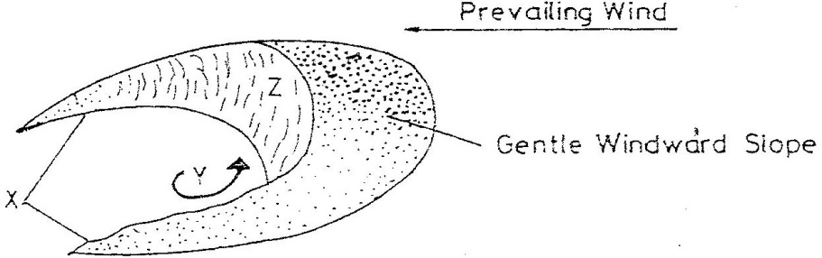

Name;
- The feature marked X. (1mk)
- The air current marked Y. (1mk)
- The slope marked Z. (1mk)

(b) Give two ways in which wind transports its load. (2mks)

- The diagram below shows a composite volcano.
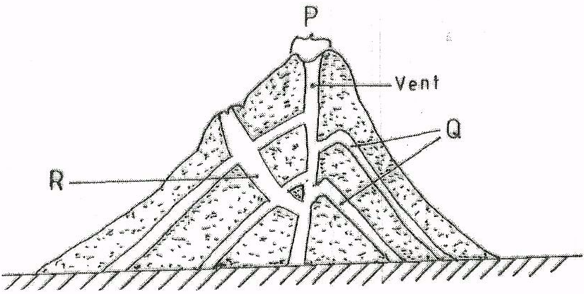
- Name the features marked P, Q and R. (3mks)
- Give two ways in which vulcanicity influences human activities. (2mks)

- (a) What is the difference between an ice sheet and an iceberg? (2mks)
(b) Name three types of glacial moraines. (3mks)

- (a) Give two components of the solar system. (2mks)
(b) State three effects of the movement of the earth around the sun. (3mks)

SECTION B:
Answer question 6 and any TWO other questions from this section.
- Study the map of Oyugis 1:50,000 (sheet 130/1) provided and answer the following questions.
- (i) What is the four figure grid reference of the Kokungu dam? (2mks)
(ii) What is the magnetic variation of the map? (1mk)
(iii) Calculate the area covered by Kodera Forest. Give your answer in square kilometers. (2mks)
- Draw a square 10cm by 10cm to represent the area enclosed by Eastings 84 and 94 and Northings 28 and 38. (1mk)

On the square, mark and name;
- Forest. (1mk)
- Swamp. (1mk)
- District boundary (1mk)
- Range. (1mk)

- Describe the relief of the area covered by the map. (6 mks)
- Identify three social services of Kamagambo trading centre. (3mks)
- Citing evidence from the map, explain three factors that favour coffee growing in the area covered by the map. (6mks)

- (a)(i) Difference between a tributary and a confluence. (2mks)
(ii) The diagram below shows the three stages of the long profile of a river.
(i) Youthful stage
(ii) Mature stage
(iii) Old stage

- Give one activity that takes place in each stage. (3mks)
- State two features formed at the mature stage. (2mks)
- Describe three processes by which a river transports its load. (6mks)
- With the aid of a well labeled diagram, describe the process of a river capture. (7mks)
- You are required to carry out a field study on the materials deposited by a river.
- State three methods you would use to collect data. (3mk)
- State two advantages of studying the work of rivers through fieldwork. (2mks)

- (a)(i) Apart from the Rift Valley, name three other relief features formed as a result of faulting. (3mks)
(ii) With the aid of diagrams, describe how the Rift Valley may have been formed by tensional forces. (8mks)

(b) Explain three ways in which faulting influences drainage systems. (6mks)
(c) Explain four ways in which features resulting from faulting are of significance to the economy of Kenya. (8mks)
- The map below shows some vegetation regions of the world. Use it to answer questions (a) and (b)
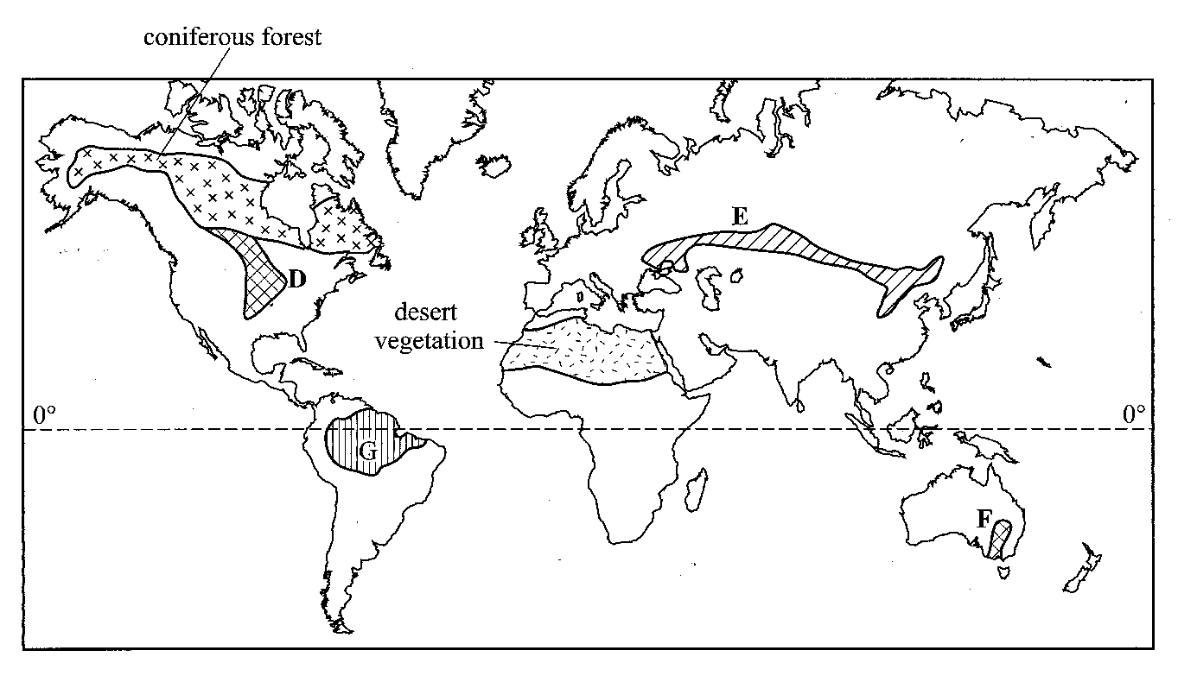
- (i) Name the temperate grasslands marked D, E and F. (3mks)
(ii) Describe the characteristics of the natural vegetation found in the shaded area
marked G. (6mks)
- Explain how the following factors influences existence of various vegetation types.
Altitude:- (2mks)
Aspect: - (2mks)
Precipitation :- (2mks)
Drainage: - (2mks)

- You are required to carry out a field study of the natural vegetation within your local environment.
- State three activities that are necessary before undertaking the study. (3mks)
- State two methods that you would use to record the data collected. (2mks)
- State three follow up activities you are likely to undertake. (3mks)

10.
(a)(i) Differentiate between weathering and mass wasting. (2mks)
(ii) Give two processes of slow mass wasting. (2mks)
(iii) State two physical conditions that may influence landslides. (2mks)
(b) Explain the following processes of weathering.

- Frost action. (2mks)
- Oxidation. (2mks)
- Hydration. (2mks)

(c) Describe how an exfoliation dome is formed. (6mks)

(d) State four indicators of occurrence of soil creep in an area. (4mks)

(e) Name three human activities influenced by weathering. (3mks)

