LANJET 2018
121/2 - MATHEMATICS MARKING SCHEME PAPER 2

1. No Log M1  logs
849.6 2.9292 +
2.41 0.3820
3.3112 - M1 + -
3941 3.5956
$\overset{−}{1}\text{.}\text{7156}$ M1 ÷
$\frac{\overset{−}{3} + 2\text{.}\text{7156}}{\text{31}} = \overset{−}{1}\text{.}\text{9052}$
8.039 × 10ˉ¹
= 0.8039 A1

4

2. Det = 0-3 = -3 ignore – sign M1

Area of Δ ABC x Det = Area of A′B′C′

Area of Δ ABC X 3 = 36cm² A1

Area of Δ ABC = 36/3cm² = 12cm² 03

3

3. (a) $\left(1 + \sqrt{3}\right) \left(1 − \sqrt{3}\right) = −2$ M1

(b) $\frac{1}{1 + \text{53}} × \frac{1 − \sqrt{3}}{1 \sqrt{3}}$
= $\frac{1 − \sqrt{3}}{−2} = \frac{1 − 1\text{.}\text{7321}}{−2}$ M1
= 0.36605
= 0.366 A1

3

4. $\frac{m + n}{m − n} = 83$ M1
3(m + n) = 8(m – n)
8m – 3m = 3n + 8n M1
5m = 11n
m: n = 11: 5 A1

3

5
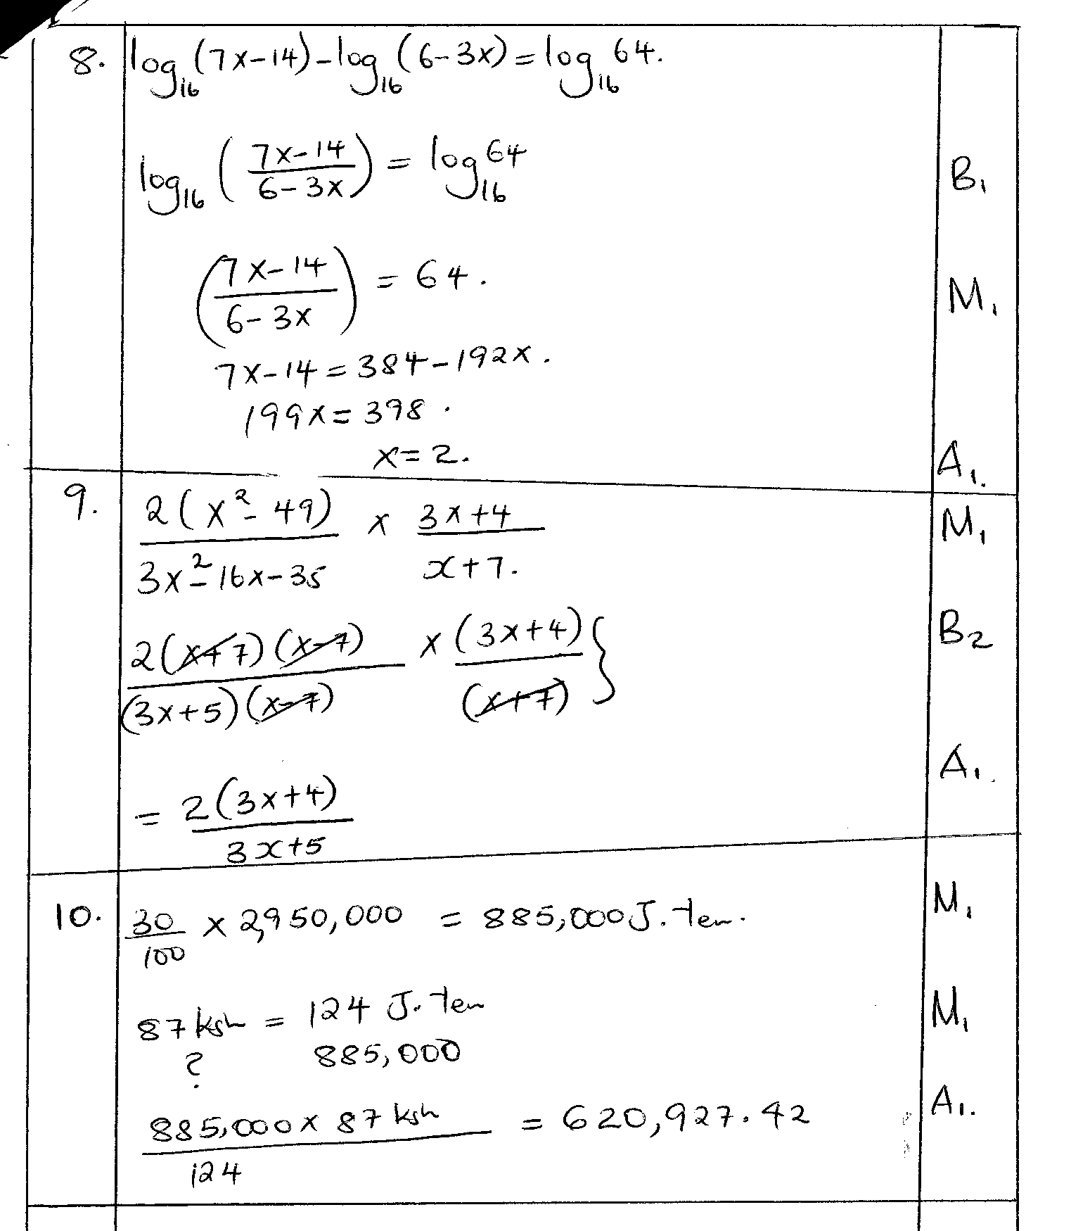
6. $P = \frac{\text{nq} − m}{q}$
P³q = nq – M M1 Correct removal of $\sqrt[3]{}$
P³q – nq = - M
q(P³ - n) = -M M1
$q = \frac{−M}{P^{3} − n} \text{or} \frac{M}{n − P^{3}}$ A1
3

7. T₃ = ar² = 20 i) a = 20/r²
T₆ ar⁵ = -160 ii) and ….in ii) = 160 = -160
r³ = -8 r = -2
a=20 = 5
4
T₈ = 5(-2)⁷ = -640

8. A.E in A + B = 0.05 + 0.05 = 0.10 $\frac{\text{Alternative}}{\text{Max} = 5\text{.}\text{692307692}}$
R.E = $\frac{0\text{.}\text{10}}{\text{11}} = 0\text{.}\text{009091}$ M1 Min = 5.317073171
Actual = 5.5
RE in C = $\frac{0\text{.}\text{05}}{\text{20}} = 0\text{.}\text{025}$ M1 $\frac{\frac{1}{2}\left(\text{Max} = \text{Min}\right)}{\text{Actual}} × \text{100}$
% error = (0.009091 + 0.025) × 100 = 3.41%
= 3.4091% A1
= 3.41% 3

9. $\frac{2χ^{2} + 4χ − 3χ − 6}{\left(χ − 2\right) \left(χ + 2\right)} + \frac{1}{χ − 2}$ M1
$\frac{\left(2χ − 3\right) \left(χ + 2\right)}{\left(χ − 2\right) \left(χ + 2\right)} + \frac{1}{\left(χ − 2\right)}$ M1
= $\frac{2χ − 2}{χ − 2}$ A1

3
10. 15 + 5(-2χ) + 10(-2χ)² + 10(-2χ)⁴ + (2χ)⁵
1 - 10χ + 40χ² - 80χ³ + 80χ4 - 35χ⁵ M1
0.98 = 1 – 2χ
2χ = 0.02
- = 0.01
1 – 10(0.01) + 40(0.01)² - 80(0.01)³ + 80(0.01)⁴ M1
1 – 0.1 + 0.004 – 0.00008
= 0.90392 A1
3

11. $\frac{\text{200}}{χ − 5} − \frac{\text{200}}{χ} = 2$ M1
200χ - 200χ + 1000 = 2χ² - 10χ
1000 = 2χ² - 10χ
2χ² - 10χ - 1000 = 0 M1
χ² - 5χ - 500 = 0
(χ + 20) (χ - 25) = 0 M1
χ = -20 or χ = 25
Price = sh.25 A1

12. χ² - 6χ + y² + 8y = 11
χ² - 6χ + (3)² + y² + 8y + (4)² = 11 + 9 + 16 M1
(χ - 3)² + (y + 4)² = 36 M1
C(3, -4) A1 both
r = 6
3

13. A = $P{\left(1 − \frac{R}{1−\text{100}}\right)}^{n}$
$3,\text{000},\text{000} {\left(1 − \frac{\text{12}}{\text{100}}\right)}^{4}$ M1
1,799,086.08 M1
Ksh,1799,000 A1

3

14.
PR = 12² + 9² = 144 + 81 = 225 = 15cm
h = 19.52 – 7.52

= 380.25 – 56.25

= 324 = 18

tanθ = 18 = 2.4
7.5
θ = 67.38º

3

15. $\begin{aligned}\left(−5 | \right) \\ \end{aligned}$
$T = \begin{aligned}\left(−1 | \right) \\ \end{aligned}$ M1
$\begin{aligned}\left(−4 | \right) \\ \end{aligned}$ M1
= (0, 0) A1

3

16. $\frac{\text{dy}}{dχ} 2aχ + b$ B1
at χ = 0 2a(0) + b = 8
b = 8
at χ = 4
2a(4) + 8 = 0 M1
a = -1 A1

3 angle difference
17
(a)166.25% = sh.9036 M 1
100% = ?
100 x 9036 = sh. 5435p.m
166.25
= 5435 x 12 = 65220p.a
= £ 3261 A 1

b) Tax due = 3261+633.6 = 3894.6 M 1
5808 x 110% = 580.8
5472 x 15% = 820.8 M 1
5472 x 20% = 1094.4
5472 x 25% = 1368 M 1
30.6x 30% = 9.18
£ 22254.6 3873.18.

Taxable income = £ 22254.6 p.a
= shs. 22254.6 x 20 = sh. 37091 M 1
12

Salary = 37091 – 1271 = shs. 24370 M 1
c) Net income = 37091 + 50 x 24370
100
= 49276 M 1
Net pay = 49276 – 9036 = 40240
Net pay before = 37091 – 5435
= 31656 M 1
% increase = 8584 x 100 = 23.14%
37091 A 1

18 | a) y ≤2x  x+y < 30  y> 10  4x+y ≥ 50  b) 80x + 20y ≥ 1000  for y ≥ 2x drawn  for x+y < 30 drawn  c) for search line drawn  max (8,14)  B1- 28,400 8x1800 + 14 x 1000  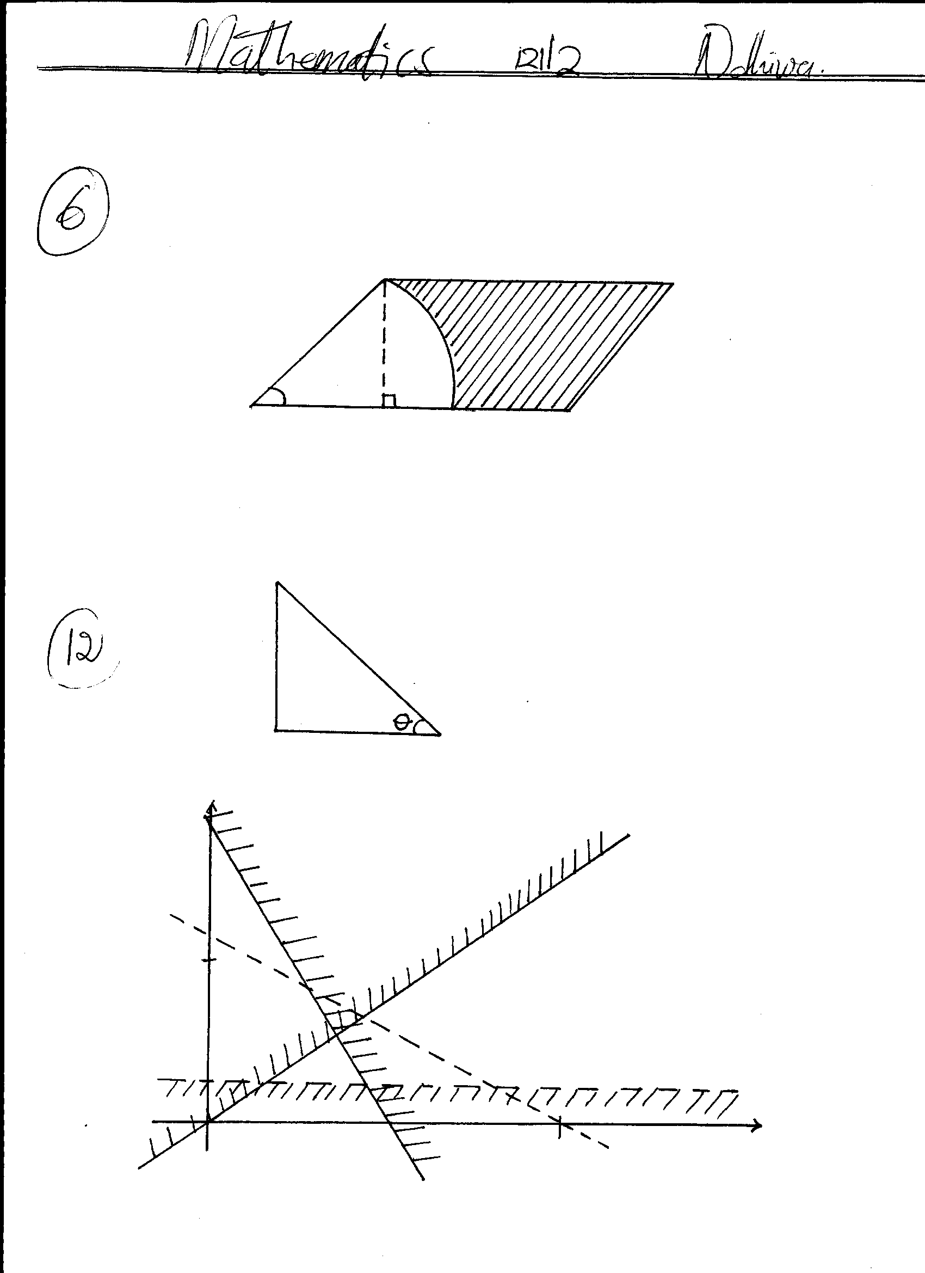  4x+y≥ 50  Search line  y≤2x  y≥10  150
19 | (a) θ = 5°  $\text{PQ} = \frac{5}{\text{360}} × \text{6370} × \frac{\text{22}}{7} × 2$  = 556.11km  (b) θ = 2(90 – 35) = 110°  = 110° × 60  = 6,600nm  - θ = 135 + 45 = 180  180° × 60 Cos 35  = 8,846.84  = 8850nm  (c) S = 5 × 60 + 6,600 = 6,900  Time $= \frac{\text{6900}}{\text{420}}$ = 16.429hrs  S = 5 × 60 + 8850 = 9,150  Time = $\frac{9,\text{150}}{\text{420}}$ = 21.78hrs  Time differ = 21.786 – 16.429  = 5.357hrs or 5hrs 21.42min | M1  A1  M1  A1  M1  A1  M1  M1  M1  A1  allow if appr to nearest minutes
20. | 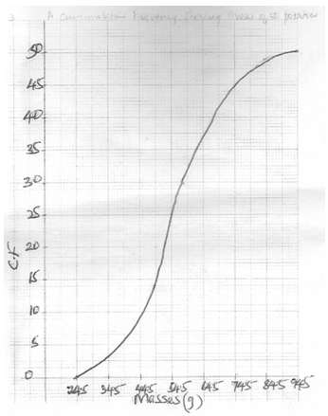  B1 for CF  S1  P1  C1  (b) (i) Position of 60° percentile $\frac{\text{60} × \text{50}}{\text{100}}$  ∴Mass of 30th potato = 58.5g  60th percentile mass = 58.5g  - No. of potatoes with mass pf 53g or less = 28  No of potatoes with mass of 68g of less = 40  ∴ No of potatoes with mass of 53 to 68g = 40 – 28 = 12  ∴ Age of potatoes with mass 53g to 68g  $\frac{\text{12} × \text{100}}{\text{50}} = \text{24}\text{\%}$  (iii) Median = 54.5 | M1  A1  B1  B1  B1  B1  A1
  19. | (a) | Mass (g) | 25 - 34 | 35 - 44 | 45 - 54 | 55 - 64 | 65 - 74 | 75 - 84 | 85 94
   |  | No. of potatoes | 3 | 6 | 16 | 12 | 8 | 4 | 1
   |  | Cf | 3 | 9 | 25 | 37 | 45 | 49 | 50
   |  | Upper class boundaries | 34.5 | 44.5 | 54.5 | 64.5 | 74.5 | 84.5 | 94.5
21 | $$\begin{aligned}\left(4 7 | \right) \\ \end{aligned}$$  = -3  $P^{−1} = \frac{1}{−3}\begin{aligned}\left( 8 −7 | \right) \\ \end{aligned}$  = $\begin{aligned}\left(−83 73 | \right) \\ \end{aligned}$  8B + 14M = 47,600  10B + 16M = 57,400  4B + 7M = 23800  5B + 8M = 28700  $\begin{aligned}\left(4 7 | \right) \\ \end{aligned}$= $\begin{aligned}\text{23800} \\ \text{28700}\end{aligned}$  $−13\begin{aligned}\left( 8 −7 | \right) \\ \end{aligned}$  $\begin{aligned}\left(1 0 | \right) \\ \end{aligned}$  $\begin{aligned}\left(B | \right) \\ \end{aligned}$  Beans = 3500 Maize 1,400 for both  Beans new price $\text{105}\text{100} × \text{3500} = \text{3675}$  3675(8) + 1400(m) = 47600  M = 13  Ratio 8: 13 | M1  A1  B1  B1  M1  M1  M1  A1  M1  A1  10
22 | R  R¹  B¹  B  B¹  B  T  T¹  T¹  T  D  D¹  D¹  D  ⁶/₇  ¹/₇  ⁴/₁₅  ¹¹/₁₅  ⁴/₅  ¹/₅  ⁵/₇  ²/₇  ¹/₁₃  ¹²/₁₃  ⁴/₅  ¹/₅  ⁵/₇  ²/₇  (b) (i) Not bitten  $\left(\frac{6}{7} × \frac{\text{11}}{\text{15}}\right) + \left(\frac{1}{7} × \frac{\text{12}}{\text{13}}\right)$  $\frac{\text{66}}{\text{105}} + \frac{\text{12}}{\text{91}} = \frac{\text{346}}{\text{455}}$  (ii) $\left(\frac{6}{7} × \frac{4}{\text{15}} × \frac{1}{5} × \frac{5}{7}\right) + \left(\frac{1}{7} × \frac{1}{\text{13}} × \frac{1}{5} × \frac{5}{7}\right)$  $\frac{\text{24}}{\text{735}} + \frac{1}{\text{637}} = \frac{\text{109}}{\text{3185}}$  (iii) $\left(\frac{6}{7} × \frac{4}{\text{15}} × \frac{4}{5}\right) + \left(\frac{6}{7} × \frac{4}{\text{15}} × \frac{1}{5} × \frac{2}{7}\right) + \left(\frac{1}{7} × \frac{1}{\text{13}} × \frac{4}{5} \right)$ +  $\left(\frac{1}{7} × \frac{1}{\text{13}} × \frac{1}{5} × \frac{2}{7}\right)$  = $\frac{\text{76}}{\text{525}} + \frac{\text{48}}{\text{3675}} + \frac{4}{\text{455}} + \frac{2}{\text{3185}}$  = $\frac{\text{654}}{\text{3185}}$ | R – Rides  B – Bitten  T – Treatment  D – Get rabies  M1  A1  M1  A1  M1  A1  10
23 | BC² = 6² + 8² - 2 × 6 × 8 Cos 50  = 100 – 61.71  BC = $\sqrt{\text{38}\text{.}\text{3912}} = 6\text{.}\text{19}\text{cm}$  - Let ∠ABC be β°  $\frac{\text{Sin} β^{o}}{6} = \frac{\text{Sin} {\text{50}}^{o}}{6\text{.}\text{19}}$  Sin β°=$\frac{6 \text{Sin} \text{50}}{6\text{.}\text{19}}$ β° = 47.95  - Let ∠CAD be ∝°  2.82² = 7² + 6² – 2 × 7 × 6 Cos ∝°  Cos ∝° = $\frac{\text{49} + \text{36} − 7\text{.}\text{9524}}{\text{84}}$ = 23.48°  - Area of ΔACD  = $\frac{1}{2} × 7 × 6 \text{Sin} \text{23}\text{.}{\text{48}}^{o}$  = 8.37cm² | M1  A1  M1  A1  M1  M1  M1  A1 10
24 | 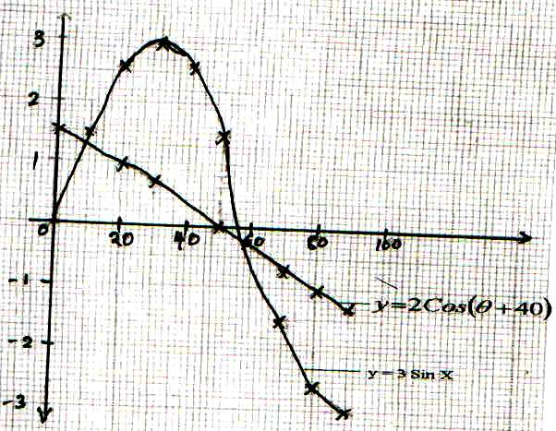  (b) (i) 9± 1, 62±1  (ii) 50⁰ | B2 ✓ all  B1 any 5  S1 ✓scale  P1 ✓ plotting  C1 ✓ curve 1  P1 ✓ plotting curve 1  C1 ✓ curve 2  B1B1 for each  B1
  θ | 0 | 10 | 20 | 30 | 40 | 50 | 60 | 70 | 80 | 90
  2sin3θ | 0 | 1 | 2.60 | 2.00 | 2.60 | 1.50 | 0 | -1.50 | -2.60 | -2
  2cos(θ+40) | 1.53 | 1.29 | 1.00 | 0.69 | 0.34 | 0.00 | -0.35 | -0.68 | -1.00 | -1.29

