**Name……………………………………… Index No:…………………….ADM:….......**

**School…………………………………………………… Date ………………………….**

**Candidate’s Signature………………………**

**121 /1**

**MATHEMATICS**

**PAPER 1**

**JULY 2018**

**2 ½ HRS**

**LANJET– 2018**

***Kenya National Examination Council (K.C.S.E)***

**121 /1**

**MATHEMATICS**

**PAPER 1**

**JULY 2018**

**2 ½ HRS**

## INSTRUCTIONS TO CANDIDATES

1. Write your name and index number in the spaces provided at the top of this page.

2. This paper consists of two sections: Section I and Section II.

3. Answer ALL questions in section I and ONLY FIVE questions from section II

4. Show all the steps in your calculations, giving your answers at each stage in the spaces below each question.

5. Marks may be given for correct working even if the answers are wrong.

6. Non – Programmable silent electronic calculators and KNEC mathematical tables may be used, except where stated otherwise.

**FOR EXAMINERS USE ONLY**

Section I

|  |  |  |  |  |  |  |  |  |  |  |  |  |  |  |  |
| --- | --- | --- | --- | --- | --- | --- | --- | --- | --- | --- | --- | --- | --- | --- | --- |
| 1 | 2 | 3 | 4 | 5 | 6 | 7 | 8 | 9 | 10 | 11 | 12 | 13 | 14 | 15 | 16 |
|  |  |  |  |  |  |  |  |  |  |  |  |  |  |  |  |

**GRAND TOTAL**

**Section II**

|  |  |  |  |  |  |  |  |  |
| --- | --- | --- | --- | --- | --- | --- | --- | --- |
| 17 | 18 | 19 | 20 | 21 | 22 | 23 | 24 | TOTAL |
|  |  |  |  |  |  |  |  |  |

SECTION 1: *ANSWER ALL QUESTIONS IN THIS SECTION*

1. Evaluate 5 ½ - 1 1/7 (1 1/5 + 9/10 ) + 1/3 of (2/3  ÷5/6) (3mks)
2. Simplify

 ( 3mks)

1. A positive two digit number is such that the product of the digits is 20.When the digits are reversed , the number so formed is greater than the original number by 9.Find the number.
2. Three years ago,Juma was three times old as Ali.In two years time, the sum of their ages will be 62.Determine their current ages (2 mks)
3. A number n is such that when its divided by 3,7,11 or 13, the remainder is always one . Find the number n. ( 2mks)
4. The size of each Interior angle of a regular polygon is seven times the size of the exterior angle.

Find the number of sides of the polygon. (2 mks)

1. Use reciprocal, square and square root tables to evaluate, to 4 significant figures, the expression. (4 marks)
$$\frac{2}{{(0.5245)}^{2}}-\frac{5}{\sqrt{363.4}}$$

2. The surface area of two similar bottles are 12cm2 and 108cm2 respectively. If larger one has a volume of 810cm3.Find the volume of the smaller one. (3mks)
3. A solid block in the shape of a cylinder has a height of 14cm and weighs 22kg. If it is made of material of density 5g/cm3, find the radius of the cylinder. Take π= (3mks)
4. Find the value of x in the following equations: (3mks)

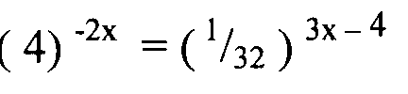

1. A line Ax +3y-6=0 is perpendicular to the line 5x+7y-k=0. If 5x+7y-k=0 passes through the point (4,3). Determine the values of A and K (4mks)
2. Agnes paid rent which was 1/10 of her net salary. She used ½ of the remaining amount to make a down payment for a plot. She gave her mother Kshs. 2,500 and did shopping worth Kshs. 7,500 for herself. She saved the remainder which was Ksh. 12,500. How much was the down payment that she made. (4mks)

1. A watch which loses a half-minute every hour was set to read the correct time at 0545h on Monday. Determine the time, in the 12 hour system, the watch will show on the following Friday at 1945h. (3 marks)
2. Use the exchange rates below to answer this question.

Buying Selling

1 US dollar 63.00 63.20

1 UK £ 125.30 125.95

A tourist arriving in Kenya from Britain had 9600 UK Sterling pounds (£). He converted the pounds to Kenya shillings at a commission of 5%. While in Kenya, he spent ¾ of this money. He changed the balance to US dollars after his stay. If he was not charged any commission for this last transaction, calculate to the nearest US dollars, the amount he received. (3 marks)

1. Solve the following inequality and show your solution on a number line. (3mks)

4x – 3 $≤ \frac{1}{2}\left(x+8 \right)<x +5$

1. The table below shows marks obtained by a form four class in a certain school.

|  |  |  |  |  |  |  |
| --- | --- | --- | --- | --- | --- | --- |
| Marks (x) | 8≤X<9 | 9≤X<11 | 11≤X<13 | 13≤X<16 | 16≤X<20 | 20≤X<21 |
| No. of contents y | 2 | 6 | 8 | 3 | 2 | 1 |

Use the table to represent the information on a histogram. (3 Marks)

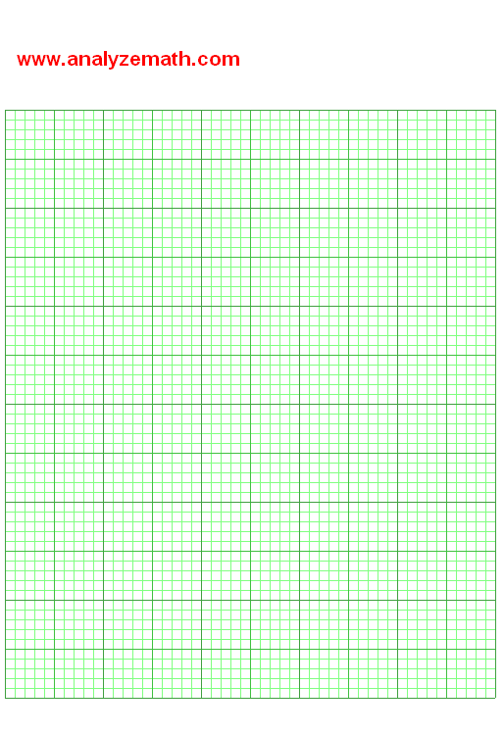

***SECTION B: ATTEMPT ANY FIVE QUESTIONS***

1. The figure below shows a cone from which a frustum is made. A plane parallel to the base cuts the cone two thirds way up the vertical height of the cone to form frustum ABCD. The top surface radius of the frustum is labelled r and the bottom radius R.

A

D

A

C

y

V

R

r

1. Find the ratio r:R. (1 Mark)
2. Given that r = 7cm, find R. (2 Marks)
3. If the height VY of the original cone is 45cm. Calculate to the nearest whole number the volume of the frustum. (Take $π= \frac{22}{7}$) (4 Marks)
4. The frustum represents a bucket which is used to fill a rectangular tank measuring 1.5m long, 1.2m wide and 80cm high with water. How many full buckets of water are required to fill the tank. (3 Marks)
5. The displacement h metres of a particle moving along a straight line after t seconds

is given by h = -2t3 + 3/2 t2 + 3t

(a) Find the initial acceleration. ( 3 marks )

(b) Calculate

(i) The time when the particle was momentarily at rest. ( 3 marks )

(ii) Its displacement by the time it comes to rest momentarily. ( 2 marks)

(c ) Calculate the maximum speed attained. ( 2 marks )

1. (a) The figure below shows two intersecting circles. Circle DCB has its centre P while DAB centre O.

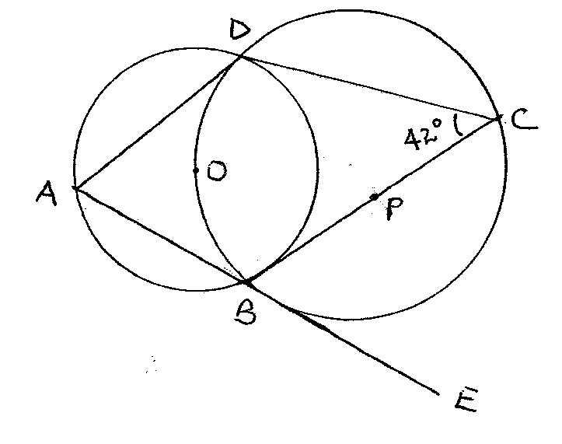

Giving reasons, determine the size of:

1. Angle CBD (2 marks)
2. Angle ODB (2 marks)
3. Angle BAD (2 marks)
4. Angle ABC (2 marks)
5. Angle ODA (2 marks)
6. A car leaves town X for town Y 120 km away at an average speed of 80 km/hr at 8.30 a.m. At the same time a bus leaves town Y for town X at an average speed of 60 km/hr. At 8.45 a.m., a cyclist leaves town Y for town X at an average speed of 30 km/hr.
   * 1. Calculate the time when the bus meets the car to the nearest minute. (3 marks)
     2. Calculate the distance between the car and the bus by the time the cyclist meets the car. (4 marks)
     3. If the bus upon reaching town X stops for 10 minutes then starts its journey back to Y, Calculate how far from X the bus meets the cyclist. (3 marks)
7. In the figure below, PQRS is a trapezium. Line PT and QS intersect at X and line QP is parallel to RS.***QT = a****,****QP = b****,QR =* ***3QT,RS = 2QP,QX =*** *t****QS****,* and ***PX =*** *k****PT*** where *k* and t are constants.

R

S

Q

P

X

T





a) Find in terms of ***a***and***b***:

(i) **PT** (1 mark)

(ii) **PX** (2 marks)

(iii) **QS** (1 mark)

b) Express **QX** in terms of: (2 marks)

(i)**a, b,** and *t***.**

(ii)**a, b** and*k*

(c) Determine the value of *k* and *t.* (3 marks)

(d) Find the ratio PT:TX (1 mark)

1. Two circles with centres O and Q and radii 8cm intersect at points A and B as shown below.

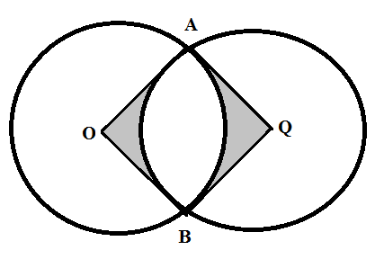

Given that the distance between O and Q is 12cm and that the line AB meets OQ at X, find:

(a) the length of the chord AB. (3marks)

(b) the reflex angle AOB. (3marks)

(c) the area of the shaded region.  (4marks)

1. The diagram below shows a triangle ABC with A (3, 4), B (1, 3) and C (2, 1).

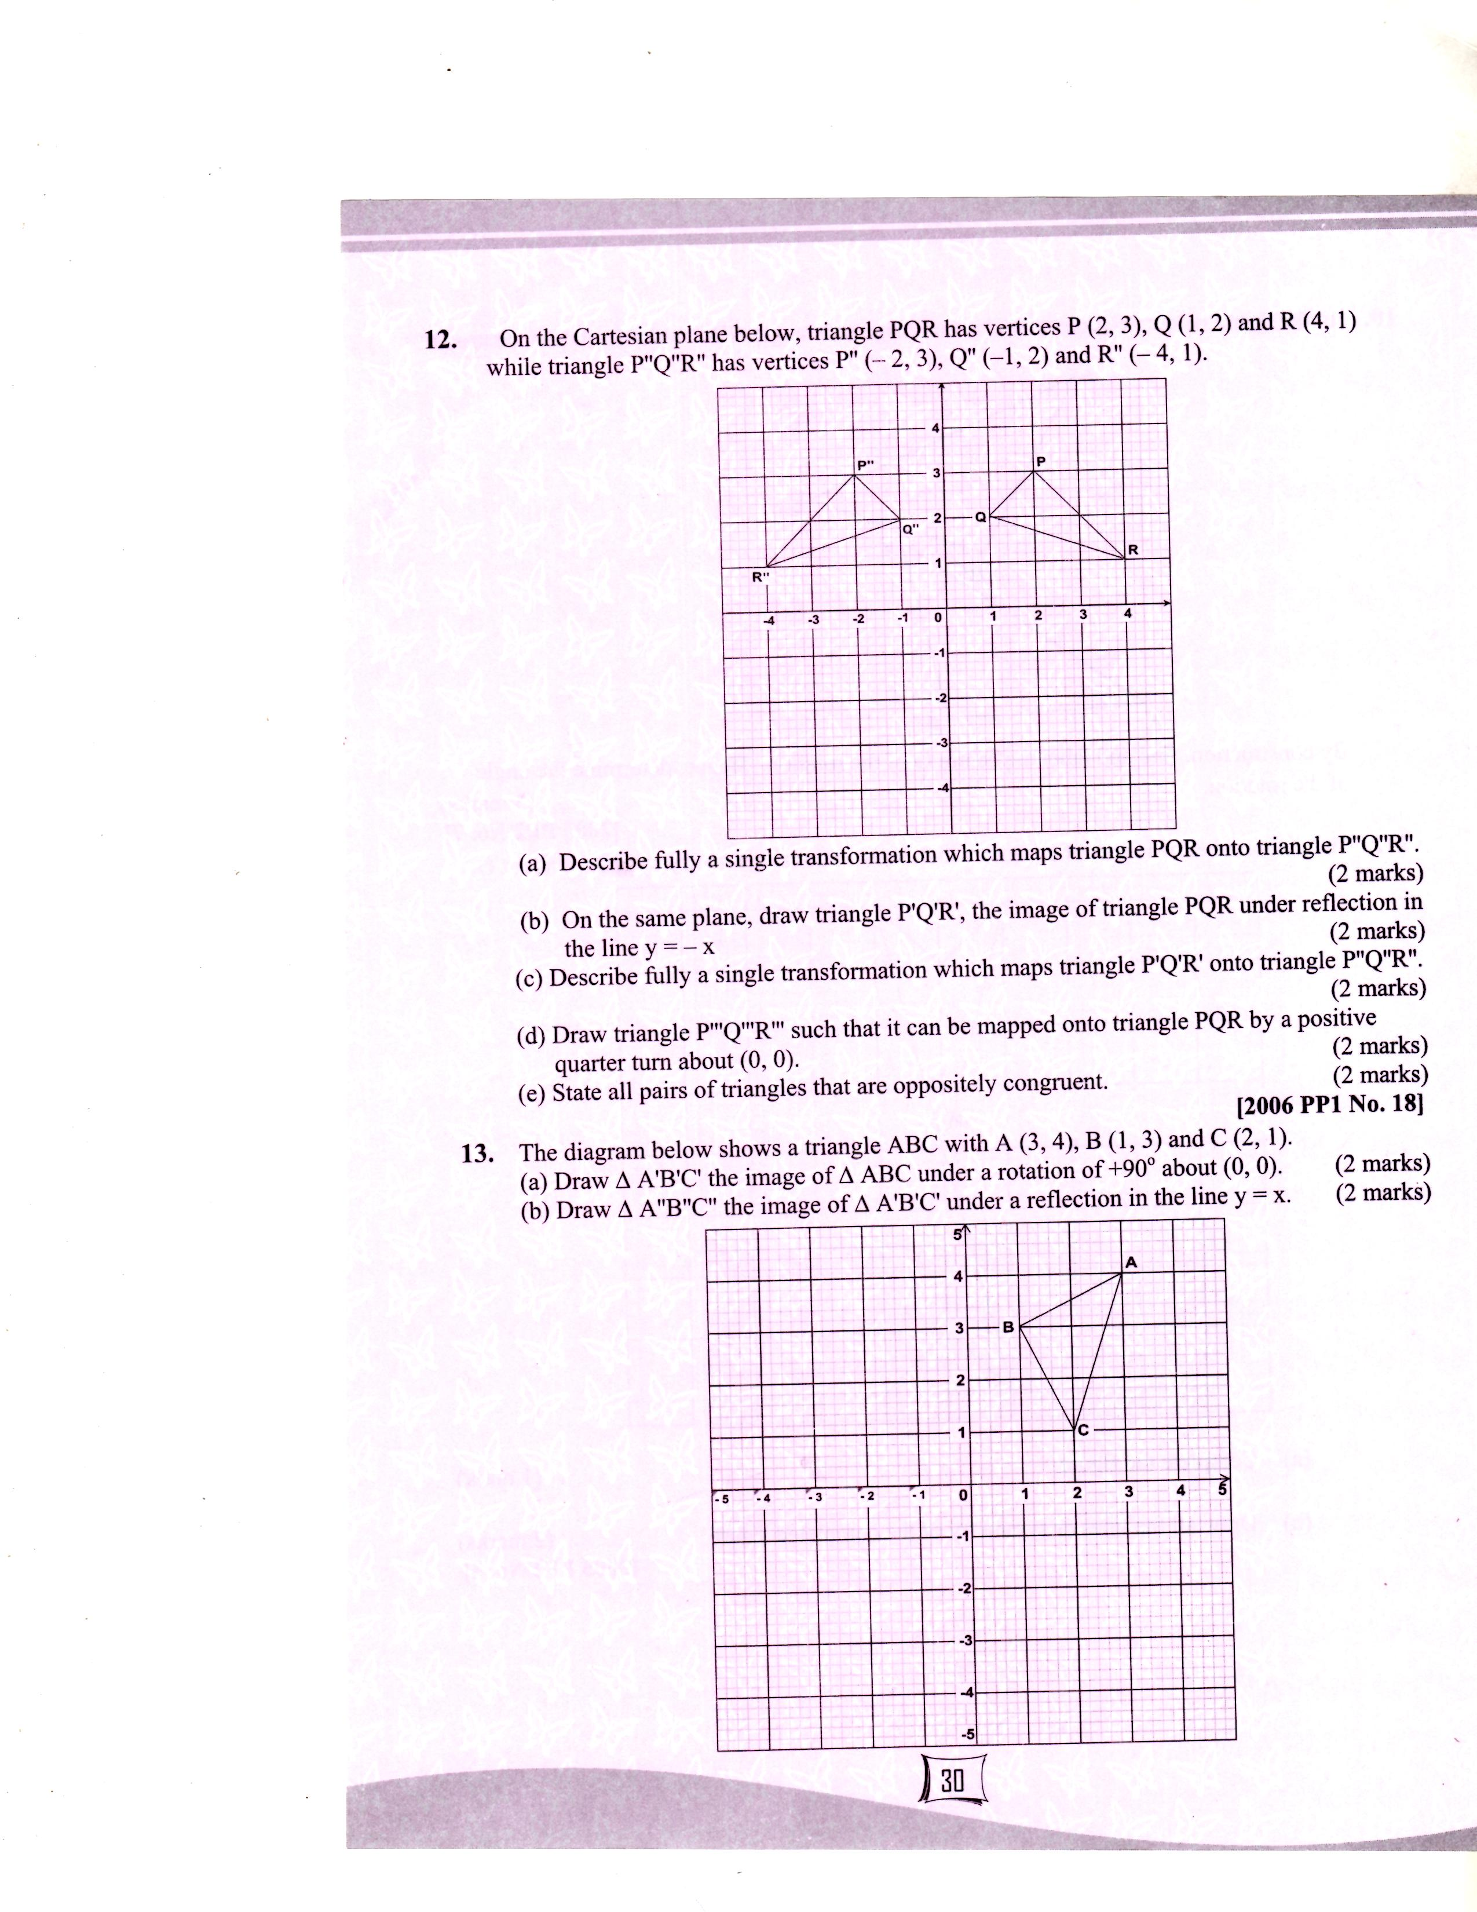

a) Draw △A ′B′C′ the image of ABC under a rotation of +900 about (0, 0). 2mks

b) Draw △ A″B″C ″ the image of A ′B′C ′under a reflection in the line y=x. 2mks

c) Draw △ A″′B″′C″′ the image of ∆ A″B″C″ under a rotation of -900 about (0, 0). 2mks

d) Describe a single transformation that maps △ABC onto △ A′″B′″C′″. 2mks

e) Write down the equations of the lines of symmetry of the quadrilateral BB″A′′′A′ . 2mks

1. Complete the table below for for the domain -5 (2 marks)

|  |  |  |  |  |  |  |  |  |  |
| --- | --- | --- | --- | --- | --- | --- | --- | --- | --- |
| **x** | **-5** | **-4** | **-3** | **-2** | **-1** | **0** | **1** | **2** | **3** |
| 14 | 14 | 14 | 14 | 14 | 14 | 14 | 14 | 14 | 14 |
| -5x | 25 | 20 |  |  | 5 | 0 | -5 |  | -15 |
| -2x² | -50 |  | -18 |  | -2 | 0 | -2 | -8 |  |
| y | -11 |  |  |  | 17 | 14 | 7 |  |  |

(b) Draw the graph of  for the domain -5 (3marks



(c) Use your graph to solve the equations:

1.  (2mark)
2.  (2marks)
3. Write down and simplify the equation in x which would be solved by drawing the line y=3x+2 on the same axes as (b) above. (1mark)