**Name......................................................................Index No....................Adm:………..**

**Class .............................Sign .............................................Date.....................................................**

**232/1**

**PHYSICS**

**2 HOURS**

**LANJET – 2018**

**MARKING SCHEME**

***INSTRUCTION TO CANDIDATES***

*a) Write your name, index number/Admission number in the spaces provided above.*

*b) This paper consists 11 of the sections: A & B.*

*c) Attempts all the questions in the spaces provided.*

*d) Silent Non Programmable electronic calculator may be used*

*e) All working must be clearly shown.*

**For examiners Use only**

|  |  |  |  |
| --- | --- | --- | --- |
| **SECTION** | **QUESTION** | **Maximum Score** | **Candidates Score** |
| A | 1 - 13 | 25 |  |
| B | 14 | 11 |  |
| 15 | 11 |  |
| 16 | 10 |  |
| 17 | 11 |  |
| 18 | 13 |  |
| **Total Score** |  | **80** |  |

1. (a) The change in direction changes the instantaneous velocities .

(b) f=3 Hz, r=1.5 m

V=ѡr= 2Пfr=2 x Пx3x 1.5 = 28.2857 m/s

1. Elastic potential energy = mechanical potential energy.} 🗸¹

1/2mv² = mgh

1/2 x 15 x 0.2² = 0.05 x 10h 🗸¹

h = 0.6m (3mks)

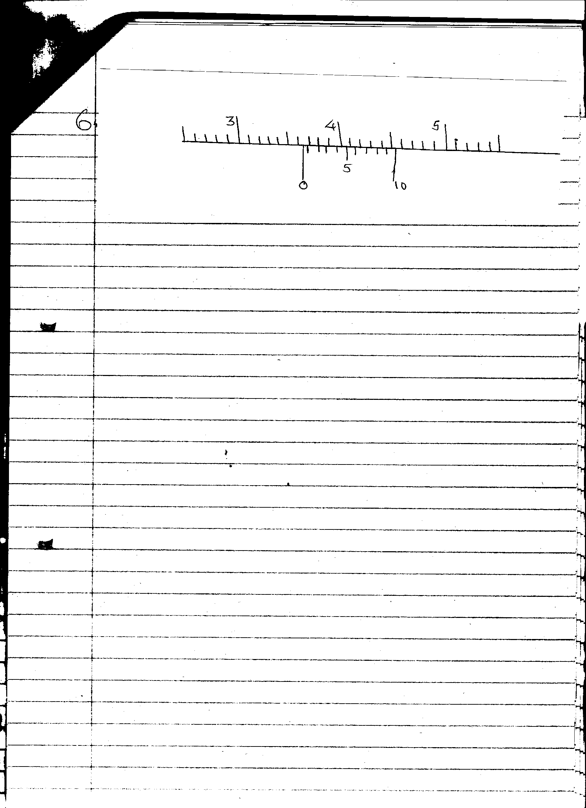

1. Radius of inlet = 10cm = 5cm = 0.05m

2

Cross sectional area of inlet A = 3.142 x 0.052

= m2

0.5m3 = a1v1

10

v = 0.5

3.14 x 0.05 x 0.05

= 63 .65 m/s

1. It is continuously knocked/bombarded/hit by the unseen air molecules/particles. (1mk)

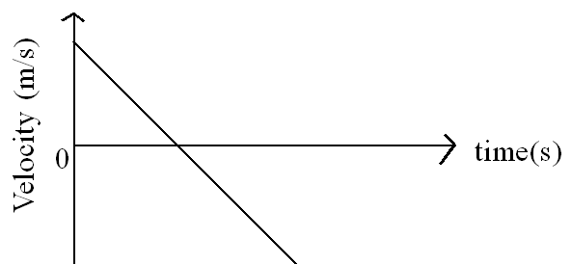

1. h1p1g = h2p2g

  h × 900 = 0.06 × 1200

h=0.08 m



1. In liquids the forces are smaller and molecules are able to roll over one another while in the gaseous sate, the molecules are free to move because gases have the weakest force of attraction.
2. Hollow bricks contain air in them, which is a poor conductor of heat hence reduces heat loss.

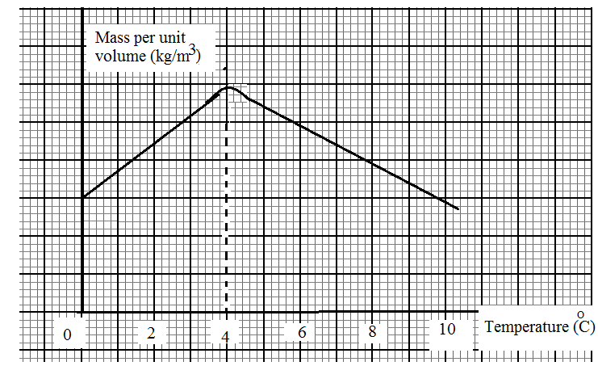

-Shape🗸

-Curving at 40C🗸

1. Stronger cohesive forces between oil molecules forming a spherical shape. Between water and glass, adhesive force are stronger causing the water to spread on glass.
2. Mechanics is the study of motion of bodies under the influence of force

**SECTION B**

1. (a) The rate of change of momentum is directly proportional to the external resultant force and takes place in the direction of force. (2mks)
2. m1v1 + m2v2 = (m1 + m21)v

8v = 5 x 2 – 3 x 4

8v = 10 – 12

V = -2/8 = -0.25m/s

They move at 0.25 m/s to the left. (3mks)

(c) (i) m1 = 2g u1 = 300m/s

m2=5kg u2 = 0

m1u1 + m2u2 = (m1+m2)v

0.002 x 300 +5 x0= 5.002v

V= 0.112 m/s

(ii) $\frac{1}{2}mv^{2}=mgh$

h= $\frac{5.002 x0.5 x {0.112}^{2}}{5.002 x10}$ = 0.0006272m

1. (i) specific latent heat of fusion is the quantity of heat required to change the state of a unit mass of a substance from solid to liquid without change in temperature.

(ii) a) 00C

b) Q = Cɵ

= 400 x 60 = 24000 J

c) Q = mcɵ

= $\frac{60}{1000}x 4200 x 60$ = 15120 J

d) mlf=24000 + 15120

$\frac{80}{100}x \frac{300}{1000}x$ lf= 39120

lf== 163000 J/kg

e) mlf + mcɵ = Cɵ + mcɵ

let the final temperature be t

$$\frac{300}{1000}x163000+\frac{300}{1000} x 4200 x t= \frac{60}{1000}x 4200 x \left(80-t\right)+400(80-t)$$

$$48800+1260t=20160-252t+32000-400t$$

20160+32000-48800 = 1260t +252 t + 400t=1912t

3360=1912t

t = 1.7570 C

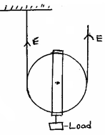 Correct

Diagram 🗸¹ (2mks)

Labelling 🗸¹

1. Distance travelled by the effort in one revolution 2πR} 🗸¹

Distance travelled by load = 2πr

Velocity ratio (V.R) 🗸¹ 🗸¹



(ii) 🗸¹

🗸¹ 



🗸¹





= 15.6(3)N

= 15.6N 🗸¹

(iii) When the load is large the effect of friction and weight of the moving parts is negligible. 🗸¹ (1mk)

**NB**: Friction and weight of moving parts to be mentioned.

1. (a) When a body is partially or totally immersed in a fluid it experiences an upthrust equal to weight of fluid displaces.

  (b) (i)Weight of hydrogen

  Total weight

= Weight of hydrogen + weight of balloon

= 2 + 13= 15N

  ii) Upthrust= weight of displaced air

= vdg

= 2 × 1.3 × 10 = 26N

  iii)Tension = U - W

= 26N - 15N = 11N

1. (a) B;

Hydrogen is lighter (less dense) than oxygen hence moves faster; molecules collides more with the walls of the container hence higher pressure.

(b) (i) X — Millimeter scale , Z — Dry air

(ii) - Length of the air column

* Volume of the gas (using the millimeter)
* Temperature of the gas

(iii) A graph of volume against absolute temperature is drawn; If the graph is a straight line; this is a proportionate change between volume and temperature which varies Charles’ Law.

(iv) - To trap the fixed mass of gas under investigation.

* To act as the level/pointer of volume of the gas

(v) $\frac{p_{1V_{1}}}{T_{1}}$ = $\frac{p_{2V_{2}}}{T_{2}}$

$\frac{2.4 X {{10}^{5} X{4.0 CM}^{3}}^{}}{288}$ = $\frac{1.6 X {10}^{5}X V_{2}}{283}$ = V = ${5.896 cm}^{3}$