**LANJET JOINT EVALUATION TEST**

**JULY/AUG 2018**

**Kenya Certificate of Secondary Education**

**Marking scheme**

**PHYSICS (232/3)**

**QUESTION 1**

**1**(a) V = 14ml + 0.1ml✓1 or 14cm3+ 0.cm3 (1mk)

- Pour some water in the measuring cylinder and record the volume V1. ✓½

- Lower the 100g mass into the measuring cylinder using a string and record the new volume V2. ✓½

Therefore volume of 100g mass = V2 – V1. ✓½ (1mk)

1. (i) Centre of gravity = 50cm + 0.5✓1 (1mk)

(ii) X = 10.0cm

Y= 9.3cm✓1 or 930mm (1mk)

|  |  |  |  |  |  |  |
| --- | --- | --- | --- | --- | --- | --- |
| Xmm | 100 | 150 | 200 | 250 | 300 | 350 |
| Ymm | 93 | 133 | 178 | 221 | 263 | 306 |

Accuracy of+1mm ½ each Max= 3mks

**A GRAPH OF YCM AGAINST XCM**

**N/B 2mks** for conversion of X and Y into Cm

|  |  |  |  |  |  |  |
| --- | --- | --- | --- | --- | --- | --- |
| X cm | 10 | 15 | 20 | 25 | 30 | 35 |
| Y cm | 9.3 | 13.3 | 17.8 | 22.1 | 26.3 | 30.6 |

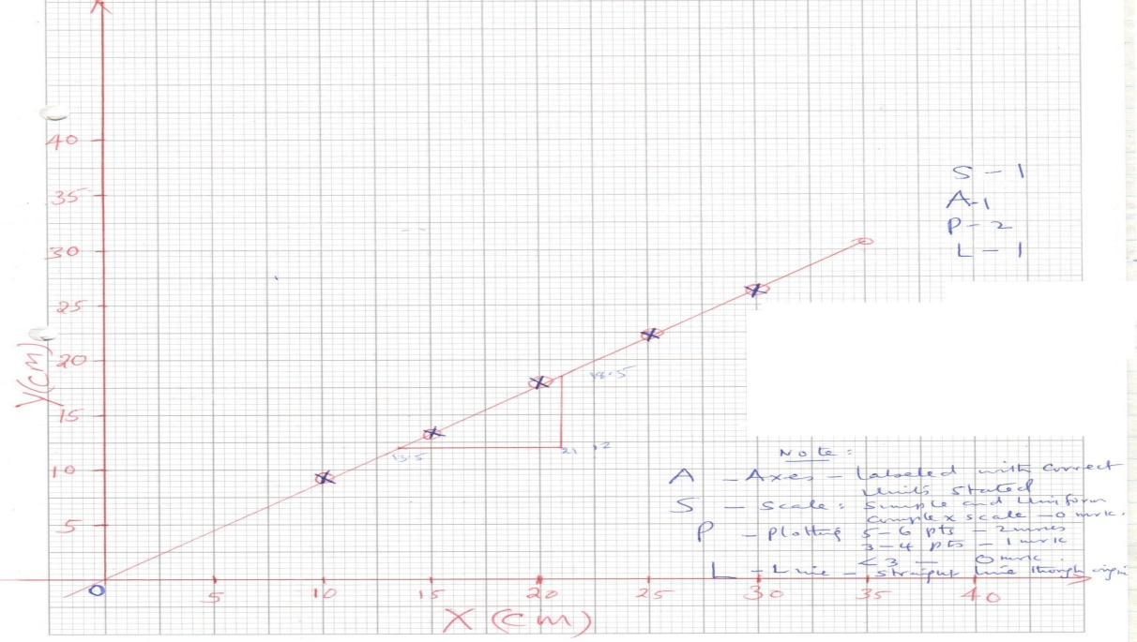

**NOTE:**

S – Scale: simple and uniform.

A – Axes: labeled with correct units.

P – Plotting: 4 – 5 points – 2mks

2 – 3 – 1mk

<2 – 0

L – Straight line through the origin.

1. N = DY = 18.5 – 12= 6.5

DX 21 – 13.5 7.5

= 0.8667✓1 (unit less) (3mks)

1. Given N = F/W where F – apparent weight of mass in salt solution.

W – Actual weight of mass in air.

N – Is the gradient.

1. F = WN but w = 0.1kg x 10N/Kg = 1N

= 0.8667 x 1

= 0.8667N = 0.87N✓1

(ii) U = W – F

= (1 – 0.8667) ✓1

= 0.133

~ 0.13N✓1

1. Up thrust = pvg

0.13 = p x 14 x 10-6 x 10

Rho p = 0.13✓1

14x10-6 x 10= 928.57Kg/m3✓1

**QUESTION 2**

**a)** i) Diameter of wire W. D = 0.36 × 10-3m✓1

ii)



Sub. 1 markCal. 1 mark

**b)**

|  |  |  |  |  |  |  |  |
| --- | --- | --- | --- | --- | --- | --- | --- |
| *l* (cm) | 10.0 | 20.0 | 30.0 | 40.0 | 50.0 | 70.0 | 80.0 |
| L (cm) | 91.0 | 81.0 | 73.0 | 65.5 | 60.0 | 55.0 | 46.5 |
|  | 0.01098 | 0.01234 | 0.01369 | 0.01526 | 0.01666 | 0.01818 | 0.02150 |

**N/B**

L (cm)**Mus**t be to 1 D.p for the candidate to earn 1mk (Trend decreasing- 2mks allow +/- 0.5cm)

**Must** be to 4 S. f if not deduct 1mk. Correct candidates’ values award (2marks)



c) Plot a graph of *l*cm against (5 marks)

 NOTE:

S – Scale: simple and uniform. 1mk

A – Axes: labeled with correct units. 1mk

P – Plotting: 4 – 5 points – 2mks

2 – 3 – 1mk

<2 – 0

L – Straight line cutting the X-axis at 0.94 × 10-2cm-1and Y-axis at -65.0cm1mk, if not award 0mks

d) From the graph find the slope S of your graph. (3 marks)





e) From the graph state the value of when *l* = 0 (1 mark)

*x* - Intercept = 0.94 × 10-2cm-1✓1 correct reading for x-intercept.



f) Given that find the value of J when R = 10. (2 marks)