LANJET CLUSTER JOINT EXAMINATION JULY/AUG - 2018
MARKING SCHEME
232/2
PHYSICS
PAPER 2
JULY/AUG 2018
SECTION 1
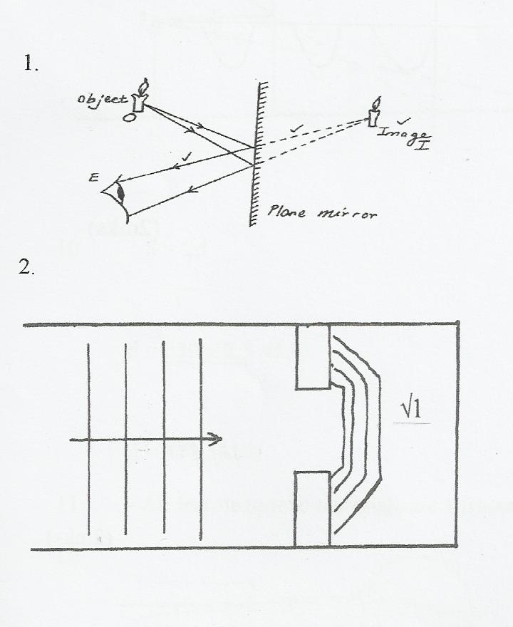
3. A will have a positive charge when charged rod is brought near metal A. positive charges are
attracted towards it while the negative charges are repelled.
4. Work function = hf_{o}
⇒ f_{o} = $\frac{W_{o}}{h}$
= $\frac{{6.8 x 10}^{-19}}{{6.63 x 10}^{-34}}$
= 1.03 x 10¹⁵ HZ
5. (a)
R
~

(1 Mark for correct directions)

(b)
+ Voltage (V) -

Time (Sec)

6. The image is diminished and upright.

7. (i) D – South pole;
A B
C D

(ii)

Correct field pattern;
Direction of field lines;
8.

9. f = 2HZ
T=1 = ½ = 0.5sec
f
t₃= ¾ x 0.5 = 0.375sec
10. The induced current flows in such a direction that produces magnetic effect that opposes the change producing it. (1mk)
11. a) A – zinc
B- Dilute sulphuric acid.

b) The bulb goes off because of a simple cell polarization and local action

12. In (a) the load is before the fuse so blowing out the fuse does not cut off power from the load . ie the load is still at a higher potential while in (b) the fuse is before the load so melting of the fuse disconnects the load from the power √1
13. x-rays → uv rays → red light→micro waves

SECTION II
14. (a) Using, $\frac{1}{f}$ = $\frac{1}{u}$ + $\frac{1}{V}$
Taking $\frac{1}{V}$ = 0
⇒ $\frac{1}{f}$ = $\frac{1}{u}$ = 0.06 Extrapolating the line to intercept the x and y axis.
f₁ = $\frac{1}{0.06}$
= 16.67cm
Taking $\frac{1}{u}$ = 0
⇒ $\frac{1}{f}$ = $\frac{1}{v}$ = 0.055
f₂ = $\frac{1}{0.055}$
= 18.18cm
f = $\frac{f_{1+ f_{2}}}{2}$ ⇒ $\frac{16.67+18.18}{2}$ = 17.43cm

(b) $\frac{1}{f}$ = $\frac{1}{u}$ + $\frac{1}{v}$
(i) $\frac{1}{20}$ = $\frac{1}{30}$ + $\frac{1}{V}$
⇒ v = $\frac{600}{10}$ = 60cm 2
⇒ Image is 60cm from the lens on the opposite side to that object.√
(ii) The image is real

(c ) E = 1²RT
= 13² x 8.5 x 1.5 x 60
= 1.293 x 10⁵J

- (i) Power consumed by five 60W bulb = 60 x 5 = 300W = 0.3Kw
        - Power consumed per day = 0.3 x 3.5 = 1.05Kwh

(ii) - Power consumed in 7 days = 1.05 x 7 = 7.35Kwh
Cost per week = No. of Kwh x cost per Kwh
= Ksh. 49.25

15 .(a) Measures both D.C and A.C (1mk)
Its accurate and does not take any current (1mk)
(b) Presence of magnetic coils (1mk)
Incoming signal from the aerial is fed into the grid
(c)i). Grid controls brightness of the spot (1mk)
ii). x-plates –horizontal displacement
-time base control (1mk)
iii). Identify the position of the electron beam (1mk)
(d) (i) To focus the electron beam produced onto the target.
(ii) To accelerate the electrons to give them enough K.E. to produce X-rays at the anode
(iii) To absorb stray X-rays.
(iv) To withstand the high temperature (immerse heat) preventing the target from melting since most of the K.E of the electrons is converted into heat .
16. (a) Radioactivity is the spontaneous disintegration of a nucleus releasing 1mk
alpha, beta and gamma radiations accompanied by the release of energy 1mk
(b) Radioactive substances are harmful to body cells when ingested 1mk
(c)
- It allows the radiation into the casing1
- The bromine gas causes quenching effect so that it reduces secondary ionisation.1
- The radiation enters through the mica window. It causes ionization1postive ions move to the cathode while negative ions move to the anode. A pulse current flows which is measured by scalar or ratemeter
(d) (i) Negative
(ii) A- Beta particles 1mk
B-Alpha particles 1mk
(iii) C more massive than A(1mk)
17. (a) Parallel 1 = 1 + 1 + 1
R 6 4 8

1 = 2 + 3 + 4
R 12

1 = 9
R 12

R = 4 = 1¹/₃Ω
R_{t} = 4 + 1¹/₃
= 5¹/₃Ω

V = IR

I = V = 4.5
R 5.33
= 0.844A
V = 4 x 0.844
= 3.377V

(b) (i) D = S X ½t
= 1450 x ½ x 0.20 s √
= 145m √
(ii) Depth from the water surface to the top of the reef
= 1450 x ½ x 0.16
= 1450 x 0.08
= 116m √
∴ Height of sunken reef = 145 - 116
= 29m√
(c) Np = Vp ;
Ns Vs

Vs = 240 x 20
400
= 12v
Is = V= 12;
R 50

= 0.24A;

- (a) (i) Dispersion of white light
(ii) X – Red
Y – Violet
(iii) Red has the lowest frequency/longest wavelength hence it is least deviated while violet has the highest frequency/short wavelength hence it is most deviated.
(iv) Acts as a point source of light.
(b) (i) _{a}n_{g} = $\frac{C}{V}$
= $\frac{{3.0 X 10}^{8}}{{1.8 X 10}^{8}}$
= 1.6667
(ii) Sin C = $\frac{1}{n}$
= $\frac{1}{1.667}$
C = Sin⁻¹0.5999
= 36.86

C
(
60⁰
r
θ

(iii) $\frac{Sin }{Sin r}$ = _{a}n_{g}
Sin θ = 1.6667 x Sin 31.2⁰
θ = Sin⁻¹ 0.8634
= 59.7⁰

19. (a) The measure of the amount of change a capacitor can store when connected to a given voltage or change stored per unit voltage
(b) The leaf falls. The sharp pin discharges the electroscope by concentration of charges at sharp points. Leading to leakage of charges.
(c) (i) Charge Q₁ on C₁ is given by
Q₁ = C₁V or Q₁ = C₁V
= 0.6μF x 4.5 = 0.6 x 10⁻⁶ x 4.5
= 2.7μC = 2.7 x 10⁻⁶C
(ii) C_{T} = C₁ + C₂
= (0.6 + 1.0) μF
= 1.6μF
= 1.6 x 10⁻⁶F

(iii) 4.5V, All the voltage drop is across C₁. No current through C₂.

Voltmeter reading p.d drops below 4.5; the charge on C₁ is distributed to C₂. Since the value of C₁ and C₂ remain constant, when Q on C₁ reduces, then Q₁ = C₁V implies V must reduce also, hence voltmeter reading.
(d) – Reduce the area of overlap for the plates
- Increase the distance between the plates

