Name………………………………………………… Index number………………………….…
Signature……………………………………..……… Date………………………………….……

232/2
PHYSICS
PAPER 2
JULY/AUGUST 2018
TIME: 2 HOURS

LANJET CLUSTER JOINT EXAMINATION 2018
Kenya Certificate of Secondary Education (K.C.S.E.)

232/2
PHYSICS
PAPER 2
TIME: 2 HOURS

INSTRUCTIONS TO THE CANDIDATES:
- Write your name and index number in the spaces provided above
- This paper consists of two sections A and B.
- Answer all questions in section A and B in the spaces provided.
- All working must be clearly shown in the spaces provided.
- Mathematical tables and non programmable silent electronic calculators may be used.

For Examiners’ Use Only

SECTION | QUESTION | MAXIMUM SCORE | CANDIDATE’S SCORE
A | 1-13 | 25
B | 14 | 12
 | 15 | 11
 | 16 | 11
 | 17 | 08
 | 18 | 11
 | 19 | 09
 | TOTAL | 80

This paper consists of 13 printed pages. Candidates should check to ascertain that all pages are printed as indicated and that no questions are missing.

SECTION A: (25 MARKS)
- Figure 1 below shows an object O placed in front of a plane mirror.

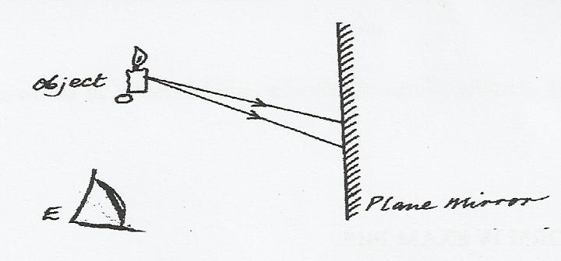
On the diagram, draw rays to locate the position of the image I, as seen from the eye, E. (2 marks)

- The figure 2 below water waves of different wave length incident on aperture which is greater than the wave length of the wave.

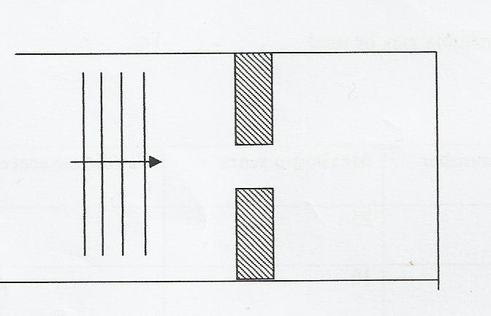
Complete the diagram to show the pattern of the wave beyond the aperture. (1 mark)

- Two identical metal spheres A and B each standing on an insulating base are in contact.
A negatively charged rod is brought near sphere A as shown in the figure 3 below.
A
B

In what way will sphere A differ from B if it is separated while the rod is near?
- A metal iron has work function of 6.8 x 10⁻¹⁹J. Calculate the minimum frequency of light that can cause photoelectric emission. (Take h = 6.63 x 10⁻³⁴ Js) (2 Marks)

- The figure 4 below shows a rectifier circuit for an alternating current input.
~
Input
R

(a) On the circuit, indicate the flow of current to illustrate rectification. (1 Mark)

(b) Sketch a graph to show how the voltage across R varies with time. (2mks)

- The image formed by a convex mirror is virtual. State two other characteristics of image formed by the convex mirror. (2 Marks)

- Figure 5 below shows a plotting compass placed between two strong magnets.
Fig. 5
C D
A B

- Give the polarity of the end D of the right hand magnet. (1mk)

- Draw on the diagram the resulting magnetic field pattern between B and C. (2mks)

- Figure 6 below shows a conductor in a uniform magnetic field carrying current in the direction shown.
Magnetic field
Conductor

Indicate on the diagram the direction of motion of the conductor. (1mk)
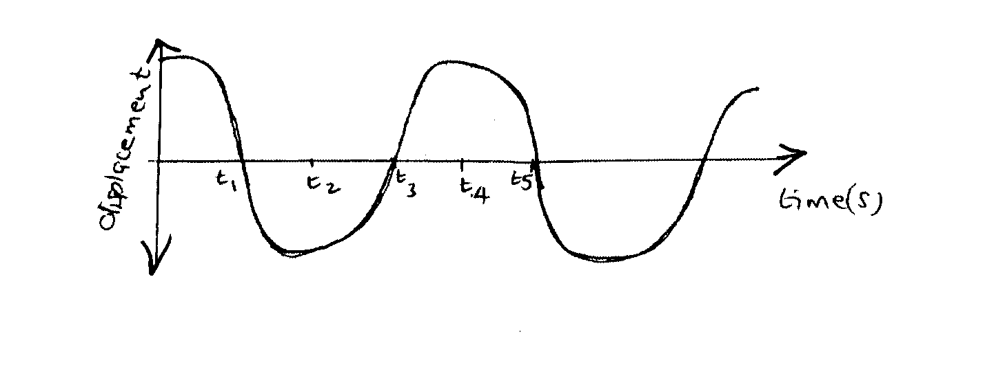
- The figure 7 below shows a wave profile for a wave whose frequency is 2HZ

Determine the value of t₃(s) (2mks)

10. State Lenz’s law of electromagnetic induction (1mk)

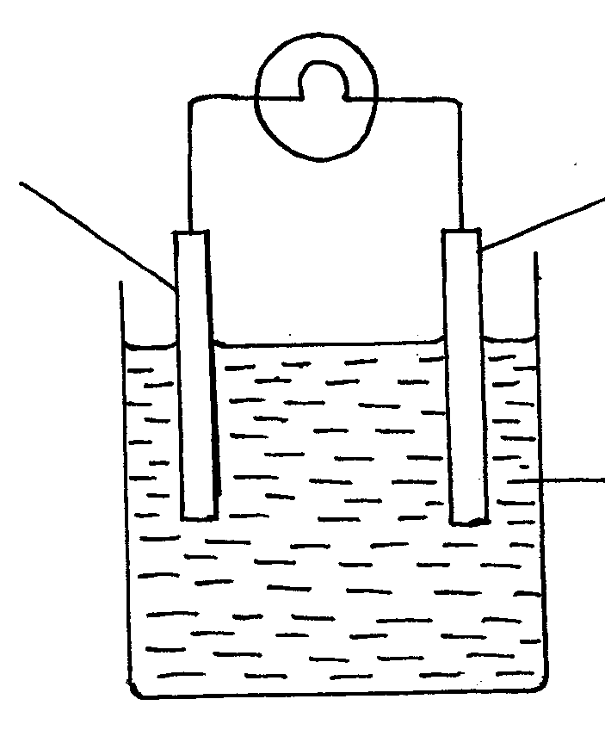
- The figure below 8 below shows a simple cell.
copper
A
I
B

Use the information on the figure to answer the questions below.
- Name the parts labeled A and electrolyte B. (2mks)
A

B

- It is observed that the bulb goes off after a short time. Explain this observation (1mk)

- The figure 9 below shows how a fuse may be connected in electric current
Load
L
(a)
(b)
Fuse
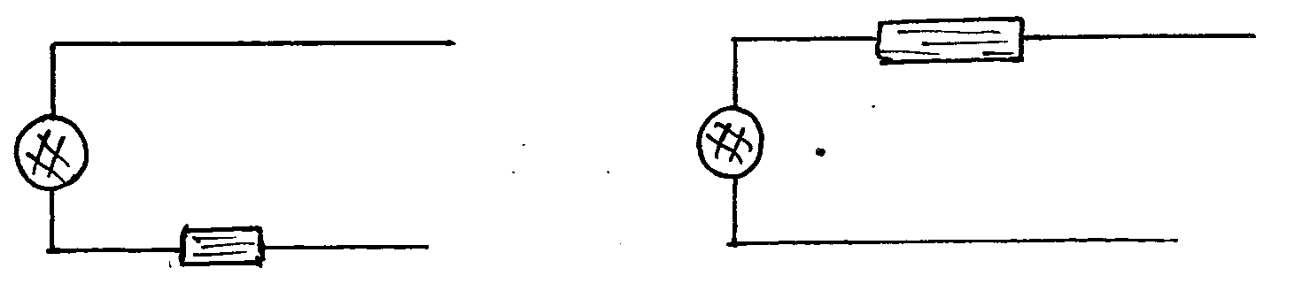
L
Fuse
N
N
Load

In either case the fuse blows out but (a) is dangerous while (b) is not. Explain (2mks)

- The figure shows part of electromagnetic spectrum

Ultra violet rays | Micro waves | X-rays | Red light

Arrange the electromagnetic waves in the order of decreasing energy. (1mk)

SECTION II: (55 MARKS)
ANSWER ALL QUESTIONS IN THIS SECTION
14. (a) The graph below shows values obtained in an experiment to determine the focal length of a convex lens. Use the graph to determine the focal-length of the lens.(2mks)

GRAPH OF $\frac{I}{u}$ AGAINST $\frac{I}{V}$

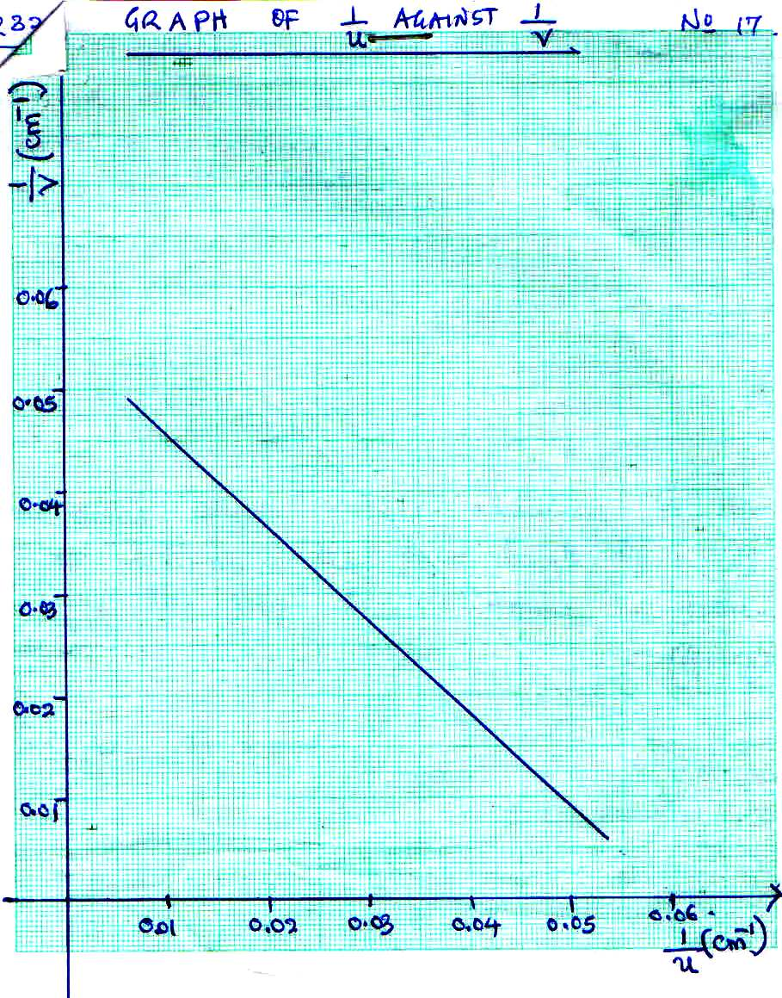
(b) An object is placed 30cm in front of a converging lens of focal length 20cm.
(i) By calculation determine the position of the image. (2 mks)

(ii) State the nature of the image (1 mk)

(c) A current of 13A flows through a heating element of resistance 8.5Ω for 1.5 minutes. Calculate the quantity of heat supplied. (3mks)

- A house has five rooms with 240V, 60W bulbs. If the bulbs are switched on from 7.00p.m. to 10.30p.m.
  - Calculate the power consumed per day in Kilowatt-hours. (2mks)

  - Find the cost per week for lighting these rooms at Kshs. 6.70 per unit. (2mks)

15. (a) State two advantages of a C.R.O as a voltmeter (2mks)
(i)
(ii)
(b) A television tube is a cathode ray tube modified. State two modifications (2mks)
(i)
(ii)
(c) State the functions of the following parts of a C.R.O (3 mks)
(i) Grid

(ii) X-plates

(iii) Fluorescent screen

(d) Figure15 shows the parts of an x-ray tube.
Figure 15

a) Explain why:
i) The cathode is concave shaped (1mk)

ii) A high potential difference is applied between the cathode and the anode (1mk)

iii) Most of the tube is surrounded by lead. (1mk)

iv) The target of X-ray tube is made of metals of high melting point. (1mk)

16. (a) Define Radio-activity (2mks)

(b) When carrying out experiments with radioactive substances the source should never be held with bare
hands but with forceps. Explain? (1mk)

- The figure below shows a G.M tube.

Argon gas mixed
with little bromine
Mica window
Anode
Aluminum casing
Scalar or ratemetre

- What is the purpose of the mica window? (1mark)

- What is the purpose of the bromine (1mark)

- Briefly explain how it works. (2marks)

(e) The diagram in the figure below shows paths taken by three radiations A,B and C from a radioactive
isotope through an electric field.
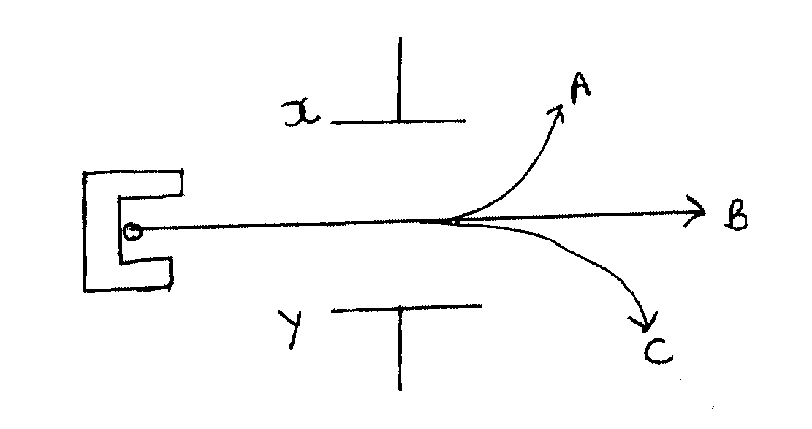
X
A
B
C
Y

(i) State the charge on plate Y (1mk)

(ii) Identify the radiations A and C (2mks)

(iii) Give a reason why C deviates more than A (1mk)

- (a) Study the circuit diagram below and answer the questions that follow.
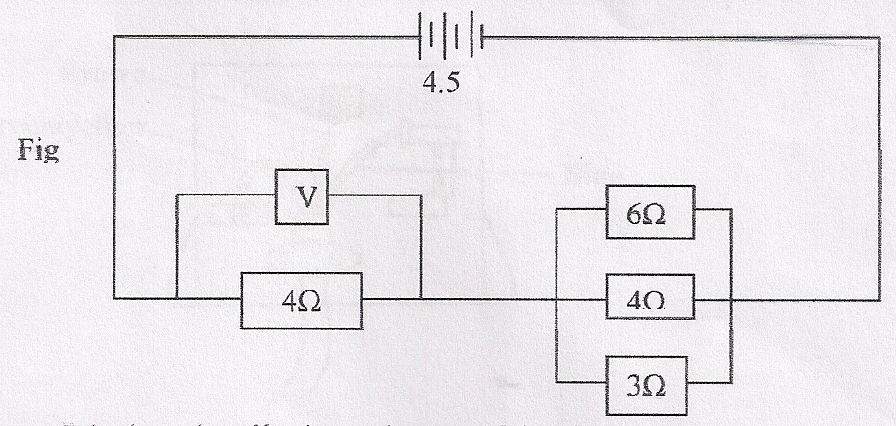
Calculate the effective resistance of the circuit and hence the voltmeter reading (4mks)

(b)An echo sounder of a ship received the reflected waves from a sea bed after 0.20s.
(i)Determine the depth of the sea bed if the velocity of sound in water is 1450m/s (2mks)

(ii)When the ship above passes over a sunken reef, the echo sounder receives an echo after 0.16s. Determine the height of the sunken reef (2mks)

(c) A step-down transformer has 400 turns in the primary coil and 20 turns in the secondary coil. A 50Ω resistor is connected to the secondary output. If the effective primary voltage is 240v, determine the current through the 50 Ω resistors. (3mks)

18 (a) The diagram below shows a narrow beam of white light onto a glass prism.
X
Y

(i) What is the name of the phenomenon represented in the diagram? (1 mk)

(ii) Name the colour at X and Y (1 mk)

(iv) What is the purpose of the slit (1 mk)

(b) The figure below shows the path of ray of yellow light through a glass prism. The speed of
yellow light in the prism is 1.8 x 10⁸ m/s
(
60⁰
r
Ɵ

(i) Determine the refractive index of the prism material (Speed of light in vacuum, C = 3.0 x 10⁸ m/s) (2 mks)

(ii) Show on the same diagram, the critical angle C and hence determine its value. (3 mks)

(iii) Give that r = 31.2⁰ determine the angle θ (3 mks)

- (a) Define capacitance (1 mk)

(b) In the figure below, a sharp pin is fixed on a cap of a leaf of the electroscope. The electroscope is highly charged and then left for some time.

Sharp pin
Charged electroscope

State and explain the observation made after sometime (2 mks)

(c) The figure below shows a circuit where a battery of e.m.f. 4.5V, switches A and B, two capacitors C₁ =0.6μF and C₂ = 1.0μF and a voltmeter are connected.
4.5 V
V
A
B
C₁ = 0.6μF
C₂ = 1.0μF

- Determine the charge on C₁ when both switch A is closed and switch B is open.(2 mks)

(ii) What is the effective capacitance when both switches are closed? (2 mks)

(d) State two ways in which the capacitance of a parallel plate capacitor can be reduced.(2 mks)

