K.C.S.E 1995 PAPER 1 MARKING SCHEME

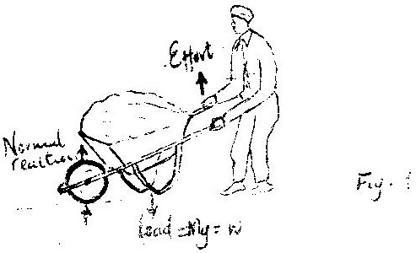
- Micrometer screw gauge

- Effort would reduce
- Flow from a to B
- Pressure difference between liquids in A and B is P = egh where e is liquid, g = acceleration due to gravity and h is height
But force = P x cross section area of siphon, P = F/A
Thus F = egh A Since e.g. A are constants
Fα h
- No change in flow OR the flow will still continue
- Oil spread until it is one molecule thick or film taken as a perfect circle or oil drop has been taken as perfect sphere/ cylinder/ uniform thickness
- The liquid expand uniformly, expansion is measurable ( large enough), thermal conductivity
- Rectilinear propagation/ light travels in a straight line
- Water/ or glass are poor conductor of heat
- Each material is brought in turn to touch the cap. The conductor will discharge the electroscope while the insulator will not ( accept bring near conductor gauge)
- Can be short – circuited without being destroyed
  - Longer life/ electrolyte never need attention
  - Can stay discharged without being destroyed
  - Can be charged with large currents faster charging
  - More rugged/ not damaged by rough condition of use/ robus
  - Delivers large current, light
- Surface tension / adhesive forces supports water column or more capillarity in tube 2 than tube 1
  - Surface tension is the same in both tubes and equal to the weight of water column supported
  - Narrow tube has longer column to equate weight to wider tube
  - Volume of water in the tubes is same hence narrower tube higher column

- – Length of conductor in the field
- Angle between conductor and fields
- All ferromagnetic materials are attracted by magnets or any magnetic materials is attracted
- – increasing the tension
- Reducing the length
- At equilibrium sum of clockwise moment = sum of anti – clockwise moments
Clockwise moments = P x X = QY
Px = Qy
- h glass = V air / V glass 1.5 = 3 x 10⁸ √ g
Vg = 3 x 10⁸ / 1.5 = 2 x 10⁸ ms⁻¹
- V = f λ sine V is constant reducing f to 1/3 ⇒ λ increases 3 fold
- While light is composed of seven colour different/ many colour. For each colour glass had different value of refractive index/ different velocities of different λ. So each colour is deviated differently causing dispersion

- A body at rest or in state of uniform motion tends to stay in that state unless an unbalanced force acts on it.

- Heat capacity is quantity of heat required to raise the temperature of the body by 1 k or 1 ⁰C while, specific heat capacity is quantity of heat required to raise temperature of unit mass of body by 1 k/ 1⁰ C.

- (If x ≠z but both above y give 1 mk. Accept difference of 1.0 mark)
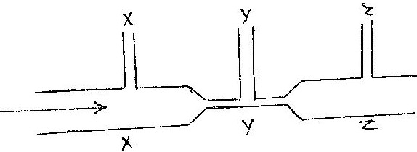

hX = hZ > hY

- – Reducing - Increasing

- Polarization

Type of radiation | Detector | Uses
Ultra violet | Photographic paper fluorescence material | Cause ionization kills bacteria OR operating photosular cells photography
Infrared | Phototransistor blackened thermometer | Warmth sensation
Radio waves | Radio receiver or TV receiver | Communication

- E₂ = E₁ + h f i or E₂ – E₁= h = c/λ
h= plank constant
c- Velocity of light
λ- Wave length of light

- – Lead - Very dense/ has high atomatic mass
- Extrapolation on graph ( line to touch frequency)
Reading on graph to (4.0 + - 0.2) x 10¹⁴Hz
- Lines parallel to the one shown but cutting of axis further in
- Quality / Timbre
- X = 14
- The point where the weight of the body acts
- Temperature of source be the same
- Length of rods be the same / wax
- Amount of wax (detector) be the same
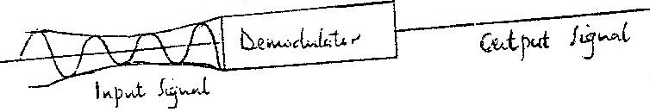

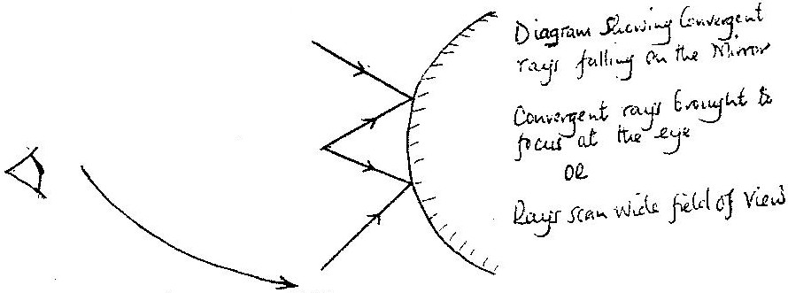

K.C.S.E 1995 PHYSICS PAPER 232/2 MARKING SCHEMES
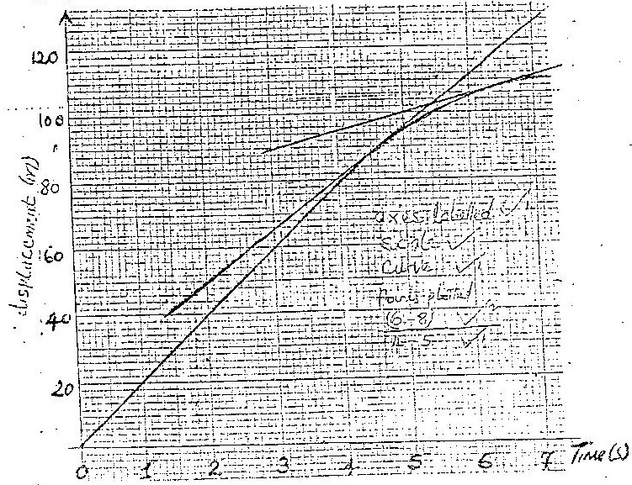
1. (a)

(b) Constant Vel⁰ Uniform vet - zero accl^{n}

(c) √4.5 = 118 – 50 = 15m/s 15.5 + -1.5 ( 14-17)
6.5-2
√ 6.5 = 112 – 70 = 6 m/s (4=6)
7
Average accln = ∆v = v – 11 = ( 6-15)
t t 2
= - 4.5 m/s²

2. l = 7 + l + l
R_{C} R₁ R₂ R₃

= 1 + 1 + 1
6 + 3 6
= 1
6
R_{C} = 6 = 1.5 Ω
4

(b) Total resistance = 1.5 + 2.5 = 4 Ω
E = 1(YFR) Or l = V
R
2 = Ll
Current through xy l = 0.5 A
P.d across yz = 0.5 x 1.5 V
s= current through 3 Ω = 0.5 x 1.5 = 0.25 A
3

(c) R = /L A
I = RA = 6 x 5.0 x 10⁻⁶ Ωm²
L 1.0 m
= 3.0 x 10⁻⁵Ω m

3. (a)
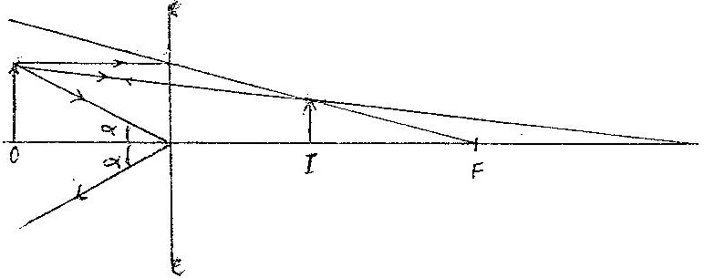

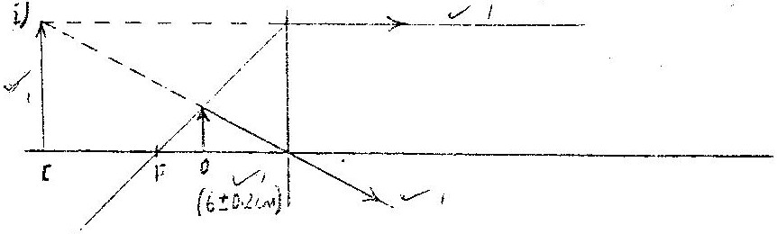

(ii) Magnification = V Isign = 1.1 OR 1.75
u Osign 1.6 2.5 = 0.7 ± 0.05

- l = l + l l = 10
f u v u 60

l = l + l u = 6cm
10 u v

l = l + l Objects is 6 cm from the lens
U 10 15

4 (a) Lens symbol object between f & F 2 appropriate rays position of image
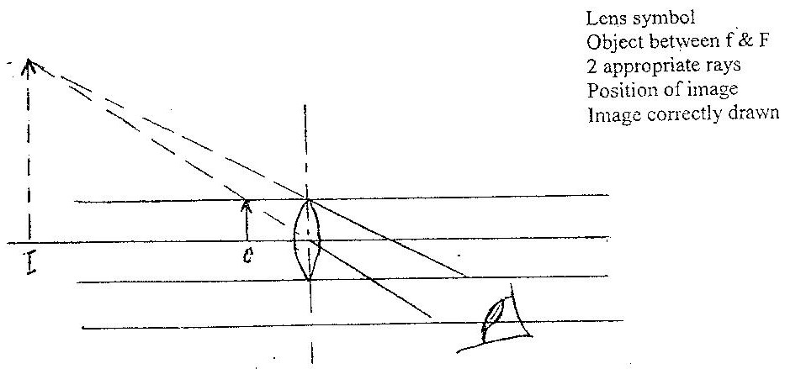
Image correctly drawn

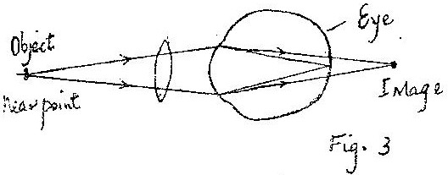
The diagram in figure 3 shows a certain eye defect

(b) (i) Name of defect is long sightedness
(Refer to the diagram in the figure 3 above)
(c) (i) For water not to pour weight of the water must be less centrifugal force OR for water to pour out MV² > mg
r
(ii) Frictional force F = Centripetal force
MV² = 1200 x (25)²
R 150
= 5.0 x 10³N
5. (a) (i) The magnitude of the induced e.m.f is directly proportional to the rate at which the conductor cuts the magnetic field lines
The induced current flows in such a direction as to oppose the changes producing it.

(ii) Plugging a magnetic into a coil
- in speed its g twins as straight of magnetic field
- Results in an increased in the induced e.m.f
(b) (i) Energy is neither created nor destroyed
Make power constant
VU = Joules ( ½ ) current = charge ( ½ )
Count time
P = IV
For large V, 1 must lower for power input to be equal to power output

(ii) Vs - Vp OR Vs - Na
Ns Vp Vp NP

Ns = Vs x Np = 9 x 480
Vp 240 Ns = 18

SECTION II
6. (a ) Progressive wave- Wave profile moves along with the speed of the wave
Stationary wave – wave profile appears static

Progressive wave – Phase of points adjacent to each other is different
Stationary wave – All points between successive node vibrate in phase

Progressive wave – Energy translation in the direction of the wave travels
Stationary wave- No translation of energy but energy associated in the wave

(b) (i) A glass slide i.e. blackened with soot or paint lines are drawn close together using
a razor blade or pin.

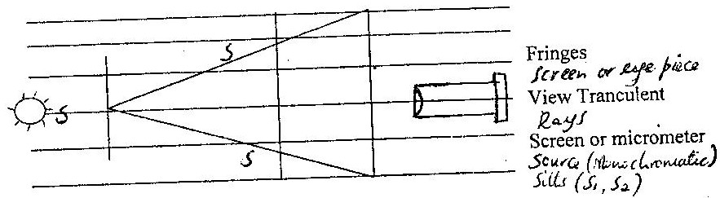
(ii) Path differences equals to an odd number of half wavelengths or completely out of phase ( 180⁰)

(iii) Photometer / photocell or thermometer with a bulb
7. (a) Common or sillen ( semiconductor) is doped with impurity atoms which trivalent ( e.g boron or indium) intensity in currency on pole group 4 doped with trivalent
(b) p-n-p emitter and carries made of p type material are of n- type material for charge carries holes
- n – p – n – emitter and collector made of n- type material are made of p- type ( or charge carries electrons)
(c) At the middle of the reaction of a curve a tangent is drawn change on output (∆V₀) is determined and a corresponding change input ( ∆V₁) also attained change amplification.
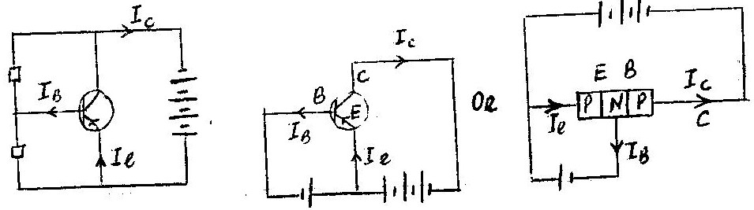
(d) (i)

(ii) i₂ = l_{C} r l_{B}
(e) Base – emitter – forward biased Base collector – reversed biased

