TERM TWO EXAMINATIONS YEAR 2020
FORM TWO BIOLOGY
NAME……………………………………………………………..………………………ADM………….CLASS…………….
1. a) Name the fluid that is produced by sebaceous glands. (1 mark)

................................................................................................................................................................... b) Explain the importance of sweat on the human skin. (1 mark)
...................................................................................................................................................................

2.a)Name one disease of the circulatory system in humans (1mk)
...................................................................................................................................................................

b)Explain ways in which carbon (IV) oxide is transported in the mammalian blood(3mks)
...................................................................................................................................................................
...................................................................................................................................................................
...................................................................................................................................................................
3. An experiment was set up as shown in the diagram below.

Visking Tubing Starch solution

Iodine solution

The set up was left was 30 minutes.

- State the expected results from the starch solution. (1 mark)
...................................................................................................................................................................
b)Explain the observation made
...................................................................................................................................................................

...................................................................................................................................................................

...................................................................................................................................................................

...................................................................................................................................................................

4.C6 H12O6 + 6O2 → 6CO2 + 6H2O + 36 ATP
a) Identify the type of respiration illustrated in the equation above. (1 mark)
...................................................................................................................................................................
b) Explain why lactic acid was not produced in the reaction illustrated in the equation above.
(2 marks)
...................................................................................................................................................................

...................................................................................................................................................................

...................................................................................................................................................................

5. a) State the function of co-factors in the cell metabolism (1 mark)

................................................................................................................................................................... b) Give an example of a metallic co-factor. (1 mark)
................................................................................................................................................................... c) Give a reason why lack of roughage in the diet often leads to constipation. (1 mark)
...................................................................................................................................................................

...................................................................................................................................................................

6. State the form in which carbohydrates are stored in

i) Plants. (1 mark)

................................................................................................................................................................... ii) Animals (1 mark)
...................................................................................................................................................................
7.Define translocation (1mk)
…………………………………………………………………………………………………………………………………………………………………………………………………………………………………………………………………………………………
b)Name the vessel in which translocation occurs in plants (1mks) …………………………………………
c)Name any two materials translocated in plants (2mks)
…………………………………………………………………………………………………………………………………………………………………………………………………………………………………………………………………………………………
8.State three roles of active transport (3mks)
…………………………………………………………………………………………………………………………………………………………………………………………………………………………………………………………………………………………
……………………………………………………………………………………………………………………………………………
9.In an experiment, a leafy shoot was cut and placed in a beaker containing a red dye. After an hour the leaves started turning red. Explain (2mks)
………………………………………………………………………………………………………………………………………………………………………………………………………………………………………………………………………………………………………………………………………………………………………………………………………………………………………
……………………………………………………………………………………………………………………………………………
10.a)Explain why protein is absent in urine (1mk)
…………………………………………………………………………………………………………………………………………………………………………………………………………………………………………………………………………………………
b)Explain why insulin tablets cannot be administered orally (1mk)
…………………………………………………………………………………………………………………………………………………………………………………………………………………………………………………………………………………………
11.A certain animal has no incisors, no canines, 6 premolars and 6 molars in its upper jaw. In the lower jaw there are 6 incisors, 2 canines, 6 premolars and 6 molars
i)Write its dental formula (2mks)

ii)Identify the mode of feeding of the above animal (1mk)
……………………………………………………………………………………………………………………………………………
iii)Explain your answer in 6 (ii) above (2mks)
…………………………………………………………………………………………………………………………………………………………………………………………………………………………………………………………………………………………
12.Below is a summary of blood clotting in man (4mks)
prothrombin
Blood cells K

thromboplastin
Blood protein w
Metal ion X

Substance F
fibrinogen

a)Identify blood cell K …………………………………………………………………………………………………….
ii)Blood protein W ……………………………………………………………………………………………………….
iii)Metal ion X ………………………………………………………………………………………………………
b)Identify product F and its significance
………………………………………………………………………………………………………………………………………………………………………………………………………………………………………………………….……………………………………………………
………………………………………………………………………………………………………………………………………………………
13. (i) Name the type of immunity developed by the body when one is vaccinated against a certain disease (1mk) ………………………………………………………………………………………………………………………………………………
……………………………………………………………………………………………………………………………………………
ii)Name the blood groups of a person whose blood plasma has antibody b (2mks)
……………………………………………………………………………………………………………………………………………
iii)State the role of thrombin in blood clotting (1mk)
……………………………………………………………………………………………………………………………………………………………………………………………………………………………………………..………………………………………………………………
14.a)Define respiration (1mk)
…………………………………………………………………………………………………………………………………………………………………………………………………………………………………………..…………………………………………………………………
b)Study the equation below. Identify the process represented below (1mk)
C₆H₁₂O₆ 2C₂H₅OH +CO₂ + 210KJ
………………………………………………………………………………………………………………………………………………………………………………………………………………………………………………………………………………………………………………
c)Name an organism this process may occur (1mk)………………………………………………………………………….
d)Identify the food substrate of whose respiratory quotient (RQ) was found to be 0.7 (1mk)
……………………………………………………………………………………………………………………………………………
15.State the functions of the following hormones
a)Antidiuretic hormone (2mks)
…………………………………………………………………………………………………………………………………………………………………………………………………………………….…………………………………………………………………………………………

b)Glucagon (2mks)
…………………………………………………………………………………………………………………………………………………………………………………………………………………………..…………………………………………………………………………………
16.State the structural modifications of the nephrons of desert mammals (3mks)
…………………………………………………………………………………………………………………………………………………………………………………………………………….…………………………………………………………………………………………………
17.State two difference between:-
i)The composition of blood between hepatic portal vein and hepatic vein (2mks)
Hepatic portal vein | Hepatic vein

18. A form three student carried out an experimental set up as shown below. Bromolthymol blue (BTB) is sensitive to pH change (bromoltymol is yellow is low pH )

leaf

indicator
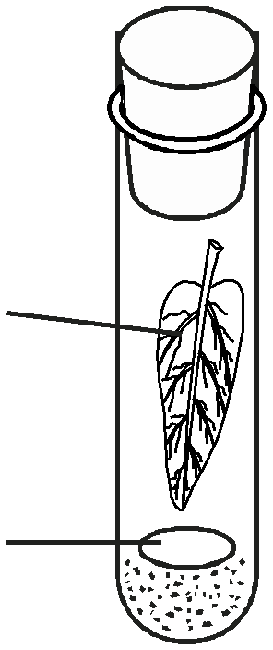

leaf

indicator
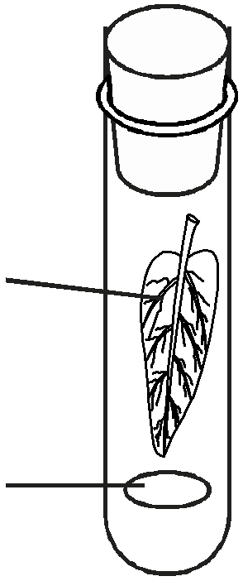

Set up A : Boiling tube covered with aluminium foil. Set up B

a) What was the aim of his experiment? (1 mark)

....................................................................................................................................................................

.................................................................................................................................................................... b) Why was set up B included in this experiment? (1 mark)
....................................................................................................................................................................

....................................................................................................................................................................

c) Why was aluminium foil used in this experiment? (1 mark)

....................................................................................................................................................................

....................................................................................................................................................................

d) Explain why BTB changed it colour from blue to yellow in tube A after 30 minutes. (2 marks)
...................................................................................................................................................................

....................................................................................................................................................................

19. The diagram below shows a part of a plant tissue.

Z

X
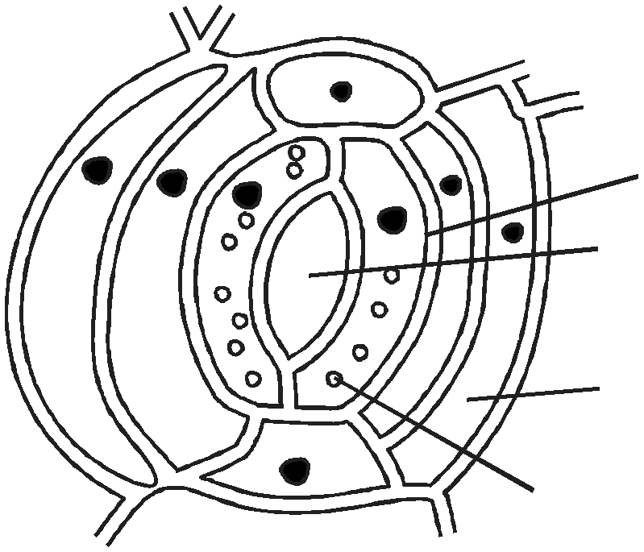

X ................................................................................................................................................ (1 mark) Y .................................................................................................................................................(1 mark) Z .................................................................................................................................................(1 mark)
20. a) Distinguish between transpiration and guttation. (2 marks)

...................................................................................................................................................................

...................................................................................................................................................................

...................................................................................................................................................................

b) The diagrams below shows two types of patterns of lignification in xylem vessels.
Figure 1 Figure 2

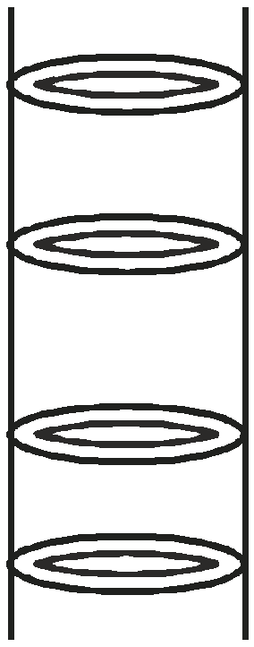

Name the pattern in
Figure 1 .................................................................................... (1 mark)

Figure 2 ................................................................................... (1 mark)

21. In an experiment to measure gaseous exchange between flying locust and its surrounding it was found that for every 1cm3 of carbon (IV) oxide, 1.43cm3 of oxygen was consumed.
i) Calculate the respiratory quotient forthe food substance that was being oxidised. (2 marks)

...................................................................................................................................................................

...................................................................................................................................................................

...................................................................................................................................................................

...................................................................................................................................................................

................................................................................................................................................................... ii) State the importance of respiratory quotient. (2 marks)
...................................................................................................................................................................

...................................................................................................................................................................

...................................................................................................................................................................

