TERM TWO EXAMINATIONS YEAR 2020
FORM THREE BIOLOGY PAPER ONE
NAME……………………………………………………………..………………………ADM………….CLASS…………….
1. State the importance of the following processes to living organisms.

a) Locomotion. (1 mark)

................................................................................................................................................................... b) Irritability (1 mark)
...................................................................................................................................................................

2. Distinguish between taxon and taxonomy. (2 marks)

...................................................................................................................................................................

...................................................................................................................................................................

...................................................................................................................................................................

3. a) State the functions of the following organelles.

i) Centriole (1 mark)

................................................................................................................................................................... ii) Nucleolus. (1 mark)
...................................................................................................................................................................

b) A form one student trying to estimate the size of onion cells observed the following on the microscope field of a view.

i) Define the term resolving power. (1 mark)
..................................................................................................................................................................
ii) If the student counted 20 cells across the field of view, calculate the size of one cell in
micrometers. (2 marks)

...................................................................................................................................................................

...................................................................................................................................................................

...................................................................................................................................................................

...................................................................................................................................................................
4. A potato cylinder measuring 100 mm was placed in a concentrated salt solution for 30 minutes.
Describe its texture and appearance after 30 minutes. (3 marks)

...................................................................................................................................................................

...................................................................................................................................................................

...................................................................................................................................................................

5. Explain why a cross-circuit athlete pants heavily after sprint race. (3 marks)
...................................................................................................................................................................

...................................................................................................................................................................

...................................................................................................................................................................

...................................................................................................................................................................
6. a) Name a respiratory substrate usually available for energy release during starvation. (1 mark)

................................................................................................................................................................... b) What is respiratory quotient. (1 mark)
...................................................................................................................................................................

...................................................................................................................................................................

7. a) Give the difference between pyramid of biomass and pyramid of numbers. (2 marks)

...................................................................................................................................................................

...................................................................................................................................................................

...................................................................................................................................................................
b) Why is pyramid of biomass a better method of representing ecological relationships in habitats.
(1 mark)
...................................................................................................................................................................

...................................................................................................................................................................

8.a) How does each of the following structures in the mammalian skin adapted to perform its function?

i) Cornified layer.(1 mark)…………………………………………………………………………….

................................................................................................................................................................... ii) Sebaceous gland. (1 mark)…………………………………………………………………………...
................................................................................................................................................................... b) Explain why protein is absent in urine of a normal person. (1 mark)
...................................................................................................................................................................
9.Give a reason for each of the following:

a) Wind pollinated flowers produce large quantities of pollen grains. (1 mark)

...................................................................................................................................................................

................................................................................................................................................................... b) Flowers of certain plants show heterostyly. (1 mark)
...................................................................................................................................................................

...................................................................................................................................................................
10. The set-up below shows an experiment to investigate photosynthesis.

Gas collected

water containing
sodium hydrogen
carbonate

Aquatic plants

At start of experiement After the Experiment

a) What gas was collected in the test-tube. (1 mark)

................................................................................................................................................................... b) What two environmental conditions are necessary for the experiment? (2 marks)
...................................................................................................................................................................

................................................................................................................................................................... c) What was the role of sodium hydrogen carbonate in the experiment. (1 mark)
...................................................................................................................................................................

11.State THREE ways in which schistosoma species is adapted to parasitic mode of life. (3 marks)

...................................................................................................................................................................

...................................................................................................................................................................

...................................................................................................................................................................
12.In an experiment, two equal volumes of solutions L and M were placed into visking tubings. The two viskig tubings were suspended as shown below.

Solution
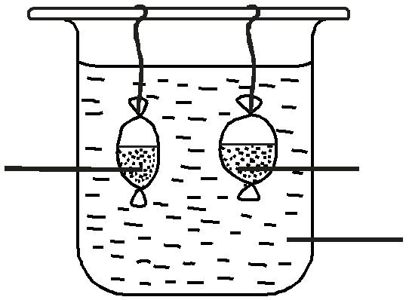

M
Solution L Solution M Solution K
start of experiement End of the Experiment
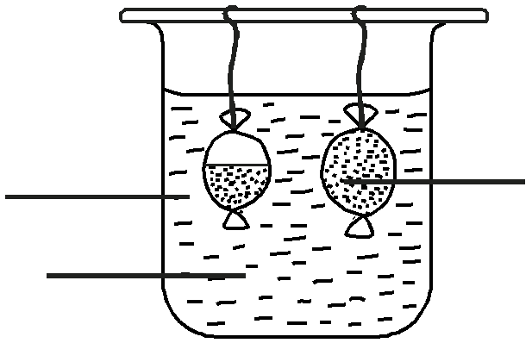

Explain the results that were obtained in the visking tubings at the end of the experiment. (4 marks)

...................................................................................................................................................................

...................................................................................................................................................................

...................................................................................................................................................................

...................................................................................................................................................................

...................................................................................................................................................................

...................................................................................................................................................................

13.Give a reason why primary productivity in an aquatic ecosystem decrease with depth. (1 mark)

...................................................................................................................................................................

..................................................................................................................................................................
14a).Name one components of blood that are not present in the glomerular filtrate.(1mks)………………………………………………………………………………………
b)Explain why insulin tablets cannot be administered orally (1mk)
…………………………………………………………………………………………………………………………………………………………………………………………………………………………………………………………………………………………

15. Explain what happens when diaphragm muscles contract during breathing in mammals. (3 marks)

...................................................................................................................................................................

...................................................................................................................................................................

...................................................................................................................................................................

...................................................................................................................................................................

...................................................................................................................................................................

16. Give two reasons why potato tubers become sweeter after boiling. (2 marks)
...................................................................................................................................................................

...................................................................................................................................................................

...................................................................................................................................................................

17.Give two adaptive features the make a predator efficient in capturing prey. (2 marks)

...................................................................................................................................................................

...................................................................................................................................................................

...................................................................................................................................................................

18.List three ways in which the proximal convoluted tubule is adapted to its functions. (3 marks)

...................................................................................................................................................................

...................................................................................................................................................................

...................................................................................................................................................................

19.Briefly explain the meaning of the following terms as used in ecology. (3 marks)

i) Carrying capacity

……………………...................................................................................................................................

................................................................................................................................................................... ii) Habitat
…………...................................................................................................................................................

................................................................................................................................................................... iii)Community
………………..........................................................................................................................................

...................................................................................................................................................................

20.The diagram below represents a bacterium cell.
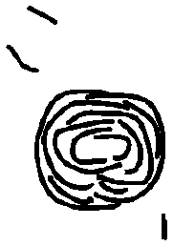

a) Name the kingdom to which the bacterium belong. (1 mark)

.................................................................................................................................................................... b) State two distinguishing characteristics of the members of the kingdom named above. (2 marks)
....................................................................................................................................................................

....................................................................................................................................................................

....................................................................................................................................................................

....................................................................................................................................................................

21 a) Name one element found in proteins but not not in carbohydrates. (1 mark)

....................................................................................................................................................................

.................................................................................................................................................................... b) State TWO functional roles of proteins in the body. (2 marks)
....................................................................................................................................................................

....................................................................................................................................................................

22.The diagram below shows a type of epithelial tissue.
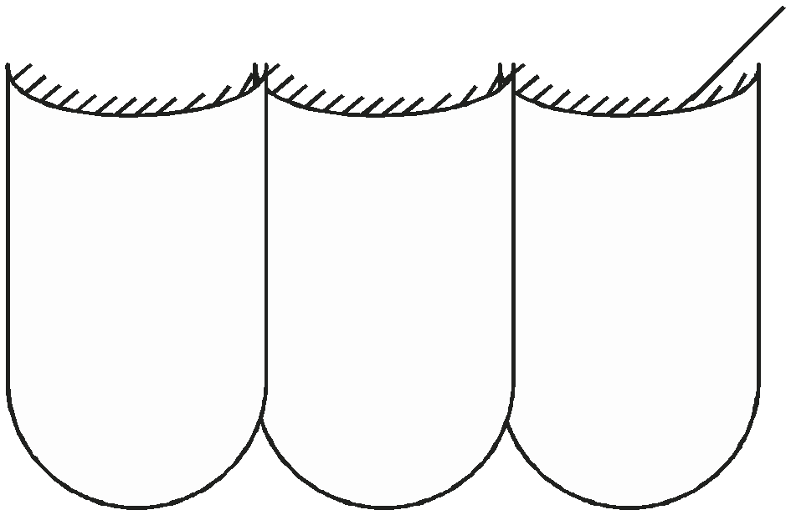

Hair-like processes

a) State the possible functions of the hair-like processes on the tissue. (1 mark)

....................................................................................................................................................................

.................................................................................................................................................................... b) Name two mammalian organs where this type of epithelium is found. (2 marks)
....................................................................................................................................................................
....................................................................................................................................................................

23 a) In which phase of photosynthesis are carbohydrates formed? (1 mark)

....................................................................................................................................................................

.................................................................................................................................................................... b) Explain the biological disadvantage of growing some aesthetic plants in the living rooms.(2 marks)
....................................................................................................................................................................

....................................................................................................................................................................

....................................................................................................................................................................

....................................................................................................................................................................

24. A certain organ K was surgically removed from a rat. It was later found that there was a drastic increase in glucose level in the blood. When substance Q was injected into the animal the glucose in the blood went back to normal. Identify

i) Organ K (1 mark)

.................................................................................................................................................................... ii) Substance Q. (1 mark)
....................................................................................................................................................................

25.The table represents certain aspects of the circulatory system in certain animals. Fill in the missing spaces. (3 marks)
Heart | No. of atrium | No. of ventricles | Type of circulation
A | 2 | 2
B | 2 | 1
C | 1 | 1

26.What is the importance of a pooter to an ecologist? (1 mark)

....................................................................................................................................................................
....................................................................................................................................................................

27.The red blood cells lack mitochondria.

a) How is this advantages to red blood cells? (1 mark)

....................................................................................................................................................................

.................................................................................................................................................................... b) Apart from the reason stated above, give one other reason. (1 mark)
....................................................................................................................................................................

.................................................................................................................................................................... c) State two other characteristics of the red blood cell. (2 marks)
....................................................................................................................................................................

....................................................................................................................................................................

....................................................................................................................................................................

28.Two glucose molecules combine to form the disaccharide sucrose. The moleculer formula of glucose is C6H12O6 while a single sucrose molecule has the molecular formula C12H22O11. Account for the observation. (3 marks)

....................................................................................................................................................................

....................................................................................................................................................................

....................................................................................................................................................................

....................................................................................................................................................................

29. Below is a stage in cell division
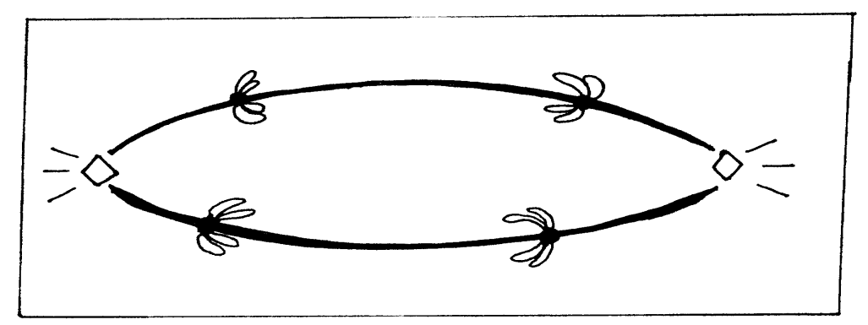

(a) Identify the stage (1mk)

(b)Give reasons for your answer (2mks)

