TERM TWO EXAMINATIONS YEAR 2020
FORM THREE BIOLOGY PAPER TWO
NAME……………………………………………………ADM………….CLASS…………….
1. In a class experiment to establish the size of an onion cell, a leaner observed the following on the microscope field of view.
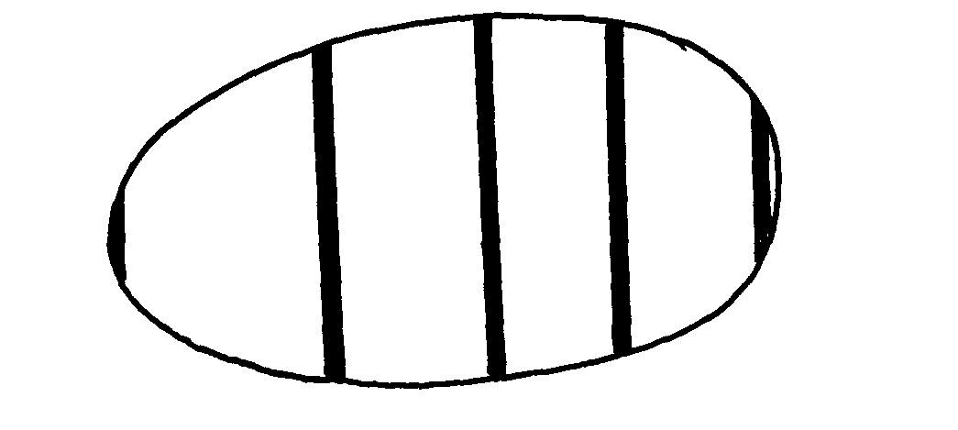
If the student counted 20 cells across the diameter of this field of view, calculate the size of one cell in micrometers. (3 marks)

b) Identify the structures of the cells that perform the following functions:- (3 marks)
(i) synthesize ribosomes………………………………………………………………………………………….
(ii) regulate exchange of substances in and out of the nucleus………………………………………………
(iii) osmoregulation in amoeba ………………………………………………………………………………
c) Why are the following procedures done when preparing sections to be observed under a light microscope? (2 marks)
(i) Making of thin sections………………………………………………………………………………………….
………….…………………………………………….……………………………………………………………
(ii) Using a sharp blade to make the sections ………………………………………………………………………………………………………………………
2. The table below gives information about an aquarium community which is ecologically balanced.

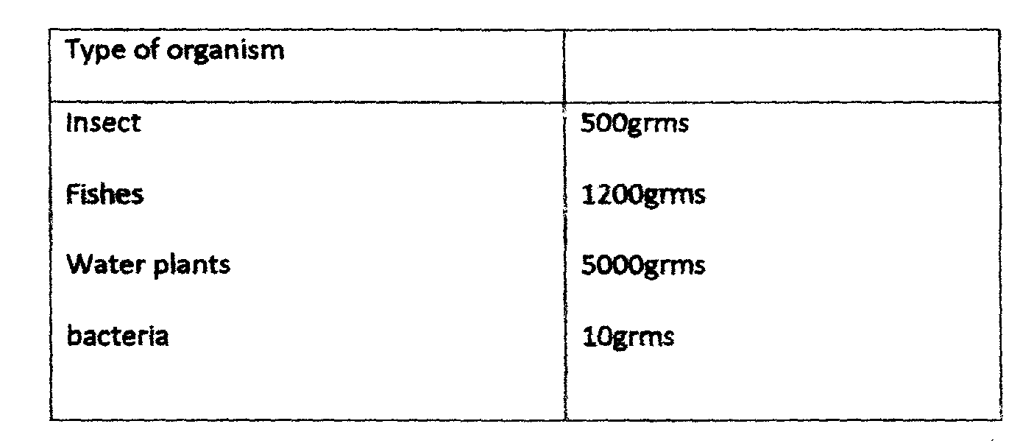

a) What do you understand by the term ecological balance? (1mark)
...................................................................................................................................................................................................................................................................................................................................................................
b) Calculate the total biomass of the aquarium. (2marks)

c) With a reason, identify which organism in the table is a producer. (2marks)
................................................................................................................................................................................................................................................................................................................................................................
d) Explain why energy is never transferred fully(100%) to the subsequent trophic level. (1 mark)
................................................................................................................................................................
.................................................................................................................................................................
e) In an attempt to estimate the number of weaver birds in a small woodland 435 were captured , marked and released. Three days later, 620 were captured 75 of which were marked.
Calculate the approximate size of the weaver bird population in the woodland. (2marks)

3. The diagram below represent a phenomenon which occurs during cell division.
J
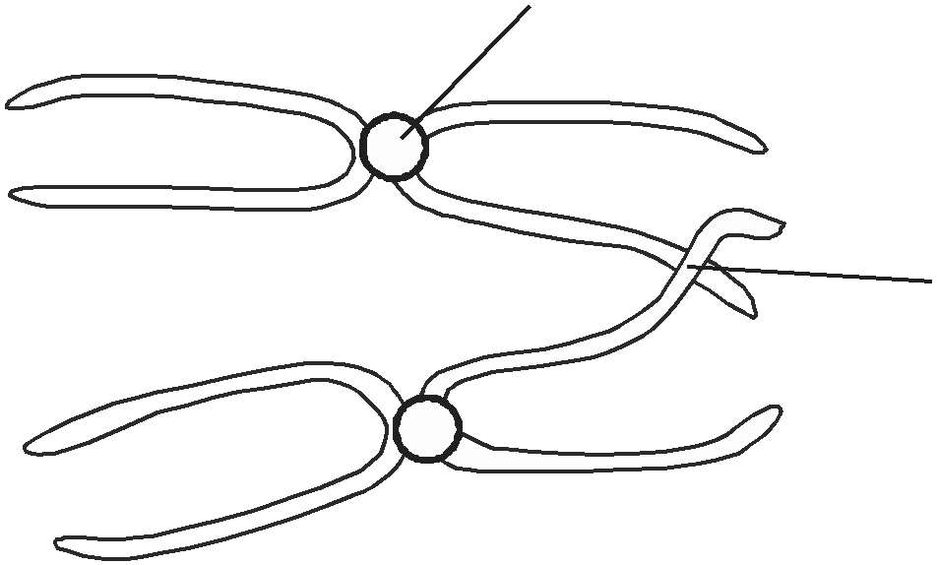
K

a) Name the parts labelled J and K (2 marks)

J ..........................................................................................................................................................
K ........................................................................................................................................................
b) State the biological importance of parts labelled J and K (2mks)

J …………………………………………………………………………………………………………………

K............................................................................................................................................................................
c)Name two organs in humans where this type of cell division occurs (2mks)
i)………………………………………………….………(ii)………………………………………………….
d) State two significance of this type of cell division. (2 marks)

...................................................................................................................................................................

5.The diagram below is a longitudinal section of an organ in mammals.

T S
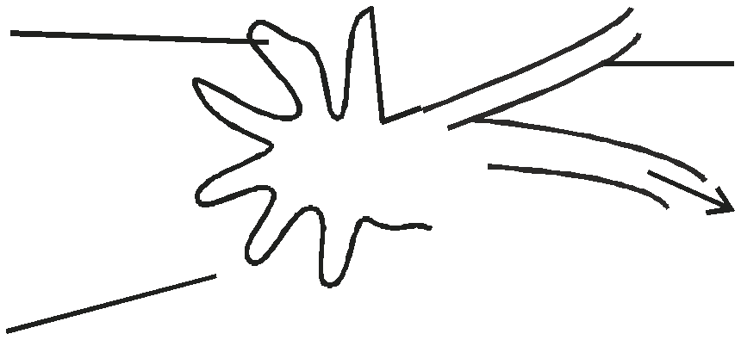

R
collecting duct

Q

a) Name the organ................................................................... (1 mark)

b) Identify the parts R and S. (2 marks)

...................................................................................................................................................................

................................................................................................................................................................... c) i) State three differences in the structure above found in the desert rat and fish. (3 marks)
...................................................................................................................................................................

...................................................................................................................................................................

...................................................................................................................................................................

................................................................................................................................................................... ii) Account for the differences stated above. (2 marks)
...................................................................................................................................................................

...................................................................................................................................................................

...................................................................................................................................................................
d) Name the gland associated with the secretion of aldosterone hormone. (1 mark)
...................................................................................................................................................................

..................................................................................................................................................................

6.a) The diagram below represents a mature fruit from a dicotyledonous plant. Observe it and answer questions that follow.

i) To what group of fruits does the specimen belong? ........................................................... (1 mark)

ii) Suggest the possible agent of dispersed of the fruit.............................................................(1 mark)

b) State two ways in which male parts of a wind pollinated flower are adapted to their mode of pollination. (2 marks)

...................................................................................................................................................................

...................................................................................................................................................................

c) Differentiate between Monoecious and Dioecious plant. (2 marks)

...................................................................................................................................................................

...................................................................................................................................................................

d) State any two differences between an ovum and a sperm. (2 marks)

i)
Ovum | Sperm

ii)

SECTION B (40 MARKS) Answer question 6 (compulsory) and either question 7 or 8

6. In an experiment, lactic acid concentration was measured before, during and after exercise to determine the effect of exercise on the concentration of lactic acid in blood. Study the data obtained and use it to answer the questions that follow.

Time (minutes) | 0 | 10 | 20 | 25 | 30 | 40 | 50 | 60 | 70 | 80 | 90 | 100
Lactic acid conc. /obitery units | 0.5 | 0.5 | 5 | 13 | 12 | 8 | 6 | 4 | 3 | 2 | 1 | 0.9

a) Plot a graph of the concentration of lactic acid against time using a suitable scale. (6 marks

b) From the graph:
i) Determine the period of exercise. .............................................................................. (1 mark)
ii) Explain (1 mark)

...................................................................................................................................................................
c) i) Determine the time when oxygen debt incurred. (1 mark)
................................................................................................................................................................... ii) Explain (1 mark)
.................................................................................................................................................................. d) i) The duration it took to pay back the oxygen debt (1 mark)
...................................................................................................................................................................
ii) Explain (1 mark)
...................................................................................................................................................................
e) Plot a hypothetical curve for oxygen intake during the experimental period on the same axes.(2 mks)
f) Why does lactic cid level usually continue to rise in the blood after the exercise ceases? (2 marks)
...................................................................................................................................................................

...................................................................................................................................................................

................................................................................................................................................................... g) State two of effects of lactic acid on tissues. (2 marks)
...................................................................................................................................................................

...................................................................................................................................................................

7. | a) Explain how mammalian lungs are adapted for gaseous exchange. | (10 marks)
8. | b) Describe the role of the mammalian liver in carbohydrate metabolism.  Describe the effects of the various abiotic factors in a terrestrial ecosystem to plants. | (10 marks)  (20 marks)

