TERM TWO EXAMINATIONS YEAR 2020
BIOLOGY PPR 3
NAME………………………………………….. ADM NO……………. CLASS………..

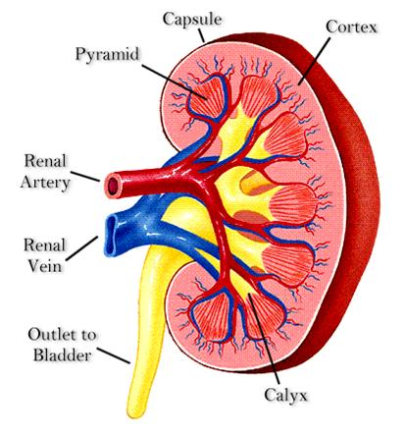
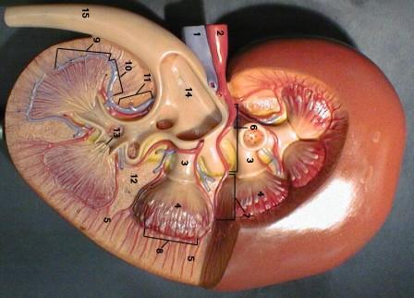
1. Below is a section through a mammalian organ.
A
B
C

i) Identify the section (1mark)

…………………………………………………………………………………………

ii) Name the parts labeled A, B and C (3marks)

A ………………………………………………………………………………….

B …………………………………………………………………………………...

C …………………………………………………………………………………...
iii) State three functions of the photographed specimen. (3marks)

…………………………………………………………………………………………

…………………………………………………………………………………………

iv) Label on the photograph using G and L the region where the Glomerulus, and
Loop of Henle are located respectively. (2marks)

(v) Name a process that occurs in the glomerulus and Loop of Henle (2marks)

a) Glomerulus ………………………………………………………………

b) Loop of Henle ………………………………………………

(vi) Name two renal diseases (2marks)

2. You are provided with solution W.Using the provided reagents; carry out possible food tests to identify food substances present in solution. W

Food substance | Procedure | observation | Conclusion

3. Examine photographs labeled T and S given below and use them to answer the questions that follow.
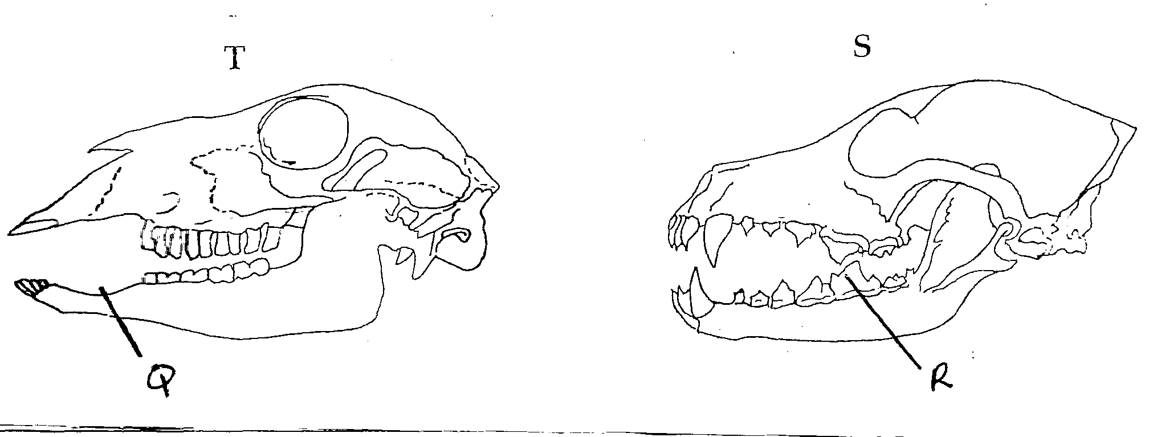

- Giving reasons, name the mode of nutrition of the mammals whose skulls are shown in the photographs.
T………………………………………………. (1mk)

Reasons (2mks)

………………………………………………………………………………………
………………………………………………………………………………………
………………………………………………………………………………………

S………………………………………………. (1mk)
Reasons (2mks)
………………………………………………………………………………………
………………………………………………………………………………………
………………………………………………………………………………………
- In the appropriate diagram, label the position where the horny pad would be found in living animals. (1mk)
- Name the part labeled Q and state its function in photograph T.
Name………………………………………………………………… (1mk)

Function………………………………………………………………… (1mk)
- Explain how the part labeled R is adapted to its function. (3mks)
………………………………………………………………………………………
………………………………………………………………………………………
………………………………………………………………………………………

4. Study the photographs below for specimen Rand S
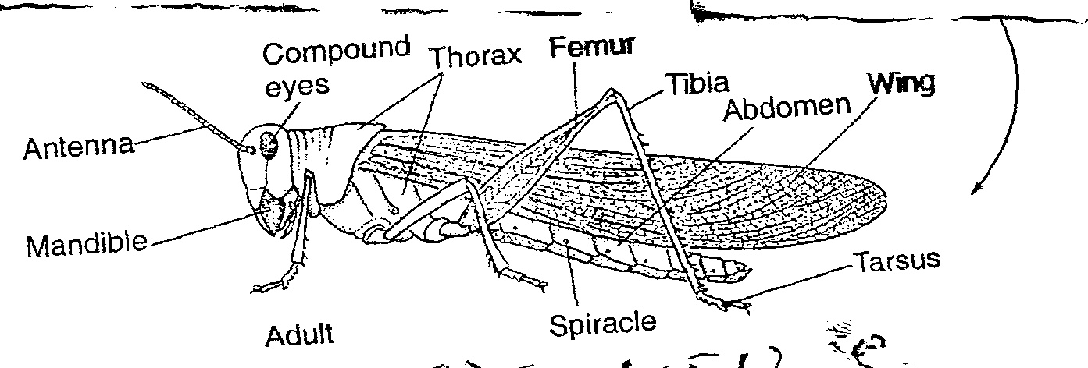
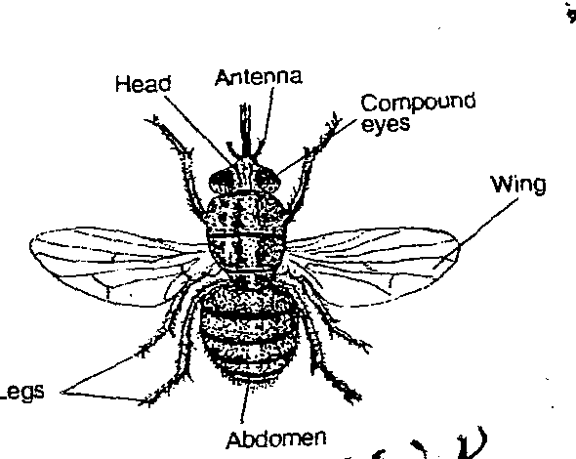
Specimen S

Specimen R

- State two observable differences between the specimen R and S (2mks
Specimen R | Specimen S

ii) Suggest the advantage of the adaptations on the limbs of specimen S (2mks)

