BIOLOGY FORM 4
PAPER 1
Name: …………………………….……………………………………… Adm no ……..….......... Class.................

INSTRUCTIONS TO CANDIDATES:Answer ALL the questions .Answers should be written in the spaces provided
1. a) Lietego school biology student used a microscope with X40 objective lens and X5 eye piece lens which had 2mm radius. Calculate the area of the field of view in micrometers. (2mks)

b) What is the average size of the cell in micrometers if there were 5 cells on the field of view (2mks)

2. State three differences between osmosis and active transport. (3mks)
Osmosis | Active transport
3. The lungs and ileum are adapted for absorption .State three features they have in common which facilitate absorption. (3mks)
…………………………………………………………………………………………………………………………………………………………………………………………………………………………………….............................................................................................................................................................................
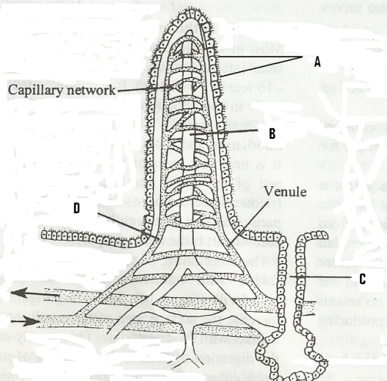
4. The figure below represents a structure obtained from the ileum of a mammal.
a) Give the identity of the structure. (1mk)
…………………………………………………………………….
b) What is the importance of the structure named in (a) above? (1 mk)
..…………………………………………………………………
c) Name the parts labeled A, B and D. (3mks)
A......................................................... B.......................................
D......................................................................................................
A…………………….…………………………………………….
B………………….……………………………………………….
D…………….…………………………………………………….

d) i) Name the juice secreted by the part labeled C...............................................................................(1mk)
ii) List two enzymes present in the juice named in d (i) above. (2mks) ………………………………………………… ……………………………………………………………
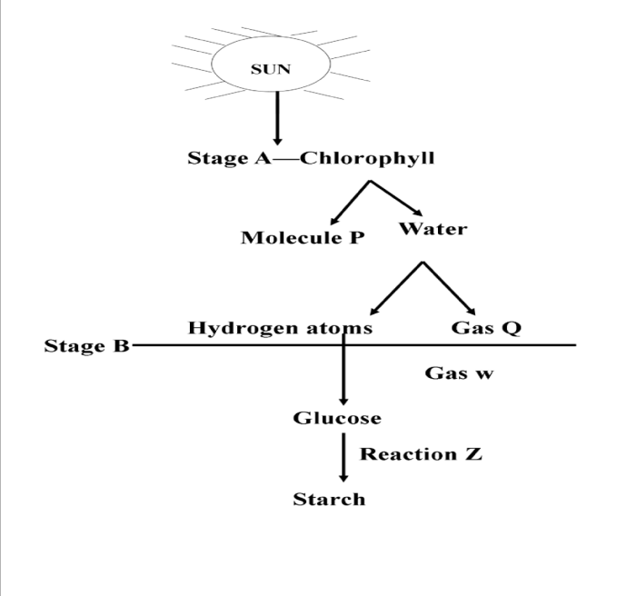
5. Below is a diagrammatic summary of the main biochemical events in photosynthesis. Study it carefully and answer the questions that follow.
- Suggest the identify of molecule P. (1mk)
.............................................................................................
- Name the gases represented by the letters (2mks)
Q...........................................................................................
W..........................................................................................
c) Name the specific site for the reactions in stage B (1mk)
.............................................................................................
d) Name reaction Z. (1mk)
Z ...................................................................................

Molecule P

6. (a) What is the importance of the following substances in blood clotting process in man?
- Vitamin K: ……………………………………………………………………….....…(1mk)
- Thrombin: ………………………………………………………………………......… (1mk)
(b) Comment on:
(i) Disadvantage of having blood group O. (1mk)
……………………………………………………………………………………………………….
(ii) Advantage of having blood group AB. (1mk)
……………......………………………………………………………………………………………
- (a) State the reasons for the following adaptations of the xylem vessels. (2mks)
  - Narrow lumen: …………………………………………………………………………………………
  - Lack of cross walls:
………………………………………………………………………………………………………………………………………………………………………………………………………………………………
(b) State two distinguishing features of the phloem sieve tubes. (2mks)
............………………………………………………………………………………………………………………………………………………………………………………………………………………………
8. (a) State two functional differences between arteries and veins in mammals. (2mks)
…………………………………………………………………………………………………………..........
…………………………………………………………………………………………………………............................................................................................................................................................................................
9. a) List down three respiratory diseases in human beings (3mks)

b) State the three theories that explains the mechanisms of opening and closing the stomata (3mks)
…………………………………………………………………………………………………………..........…………………………………………………………………………………………………………................................................................................................................................................................................................
10. Name the nitrogenous wastes excreted by a fresh water fish (1mk)
..........................................................................................................................................................................................................................................................................................................
11. State the function of septum in the heart (1mk)…………………………………………………….
.....................................................................................................................................................
12. The equation below represents a metabolic process that occurs in the mammalian liver.
Amino Acids Organic compound + Urea
- Name the process............................................................................................................................(1mk)
- What is the importance of the process to the mammal? (2mks)
……………………………………………………………………………………………………………….……………………………………………………...……………………………………………………...
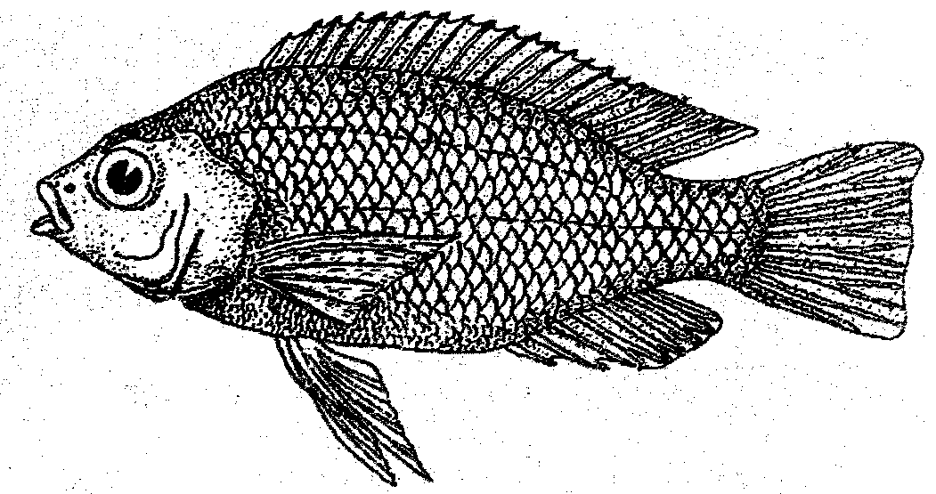
13. Below is a diagram of an organism
- State the class which the organism belongs to (1mk)
..........................................................................................
- State two observable characteristics used to classify the organism in the class you have mentioned in (i) above
(2mks)
......................................................................................................................................................................................................................................................................................................................

- Name two classes of phylum arthropoda with cephalothorax. (2mks)
- .............................................................................................................................................
- ............................................................................................................................................
14. In mitosis in animals chromatids failed to separate and move to opposite poles
a) Name the organelle that the cell was lacking .(1mk)
…………………………………………………………………………………………………………
b) Name two regions in plants where cells actively undergo mitosis (2mks)
…………………………………………………………………………………………………………………………………………………................................……………………………………………
15. a) What is the meaning of the following terms (2mks)
i) Autecology……………………………………………………..........………………………………
.................................................................................................................................................................

ii) Synecology.........................................................................................................................................
………………………………………………………………………………………………………...
b) The number and distribution of stomata on three different leaves are shown in the table below.
Leaf | Number of | stomata
 | Upper epidermis | Lower epidermis
A  B  C | 450  185  03 | 0  270  15
Suggest the possible habitats of the plants from which the leaves were obtained (3mks)
A………............………………………………………………………………………………
B………………………………………………………………………………………………
C........…………………………………………………………………………………………
c) Apart from predation, state two other biotic factors that will influence the distribution of an organism in an ecosystem. (2mks)
…………………………………………………………………………………………………………………..............................................................................................................................................................................
- What is the function of the following structures in the human reproductive organs?
  - Prostate gland (1mk)
………………………………………………………………..……………………………………………..
  - Uterus (1mk)
………………………………………………………………..……………………………………………..
  - Epididymis (1mk)
………………………………………………………………..……………………………………………..
17. Define the term oxygen debt as used in biology (1mks)
...............................................................................................................................................................................................................................................................................................................................................................................................................................................................
18. a) Differentiate between incomplete and complete metamorphosis. Give example in each case.
....................................................................................................................................(4mks)
...............................................................................................................................................................................................................................................................................................................................................................................................................................................................................................................................................................................................................................................................................................................................................................................................................................................................................................

19. State two adaptations of a seed to its functions. (2mk)
...............................................................................................................................................................................................................................................................................................................................................................................................................................................................
20. Name the causative agent of cholera (1mk)
..........................................................................................................................................................................................................................................................................................................
21. Define the term resolution power as used in microscopy (1mk)
...............................................................................................................................................................................................................................................................................................................................................................................................................................................................
22. What is haemolysis (1mk)
...............................................................................................................................................................................................................................................................................................................................................................................................................................................................
23. a) Name the compound that stores energy released during oxidation of glucose, (1mk)
…………………………………………………………..………………………………………………….
- A goat weighing 15.2kg requires 216KJ while a rat weighing 50g requires 2736KJ per day. Explain. (2mks)
…………………………………………………………..………………………..………………………….…………………………………………………………..……………………………..…………………….…………………………………………………………..…………………………………..……………….………
24. Explain why plants do not require complex excretory organs. (3mks)
……………………………………………………………………………………………………………..……………………………………………………………………………………………………………..……………………………………………………………………………………………………………..……………………………………………………………………………………………………………..……………………
25. Name the instrument used in measuring wind velocity (1mk)
..........................................................................................................................................................................................................................................................................................................
26. What is ecdysis (1mk)
..........................................................................................................................................................................................................................................................................................................

