Name: …………………………….……………………………………… Adm no ……..….......... Class.................

231/2 BIOLOGY
FORM 4
PAPER 2 WXAM

INSTRUCTIONS TO CANDIDATES:
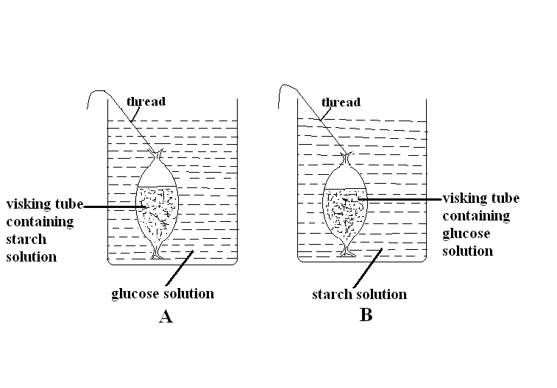
- Answer ALL the questions
- Answers should be written in the spaces provided

- The following experiment was set up by a form one class. After an hour, the contents of the visking tubing and the beaker were tested using iodine solution and benedict’s solution.

Record in the table below the expected observations after the contents in set up A and B were tested using iodine solution and benedict’s solution. [8 marks]
 | Visking tubing |  | Beaker
Set up | Iodine solution | Benedicts solution | Iodine solution | Benedict’s solution
A
B
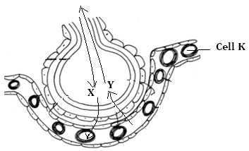
2. The diagram below shows the association between the alveolus and a blood capillary. Study it and answer the questions that follow.

- State the physiological process by which the gas labeled X enters the cell labeled K. (1mk)
……………………………………………………………………………………………………………
- Identify gases represented by letter X and Y
X ……………………………………………………….………...........................................................(1mk)
Y ………………………………………………………………………………………….……..……(1mk)
- Give two adaptations of cell K to its functions. (2mks)
………………………………………………………………………………………………………………………………………………………………………………………………………………………………
- State three characteristics of respiratory surfaces. (3mks)
………………………………………………………………………………………………………………………………………………………………………………………………………………………………………………………………………………………………………………………………………………………………………………………………………………………………………................................................………………………
3. a) Define the following terms as used in animal nutrition
i) Dentition (1mk)
……………………………………………………………………………………………………...
ii) Homodont and heterodont teeth (2mks)
…………………………………………………………………………………………………….........................................................................................................................................................................................................................................…………………………………...................................................................................................................................................................................…………………………………………………………………...
b) State two functions of ileum (2mks)
……………………………………………………………………………………………………................................................................................................................................................................................................................
(c) Explain the importance of the following in the process of photosynthesis; (2mks)
(i) Chlorophyll
……………………………………………………………………………………………………...
(ii) Light
……………………………………………………………………………………………………...
(d) State one use of Potassium in (K⁺) ion the body (1mk)
………………………………………………………………………………………………
4. The diagram below shows a cross section through the female part of a flower.
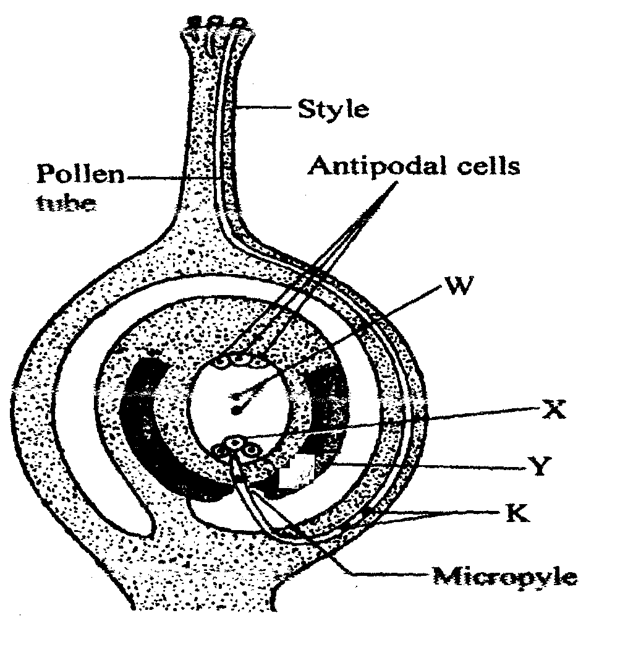
- Name the structures labelled W,X, and Y. (3mks)

X ......................................................................................
Y ......................................................................................
Z .....................................................................................
b) State two functions of the pollen tube. (2mks)
.......................................................................................................................................................................................................................................................................................................................
............................................................................................................................................................. .............................................................................................................................................................

c) What happens to antipodal cells after fertilization. (1mk) ............................................................................................................................................................. .............................................................................................................................................................
d) Name the structure labelled K and state their role. (2mks)
............................................................................................................................................................. .............................................................................................................................................................
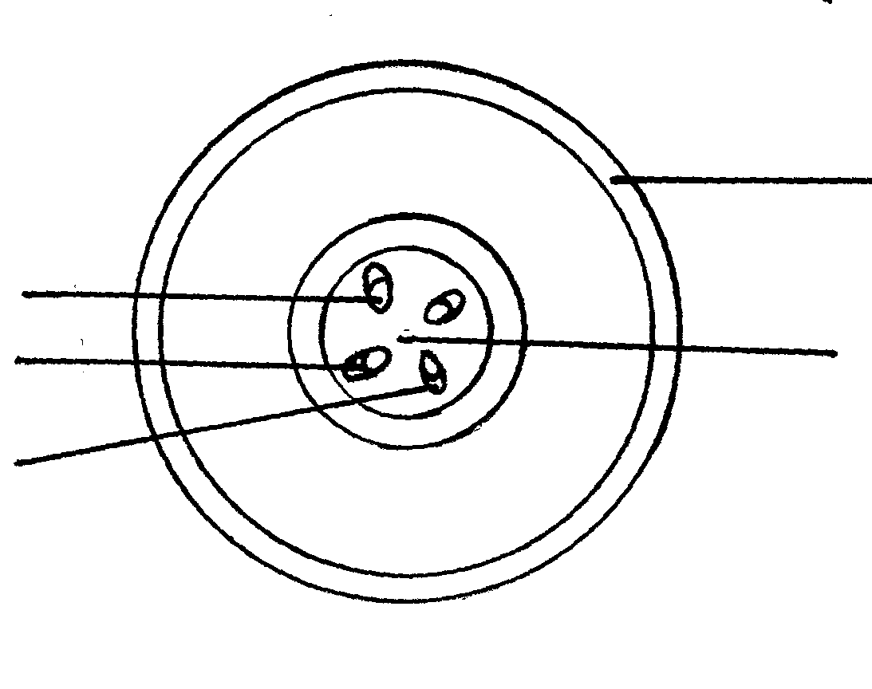
5. The figure below represents a transverse section of a young stem.
a) Name the parts labelled A and B on the diagram. (2mks)
A................................................................................
B.................................................................................
b) State the functions of the parts labelled C, D and E.(3mks)
C................................................................................................
D.......................................................................................
E........................................................................................
A
B
E
D
C

c) List three differences between the section shown above and one that would be obtained from the root of the same plant. (3mks)
...............................................................................................................................................................................................................................................................................................................................................................................................................................................................................................................................................................................................................................................................................................................................................................................................................
SECTION B( 40 MARKS)
Answer questions 6 ( compulsory)and either questions 7 or 8 in the spaces provided questions 8
6. The glucose level in mg per 100cm³ of blood was determined in two person Y and Z. Both had stayed for six hours without taking food. They were fed on equal amount of glucose at the start of the experiment .The amount of glucose in their blood was determined at intervals .The results are shown in the table below.
Times in minutes | Glucose level in blood in mg /100cm³ | Glucose level in blood in mg /100cm³
 | Y | Z
0 | 85 | 78
20 | 105 | 110
30 | 105 | 110
45 | 130 | 170
60 | 100 | 195
80 | 93 | 190
100 | 90 | 140
120 | 90 | 130
140 | 88 | 120
a) On the grid provided, plot graphs of glucose levels in blood against time on the same axes. (7mks)
b) What was the concentration of glucose in the blood of Y and Z at the 50th minute? (2mks)
Y ..........................................................................................................................................................
Z .......................................................................... ..............................................................................
c) Account for the level of glucose in person Y
i) During the first 45 minutes. (2mks)
.................................................................................................................................................................................................................................................................................................................................................................................................................................................................................................................................................................................................................................................... .......................................................................................................
ii) After 45th minute to the end of the experiment. (4mks)
..................................................................................................................................................................................................................................................................................................................................................................................................................................................................................................................................................................................................................................................................................................................................................................................................................................................................................................................................................
d) Account for the decrease in glucose level person Z after 60 minutes. (2mks)
.................................................................................................................................................................................................................................................................................................................................................................................................................................................................................................................................................................................................................................................... .......................................................................................................

e) Low blood sugar level in harmful to the body .Explain. (3mks)
.................................................................................................................................................................................................................................................................................................................................................................................................................................................................................................................................................................................................................................................................................................................................................................................................................................................................................................................................................
7.a) State the various causes of seed dormancy . (8mks)
b) Describe various factors that affect the process of seed germination. (12mks)

8. Discuss the adaptations of the mammalian skin to its functions. (20mks)

