Name: …………………………………………………………… Adm no ……..….......... Class.................

231/3
BIOLOGY PP3
FORM 4

INSTRUCTIONS TO CANDIDATES:
- Answer ALL the questions
- Answers should be written in the spaces provided
1. Take 2 clean test tubes and into each add 5cm³ of dilute hydrogen peroxide. Label the test tubes as A and B. Cut 2 cubes of irish potato measuring 1cm³ each. Boil one cube in a boiling tube with some water for about 5 minutes. Drop the boiled cube into test tube A and un-boiled cube in test tube B. State your observations

- Test tube A (1mk)
……………………………………………………………………………………………………...……..
Test tube B (1mk)
…………..……………………………………………………………………………………….......…….
Account for your observations in:
Test tube A (1mk)
……………………………………………………………..…………………………………......……….
Test tube B (2mks)
………………………………………………………….……………………………………….........…….
……………………………………………………………….………………………………………..........

- Take a small piece of substance Z provided and add to it 2cm³ of sodium hydrogen carbonate.
(i) State your observations (1mk)
…………………………………………………………………………………………………...............

(ii) Which physiological process in the body is illustrated above (1mk)
……………………………………………………………………………………................…………….

(iii) State the part of the body where the process takes place. (1mk)
………………………………………………………………………………………………...............….

(iv)What is the significance of the process (1mk)
………………………………………………………………………………………………….................
- Put 2cm³ of liquid labelled as C into a test tube. Squeeze some juice from specimen X into a beaker. Draw some of the juice into a dropper. Add 3 drops of the juice into the test tube with solution C.
- State your observation. (1mk)
………………………………………………………………………………………………….
………………………………………………………………………………………………….
- State the part of the human body where the physiological process demonstrated above occurs and the enzyme that carriers out the process. (2mks)

Part of body…………………………………………………………………………………….
Enzyme………………………………………………………………………………………….

- Which gland produces the enzyme stated in (ii) above. (1mk)
………………………………………………………………………………………………….

- Which hormone stimulates the production of the enzyme stated in (ii) above. (1mk)
………………………………………………………………………………………………….

2. Study the kidney diagrams below

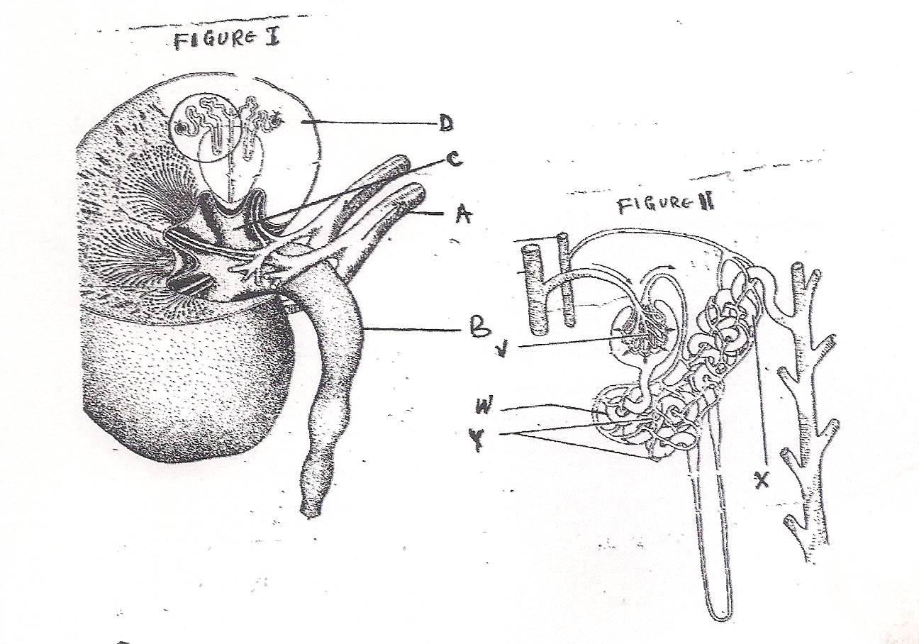
- i) Name the parts labeled A, B, C and D in figure 1 (4mks)
A………………………………………………………………………………………..
B………………………………………………………………………………………..
C………………………………………………………………………………………..
D……………………………………………………………………………………….
ii) Name the processes that take place in the parts labeled (2mks)
V……………………………………………………………………………………..
X………………………………………………………………………………………
- State three adaptations of the part labeled W (3mks)
……………………………………………………………………………………………………………………………………………………………………………………………………………………………………………………………………………………………………………………………………………………………………………………………………………………………………………………................................................................................................................................................
- On the diagram name the part where counter current flow occurs (1mk)
- State two homeostatic functions of the diagram above (2mks)
…………………………………………………………………………………………………………………………………………………………………………………………………………………………………………………………………………………………………….......................................

3. Examine the seedlings below and use them to answer the questions that follow:

D
C

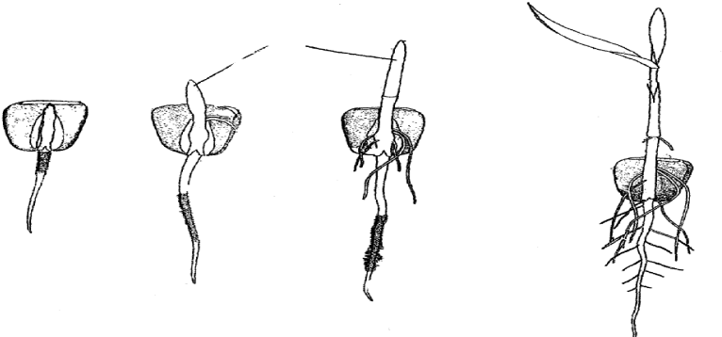
S₄
S₃
S₂
S₁
E
R₄
R₃
R₂
R₁
(a) Name the parts labeled C, D, E and state their importance for the seedling.
C:....................................................................................................................... …….. (1mk)
Imprtance (1mk)
............................................................................................................................................
...........................................................................................................................................

D................................................................................................................................... (1mk)
Importance (2mks)
...........................................................................................................................................
..........................................................................................................................................

(ii) E........................................................................................................................................ (lmk)
Importance. (lmk)
..............................................................................................................................................
...................................................................................................................................................

(b) The R series of seedlings on the roots later swell in its life:
(i) What is the name of the swelling: (lmk)
.......................................................................................................................................................................................................................................................................................................................
(ii) Name the organisms that would be found in the swellings (1mk)
.......................................................................................................................................................................................................................................................................................................................
(iii) Explain the relationship that exists between the named organisms and the plant.(1mks)
........................................................................................................................................................................................................................................................................................................................
......................................................................................................................................................................................................................................................................................................................
(c) ( i) State the type of germination exhibited by R series of the seedlings. (1mk)
........................................................................................................................................................................................................................................................................................................................
(ii) Give a reason for your answer in (c) (i) above. (1mk)
.......................................................................................................................................................................................................................................................................................................................
(d) State any two external factors necessary for germination. (1mk)

