TERM TWO EXAMINATIONS YEAR 2020
FORM ONE BIOLOGY
NAME……………………………………………………………..………………………ADM………….CLASS…………….
1.What is Biology?(2mk)
………………………………………………………………………………………………………………………………………………………………………………………………………………………………………………………………………………………………………………
2.List two branches of Biology and for each give a definition (4mks)
………………………………………………………………………………………………………………………………………………………………………………………………………………………………………………………………………………………………………………
………………………………………………………………………………………………………………………………………………………………………………………………………………………………………………………………………………………………………………
3.List four differences between a plant and animal (4mks)

4.Define the term species. Give a reason why a leopard and a lion cannot breed yet they belong to the same genus (2mks)
………………………………………………………………………………………………………………………………………………………………………………………………………………………………………………………………………………………………………………
………………………………………………………………………………………………………………………………………………………………………………………………………………………………………………………………………………………………………………
5.Observe the diagram below and answer the questions that follow.
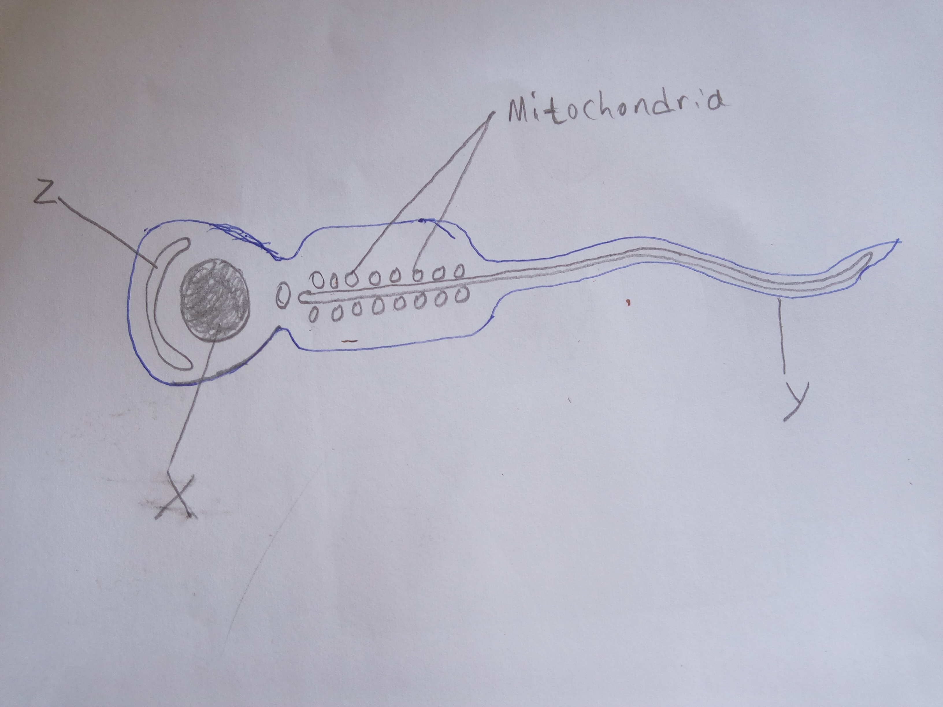

i)Identify the type of cell (1mk) ………………………………………………………………………………………………….
ii) Name the parts (3mks) X………………………………..…………………………………………………..
Y …………………………………………………………………… Z……………………………………………………………………

iii)Explain why the cell has a lot of mitochondria (2mks)
…………………………………………………………………………………………………………………………………………………………………………………………..…………………………………………………………………………………………………………………
iv)What is the function of the cell (1mk)
………………………………………………………………………………………………………………………………………………………
6a)What is cell physiology (1mk)
………………………………………………………………………………………………………………………………………………………………………………………………………………………………………………………………………………………………………………
b)State three properties of the cell membrane (3mks)
………………………………………………………………………………………………………………………………………………………………………………………………………………………………………………………………………………………………………………………………………………………………………………………………………………………………………………………………………
7.Define the following terms (5mks)
i)Diffusion
………………………………………………………………………………………………………………………………………………………………………………………………………………………………………………………………………………………………………………
ii)Plasmolysis
………………………………………………………………………………………………………………………………………………………………………………………………………………………………………………………………………………………………………………
iii)Osmosis
………………………………………………………………………………………………………………………………………………………………………………………………………………………………………………………………………………………………………………
iv)Active transport
………………………………………………………………………………………………………………………………………………………………………………………………………………………………………………………………………………………………………………
v)Diffusion gradient
………………………………………………………………………………………………………………………………………………………………………………………………………………………………………………………………………………………………………………
8.Distinguish between:-
i)Hypotonic and hypertonic solutions (2mks)
………………………………………………………………………………………………………………………………………………………………………………………………………………………………………………………………………………………………………………
ii)Haemolysis and crenation (2mks)
………………………………………………………………………………………………………………………………………………………………………………………………………………………………………………………………………………………………………………
9a)State any three roles of osmosis in organisms (3mks)
………………………………………………………………………………………………………………………………………………………………………………………………………………………………………………………………………………………………………………………………………………………………………………………………………………………………………………………………………
b)How is the rate of diffusion affected by the following (2mks)

i)Temperature
………………………………………………………………………………………………………………………………………………………………………………………………………………………………………………………………………………………………………………
ii)Size of molecules
………………………………………………………………………………………………………………………………………………………………………………………………………………………………………………………………………………………………………………
10.Define photosynthesis (2mks)
………………………………………………………………………………………………………………………………………………………………………………………………………………………………………………………………………………………………………………
11.State two raw materials for photosynthesis (2mks)
……………………………………………………………… ……………………………………………………………
12.Describe five adaptations of leaf to its function (10mks)
………………………………………………………………………………………………………………………………………………………………………………………………………………………………………………………………………………………………………………………………………………………………………………………………………………………………………………………………………………………………………………………………………………………………………………………………………………………………………………………………………………………………………………………………………………………………………………………………………………………………………………………………………………………………………………………………………………………………………………………………………………………………………………………………………………………………………………………………………………………………………………………………………………………………………………………………………………………………………………………………………………………………………………………………………………………………………………………………………………………………………………………………………………………………………………………………………………………………………………………………………………………………………………………………………
………………………………………………………………………………………………………………………………………………………
………………………………………………………………………………………………………………………………………………………………………………………………………………………………………………………………………………………………………………
………………………………………………………………………………………………………………………………………………………
………………………………………………………………………………………………………………………………………………………
13.Study the diagram and answer the questions that follow.
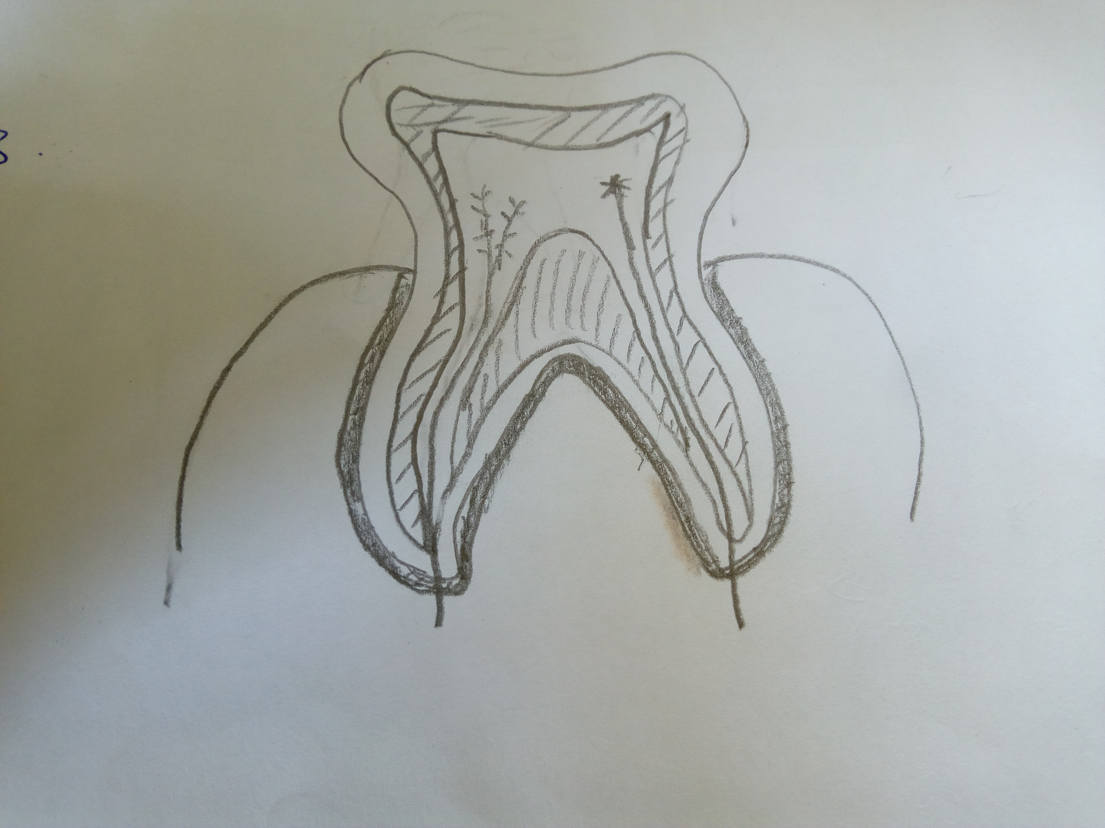

i)Identify the diagram (1mk)…………………………………………………………………………………………………..
ii)State the function of the diagram (1mk)
………………………………………………………………………………………………………………………………………………………
14.A group of student set up an experiment to investigate a certain physiological process. The set up was as shown in the diagram. After sometime, the students observed that the level of the sugar solution had raised.

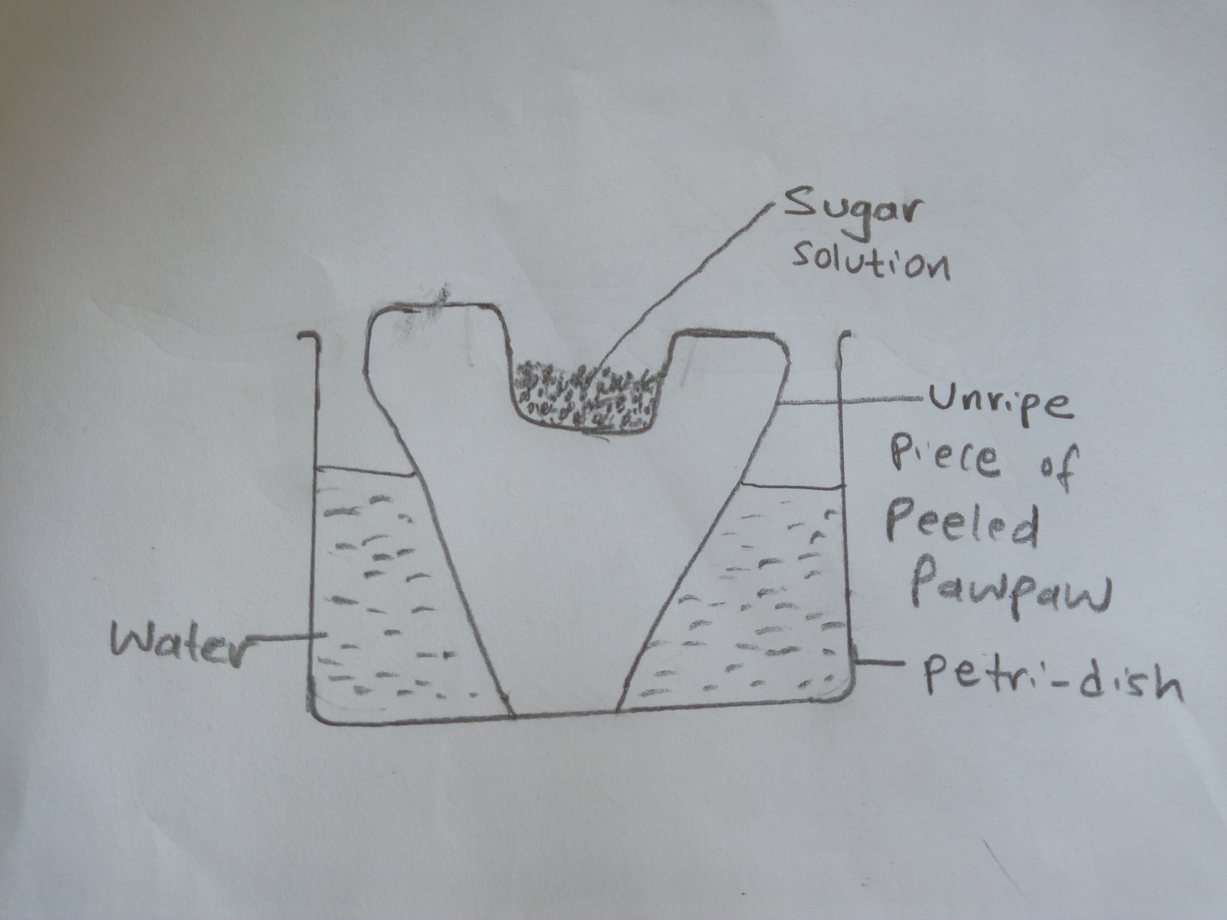

i)What physiological process was being investigated (1mk)
………………………………………………………………………………………………………………………………………………………
ii)Account for rise in level of sugar solution (4mks)
………………………………………………………………………………………………………………………………………………………
………………………………………………………………………………………………………………………………………………………
………………………………………………………………………………………………………………………………………………………
………………………………………………………………………………………………………………………………………………………
iii)Suggest the result that would be obtained if the experiment was repeated using a boiled pawpaw.
(2mks)
………………………………………………………………………………………………………………………………………………………
………………………………………………………………………………………………………………………………………………………
15.State four types of teeth in mammals (4mks)
…………………………………………………………… …………………………………………………………………………
…………………………………………………………… ………………………………………………………………………
16.State the functions of the following parts of a microscope (4mks)
i)Coarse adjustment knob……………………………………………………………………………………………………………
………………………………………………………………………………………………………………………………………………………
ii)Condenser………..…………………………………………………………………………………………………………………………
………………………………………………………………………………………………………………………………………………………
iii)Diaphragm……….…………………………………………………………………………………………………………………………
………………………………………………………………………………………………………………………………………………………
iv)Revolving nose - piece…………………………………………………………………………………………………………………
………………………………………………………………………………………………………………………………………………………..
17.State two characteristics of living things (2mks)
………………………………………………………………………………………………………………………………………………………
………………………………………………………………………………………………………………………………………………………

