NAME:………………………………………………………ADM. NO……………CLASS………….
GEOGRAPHY
TERM TWO
1. a) Define the following terms:
i) Equinox (1mark) ……………………………………………………………………………………………………………………………………………………………………………………………………………………………………
ii) Solstice (1 mark)
……………………………………………………………………………………………………………………………………………………………………………………………………………………………………
b) State three reasons why the interior of the earth is very hot (3 marks)
………………………………………………………………………………………………………………………………………………………………………………………………………………………………………………………………………………………………………………………………………………………
3. a) Define the term plate tectonics theory (2 marks)
……………………………………………………………………………………………………………………………………………………………………………………………………………………………………
b) Give three types of tectonic plate boundaries (3 marks)
………………………………………………………………………………………………………………………………………………………………………………………………………………………………………………………………………………………………………………………………………………………
c) State four human cause of earthquakes (4 marks)
…………………………………………………………………………………………………………………………………………………………………………………………………………………………………………………………………………………………………………………………………………………………………………………………………………………………………………………………………………
5. Use the table below to answer questions that follows:
The table show rainfall and temperature for town x
Month | J | F | M | A | M | J | J | A | S | O | N | D
Temperature ⁰c | 17 | 27 | 27 | 22 | 24 | 23 | 22 | 21 | 22 | 26 | 29 | 18
Rainfall (mm) | 24 | 20 | 41 | 70 | 170 | 210 | 70 | 65 | 60 | 115 | 90 | 70

a) i) Draw a combined line and bar graph to represent the data (9 marks)
ii) State three advantages of using a combined line and bat graph to represent the above data (3 marks)

b) Give four characteristics of the Inter tropical convergence zone ITCZ (4 marks)

6. a) Differentiate between plutonic and volcanic rocks (2 marks)

b) i) Give two types of rock metamorphism (2 marks)

c) Your class plans to carry out a field study on rocks in your country
i) Mention three secondary sources of information you would use (3 marks)

ii) State why you would need the following items during the study
A fork jembe (1 mark)

A polythene bag (1 mark)

iii) Suppose during the study you collected marble sandstone and granite, classify
each sample according to its mode of origin (3 marks)

e) State three economic importance of rocks to man (3 marks)

7. a) i) What is faulting (2 marks)

ii) Name three types of faults (3 marks)

b) With the aid of well labeled diagrams describe how compressional forces have led to the
formation of the great Rift Valley (8 marks)

8. Study the diagram below and answer the questions that follow:

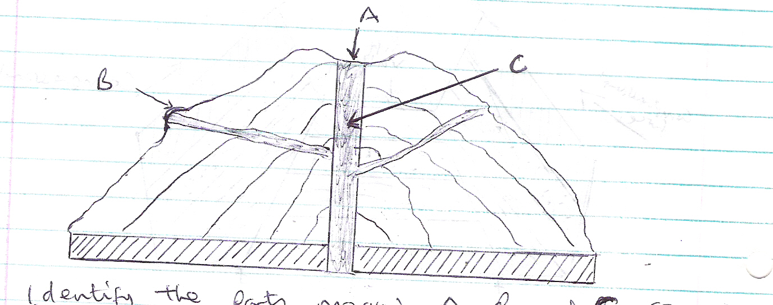

i) Identify the parts marked A, B and C (3 marks)
ii) Identify the feature shown above (1 mark)
iii) Explain four negative significance of vulcanicity (8 marks)

