PAPER 1 FORM FOUR GEOGRAPHY PRE MOCK
NAME…………………………………CLASS………..…ADM NO…………….

TERM ONE, 2017 TIME: 2 ¾ HOURS
INSTRUCTIONS
- This paper ha two section: A and B
- Answer all the questions in section A
- In section B, answer question 6 and any other two questions
- All answers to be written on the foolscaps provided.
SECTION A

- Name two scientific theories on the origin of the earth (2marks)
- Give the reason for the geoid shape of the earth (4marks)
- The diagram below some features formed due to glacial deposition in lowland areas
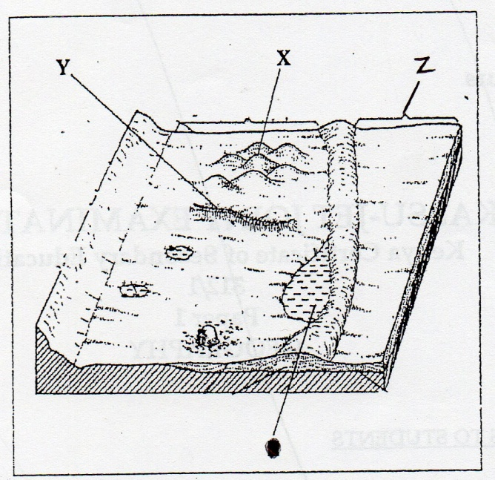
- Name the features marked X, Y and Z (3marks)
- Outline three factors which influence the rate of glacial erosion (3marks)

- What is mechanical weathering? (2marks)
- Name three processing of mechanical weathering (3marks)

- What is extrusive vulcanicity? (2marks)
- Give two examples of basic lava domes in Africa (2marks)
- State four characteristic of plutonic rocks (4marks)
SECTION B
- Study the map of Oyugis (1:50, 000, sheet 130/1) provided and use it to answer the following questions.

- Give the magnetic variation of the area covered by the map when it was drawn
(2marks)
- What is the latitudinal and longitudinal extent of the area covered by the map? (2marks)
- Determine the four figure grid reference of kuja dam (2marks)

- What is the vertical interval of the map? (1 mark)
- Give the direction and bearing of a jaggery factory at grid reference 788237 from a church at grid reference 806188. (3marks)

- Draw a square 10cm by 10cm to represent the region east of easting 85 from northing 30 to northing 40. On the square, mark and name:
- Kodera forest
- A district boundary
- All weather road-pound surface
- A seasonal swamp (5marks)
- What is the scale of the sketch that you have drawn? (1 mark)

- Citing evidence from the map, identify four crops grown in the area covered by the map. (4marks)
- Describe the distribution of settlement in the area covered by the map. (5marks)
- The map of Kenya below shows the climatic regions
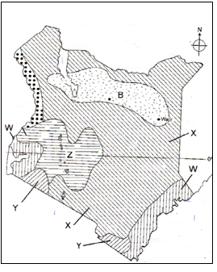
- Identify the climatic zones marked W, X, Y and Z (4marks)
- Describe the characteristics of the climatic region marked B (6marks)

- Apart from rainfall, give three other common forms of precipitation (3marks)
- Describe how convectional rainfall is formed (6marks)
- Explain three factors that influence rainfall in a place (6marks)

- (i) Differentiate between river discharge and river regime (2marks)
(ii) List three types of river erosion (3marks)
- Explain four factors which influence river deposition (8marks)
- State five characteristic of the upper stage of a river (5marks)
- Suppose you were to carry out a field study along the lower course of a major river.
- State four reasons why it is important to conduct a pre-visit to the area of study. (4marks)
- State three follow –up activities that you would do after the study (3marks)

- (i) Differentiate between earth movements and internal land forming processes
(2marks)
(ii) Give four causes of earth movements (4marks)
- Explain how fold mountains were formed according to the plate tectonics theory (4marks)

- Name two types of longitudinal seismic waves (2marks)
- Sate four natural causes of earthquakes (4marks)

- Describe how a lava plateau is formed (5marks)
- State four characteristics of a basic lava dome (4marks)

- (i) Give three examples of west coast deserts (3marks)
(ii) State three reasons why wind action is more effective in hot deserts (3marks)
- With the aid of well labeled diagrams, describe how a rock pedestal is formed
(7marks)
- Apart from rock pedestals, name for other features formed due to wind erosion
(4marks)
- Explain four positive effects of desert features (8marks)

