FORM ONE MATHEMATICS
TIME; 2HOURS

NAME………………………………………………………………..ADM. NO…………….CLASS…………………….

INSTRUCTIONS;
- Write your name, admission number and class in the above spaces.
- Answer ALL the questions in the spaces provided.
- All steps of your workings must be clearly shown, remember marks may be awarded for correct working even if the answer is wrong.
- Mathematical tables to be used where directed.
SECTION I (Answer All Questions in this section)
- What is the place value of digit 6 in the following numbers?
  - 37 286 293 (1 mk)

  - 76 349 241 (1 mk)

- Which of the following numbers are divisible by 3?
  - 574, 381, 87, 682, 426 (1 mk)

  - 147, 273, 25105 (1 mk)

3. Find the ratio a:c, if
a : b = 1: 3, and b: c = 2 : 5 (3 mks)

4. Four light signals are programmed at intervals of 40 seconds, 50 seconds, 60 seconds and 75 seconds. What is the earliest time they will give out light signals simultaneously if the last time they did so was 8.15 am? (3 mks)

5. Factorize;
  - $\frac{a^{3}}{3} - \frac{a^{2}b^{2}}{9} + \frac{a^{2}}{18}$ (2 mks)

  - mx - 2m + 3nx - 6n (2 mks)

6. Solve;$\frac{2}{5} of (6\frac{2}{5}-\frac{1}{2}\left(1\frac{2}{3}+\frac{1}{3}\right) x\frac{1}{5})$ (3 mks)

7. A rectangular tank of length 50 cm and width 30cm contains 36 litres of water.
Determine the height of water in the tank in cm (3mks)

8.Express each of the following as a fraction;

  - 1.69 (2 mks)

. .
  - 3 .7 2 (2 mks)

9. Use tables to find the square roots of the following;
    - 0. 008932 (1 mk)

    - 732.864 (1mk)

10. In a certain day, the temperature at North Pole was found to be -5⁰C. The following day, the temperature was found to be 8⁰C, what was the difference in temperature between those two days?(2 mks)

11. Find √1764 by factorization. (3 mks)

12. Convert the following fractions into percentages;
    - $2\frac{5}{7}$ (1 mk)

    - $4\frac{3}{4}$ (1 mk)

16. In the figure below, ∠ RPQ = (4x – 30) º∠ PQR = (x – 24) º. Given that PR = QR,
Find ∠ QRS (3mks)
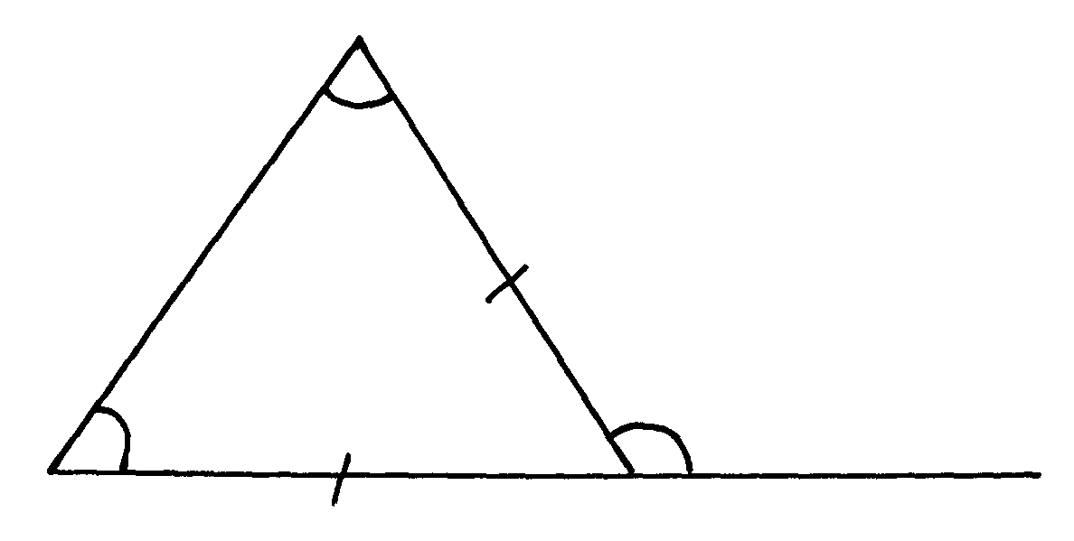
Q
x - 24
4x - 30
P
R
S

14. Express the following in 4 significant figures. (2 mks)
  - 0.035421

  - 16.04932

15. Write the following in standard form; (2 mks)
i) 123456

ii) 0.000123

16. The circumference of a circle is 31.42cm. Find the radius of the circle. (Use Π=3.142) (3 mks)

17. Convert the following units of area into the units indicated in brackets.
i) 3.4 ha (m²) (2 mks)

ii) 8000m² (ha) (2 mks)

18. Use substitution method to solve the following simultaneous equation: (3 mks)

3x - y = 8
x + y = 4

Section II (Answer ALL Questions from This Section)
19. i)Three boys shared some money. The youngest got ¹/₁₂ of it, the next got ¹/₉ and the eldest got the remainder.
    - What fraction of the money did the eldest receive? (2mks)

    - If the eldest boy got Shs. 330, what was the original sum of money? (3mks)

ii) A Forex Bureau in Kenya buys and sells foreign currencies as shown below:
Buying Selling
Currencies (Kshs) (Kshs)
Chinese Yuan 12.34 12.38
South African Rand 11.28 11.37

A business woman from china converted 195 250 Chinese Yuan into Kenya Shillings.
Calculate the amount of Money, in Kenya shillings, that she received. (2 mark)

(a) While in Kenya, the businesswoman spent Kshs 1 258 000 and then converted the balance to South African Rand. Calculate the amount of money, to the nearest Rand, that she received. (3 marks)

20. A cyclist travels 24km N45˚E from P to Q, the 20 km due East from Q to R. Using a scale of 1cm to represent 5km;
a) Show the position of P, Q and R. (4mks)

b) Find the distance and direction of R from P. (2mks)

c) State the bearing of P from R. (1mk)

d) Calculate the area enclosed by P, Q and R in km². (3mks)

