Name…………………………………………………… Class …………..…Adm No…
232/2
PHYSICS
Paper 2
Time: 2 hours
FORM THREE
Instructions to Candidates
- Write your name and class register number in the spaces provided above.
- Sign and write the date of examination in the spaces provided above.
- This paper consists of TWO sections: A and B.
- Answer ALL the questions in sections A and B in the spaces provided.
- ALL working MUST be clearly shown.
- Mathematical tables and non programmable silent electronic calculators may be used.

For Examiner’s Use Only
Section | Question | Maximum  Score | Candidate’s  Score
A | 1 – 11 | 25
B | 12 | 5
 | 13 | 15
 | 14 | 11
 | 15 | 14
Total Score |  | 80

SECTION I (25 marks)
Answer all the questions in this section
- The figure below shows two identical balloons inflated with air and suspended with a light cotton threads such that the two balloons are 2 cm apart.
Explain what is observed when a plastic ruler is rubbed vigorously against dry hair (human hair) and placed between the two balloons but without touching them. (2 marks)
………………………………………………………………………………………………………………………………………………………………………………………………………………
- An object dropped into well hits water 3.5seconds after been released. How deep is the well?
Take gas 10m/s² (3 marks)
………………………………………………………………………………………………………………………………………………………………………………………………………………………………………………………………………………………………………………………
- A car battery requires topping up with distilled water occasionally. Explain why this is necessary and why distilled water instead of tap water? (1 mark)
………………………………………………………………………………………………………………………………………………………………………………………………………………
- A small object lies at the bottom of a water pond at a depth of 1.2m. given that the refractive index of water is 1.3, determine the apparent depth of the object (3marks)
………………………………………………………………………………………………………………………………………………………………………………………………………………………………………………………………………………………………………………………
- The figure below shows a copper kept in a magnetic field and suspended on a frictionless conductor connected with a direct current supply. When the current is switched on, the copper coil rotates on its support. Explain how this motion is caused by the flow of current. (3 mark)

………………………………………………………………………………………………………………………………………………………………………………………………………………………………………………Differentiate between transverse and longitudinal waves. (1 mark)
………………………………………………………………………………………………………………………………………………………………………………………………………………………………………………
- The figure below shows a circuit that can be used to magnetize a given bar. Complete the circuit to show the direction of the current around the bar that will result the polarities shown.(1 mark)
- An object is placed 30 cm in front of a concave mirror of focal length 15 cm and another identical object is 30 cm in front of a plane mirror.
- Give one similarity between images formed. (1 mark)
…………………………………………………………………………………………………………………
- Give one difference between images formed. (1 mark)
……………………………………………………………………………………………………………………………………………………………………………………………………
- Suggest a reason why it is not possible to increase the strength of a magnet indefinitely.(2 mark)
………………………………………………………………………………………………………………………………………………………………………………………………………………
- Resistors of 2Ω and 3Ω are connected in series with a cell and voltmeter connected across the 3Ω resistor reads 1V, but this increases to 1.2V when an extra 2Ω resistor is connected in parallel with the first 2Ω resistor, calculate the e.m.f and the internal resistance of the cell. (4 marks)
………………………………………………………………………………………………………………………………………………………………………………………………………………………………………………………………………………………………………………………………………………………………………………………………………………………………
- The figure below shows a ray of light travelling from air to a liquid. The ray incidents the liquid at 48.6º and is refracted at 30º. Calculate the speed of light in the liquid (3 marks)
SECTION II(45 marks)
Answer all the questions in this section
- (a) (i) A pinhole of 1mm diameter is in the middle of a piece of black paper covering one end of a tube 1m long. The end of the tube is covered by a screen of a tracing paper. When the pin hole is directed towards the sun, the diameter of the image is found to be10mm. Draw a ray diagram showing how the images are formed. (2 marks)

(ii) The sun is just covered by a disc of 2 cm diameter placed about 2 meters from the eye from the eye. In the length of the diameter of the sun’s image formed by a pinhole camera is 0.5 cm, calculate the distance from the pinhole to the screen. (3 marks)
…………………………………………………………………………………………………………………………………………………………………………………………………………………………………………………………………………………………
- a) You are provided with a metre rule, distant object, concave mirror and a white screen. Briefly describe how you can estimate the focal length of the concave mirror. (3 marks)
............................................................................................................................................................................................................................................................................................................................................................................................................................................................................................................................................................
(b) Figure shows a parabolic surface with focal point F.A small source of light is placed at F
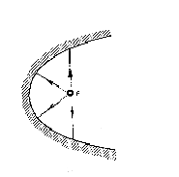
Complete the ray diagram to show reflection from the surface. (2 marks)

(c) In an experiment to determine the focal length of a concave mirror, group of form two students collected some data and used the results to plot a graph shown below

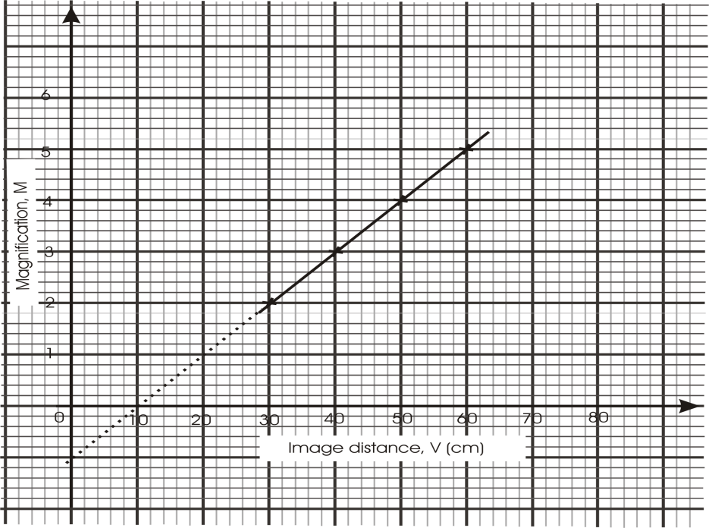

Determine:
(i).The object position when the image position is 45 cm. {2 marks}
…………………………………………………………………………………………………………………………………………………………………………………….......................................................
(ii) Slope of the graph (2 marks)
………………………………………………………………………………………………………………
……………………………………………………………………………………………………………….

(iii) Given that f= 1 determine the focal length f of the mirror (2 marks)
Slope,
………………………………………………………………………………………………………………………………………………………………………………………………………………………………………
d) Explain why a concave mirror is used as a shaving mirror. (2 mark)
........................................................................................................................................................................................................................................................................................................................................................
e) Give one difference and one similarity between virtual images formed by plane mirrors and concave mirrors. (2 marks)
.......................................................................................................................................................................................................................................................................................................................................................................................................................................................................................................................................... (a) State two ways of increasing the strength of an electromagnet. (2 marks)
........................................................................................................................................................................................................................................................................................................................................................
(b) The diagram below shows an electric bell.
Contacts
D
Battery
Switch
C
Contact
screw
Soft iron
armature
B
A

  - Name the parts labeled A, B, C and D. (2 marks)
........................................................................................................................................................................................................................................................................................................................................................................................................................................................................................................................
  - State and explain what happens to the soft iron armature when the switch is closed. (2 marks)
........................................................................................................................................................................................................................................................................................................................................................................................................................................................................................................................
(c) A thin copper wire XY is placed over two parallel thick copper conductors connected to a d.c. power supply as shown below. When the switch in the circuit is closed, the wire XY experiences a force.
N

S

X
Y

- Indicate on the diagram direction in which the wire XY experiences the force. (1 mark)
- Explain how you have determined the direction of the force in (i) above. (2 marks)
................................................................................................................................................................................................................................................................................................................................................ When is the force acting on the wire XY greatest? (1 mark)
................................................................................................................................................................................................................................................................................................................................................
- What is the effect of reversing the direction of flow of the current? (1 mark)
................................................................................................................................................................................................................................................................................................................................................ (a) State two conditions which must be satisfied for total internal reflection to occur.
(2 marks)
........................................................................................................................................................................................................................................................................................................................................................................
(b) The diagram below shows two rays of light incident normally on face PQ of a glass prism, whose critical angle is 42⁰.

45⁰
P
R
Q

Complete the diagram to show the paths of the two rays as they pass through the prism. (3 marks)

(c) A pin is fixed horizontally at the centre of a rectangular container with thin transparent walls as shown below.
Pin
16 cm
Rectangular
container
A

A transparent liquid is then poured into the container. When viewed from side A, the distance of the pin is 6 cm from the surface of the liquid. Determine the refractive index of the liquid. (3 marks)
……………………………………………………………………………………………………………………………………………………………………………………………………………………………………

(d) The figure below shows a coin placed in a large empty beaker. An observer looking into the beaker from the position shown is unable to see the coin.
Coin
Observer
Container

Sketch two rays from a point on the coin to show how the observer is able to see the image of the coin after the container if filled with water. (3 marks)

(e) A ray of light is incident on a water-glass interface as shown in the diagram below.
r
30⁰
Water
Glass

Calculate the value of angle, r, given that the refractive index of glass and water are 1.5 and 1.33 respectively. (3 marks)
……………………………………………………………………………………………………………………………………………………………………………………………………………………………………17.(a) The figure below shows a circuit diagram with three identical bulbs.
S₂
S₁
S₃

State the change in the brightness of the bulbs as the switches S₁,S₂ and S₃ are gradually switched on one after the other (1 mark)

………………………………………………………………………………………………………………………

………………………………………………………………………………………………………………………
(b). A battery made-up of a number of cells has a total e.m.f of 12V . It is placed in series with two resistors and an ammeter as shown in the diagram.
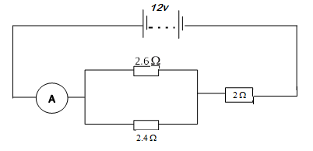
Determine:
(i).The effective resistance in the circuit. (3 marks)

……………………………………………………………………………………………………………………..

………………………………………………………………………………………………………………………

……………………………………………………………………………………………………………………..
(ii).The reading on the ammeter. (2 marks)

.....................................................................................................................................................................................................................................................................................................................................................................
(c).The graphs in the figure below show the relation between the current I and the potential difference V for a resistor and a lamp.
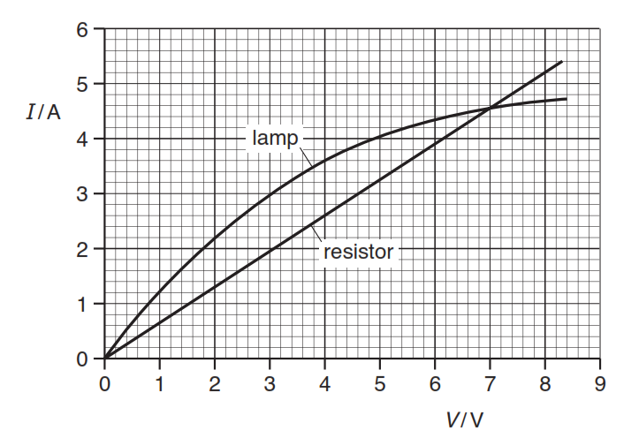

(i) Describe how, if at all, the resistance varies as the current increases in (2 marks)

-the resistor, .......................................................................................................................................

-the lamp. .....................................................................................................................................

(ii) State the value of the potential difference when the resistor and the lamp have the same
resistance. (1 mark)

………………………………………………………………………………………………………………………

(iii) The two components are connected in parallel to a supply of e.m.f. 4.0 V. Calculate the total
resistance of the circuit. (2 marks)

………………………………………………………………………………………………………………….

…………………………………………………………………………………………………………………..

………………………………………………………………………………………………………………….

