Name:……………………………………………………………. Index No:……………………………
DATE:…………………………………………………………… Candidate’s sign…………………
232/2
PHYSICS
Paper 2
2 hours

232/2
PHYSICS
Paper 2
2 hours

INSTRUCTIONS TO CANDIDATES.
1. Write your name and index number in the spaces provided above
2. Sign and write the date of examination in the spaces provided above
3. This paper consists of two sections: A and B
4. Answer all the questions in section A and B in the spaces provided
5. all working must be clearly shown
6. Mathematical tables and silent electronic calculators may be used.

Take g = 10Nkg⁻¹

FOR EXAMINER’S USE ONLY
SECTION |  | MAXIMUM SCORE | CANDIDATES SCORE
A | 1 – 12 | 25
B | 13 | 10
B | 14 | 16
B | 15 | 11
B | 16 | 10
B | 17 | 08
 | TOTAL SCORE | 80

SECTION A (25 MARKS)
Answer ALL the questions in this section in the spaces provided
1. Distinguish between soft and hard magnetic materials. (1mk)
…………………………………………………………………………………………………….………………………………………………………………………………………………………….…………………………………………………………………………………………………….………………………………………………………………………………………………………….

2. A metallic body shaped as shown is positively charged and insulated from the ground as shown.
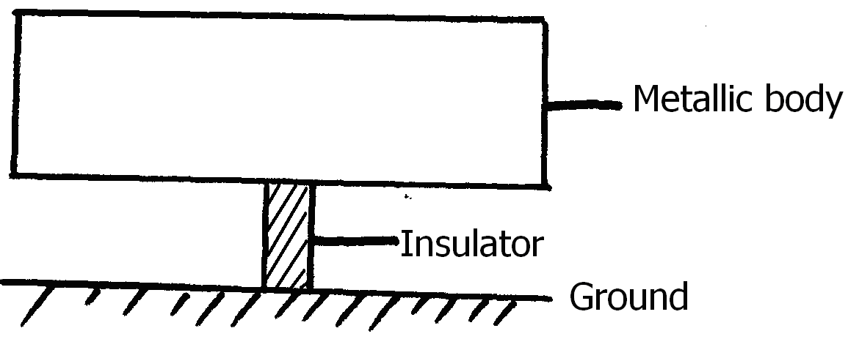Figure 1

On the figure show the charge distribution

3. Figure 2 shows three point sources of light with an opaque object placed between them and the screen.
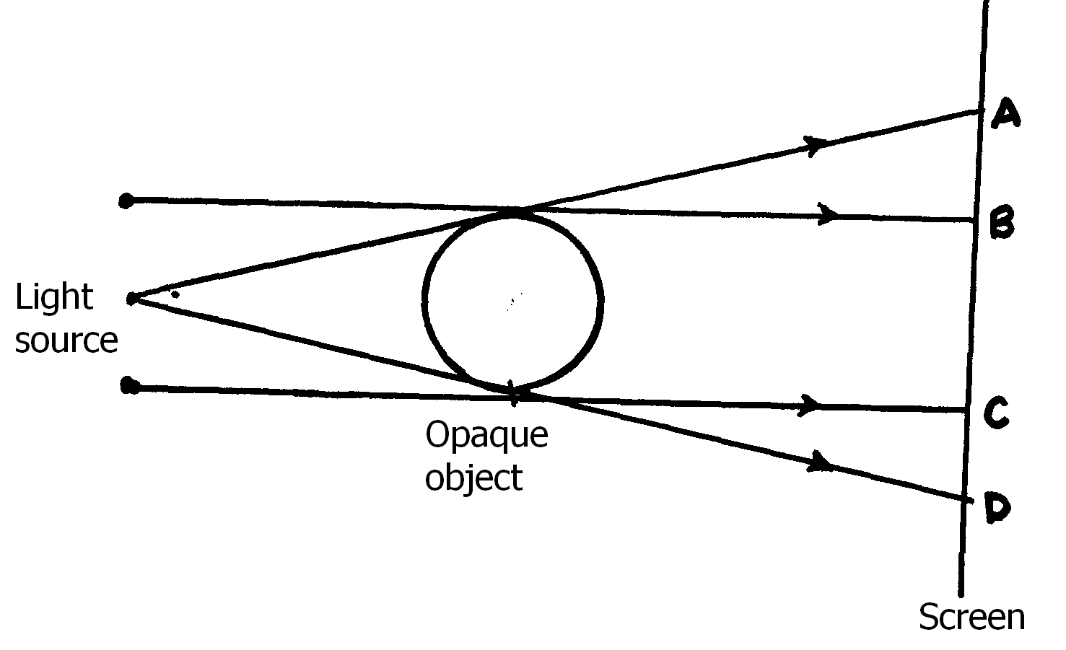
Figure 2
State and explain the nature of shadow formed along BC. (2mks)
…………………………………………………………………………………………………….………………………………………………………………………………………………………….
…………………………………………………………………………………………………….………………………………………………………………………………………………………….

4. Find the maximum number of 75W bulbs that can be connected to a 12A fuse on a 240V mains supply. (3mks)
…………………………………………………………………………………………………….………………………………………………………………………………………………………….
…………………………………………………………………………………………………….………………………………………………………………………………………………………….
…………………………………………………………………………………………………….………………………………………………………………………………………………………….

5. The diagram in figure 3 shows an object O placed in front of a converging lens. F and F’ are the principal foci for the lens.
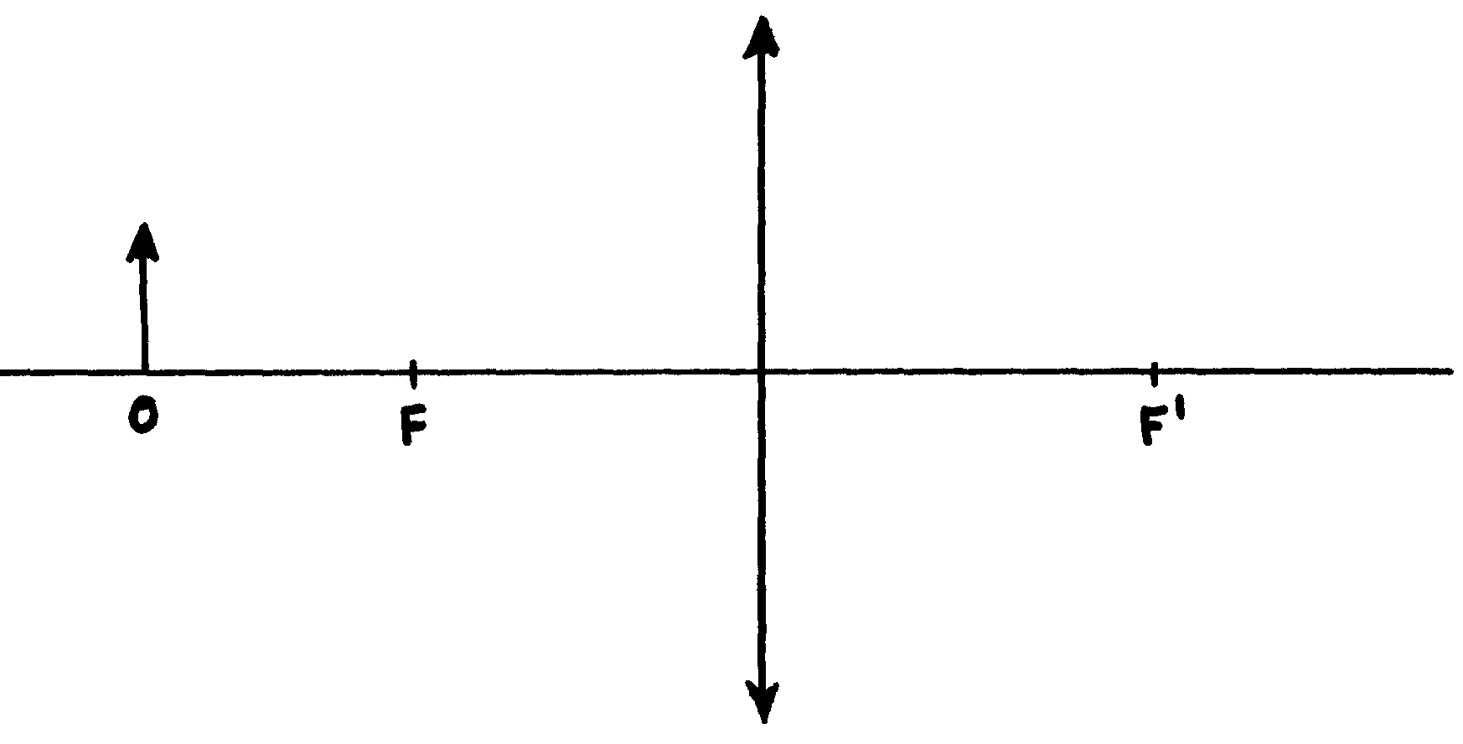Figure 3
The object is now moved along the principal axis until a virtual image is produced.
(i) Draw the object O in the new position along the principal axis. (1mk)
(ii) Sketch rays to show formation of the virtual image. (2mks)

6. Calculate the effective capacitance of the capacitors shown in figure 4 across points X and Y.
(3mks)
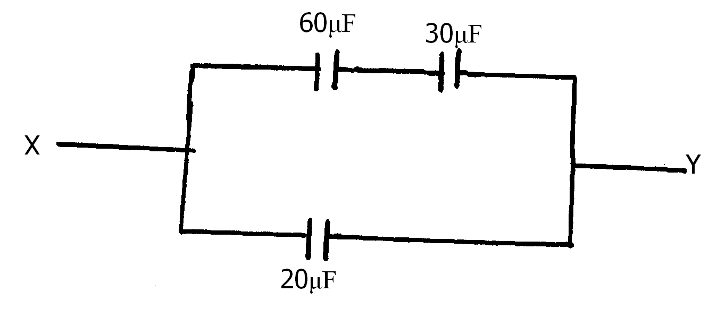Figure 4
…………………………………………………………………………………………………….………………………………………………………………………………………………………….
…………………………………………………………………………………………………….………………………………………………………………………………………………………….

7. Arrange the following radiations in order of increasing wavelengths.
Gamma rays, purple light, ultraviolet and infrared (1mk)
…………………………………………………………………………………………………….………………………………………………………………………………………………………….
8. A surface whose work function Ф = 6.4 x 10⁻¹⁹ Joules is illuminated with light of frequency 3.0 x 10¹⁵ Hz. Find the maximum kinetic energy of the emitted photoelectrons. (n = 6.63 x 10⁻³⁴Js)
(3mks)
…………………………………………………………………………………………………….………………………………………………………………………………………………………….
…………………………………………………………………………………………………….………………………………………………………………………………………………………….
…………………………………………………………………………………………………….………………………………………………………………………………………………………….

9. The following is part of a radioactive decay series.
${}_{\text{83}}^{\text{234}}{}\text{Bi} \vec{β} {}_{\text{84}}^{a}{}X \vec{} {}_{b}^{\text{230}}{}Y$
Determine the values of a and b. (2mks)
…………………………………………………………………………………………………….………………………………………………………………………………………………………….
…………………………………………………………………………………………………….………………………………………………………………………………………………………….

10. The acceleration potential of a certain x – ray tube is increased. State the change observed on the x – ray produced. (1mk)
…………………………………………………………………………………………………….………………………………………………………………………………………………………….

11. A radioactive sample of half life 130 days has 1.0 x 10²⁰ radioactive atoms. Determine the number of radioactive atoms that have decayed after 390 days. (3mks)
…………………………………………………………………………………………………….………………………………………………………………………………………………………….
…………………………………………………………………………………………………….………………………………………………………………………………………………………….
…………………………………………………………………………………………………….………………………………………………………………………………………………………….

12. Figure 5 shows two ways of biasing a P.N junction.
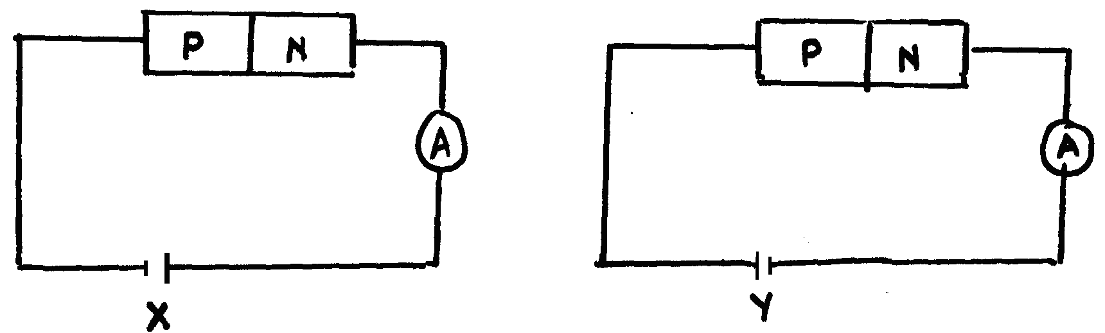
(i) In which circuit will current flow? (1mk)
…………………………………………………………………………………………………….………………………………………………………………………………………………………….
(ii) Explain your answer in (i) above. (1mk)
…………………………………………………………………………………………………….………………………………………………………………………………………………………….
SECTION B (55 MARKS)
Answer ALL the questions in this section in the spaces provided
13. (a) State one similarity and one difference between a concave lens and a convex mirror(2mks)
……………………………………………………………………………………………………………………………………………………………………………………………………………….……………………………………………………………………………………………………………………………………………………………………………………………………………………………………………………………………………….
(b) A lens forms a focused image on a screen when the distance between the object and the
lens is 100cm. the size of the image is twice that of the object.
(i) What kind of lens was used? Give a reason (2mks)
……………………………………………………………………………………………………………………………………………………………………………………………………………………………………………………………………….
(ii) Determine the distance of the image from the lens (2mks)
……………………………………………………………………………………………………………………………………………………………………………………………………………….………………………………………………………………………………………………………………………………………………………………………………………………………………………………………
(iii) Determine the power of the lens (3mks)
……………………………………………………………………………………………………………………………………………………………………………………………………………….……………………………………………………………………………………………………………………………………………………………………………………………………………………………………….
(c) The figure shown in figure 9 shown below is a human eye with a certain defect
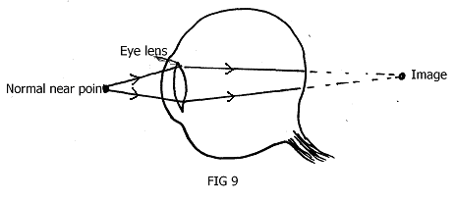
(i) Name the defect (1mk)
………………………………………………………………………………………………………………………………………………………………………………
(ii) On the same diagram, sketch the appropriate lens to correct the defect and sketch
rays to show the effect of the lens. (2mks)
14. (a) State Ohms Law. (1mk)
…………………………………………………………………………………………………….………………………………………………………………………………………………………….
………………………………………………………………………………………………………
(b) Describe an experiment to verify Ohm’s law given a cell, ammeter, voltmeter, switch, nichrome wire and connecting wires. (4mks)
……………………………………………………………………………………………………………………………………………………………………………………………………………………………………………………………………………………………………………………………………………………………………………………………………………………………………………………………………………………………………………………………………………………………………………………………………………………………………………………………………………………………………………………………………………………………………………………………………
(c) The figure below shows a series – parallel circuit.
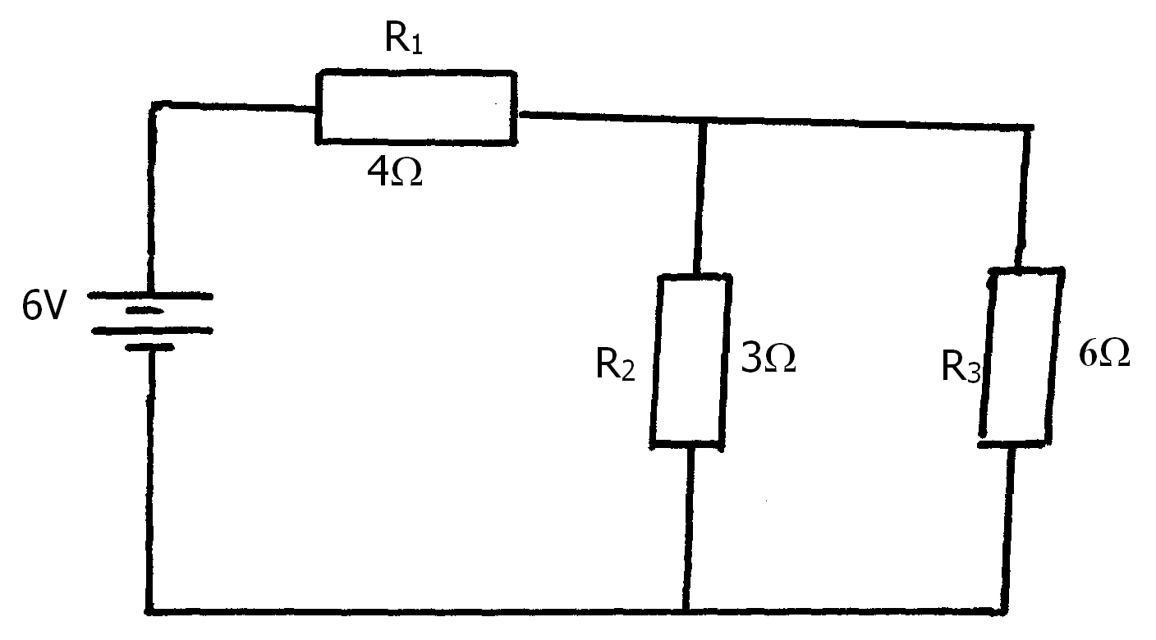
Calculate:
(i) Total resistance of the circuit. (3mks)
…………………………………………………………………………………………………….………………………………………………………………………………………………………….
…………………………………………………………………………………………………….………………………………………………………………………………………………………….
…………………………………………………………………………………………………….………………………………………………………………………………………………………….

(ii) Total current flowing in the circuit. (2mks)
…………………………………………………………………………………………………….………………………………………………………………………………………………………….
…………………………………………………………………………………………………….………………………………………………………………………………………………………….

(iii) Voltage drop across R₁ (2mks)
…………………………………………………………………………………………………….………………………………………………………………………………………………………….
…………………………………………………………………………………………………….………………………………………………………………………………………………………….

(iv) Current through the 3Ω resistor. (3mks)
…………………………………………………………………………………………………….………………………………………………………………………………………………………….
…………………………………………………………………………………………………….………………………………………………………………………………………………………….
…………………………………………………………………………………………………….………………………………………………………………………………………………………….

15. (a) The figure below shows two circuits close to each other.
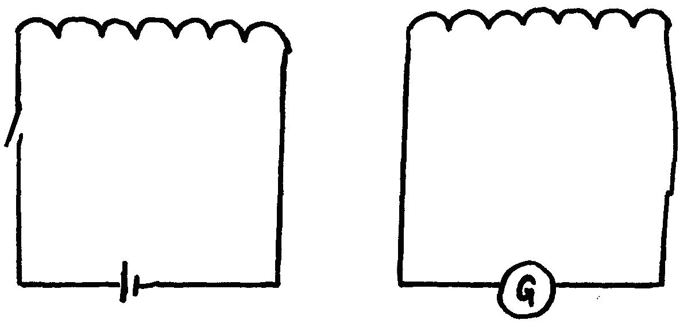
When the switch is closed, the galvanometer shows a reading and then returns to zero. When the switch is opened, the galvanometer shows a reading in the opposite direction and then returns to zero. Explain these observations. (3mks)
…………………………………………………………………………………………………….………………………………………………………………………………………………………….
…………………………………………………………………………………………………….………………………………………………………………………………………………………….
…………………………………………………………………………………………………….………………………………………………………………………………………………………….
(b) An ideal transformer has 500 turns in the primary circuit and 2000 turns in the secondary circuit. When the primary circuit is connected to a 200V a.c. source, the power delivered to a resistor in the secondary circuit is formed to be 1000W.
(i) Giving a reason compare the thickness of the wires used in the primary and secondary circuit. (2mks)
…………………………………………………………………………………………………….………………………………………………………………………………………………………….
…………………………………………………………………………………………………….………………………………………………………………………………………………………….
(ii) Determine the current in the secondary circuit (3mks)
…………………………………………………………………………………………………….………………………………………………………………………………………………………….
…………………………………………………………………………………………………….………………………………………………………………………………………………………….
…………………………………………………………………………………………………….………………………………………………………………………………………………………….
(iii) Determine the current in the primary circuit. (3mks)
…………………………………………………………………………………………………….………………………………………………………………………………………………………….
…………………………………………………………………………………………………….………………………………………………………………………………………………………….
…………………………………………………………………………………………………….………………………………………………………………………………………………………….
16. (a) The figure below show the displacement time graph of a wave traveling at 400cm/s.
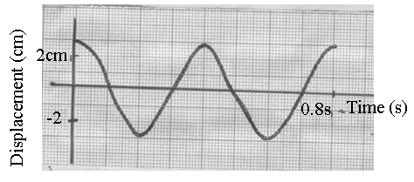
Determine for the wave the:
(i) Amplitude (1mk)
…………………………………………………………………………………………………….………………………………………………………………………………………………………….
(ii) Period (1mk)
…………………………………………………………………………………………………….………………………………………………………………………………………………………….
(iii) Frequency (2mks)
…………………………………………………………………………………………………….………………………………………………………………………………………………………….
…………………………………………………………………………………………………….………………………………………………………………………………………………………….
(iv) Wavelength (3mks)
…………………………………………………………………………………………………….………………………………………………………………………………………………………….
…………………………………………………………………………………………………….………………………………………………………………………………………………………….
…………………………………………………………………………………………………….………………………………………………………………………………………………………….
(b) The human ear can distinguish two sounds as separate only if they reach it at least 0.1s apart. How far from a wall must an observer be in order to hear an echo when he shouts?
(Speed of sound in air = 330ms⁻¹) (3mks)
…………………………………………………………………………………………………….………………………………………………………………………………………………………….
…………………………………………………………………………………………………….………………………………………………………………………………………………………….
…………………………………………………………………………………………………….………………………………………………………………………………………………………….

17. (a) A TV tube uses a voltage of 4550V to accelerate electrons released from its cathode by thermionic emission.
(i) What is meant by thermionic emission? (1mk)
…………………………………………………………………………………………………….………………………………………………………………………………………………………….
(ii) How is thermionic emission is achieved in the CRT. (1mk)
…………………………………………………………………………………………………….………………………………………………………………………………………………………….

(b) Figure (a) and (b) show the screen y – gain and time base controls from a typical oscilloscope displaying a waveform.
Screen Screen
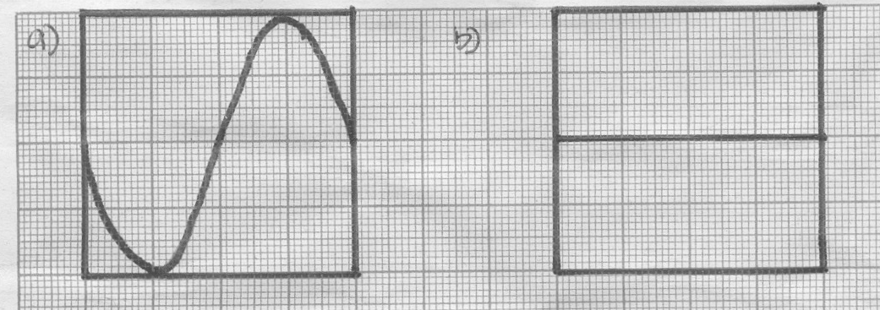
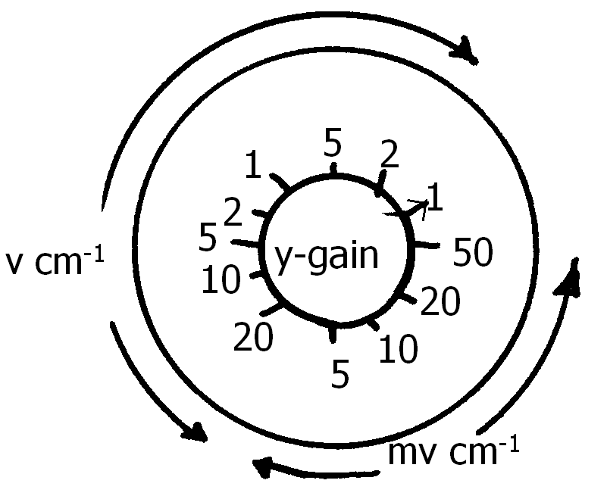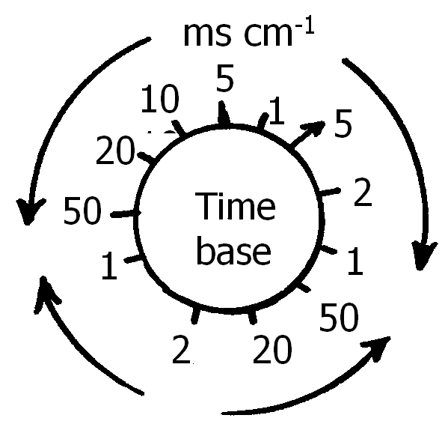
$$μs {\text{cm}}^{−1}$$
(i) What is the setting of the y – gain control? (1mk)
…………………………………………………………………………………………………….………………………………………………………………………………………………………….
(ii) What is the peak voltage of the waveform? (1mk)
…………………………………………………………………………………………………….………………………………………………………………………………………………………….
(iii) State the time base setting (1mk)
…………………………………………………………………………………………………….………………………………………………………………………………………………………….
(iv) From the display waveform, state the period of the trace. (1mk)
…………………………………………………………………………………………………….………………………………………………………………………………………………………….
(v) Calculate the frequency of the waveform. (2mks)
…………………………………………………………………………………………………….………………………………………………………………………………………………………….
…………………………………………………………………………………………………….………………………………………………………………………………………………………….

