Name ............................................................................................................... Index No. ..............................

School ............................................................................................Candidate's signature ..............................

232/1

PHYSICS
Paper 1
Time 2 hours
Date ........................................................

PHYSICS
Paper - 232/1
Time: 2 hours
INSTRUCTIONS TO CANDIDATES

• Write your name and index number in the spaces provided above.
• Sign and write the date of the examination in the spaces provided above.
• This paper consist of two sections A and B.
• Answer ALL questions in section A and B in the spaces provided.
• All working must be clearly shown in the spaces provided in this booklet.
• Non-programmable, silent electronic calculators and KNEC mathematical tables may be used.

EXAMINER'S USE ONLY

SECTION | QUESTION | MAXIMUM SCORE | CANDIDATES SCORE
A | 1 - 12 | 25
B | 13 | 12
B | 14 | 11
B | 15 | 10
B | 16 | 11
B | 17 | 11
TOTAL SCORE |  | 80

This paper consists of 11 printed pages

Candidates should check the question paper to ensure that all the printed pages are printed as indicated and no questions are missing.

SECTION A (25 marks)
Answer ALL the questions in the spaces provided.

1. State the smallest measurement that can be made by the micrometer screw gauge. (1 mark)

...................................................................................................................................................................

2. The diagram below shows a section of a micrometer screw gauge.

45
5 10 15

40

ii) The thimble of the micrometer screw gauge is rotated through two and half revolutions in the clockwise direction in order to measure the diameter of a marble. State the diameter of the marble if the instrument had a negative error of 0.03mm. (2 marks)

...................................................................................................................................................................

...................................................................................................................................................................

...................................................................................................................................................................

3. State one factor that would affect surface tension of pure water in a beaker of water. (1 mark)

...................................................................................................................................................................

...................................................................................................................................................................

4. The diagram below shows apparatus used to observe the behaviour of smoke particle in air.

Microscope

Thin glass cover

Smoke and air
Light

i) Why are smoke particles suitable for use in this experiment. (1 mark)

...................................................................................................................................................................

................................................................................................................................................................... ii) What does the experiment tell you about the behaviour of the air molecules in the cell? (1 mark)
...................................................................................................................................................................

...................................................................................................................................................................

iii) What difference if any would be seen in the motion of the smoke particles if a weaker light was used. (1 mark)

...................................................................................................................................................................

...................................................................................................................................................................

5. In the evening the inside of green houses may be seen to have water droplets on them. Why does this happen? (1 mark)

...................................................................................................................................................................

...................................................................................................................................................................

6. When a particular substance at a certain temperature is heated, it expands. When the same substance at the same temperature is cooled, it also expands. (2 marks)

a) What is the substance?

...................................................................................................................................................................

................................................................................................................................................................... b) What is the temperature?
...................................................................................................................................................................

...................................................................................................................................................................

7. A block of metal of mass 0.20kg and temperature 100°C is placed in water of mass 0.42g and temperature 21°C. If the final temperature of the water is 25°C, calculate the specific heat capacity of the metal. (Neglect heat absorbed by the container, take specific heat capacity of water 4200J/kg k.)
(3 marks)

...................................................................................................................................................................

...................................................................................................................................................................

...................................................................................................................................................................

...................................................................................................................................................................

8. The spring is fitted with a scale pan as shown in the figure below and the pointer points to the 30cm mark on the scale. When some sand is placed in the pan the pointer points to 15cm mark.

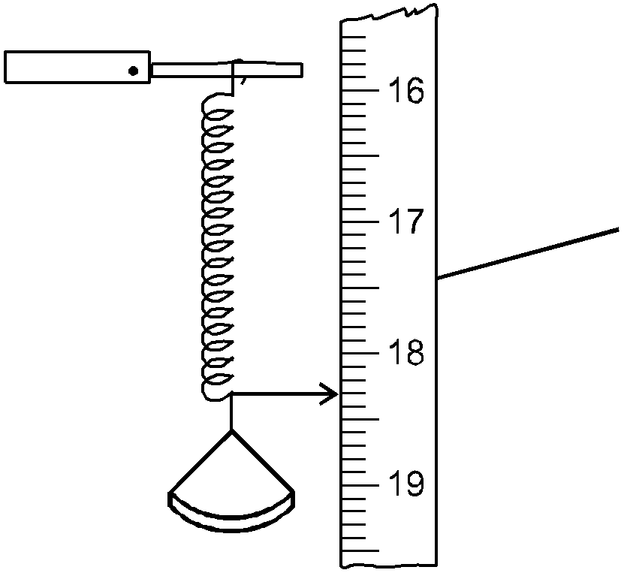 Scale

When a 20g mass is placed on top of the sand the pointer points to 5.0cm mark.
a) What extension is produced by the sand?

...................................................................................................................................................................

................................................................................................................................................................... b) What extension is produced by the 20g mass?
...................................................................................................................................................................

................................................................................................................................................................... c) What is the mass of the sand? (3 marks)
...................................................................................................................................................................

...................................................................................................................................................................

9. Define the term centre of gravity of a body. (1 mark)

...................................................................................................................................................................

...................................................................................................................................................................

10. A uniform half metre rule is pivoted at the 15cm mark and it balances when a mass of 40g is hung from the 2cm mark. Calculate the mass of the rule. (2 marks)

...................................................................................................................................................................

...................................................................................................................................................................

11. A machine of velocity ratio of 50N overcomes a load of 4.5 ×10³ N when the effort of 120W is applied.

i) Find the efficiency of the machine. (2 marks)

...................................................................................................................................................................
................................................................................................................................................................... ii) It is observed that the efficiency of the machine increase when it is used to lift large load. Give a
reason for this (1 mark)

...................................................................................................................................................................

...................................................................................................................................................................

12. Figure below shows a fluid flowing in a tube.

X Y Z

Show on the diagram the relative position of the levels of the liquid in section marked X, Y Z.
(3 marks)
SECTION B (55 marks)
Answer ALL the questions in this section in spaces provided.
I.
a) The diagram below shows a set up used by a student to show variation of pressure in a liquid. Use it
to answer the question that follow.

h

Thistle Funnel
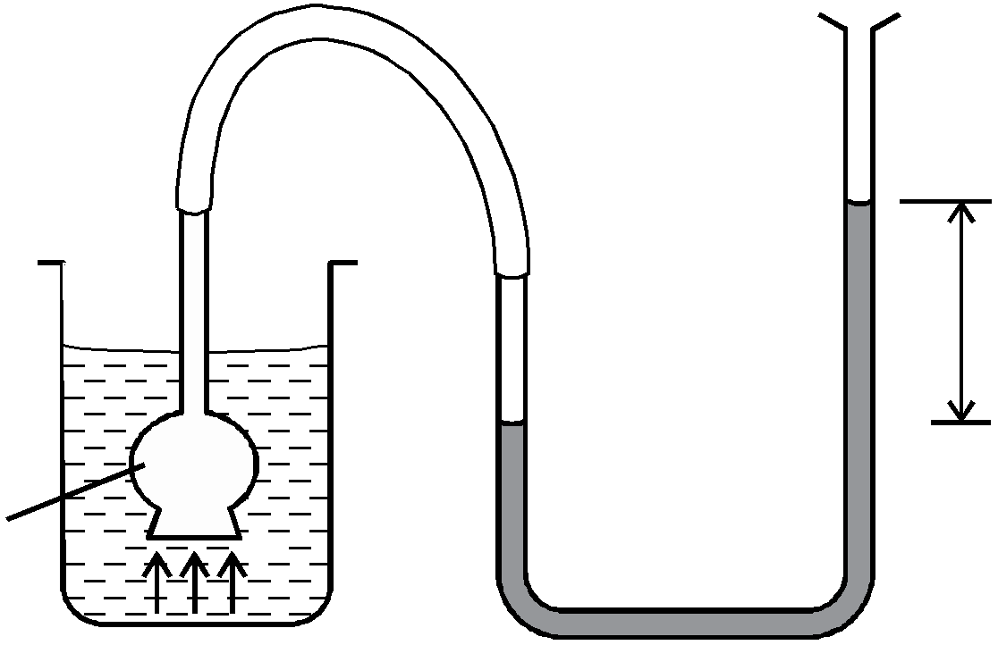

State and explain the effect on the height, h, when the thistle funnel is moved upwards towards the surface of the liquids. (2 marks)

...................................................................................................................................................................

...................................................................................................................................................................

b) Figure below shows a simple barometer.

A 2cm 2cm

74cm

1cm

1cm

a) What is the region A? (1 mark)

................................................................................................................................................................... b) What keeps the mercury in the tube? (1 mark)
................................................................................................................................................................... c) What is the value of the atmospheric pressure being shown by the barometer? (1 mark)
................................................................................................................................................................... d) What would happen to the reading if the barometer were taken up a high mountain. (1 mark)
................................................................................................................................................................... e) Give a reason for (d) above. (1 mark)
...................................................................................................................................................................
II. a) In opening a door, the moment exerted about the hinges was 15Nm. If the pushing force was 25N
and perpendicular to the door, what is the distance of the force from the hinges? (2 marks)

...................................................................................................................................................................

...................................................................................................................................................................

...................................................................................................................................................................
................................................................................................................................................................... b) A uniform plank of wood is balanced 30cm from one end when a lead of 0.08kg is hung at one
end as shown below.

0 30cm 110cm

0.08Kg

Calculate the weight of the plank. (2 marks)

...................................................................................................................................................................

...................................................................................................................................................................

................................................................................................................................................................... c) State two factors that affect centre of gravity. (1 mark)
...................................................................................................................................................................

...................................................................................................................................................................

14. a) Sketch a velocity-time graph of a ball dropped to the ground and caught when it bounces up again. (2 marks)

b) In areas of the world where a plane is unable to land free fall airdrops can be used to deliver supplies. A plane travelling at a speed of 90m/s and a height of 100m releases a load of supplies.

i) Sketch the path followed by the falling load. (1 mark)
ii) Find the horizontal distance of the load from the drop zone to where it landed. (3 marks)

...................................................................................................................................................................

...................................................................................................................................................................

................................................................................................................................................................... c) Define the Newton. (1 mark)
...................................................................................................................................................................

...................................................................................................................................................................
................................................................................................................................................................... d) The reading on a speedometer of a car of mass 1000kg is 60km/hr when the brakes are applied.
The car is brought to rest in 10m.

Find
i) the retardation. (2 marks)

...................................................................................................................................................................

...................................................................................................................................................................

................................................................................................................................................................... ii) find the average breaking force. (2 marks)
...................................................................................................................................................................

...................................................................................................................................................................

...................................................................................................................................................................

15.a) The figure below shows the motion of a ticker tape through a ticker-timer whose frequency is
100Hz.

A 12cm B P

32cm Q

Determine:

I. Velocity at AB and PQ (2 marks)

...................................................................................................................................................................

................................................................................................................................................................... II. Acceleration of the tape. (2 marks)
...................................................................................................................................................................

...................................................................................................................................................................

b) Sate two factors that affect centripetal force of a body moving a circular path. (2 marks)

...................................................................................................................................................................

...................................................................................................................................................................

c) A stone of mass 1.2 kg is tied to a rope and whirled in a vertical circle of radius 3.2m with a speed of
6.32m/s. Calculate

i) The centripetal acceleration of the stone. (2 marks)

...................................................................................................................................................................

...................................................................................................................................................................

................................................................................................................................................................... ii) The tension in the rope when the stone is at the highest point. (2 marks)
...................................................................................................................................................................

...................................................................................................................................................................

...................................................................................................................................................................

16. a) State the law of floatation. (1 mark)

...................................................................................................................................................................
................................................................................................................................................................... b) You are provided with the following
- A block of wood.
- A spring balance
- A thin thread.
- Overflow can
- A small measuring cylinder.
- Some liquid.
With the aid of a labelled diagrams describe an experiment to verify the law of floatation. (4 marks)

c) A block of length 80cm, cross sectional area 3.0cm² and density 1300kg/m³ is completely immersed in a liquid of density 1030kg/m³. Determine

i) The mass of the block. (1 mark)

...................................................................................................................................................................

................................................................................................................................................................... ii) The weight of the block in the liquid. (3 marks)
...................................................................................................................................................................

...................................................................................................................................................................

...................................................................................................................................................................
d) The diagram below shows a car acid hydrometer.

P

Stem

Q

Bulb

Lead shots

i) Indicate on the diagram the maximum and minimum measurements to be taken. (1 mark)

ii) State the reason why the bulb is wide. (1 mark)

...................................................................................................................................................................

...................................................................................................................................................................

...................................................................................................................................................................

17.a) i) State Charles law. (1 mark)

...................................................................................................................................................................
................................................................................................................................................................... ii) A gas of volume 2m³ at 27°C is cooled to -123°C, at constant pressure. What is its new volume?
(2 marks)

...................................................................................................................................................................

...................................................................................................................................................................

...................................................................................................................................................................

...................................................................................................................................................................

b)

Syringe

Pressure Gauge

Air

The figure shown illustrates an apparatus in which a fixed mass of air was compressed in a calibrated syringe, which was approximately half full of air at atmospheric pressure and a temperature of 17°C corresponding values of volume and pressure of the trapped air as shown in the table.

Pressure (Kpa) | 50 | 60 | 75 | 90 | 105 | 120
Volume (cm³) | 0.00048 | 0.00040 | 0.00032 | 0.00027 | 0.00023 | 0.00020

1 (m −3 )
Volume

2500 3704

(1 mark)

i)
you.

Complete the table by calculating values for
1
Volume

some of the values have been entered for

ii)

On grid paper plot a graph of pressure on the y-axis against

1
Volume

on the axis.

(5 marks)

iii) What relationship between pressure and volume of the trapped air can be deducted from your graph? Explain your answer. (1 mark)

...................................................................................................................................................................

...................................................................................................................................................................
................................................................................................................................................................... iv) If the temperature of air was increased to 27°C, what volume would be occupied by the air at a
pressure of 100Kpa? (1 mark)

...................................................................................................................................................................

...................................................................................................................................................................

...................................................................................................................................................................

12

