NAME: ………………………………………………………CLASS:……………ADM NO………………
GEOGRAPHY
PAPER 1
TIME: 2 ¾ HOURS

INSTRUCTIONS:

- The paper comprises of 2 sections A and B.
- Attempt all question in section A.
- In section B, answer question 6 and chose any other two.
- Use separate answer sheets for section A and each question in section B.

This paper consists of 4 printed pages. Candidates should check the question paper to ensure that all pages are printed as indicated and no questions are missing.
SECTION A
Answer ALL the questions in this section.
1. a) Outline two ways through which the interior of the earth is studied. (2 marks)
b) State three natural causes of earthquakes. (3 marks)
2. a) The map below shows the climatic regions of Kenya. Use it to answer questions
that follow
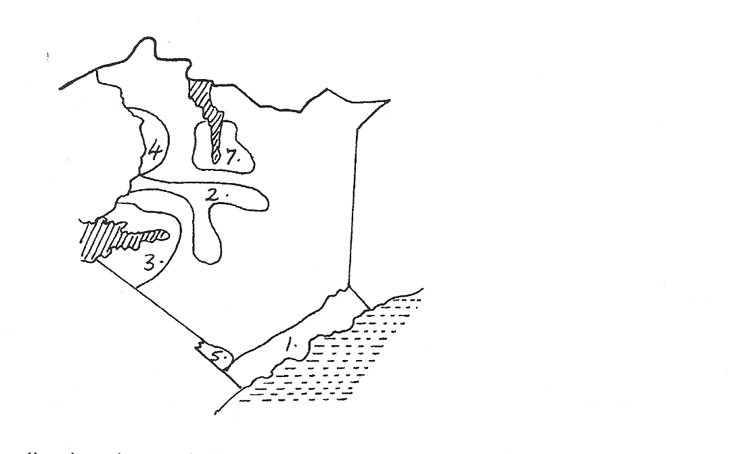

a) Name the climatic regions marked 2 and 7. (2 marks)
b) State three characteristics of climatic region marked 7 (3 marks)
3. (a) Define continental drift (2 marks)
(b) Briefly explain three evidences that support the theory of continental drift.
(3 marks)
4 (a) In your answer booklet, draw a diagram to show a limestone cave and on it mark and
name:
(i) A stalactite (1 mark)
(ii) A limestone pillar (1 mark)
(iii) Stalagmite (1 mark)
(b) State two conditions necessary for the development of Karst scenery. (2 marks)
5. a) The diagram below shows a type of mass movement.
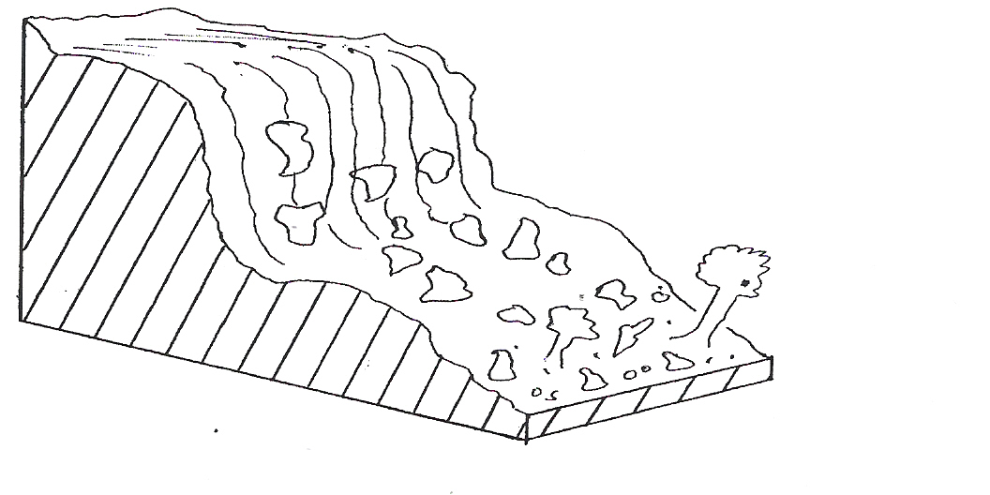

(i) Which type of mass movement is shown by the diagram? (1 mark)
(ii) How does such a movement occur? (2 marks)
(b) List two evidences of soil creep. (2 marks)

Section B.
Answer question 6 and any other Two questions
. Study the map of Kitale 1:50,000 (sheet 75/3) provided and answer the following questions
- (i) Identify the types of scales used in the area covered by
the map. (2mks)
(ii) Name two physical features found in grid square 2816.
(2mks)
(iii) Give two methods of showing relief found in the area
covered by the map. (2mks)
(iv) Calculate the area of the area covered by the papyrus swamp near Keelah Farm, give your answer in square kilometers. (2mks)
- On the square draw a square measuring 10cm by 10cm to
represent the area enclosed by Easting 25 and 30 and Northings 15 and 20. On the square mark and draw name the following. (5mks)
- All weather road loose surface
- River Koitobos
- Forested area
- Describe the drainage of the area covered by the map (6mks)
- Citing evidence from the map, explain three factors favouring the growth of the forest in the area covered by the map. (6mks)
7. a) (i) Distinguish between vulcanicity and volcanicity. (2 marks)
(ii)Name three cycles of a volcanoe. (3 marks)
(iii) Identify three causes of vulcanicity. (3 marks)
b) (i) Explain how a volcanic plug is formed. (6marks)
(ii) Explain three ways in which vulcanicity may influence the climate
of the surrounding areas. (6 marks)
c) State five economic effects of vulcanicity to man. (5 marks)
8. a) State two agents of denudation. . (2 marks)
b) Explain how the following factors affect the rate and character of weathering.
i) Nature of the rock (3 marks) ii) Plants and animals (3 marks)
c) Explain three ways in which soil creep occurs. (6 marks)
d) i) Define the term mass wasting. (1 mark)
ii) Stale three factors that influence mass wasting. (3 marks)
e) Your class plans to carry out a field study on mass wasting around your school,
i) State three reasons why you require to carry out a pre- visit, (3 marks)
ii) List two secondary sources of data you are likely to use as you prepare for
the field. (3 marks)
iii) State two methods you would use to collect data. (2 marks)
9. a) Describe how a river erodes its channel by the following processes
i) Hydraulic action (4 marks)
ii) Abrasion (4 marks)
b) i) Explain three factors that lead to rejuvenation of a river (6 marks)
ii) Describe the process of a river capture (4 marks)
c) You have been asked to carry out a field study on features produced by rivers
i) State two methods you would use to record your data (2 marks)
ii) State two hypotheses you would set (2 marks)
iii) Give three significance of the features produced by rivers they studied
(3 marks)
10. (a) (i) What is an ice sheet? (2 mks)
(ii) State two reasons why there are no ice-sheets in Kenya. (2 mks)

(b) With the use of a well labeled diagram, describe the formation of a cirque.
(7 mks)
(c) Explain four factors that influence glacial deposition in the lowlands. (8 mks)

(d) Explain how glaciation influences the following economic activities:-
(i) Mining (2 mks)
(ii) Transport (2 mks)
(iii) Fishing (2 mks)

