NAME: …………………………………. ADM NO: …………… CLASS: …………………..
GEOGRAPHY
PAPER 2
FORM 4
TIME: 2 ¾ HOURS

INSTRUCTIONS:

- The paper comprises of 2 sections A and B.
- Attempt all question in section A.
- In section B, answer question 6 and chose any other two.

SECTION A:
1. Give five uses of photographs. (5 mks)

2. What are the causes of aridity and desertification? (5 mks)

3. How has man contributed to increased carbon(iv) oxide in the atmosphere? (5 mks)

4. Name five montane forests in Kenya. (5 mks)

5. State five factors favouring the exploitation of softwood forests in Canada. (5 mks)

Section B
Answer question 6 and any other two questions from this section
6. a) The table below shows mineral production (in tonnes) in Kenya in the year 2000. Use it
to answer question a (i) and (ii)
Mineral | Mineral production (in tonnes)
Soda ash | 238,250
Limestone | 126,850
Fluorspar | 100,200
Salt | 442,450
Other | 52,050
Total | 959,800
i) Using a radius of 4cm, draw a pie-chart to represent the above data. (7 marks)

ii) Name two other statistical methods that can also be used to represent the above
given data. (2 marks)
iii) State three advantages of using a pie chart to represent data. (3 marks)

b) i) Explain how the following factors have influenced the extraction of trona in
Lake Magadi, Kenya
i) Capital (2 marks)
ii) Method of mining (2 marks)
iii) Size of trona deposits (2 marks)
c) i) Apart from land dereliction, state four other effects of mining and quarrying
activities on the environment. (4 marks)
ii) Give three methods a derelict land can be made to become useful. (3 marks)

7. a) i) Distinguish between indigenous forests and exotic forests. (2 marks)
ii) Mention four indigenous hardwood varieties found in the Kenyan forests.(4 marks)

b) Explain how the following factors have helped in the conservation of forests in Kenya.
i) Legislation (Forest Act) (2 marks)
ii) Creation of forest reserves (2 marks) iii) Setting up of Nyayo Tea Zones (2 marks)
c) Explain five reasons why forests are important in Kenya. (10 marks)
d) Name three forests found in Kenyan highlands. (3 marks)

8. a) Give the definitions of the following terms
i) Forest (2 marks)
ii) Forestry (2 marks)
iii) Agroforestry (2 marks)
iv) Afforestation (2 marks)
v) Reafforestation (2 marks)

b) The world map below shows, the major types of forests in the world
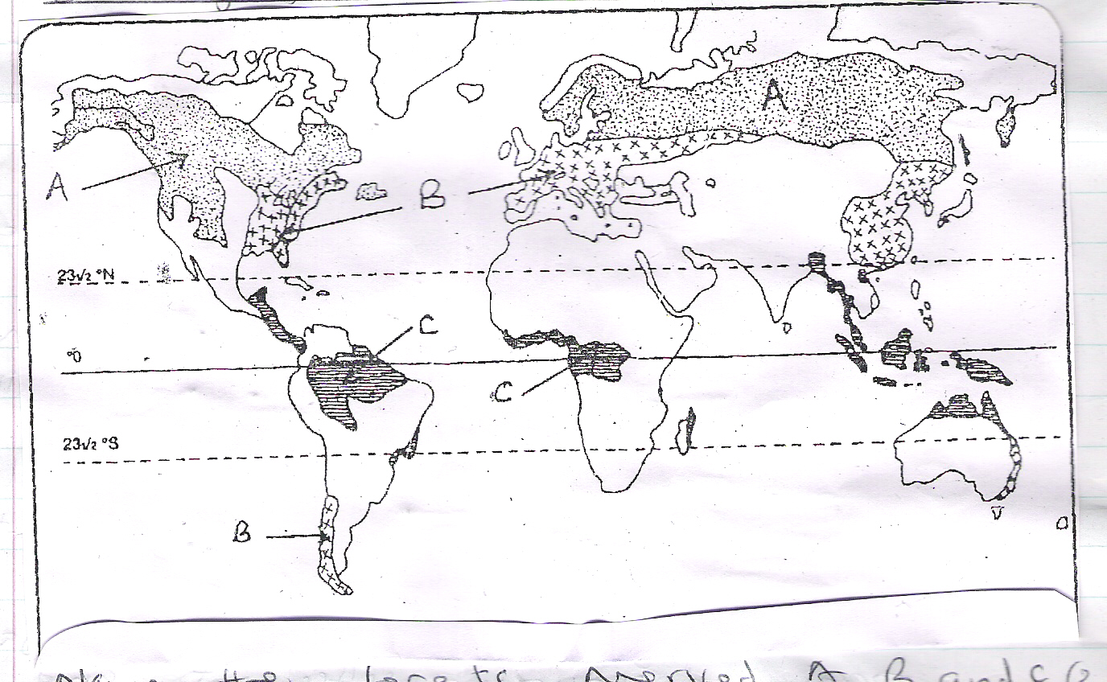
i) Name the forests marked A, B and C. (3 marks)
ii) State four characteristics of the forest marked A. (4 marks)
c) State four characteristics that influence the growth of forests on the slopes of Mt. Kenya. (4 marks)
d) Outline four problems facing forestry in Kenya. (4 marks)

9. (a) (i) State any two forms in which minerals occur (2mks)
(ii) Name any three places where limestone is mined in Kenya (3mks)
(b) Explain how the following factors influence the exploitation of a mineral
(i) Market (2mks)
(ii) The quality of ore (2mks)
(iii) Technology (2mks)

(c) (i) Name two provinces in south Africa where gold is mined (2mks)
(ii) Explain three problems facing gold mining in south Africa (6mks)
(d) Describe the processing of diamond in south Africa. (6 mks)

