FORM THREE PAPER ONE MATHEMATICS
NAME………………………………..………………………ADM………….CLASS…………….

1. Express the number 1470 and 7056 each as a product of its prime factor. Hence evaluate $\frac{{\text{1470}}^{2}}{\sqrt{\text{7056}}}$, leaving the answer in prime factor form. (3mks)

2. The figure below shows a solid made by pasting two equal regular tetrahedron
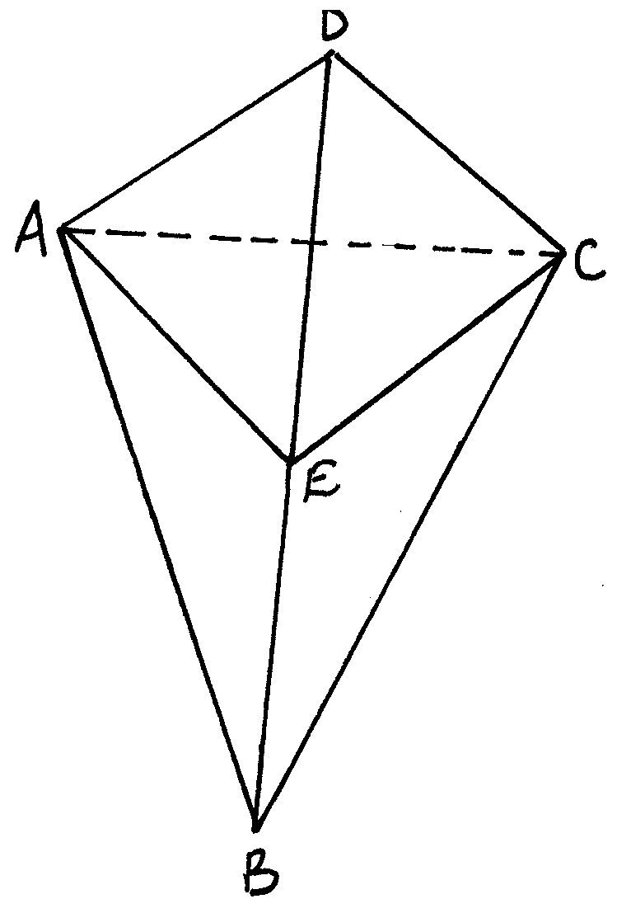
(a) Draw a net of the solid (2mks)

(b) If each face is an equilateral triangle of sides 5cm, find the surface area of the solid (2mks)

3. Solve the following equation for x
$9^{x}+3^{2x−1}−1=\text{107}$ (3mks)

4. Three businessmen Njoroge, Mwaura and Kimani contributed a total of sh. 82, 250 to start a business. The ratio of the contribution of Njoroge to Mwaura was 2:3 and that of Mwaura to Kimani was 4:5. How much did Kimani contribute? (3 marks)

5. Find the integral values of x which satisfy the compound inequality 3x – 2 ≤ 8 + x < 12 + 5x
(3 marks)

6.A line passes through the points A (2, 6) and B (4, -8). Find the equation of the perpendicular bisector of line AB. (3mks)

7. If each interior angle of a regular polygon is 150⁰, how many sides does the polygon have? (3mks)

8. Simplify $\frac{2x^{2}+x−6}{x^{2}−4}+\frac{1}{x−2}$ (3mks)

9. Use mathematical tables to evaluate to 4 decimal places.
$\frac{1}{\sqrt{0\text{.}\text{24680}}}+0\text{.}{\text{14682}}^{3}$ (4mks)

10.From the roof of a house, a boy can see an avocado tree which is 20m away from the house. He measures the angle of elevation of the top of the tree as 21⁰ and the angle of depression of the bottom of the tree as 31⁰. Find the height of the avocado tree. (3mks)

12.From a survey carried out the following information was entered in a field book
Y
- 180 to N
To R 90 180
- 60 to M
X

12.The position vectors of points x, y and z are, $x=t\overset{\text{\sim }}{i}+2\overset{\text{\sim }}{j}:y=2\overset{\text{\sim }}{i}+3\overset{\text{\sim }}{j},$ and $2=3\overset{\text{\sim }}{i}+4\overset{\text{\sim }}{j}$ respectively. If the points x, y and z are collinear, find the value of t (3mks)

13.A Kenyan bank buys and sells foreign currencies at the exchange rates shown below
Buying Selling
Kshs Kshs
1 Euro 147.56 148.00
1 US Dollar 74.22 74.50
An American arrived in Kenya with 20,000 Euros. He converted all the euros to Kenya shillings at the bank. He spent Ksh 2510200 while in Kenya and converted the remaining Kenya shillings into US dollars at the bank. Find the amount in Dollars that he received. (4mks)

14. Calculate the area of the shaded segment of the circle given in the figure below. (3mks)
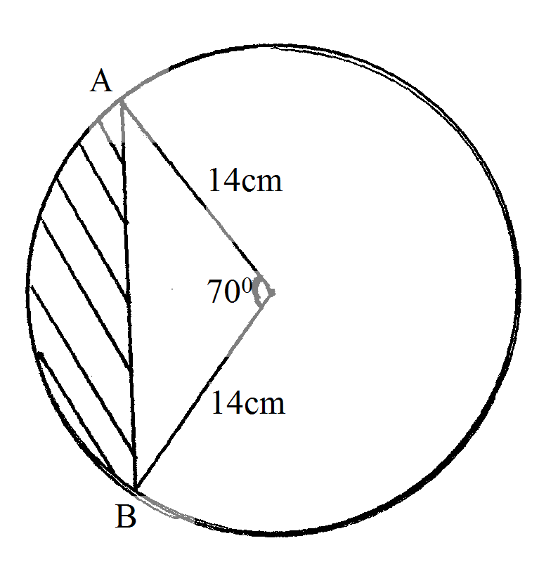

15.Okisai is three times as old as his son now. If ten years ago the sun of their ages was 44. How
Old was Okisai when his son was born ? (3mks)

16. Given that sin , find tan (90 - ) in its simplest form (3mks)

SECTION II (50 MARKS)
Answer only FIVE questions from this section.
17. Patients who attended a clinic in one week were grouped by age as in the table
Age years | $$0≤x<5$$ | $$5≤x<\text{15}$$ | $$\text{15}≤x<\text{25}$$ | $$\text{25}≤x<\text{45}$$ | $$\text{45}≤x<\text{75}$$
No. of patients | 14 | 41 | 60 | 70 | 15

(a) Estimate the mean age

(b) Draw a histogram to represent the distribution.

18. A bus left Kisumu at 9:30 a.m towards Nairobi at an average speed of 81 km/hr. A matatu left Nairobi at 10.10 a.m at an average speed of 72km/hr. The distance between Kisumu and Nairobi is 360km.
(a) Determine
(i) The time taken before the two vehicles met. (3mks)

(ii)The distance between the two vehicles 40 minutes after meeting. (2mks)

b)A car left Kisumu towards Nairobi at 9.50 a.m at an average speed of 90 km/hr.
Determine
i) The time when the car caught up with the bus. (3mks)

ii)The distance of Nairobi from the place where the car caught up with the bus. (2mks)

19. The diagram below shows a circle ABC with AB =12cm, BC= 15cm and AC = 14cm.
A

C
Calculate to 4 significant figures.
a) The angle ACB (3 marks)

b) The radius of the circle (3 marks)

c) The area of the shaded region. (4 marks)

20. A hemispherical bowl has internal and external radii 30cm and 32cm respectively.
(a) Calculate the volume of the material used in making the bowl. (4mks)

(b) The bowl is made of copper of density 9g/cm³. Calculate the mass of the copper used to make the bowl. (4mks)

(c) Find the total cost of making the bowl if copper cost shs 450 per kg (2mks)

21. On a certain day Mwema bought plates worth Ksh 120. On another day Mrs Mwema spent the same amount of money but bought the plates at a discount of 20% per plate.
a) If Mwema bought a plate at sh x write down a simplified expression for the total number of plates bought by the two people. (3 marks)

b) If Mrs. Mwema bought 6 plates more than her husband find how much each spent on a plate.
(5 marks)

c) Find the total number of plates bought by the family. (2 marks)

22. (a)Draw the graph of $y=2+3x−x^{2}$in the range of $−3≤x≤6$on the grid provided.(5mks)
b) From your graph:-
(i)Find the value of x if $x^{2}−4x=0$ (3mks)

(ii)Determine the value of x for which y is the greatest. (1mk)

(iii)Determine the range of values of x for which y is positive. (1mk)

23. During the year 2001 Samora had 40 more goats than sheep and half as many cows as sheep. In the year 2002 his goats increased by 50%, his cows decreased by 10% and his sheep increased by 20%.At the end of 2002 all his animals were 690.Calculate to the nearest whole number the percentage increase in the number of animals during the year 2002. (l0marks)

24. A rectangular tank whose internal dimensions are 2.04m by 1.68m by 26.4 m is seven – eighth full of milk
a) If the tank is made of metal of thickness 3mm. Calculate the external volume of
the tank in m³ when closed. (2 Marks)

b) Calculate the volume of milk in the tank in cubic metres. (2 marks)

c) The milk is to he packed in small packets. Each packet is in the shape of a right
- Pyramid on an equilateral triangular base of side 19.2cm. The height of each packet is 13.6 cm. Full packets obtained are sold at Kshs. 35 Per packet. Calculate;
i) The volume of milk, in cubic centimeters contained in each packet to 4 significance figures. Hence find the number of full packets. (3 marks)

ii) The exact amount that will he realized from the sale of all the packets of milk.(3 marks)

