FORM THREE PAPER TWO MATHEMATICS
NAME………………………………..………………………ADM………….CLASS…………….
SECTION 1 (50 MARKS)
Answer all the questions in this section in the spaces provided.

1. In a right angled triangle the two sides enclosing the right angle are (3x - 2) cm and (x + 2)cm. If the area of triangle is 36cm². Find the length of these two sides. (3 marks)

2. Find the percentage error in the calculation of the volume of a sphere radius 4.7 cm. (3 marks)

3.A two digit number is such that when the digits are reversed the value of the number increases by 9. Three times the sum of its digits is less than the value of the number by 8. Find the number.
(3mks)

4 Use completing squares method to solve for X (3 mks)
$3x^{2}+\text{18}x+\text{15}=0$

5.The coordinates of the end points of the diameter of a circle are A(2,4)and B(-2,6). Find the equation of a circle in the form ${\text{ax}}^{2}+{\text{by}}^{2}+\text{cx}+\text{dy}+e=0$ (3 mks)

6.A hot water tap fills a bath tab in 4 minutes, cold water tap fills the same bath tub in 8 minutes while a drainage tap empties the bath tub in 2 minutes. If initially the bath tub is full and the three taps are opened at the same time. Find how long it takes to empty the bath tub. (3 mks)

7.Given that $\overset{→}{\text{OA}}=3i+2j−4k \text{and} \overset{→}{\text{OB}}=4i−2k$ and P divides AB externally in the ratio 3:2. Determine the coordinates of P. (3 mks)

8.A tea blender buys two grades of tea at sh 60 and sh 80 per packet. Find the ratio in which he should mix them so that by selling the mixture at sh 90, a profit of 25% is realized. (3mks)

9. The sum o f the first four terms of an arithmetic series is 46. If the sum of the first ten terms is 25 find the first term and the common difference. (4mks)

10. In the figure below, AT is a tangent to the circle at A. Angle ATB = 48°, BC = 5cm and CT=4cm.

A

48° B
T
C

Calculate the length AT. (2 marks)

11. Make h the subject of the formula. q = 1 + rh
1 − ht

(2 marks)

12.Expand upto the fifth term (2mks)

Hence use your expansion to evaluate (2.5)5 to 3dp (2mks)

13. Mama Jeru deposited sh.1850 for 18 months at an interest rate of 16% p.a compounded half yearly.
How much interest did she pay at the end of the of the period? (3mks)

14. Simplify by rationaling the denominator leaving your answer in surd form. (3mks)

15.Avariable u is partly constant and partly as the square of t. When t=2,u=0 and when t=1,u=3.Find
(a)the law connecting u and t. (3mks)

(b)the value of u when t= (1mk)

16. Use logarithms to evaluate; (4 marks)

SECTION II - (attempt any five questions -50 Marks)

17.Use the taxation rates in the table below to answer the questions that follow:

Taxable income in K£ p.a | Rate (%)
1 – 4500  4501 – 7,500  7501 – 10,500  10501 – 13,500  13,501 – 16,500  Over 16,500 | 10  15  20  25  30  35
Mr Okweba is a manager of a certain company who is entitled to a monthly personal relief of sh. 3000 and his tax (P.A.Y.E) is sh. 9000 per month and cooperative shares of sh. 1200 per month is contributed.
Calculate
(a) Mr. Okweba’s total deductions per month from his earnings, (2mks)

(b) Total tax per month without relief. (1mk)

(c) Mr. Okweba’s monthly allowances amounted to sh. 12,000,calculate his basic salary.
(7mks)

18.A bag containing blue, green and red pens of the same type in the ratio 8:2:5 respectively. A pen is picked at random without replacement and its colour noted.
a)Determine the probability that the first pen is picked is.
i)Blue (2mk)

ii)Either green or red (2mks)

b) Using a tree diagram, determine the probability that .
i)The first two pens picked are both green. (3mks)

ii)Only one of the first two pens picked is red. (3mks)

19.The figure below represents a quadrilateral piece of land ABCD divided into three triangular plots. The lengths BE and CD are l00m and 80m respectively. Angle <ABE = 30⁰ <ACE = 45⁰ and <ACD =100⁰
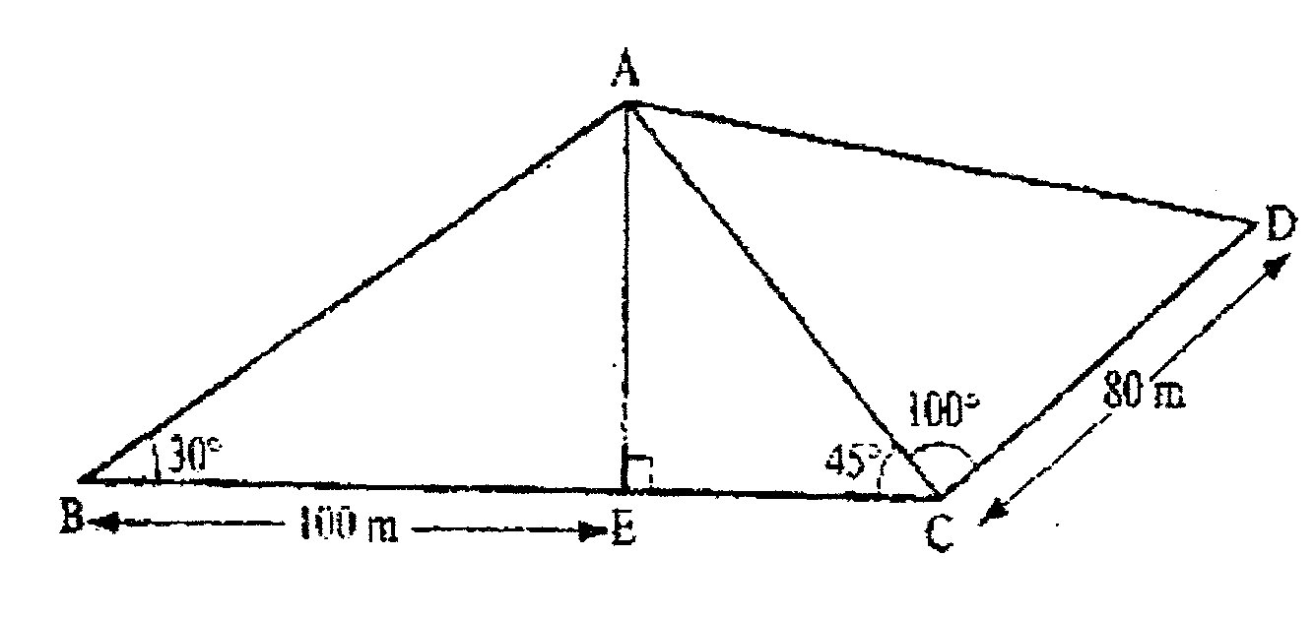
(a) Find to four significant figures:
(i) The length of AE (3mks)

(ii) The length of AD (3mks)

(iii) The perimeter of the piece of land (4mks)

20.The figure below shows solid frustum of pyramid with a square top of side 8cm and a square base of side 12cm. The slant edge of the frustum is 9cm
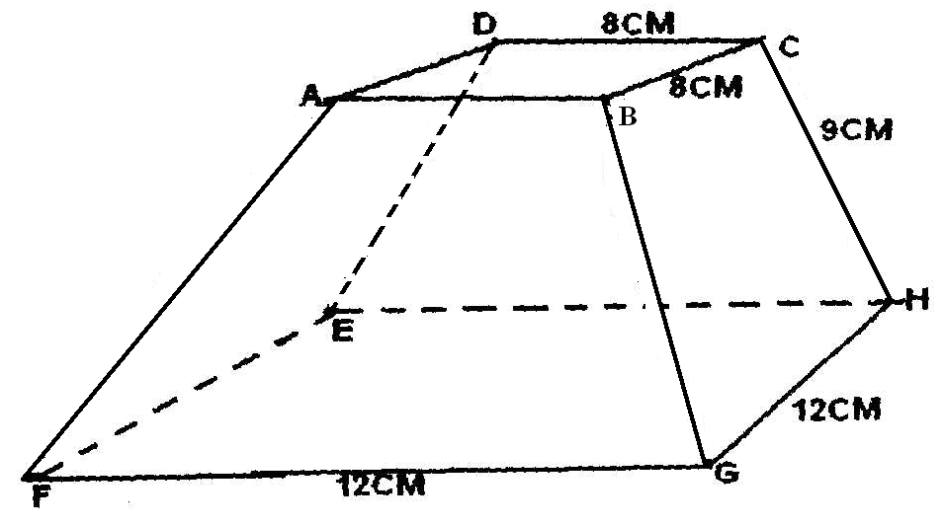
a)Calculate the total surface area of the frustrum. ( 5marks)

b)Calculate the volume of the solid frustrum. ( 5 marks)

21.In the figure below PQ = q and PR = r, QM: MR = 1:2. The point S is the midpoint of PQ. X is the intersection of PM and SR. SX = hSR, pX = kPM where k and h are constants.
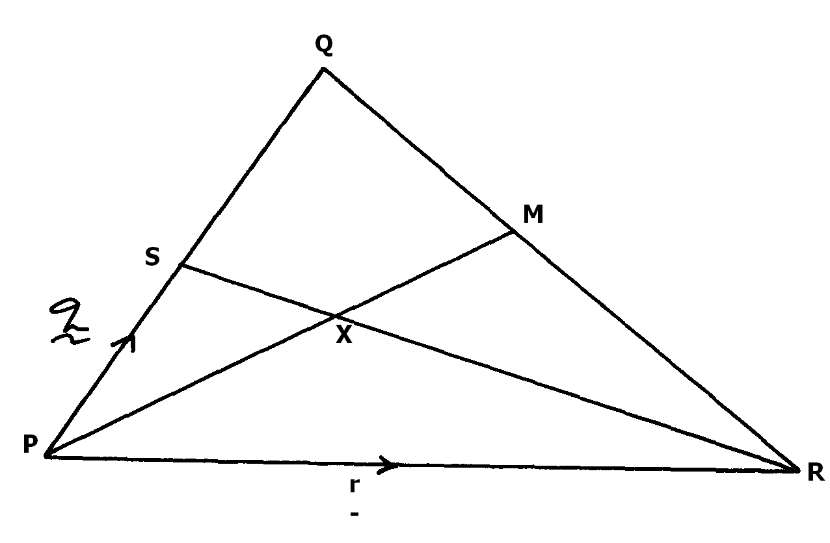

Find:
a) QR in terms of q and r. ( 1mk)

b) PM in terms of q and r ( 2mks)

c) SR in terms of q and r (1mk)

d)Express SX in two ways in terms of h,r and q and in terms of k,r and q, hence determine the ratio in which x divides SR. ( 6mks)

22, The table below shows some values of the function
Y= x³-2x² - 2x + 2 for -2 < x <3

X | -2 | -1 | 0 | 1 | 2 | 3
X³ | -8 |  | 0
-2x² | -8 |  | 0
-2x | 4 |  | 0
2 | 2 |  | 2
Y | -10 |  | 2

a)Complete the table. (4mks)
b)Use the completed table to draw the graph of the function.
Y = x³ – 2x +2 (3mks)

c) Using the graph solve the cubic equation. (3mks)
X³ – 2x² = 2x -2

23. Four schools A, B, C and D are such that B is 94Km due North of A and C is an a bearing of 295 from A at a distance of 60km D is on a bearing of 310⁰ from C and a distance of 42km. using a scale of 2cm to 20km, make an accurate scale drawing to show the relative positions of the schools. (4mks)

Find:
(i)The distance and the bearing of B from C (2mks)

(ii)The distance and the bearing of D from B. (2mks)

(iii)The bearing of A from D (2mks)

24. In the figure below ABCDE is a pentagon inscribed in a circle. CX is a tangent to the circle at C and EDX is a straight line. Angle ADE = 34⁰, angle CAD = 42⁰, AB = BC and BC is parallel to AD. Giving reasons, determine
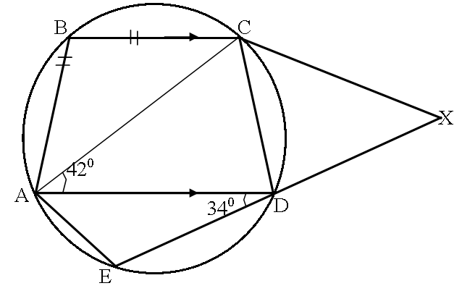

(a) (i) Angle ABC (2mks)

(ii) Angle ACD (2mks)

(iii) Angle EAD (2mks)

(iv) Angle CXD (2mks)

(b) Given that ED = 5cm, DX = 4cm, calculate the length of CX (2mks)

