FORM FOUR PAPER ONE TERM ONE

SECTION I (50 MARKS)
Answer all the questions in this section.

1. Use reciprocal tables to find the value of (3mks)
correct to 4 s.f.

2. One interior angle of a certain polygon is 84⁰. If each of the other angles is 147⁰, how many sides does this polygon have? (3 mks)

3.Solve the equation; (4 mks)

4.Solve for x and y in the following equations (3mks)
2^{x} + 3^{y} =59
2 ^{x+3} – 3^{y+2} = 13

5.Solve the following pair of inequalities and represent the solution on the number line(3mks)
4-3x<7
8-6x

6. Two containers have base area of 750cm² and 120cm³respectively. Calculate the volume of the larger container in litres given that the volume of the smaller container is 400cm³. (3mks)

7. Solve for x given that:
Log (x-4)+2=log 5+log(2x+10) (3mks)

8.From a point A, the angle of elevation of top of a watch tower is 20⁰.From another point which is 25m from the base of the tower, the angle of elevation of the top of the tower is 26⁰.Giving your answer to three decimal places, determine the height of the tower and hence calculate the distance between the points A and B if they are both on the same side of the tower and lie on a straight line with the base of the tower (3mks)

9. A train whose length is 60 metresis travelling at 40km/h in the same direction as a bus whose length is 20m. If the speed of bus is 80km/h and moving parallel to the train, calculate the time it takes the truck to over take the train completely in seconds. (3mks)

10. The figure below shows a solid made by placing two equal regular tetrahedra.

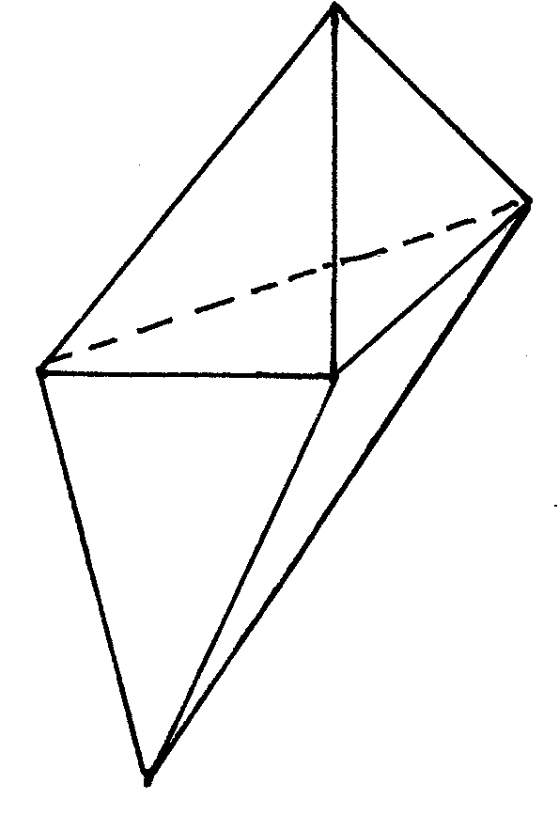
a) Draw the net of the solid. (1mk)

b) If each face is an equilateral triangle of side 5cm. Find the surface area of the soli to 4 s.f. (2mks)

11. Using a ruler and a pair of compasses only, draw a parallelogram ABCD in which AB = 8cm, BC = 6cm and <BAD = 75⁰. Drop a perpendicular from D to meet AB at N. Determine the length DN. (3mks)

12. From a survey carried out the following information was entered in a field book
Y
- 180 to N
To R 90 180
- 60 to M
X

If XY is 360m and SM, RP and QN are the offsets. Determine the area of the field in metres. (3mks)

13. The figure below represents a school field.
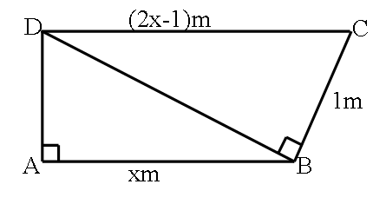
Find the length of AB given that ∠BAD and ∠CBD are right angles (3mks)

14.O is the centre of the circle below and AB is parallel to DC. Angle ACD = 70⁰ and angle ACB = 10⁰.
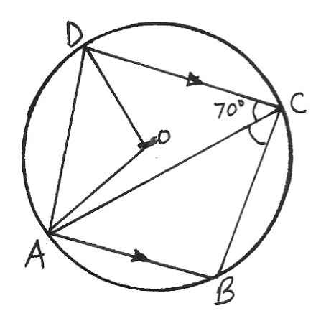
10⁰
Calculate angles
- ABC
- OAD (4mks)

15.Given the coordinates of P, Q and R as (2, -1), (3, 4) and (6, 2) respectively, find the coordinates of P¹, Q¹ and R¹ the images of P, Q and R under a transformation represented by the matrix..
. (3mks)

16.Find the equation of the perpendicular bisector of the line AB where the coordinates of A and B are (-3, 2) and (6, 4) respectively. (3mks)

SECTION II (50 MARKS)
Answer any five questions from this section.
18. The vertices of triangle PQR are P (O,O), Q(6, 0) and R(2, 4)
(a)Draw triangle PQR on the grid provided. (lmk)

b). Triangle P1Q1R’ is the image of a triangle PQR under an enlargement scale factor, ½ and centre (2, 2). Write down the coordinates of triangle P¹Q¹R¹ and plot on the same grid. (2 mks)

c). Draw triangle P¹¹Q¹¹R¹¹ the image of triangle P¹Q¹R¹under a positive quarter turn about points (1, 1). (3 mks)

d). Draw a triangle P¹¹¹Q¹¹¹R¹¹¹ the image of triangle P¹¹Q¹¹R¹¹underreflection in the line
y=l. (2mks)

e). Describe fully a single transformation that maps triangle P¹¹¹Q¹¹¹R¹¹¹ onto triangle P/Q/R/ (2 mks)

18. The members of a photograph club decided to buy a camera worth Shs. 4000 by each contributing the same amount of money. Fifteen member failed to pay their contribution due to various reasons. As a result each of the remaining members had to contribute Sh. 60 more.
- Find the number of members in the club (7 Marks)

- What was the percentage increase in the contribution per month? (3 Marks)

19. (a) (i) Fill the table below for the function.
y = 2x² + 5x – 12 for -8≤ x ≤ 4 (2 marks)

X | -8 | -7 | -6 | -5 | -4 | -3 | -2 | -1 | 0 | 1 | 2 | 3 | 4
2x² | 128 |  |  |  |  | 18 |  |  |  | 2 |  |  | 32
5x | -40 |  |  |  |  | -15 |  |  |  | 5 |  |  | 20
-12 | -12 |  |  |  |  | -12 |  |  |  | -12 |  |  | -12
Y | 76 |  |  |  |  | -9 |  |  |  | -5 |  |  | 40
(ii) Using the table, draw the graph of the function y = 2x² + 5x – 12. Use the scale 1cm to 1 unit on the x-axis and 1cm for 10 units for the y – axis (4 marks)

(b) Use the graph drawn above to solve the following equations.
(i) 2x² + 5x – 12 = 0 (2 marks)

(ii) 3 – 7x – 3x² = 0 (2 marks)

20. a) The bill for completely covering the floor of a rectangular room with carpet
costing shs.70 per square metreis shs.1960.If one side of the room is X m long; show that the length of the other side is (3mks)

b) By leaving a uniform width of ½ m uncovered all round, shs.700 could have been saved. Use this information to form an equation in x and show that it reduces to X² – 11x + 28 = 0. (4mks)

c) Solve the equation and hence find the dimensions of the room. (3mks)

21. The displacement of a particle S metres, t seconds after passing a fixed point O isgiven by
S=3+2t-5t²
Calculate:
(a) The displacement of the particle 2 seconds later (2mks)

(b) The time taken for the particle to return to O (2mks)

(c) The maximum displacement of the particle (3mks)

(d) The initial velocity of the particle (2mks)

(e) The acceleration of the particle after t seconds (1mk)

22. Two circles with centres O₁ and O₂, have radii 7cm and 6cm respectively. The two circles intersect at P and Q and the length of the common chord PQ is 10cm.

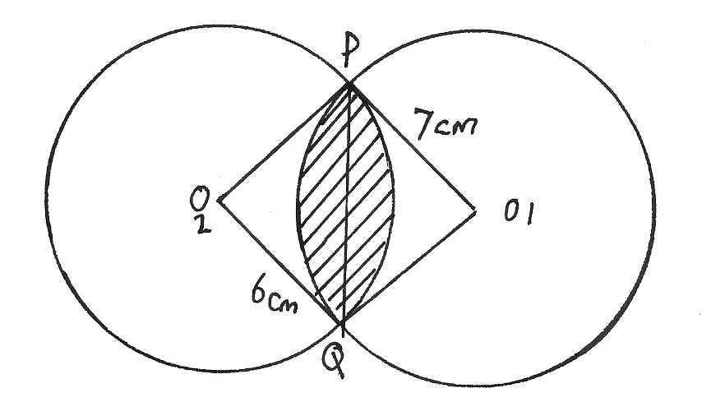

Calculate the area of the shaded region in the above diagram to 4 significant figures. (10mks)

23.The table shows marks obtained by 100 candidates at Goseta Secondary School in Biology examination.

Marks | 15 – 24 | 25 – 34 | 35 – 44 | 45 – 54 | 55 – 64 | 65 – 74 | 75 – 84 | 85 - 94
Frequency | 6 | 14 | 24 | 14 | x | 10 | 6 | 4

(a) Determine the value of x (2mks)

(b) State the modal class (1mk)

(c) Calculate the median mark (2mks)

(d) Calculate the mean mark. (5mks)

24. Draw triangle ABC with A(3,4), B(1,3) and C(2,1)

a)Draw ∆A^{I}B^{I}C^{I}, the image of ∆ABC under a rotation of +90⁰ about (O,O) (2 marks)

b)Draw ∆A^{II}B^{II}C^{II}, the image of ∆A^{I}B^{I}C^{I} under a reflection in the line y=x. (2 marks)

c)Draw ∆A^{III}B^{III}C^{III}, the image of ∆A^{II}B^{II}C^{II} under a rotation of +90⁰ about (O,O)(2 marks)
d) Describe a single transformation that maps ∆ABC onto ∆A^{III}B^{III}C^{III}. (2 marks)
e) State the type of congruence between the object and the final image. (2 marks)

