NAME: …………………………………………………… CLASS: ………. ADM: …………
MATHS FORM 4 PP 2

SECTION 1(50 MARKS)
1. Use logarithms to evaluate
(4marks)

2. Make x the subject of the formula
(3marks)

3. In the figure ABCDE below angle ABC = 1000, angle BAC = 33° and angle
CDE = 18°. Calculate the size of angle AED. (2 marks)
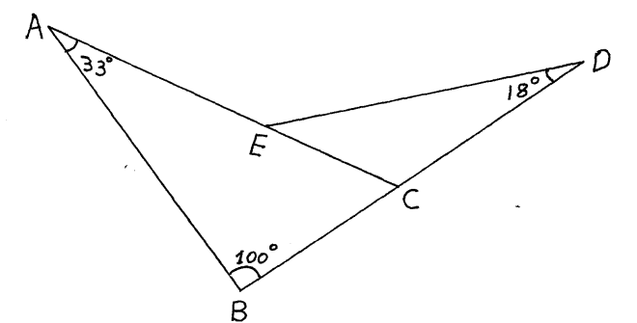

4. Factorize completely and simplify; (3mks)

5. A quantity P varies jointly as Q and the square of R. If Q increased by 20% and R decreasedby15%. Find the percentage change in P. (4mks)

6..Expand (2 – x)⁶ in ascending power of x. Use the first four terms of expansion to solve (1.95)⁶Correct to four decimal places. (4mks)

7. Write an equation of a circle that has a diameter whose end points are at (2,7) and (-6, 15) in the form x²+y²+ax+by+c=0 where a,b and c are integers (3mks)

8. Miss Jaber bought a motor cycle at Shs.160,000. The depreciation rate was 6% per annum determined semi annually. How long will it take the motor cycle to be valuedat a quarter of its original cost? (3mks)

9. The velocity of a particle, Vm/s moving in a straight line after t seconds is given by
V = 3t² - 3t – 6. Find the distance covered by the particle between t = 1 and t = 4 seconds. (3mks)

.

10 A line segment joining two points P(0,7) and S (2, 3.8) is divided externally by point Q in the ratio 7:3. Find the co-ordinates of point Q. (3mks)

11.Draw a line PQ = 7.2cm and on one side of the line, use a ruler and pair of compasses only to draw the locus of a point A such that ∠ PAQ = 60⁰ and on it mark point A such that PA = QA. (3mks)

12. Two containers have base area of 750cm² and 120cm² respectively. Calculate the volume of the larger container in litres given that the volume of the smaller container is 400cm³. (3 Marks)

13. Object A of area 10cm² is mapped onto its image B of area 60cm² by a transformation. Whose matrix is given by p = $\left(\begin{matrix}x & 4 \\ 3 & x+3\end{matrix}\right)$. Find the positive values of x (3 Marks)

14A surveyor finds that she needs 28 beacons placed 40m apart when she surveys a length of the road. If she were to place the beacons 30m apart, how many would she need? (2mks)

15.The position vectors of A and B are given as a= 2i-3j+4k and b= -2i-j+2k respectively. Find to 2decimal places, the length of the vector $\vec{AB}$ (3mks)

16.Solve for θ in the equation sin ( 4θ + 10º)-cos(θ+70º) = 0 (3mks)

SECTION II ( 50 MARKS)

Answer any five questions from this section

17.Mr. Ouma is a civil servant on a basic salary of Kshs.18,000. On top of his salary, he get a monthly house allowance of Kshs.14,000, medical allowance of Kshs. 3080 a commuter allowance of Kshs. 4640. He has a life insurance policy for which he pays a premium of kshs.800 p.m and claims an insurance relief of shs 3 for every 20/= on the monthly premiums. He is entitled to a personal reliefof kshs.1056 p.m

- Using the tax table below calculate his PAYE

Income in K£ p.m | Rate %
1 – 484  485 – 940  941 – 1396  1397 – 1852  over 1852 | 10  15  20  25  30

b) In addition to PAYE the following deductions are made on his pay every month.
- Wcps at 2% of his basic salary
- NHIF of kshs. 400
- Loan repayment of kshs. 4000
- Co-op shares of kshs. 800
(i) Calculate his total monthly deductions in Kshs. (7mks)

(ii) Calculate his net monthly pay in Kshs. (3mks)

18.A passenger plane takes off from airport A(60ºN,5ºE) and flies directly to another airport B(60ºN,17ºE) and then flies due North for 600 nautical miles (nm) another airport C

(a) Find the position of airport C (3mks)

(b) Find the distance between airport A and B in nautical miles (3mks)

(c) If the plane at an average speed of 300knots, find total flight time (2mks)

(d)Given that the plane left air port A at 9.20am. Find the local time of arrival at airport C (2mks)

19. Bag X contains 2 green marbles and 8 yellow marbles. Bag Y contains 4 green marbles and 5 yellow marbles. A bag is selected at random and two marbles drawn one at a time without replacement.
(a)Represent this information on a tree diagram. (4 marks)

(b) Find the probability that:

(i)They are both green. (2 marks)

(iiThey are both yellow and form bag X. (2 marks)

(iii)The second ball is yellow. (2 marks)

20. A baker bakes two types of cookies, marmalade cake and sweat loaves of bread. Each day he bakes x cakes and y sweat loaves of bread. The conditions of the cookies are subject to the following conditions.
x> 20
y> 10
4x + 3y <240
5x + I 9y>450
He makes a profit of ksh 5 on each cake and ksh 6 on each loaf of bread.
a) Draw a graph to represent the above information. (6 Marks)

b) From the graph, determine how many cookies of each type he should bake to maximize his daily profit. (2 Marks)

c) Calculate the maximum profit. (2 Marks)

21.In a botanical experiment, the length of 60 leaves of a certain type of a tree were measured correct to the nearest 0.1 cm.

Length ( cm) | 3.0 – 3.4 | 3.5 – 3.9 | 4.0 – 4.4 | 4.5 – 4.9 | 5.0 – 5.4 | 5.5 – 5.9 | 6.0 -6.4 | 6.5-6.9 | 7.0-7.4
No. of leaves | 1 | 4 | 9 | 14 | 12 | 10 | 6 | 3 | 1

a)State the modal class (1mk)

b)Calculate the median length (3 mks)

c)Using a working mean of 5.2 find;
i)The mean (4mks)

ii)The standard deviation ( 2mks)

22. The diagram below shows a right pyramid VABCD, v as the vertex. The base of pyramid is a rectangle ABCD, with AB = 4CM and BC= 3CM. The height of the pyramid is 6 cm.
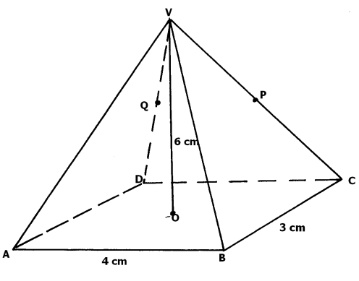
a) Calculate the
i) Length of the projection of VA on the base and the angle it makes with the base. (4mks)

ii) Angle between the face VAB and the base. (2mks)

b) P is the midpoint of VC and Q is the midpoint of VD. Find the angle between the plane VAB and the plane ABPQ. (4mks)

23.a)Complete the table below for y = y cos x and y = sin ( x +30) 2marks

X | -90 | -60 | -30 | 0 | 30 | 60 | 90 | 120 | 150 | 180 | 210 | 240 | 270
2cos x | 0 | 1.0 |  | 2 |  |  | 0
sin x + 30 | -0.87 | -0.51 |  | 0.5 |  |  | 0.87
b)Draw the graph y= 2 cos x and y = sin ( x + 30) on the same axes.
Use a scale of 1 cm to represent 30° on the x – axis and 2 cm for 1 unit on the yaxis(3 marks)

c) Using the graph solve ½ sin ( x + 30) – cos x = 0 3marks

d)State the amplitude and period of y = 2 cos x 2 marks

20. The diagram below shows triangle O.A.B in which N is the midpoint of AB. Mis a point on OA such that OM :MA=2:1.Lines ON and BN meet at X such that vector OX=h vector ON and ,MX= kMB

Given that vector OA =a and vector OB=b
Express the following interms of a and b
- Vector AB (1mk)

- Vector ON (2mks)

- Vector BM ( 1mk)

By expressing vector OX in two different ways, determine the values of h and k. (6mks)

