NAME:…………………………………………..CLASS…….……ADM NO:……….…….
PHYSICS FORM 1
INSTRUCTIONS TO STUDENTS
- This paper consists of 20 questions.
- Answer ALL the questions in the spaces provided.
- ALL working MUST be clearly shown.
- ALL numerical answers MUST be expressed in decimal forms.

- (a) Name three features of liquids to be used in a thermometer. (3mks)

- should have
- (a) Name three methods by which heat energy transfer. (3mks)

(b) State two applications of convection process. (2mks)

- (a) Name three factors which affect heat transfer by conduction. (3mks)

(b) State two applications of heat transfer. (2mks)

- Define each of the following terms as used in Physics and state the SI units. (8 mks)
(a) Volume –
(b) Density -
(c) Force –
(d) Pressure –

- A person while walking along a road is acted upon by some forces. Identify any three forces acting on the person. (3mks)

- While cutting grass a sharp slasha does the work more easily/quickly. Explain this observation.
(3mks)

- A man 84kg stands upright on a floor. If the area of his shoes and the floor is 420cm² determine the average pressure he exerts on the floor. (Take g=10Nkg⁻¹) (4mks)

- Name 3 applications of pressure. (3mks)

- 1800cm ³ of fresh water of density 1g/cm³ are mixed with 1200cm³ of sea water; the relative density of the mixture is 1.1g/cm³,determine the density of sea water. (3mks)

- State the type of force exhibited when a boy swings a sling. (1mk)

- Explain why a pin floating on water sinks when camphor is added. (2mks)

- A block measuring 20cm by 10cm has a height of 3cm.The block has a weight of 6N.Determine the minimum pressure it exerts on the surface. (3mks)

- a) Explain why the smoke particles are seen in random motion in a smoke cell. (2mks)

b) Distinguish between gases and liquids in terms of intermolecular forces. (2mks)

- a)When a gas x and gas y are set in an enclosed transparent pipe from both ends, a white deposit closer to gas y is observed. Explain why. (2mks)

b) Compare the density of the two gases (1mk)

c) State one factor that affects the process (1mk)

d) Differentiate between kinetic theory of matter and Brownian motion (1mk)

- a) State two modifications that enhance the sensitivity of a thermometer (2mks)

b) Give a reason why concrete beams are reinforced with steel do not crack (1mk)

c) Explain why wire gauze is placed below a beaker while heating water. (1mk)

- State the role of a bimetallic strip in an electric iron box. (1mk)

- Explain how heat loss by radiation is minimized in a vacuum flask. (1mk)

- State the fastest mode of heat transfer. (1mk)

- A form one student set up the apparatus as shown below.

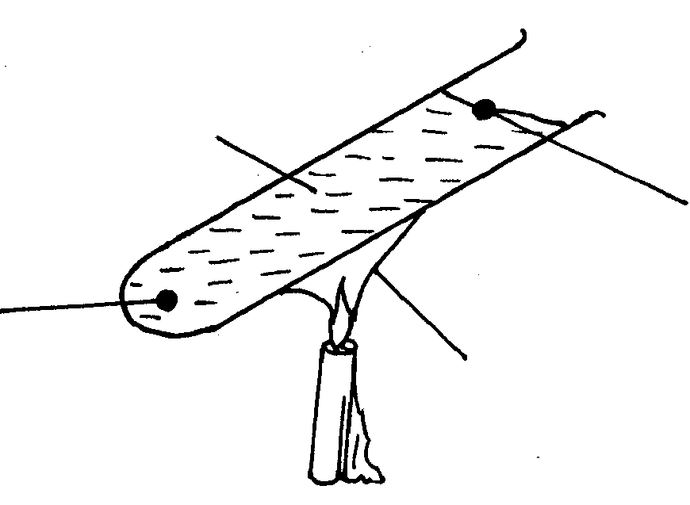
B
A
Floating wax
Flame
Water
Wax fitted with lead shot
Fig 1

The boiling tube was heated in the middle as shown.
(i) Which wax melted first? (2mk)

(ii) Explain your answer in (i) above. (2mk)

- (a) One the axis provided, sketch a graph of volume against temperature of water from 0º to 20ºC.
Temperature (ºC)
Volume (cm³)

(3mks)

4
20

(b)During anomalous expansion of water, heat transfer is limited to conduction and radiations only explain . (2mks)

(c)Give three applications of Expansion and contraction. (3mks)

