NAME:…………………………………………..CLASS…….……ADM NO:……….…….
PHYSICS FORM 2
INSTRUCTIONS TO STUDENTS
- This paper consists of 20 questions.
- Answer ALL the questions in the spaces provided.
- ALL working MUST be clearly shown.
- ALL numerical answers MUST be expressed in decimal forms.

Answer all the questions in the provided space
SECTION A (30 MARKS)
- The diagram below shows a micrometer screw gauge. What is the reading in SI units? (2mks)
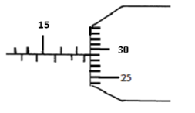
- In an experiment to estimate the height of the following measurement were obtained. Length of the shadow of the metre rule = 120cm (3mks)
Length of the shadows of the tree = 20m
Length of the shadow of the rod= 1m
Estimate the height of the tree

- The water level in a burette is 27cm³. If 88 drops of water fall from the burette and the average volume of one drop is 0.25cm³. What is the final water level in the burette? (2mks)

- a) State three precautions that must be taken when using the density bottle. (3mks)

b) The mass of an empty density bottle of volume 25cm³ is 10g. Iron fillings are poured into
the bottle and the total mass is 35g. Water of density 1g/cm³ is added into the filling until the bottle is full. If the total mass of the bottle and its contents is 50g. Calculate the density of iron fillings. (3mks)

- a) Name 3 types of forces that act without contact (3mks)

b) Explain why drops of filling water are approximately spherical (2mks)

(c) A girl standing 600m away from a cliff bangs two pieces of wood together
and hears an echo 3.5 seconds later. Determine the speed of sound in air at that place .(3mrks)

6. (a) Define a resultant vector (1mk)

b) Find the resultant of a force of 5N and 3N acting at the same point on an object in opposite
direction and in a straight line (2mks)

c) The moons gravitational pull is ¹/₆ of the earth’s gravitational pull. Calculate the weight
of a body whose mass is 60kg on the moon’s surface given that the earth’s gravitational
pull is 10N/Kg (3mks)

d) A spring stretches by 5cm when supporting a load of 20N. By how much would it stretch
when supporting a load 5kg? (3mks)

SECTION B (40 MARKS)
- a) The figure below shows a section of a flexible wire carrying current perpendicularly out of the paper.

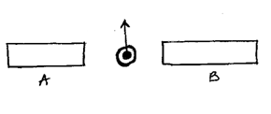

The wire moves in the direction shown as current passes through it.
- Label the polarities of the magnets A and B. ( 2mks)

- Explain the behaviour of the flexible wire. (2mks)

b) The diagram below shows a simple electric motor.

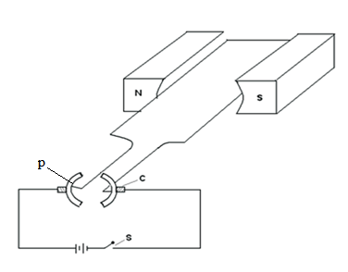

i) Name the part labeled C and P (2mks)

ii) State three factors that will affect the speed of rotation of the motor. (3mks)

- the figure below shows an electromagnetic relay being used to switch an electric motor on and off. The electromagnet consists of a coil of wire wrapped around a core. The motor in figure is switched off.
Motor
Springy metal strips
Contacts
Soft iron armature
Core
S
A
B
Pivot
Insulator

- Suggest suitable material for the core. (1mk)
- What happens to the core when switch S is closed? (2mks)

- Why do the contacts A and B close when the switch S is closed. (2mks)

- When the switch S is opened, what will happen to;
- The core (1mk)

- Soft iron armature. (1mk)

- Give one other application of an electromagnet. (1mk)

- State two ways in which an electromagnet could be made more powerful. (2mks)

- Figure 5 below shows how the displacement varies for a certain wave.
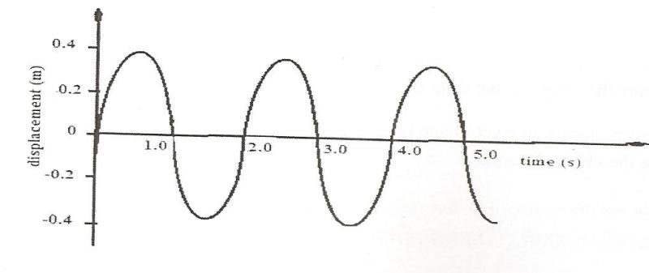

- What is the amplitude of the wave? (1mk)

- What is the periodic time of the wave? (1mk)

- Determine the frequency of the wave (2mks)

- Given that the speed of the wave is 20m/s, calculate the wave length (3mks)

- a) Define pressure and give its S.I nits. (2mks)

- The diagram below represents a motor car hydraulic braking system;
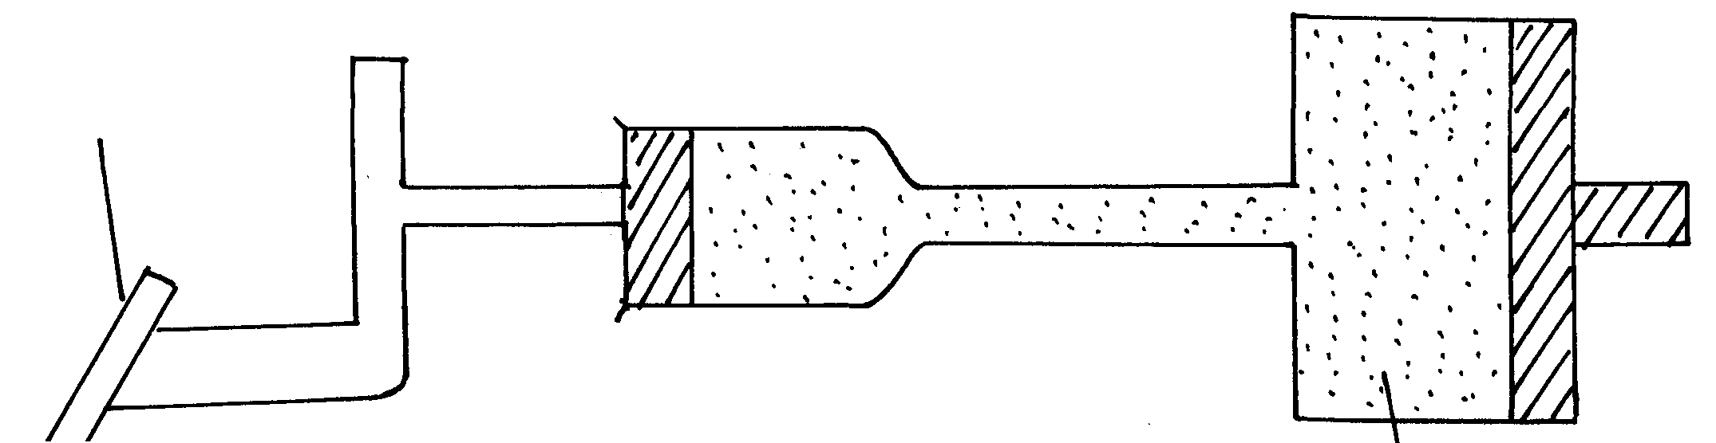
Brake pedal
Master piston
Slave piston brake fluid
B
A

- State two properties of the liquid used as a brake fluid (2mks)

- Given that in the diagram (b) above the master piston has an area of 15cm² and the slave piston has an area of 50cm² a force of 100N is applied on the master piston. Find the force used to stop the car. (3mks)
- Compare the values of pressure in the two pistons above and give a reason for your answer. (2mks)

- Give a reason why gas is not suitable for use in place of the brake fluid. (1mk)

11 (a) State Hooke’s Law (1mk)

(b) The diagram below shows a graph of force against extension for a certain spring.
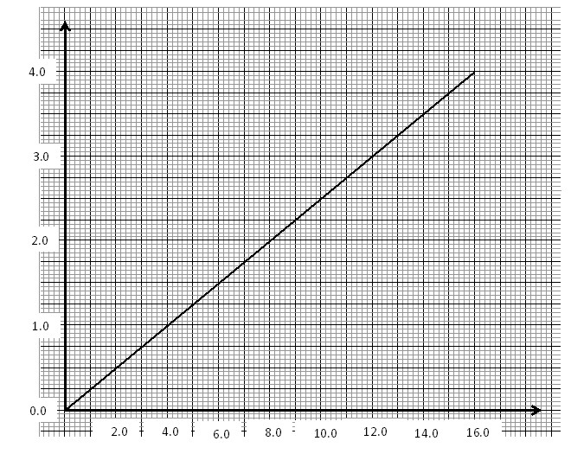
Extension (cm)
Force (N)

What is the spring constant of the spring? (3mks)

