FORM 3 PHYSICS PAPER 3
MARKING SCHEMS
Question1
(v) Table of results
x (cm) | 5.0 | 10.0 | 15.0 | 20.0 | 25.0 | 30.0  ± 2 -3mrks  ± 2 -3mrks  -1mrk  -1mrk  Total 8mrks
u (cm) | 33.0 | 31.0 | 29.0 | 28.0 | 27.0 | 26.0
v (cm) | 38.0 | 41.0 | 44.0 | 48.0 | 52.0 | 56.0
(u +v )cm | 71.0 | 72.0 | 73.0 | 76.0 | 79.0 | 82.0
uv (cm²) | 1254 | 1271 | 1276 | 1344 | 1404 | 1456

(vi) See the graph on the grid below
- Slope = D u + v√ 1
D uv
= (78 – 75)cm√ 1 must be shown on the graph.
1400 -1328
= 4
72cm
= 1
18cm⁻¹
= 0.05556cm⁻¹√ 1
03
- 1/f = 1/u + 1/v
1/f = u +v
Uv
u+v = uv/f √1 correct evaluation
Slope of the graph of u+v against uv is a straight line with a slope of 1/f hence
1/f = 0.05556cm²
F= 18cm√ 1
- R = 4 x 18cm√1 correct substitute
0.05556cm⁻¹
R = 23328cm²√ 1 correct answer

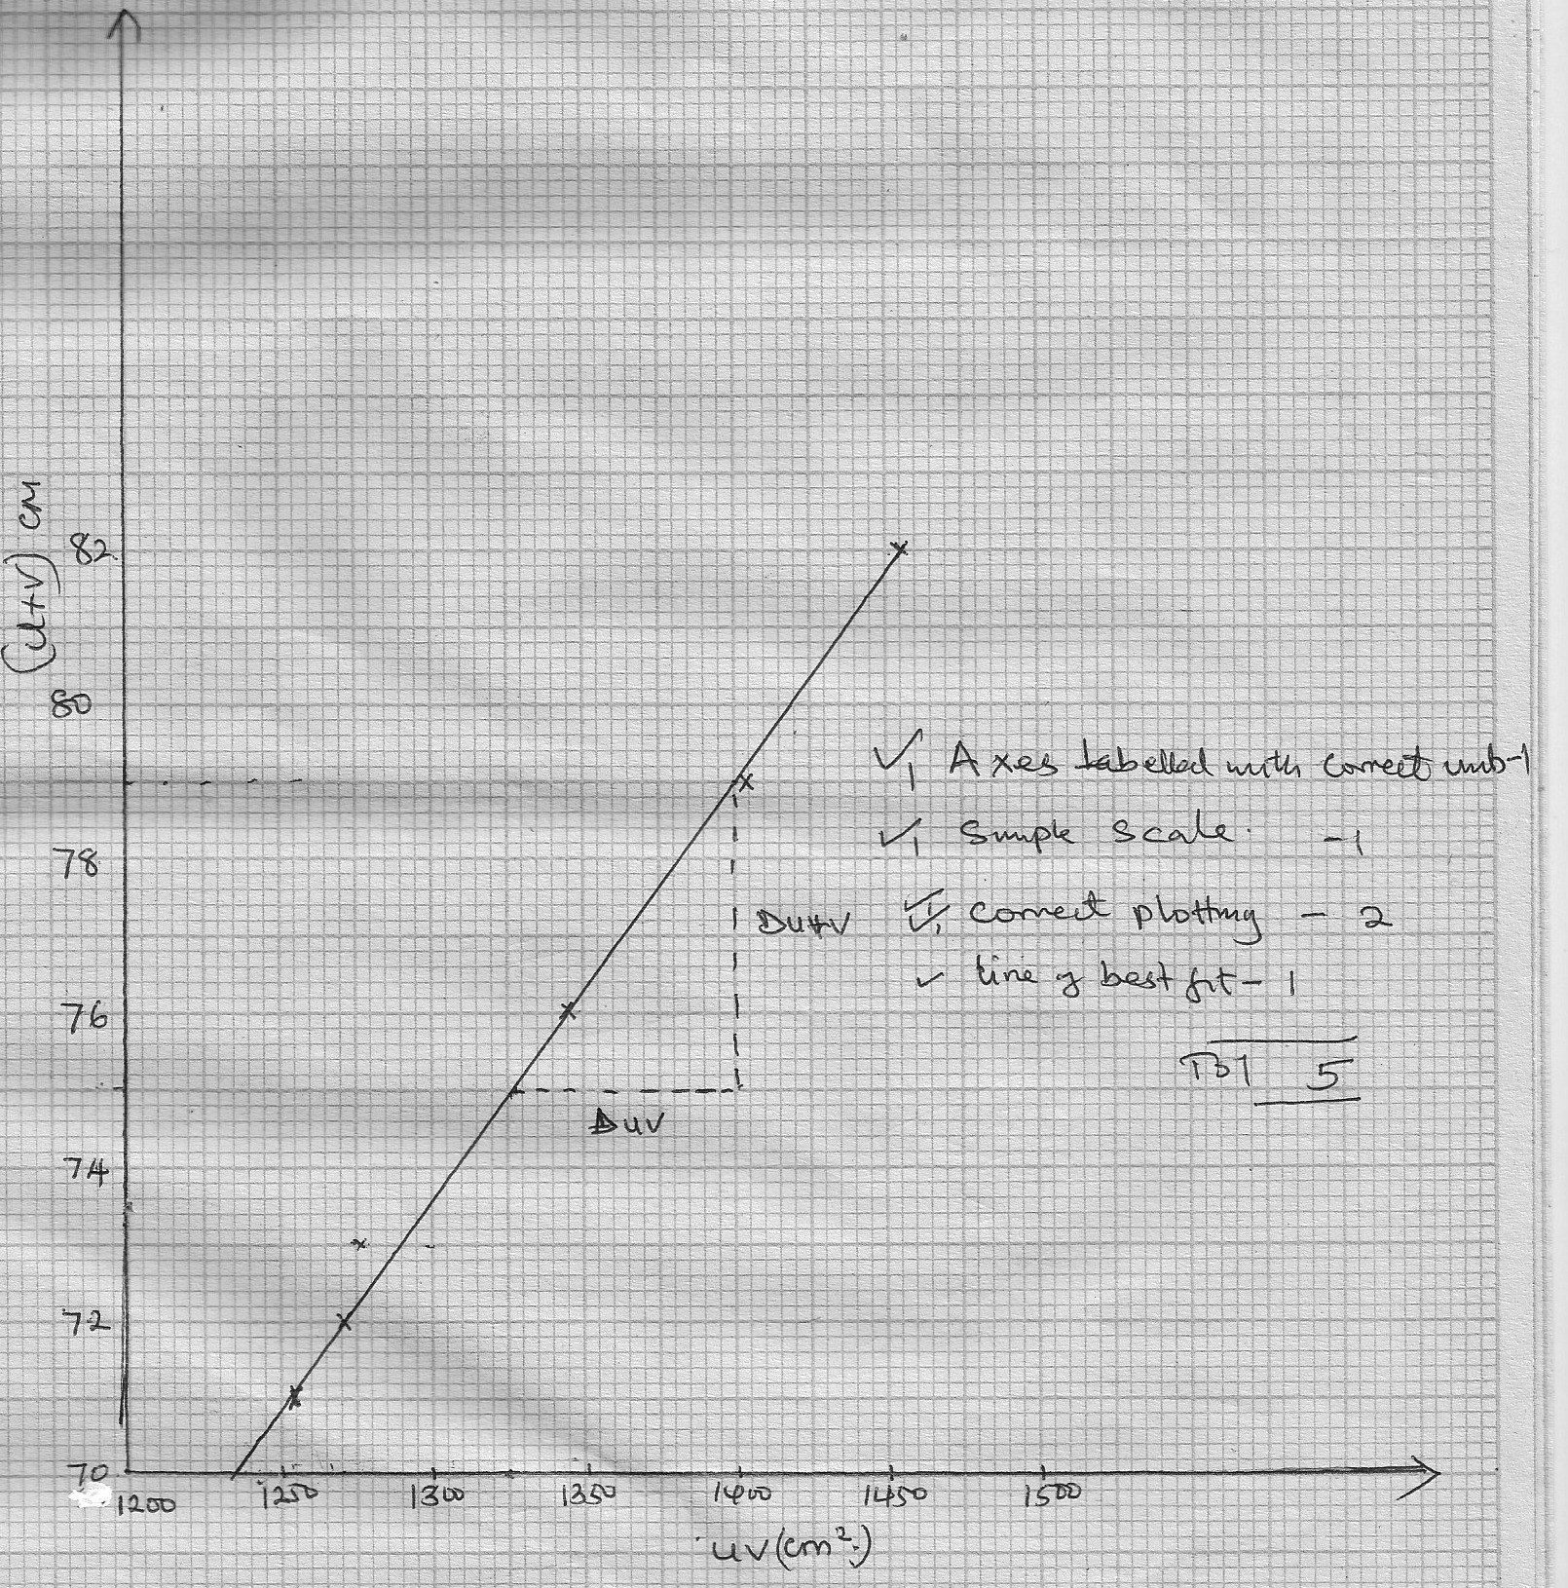
The graph (u+1) against uv

Question2
- Average diameter = 0.35 +n 0.01 mm√ 1
L (cm) | L (m) | V (volts) |  | I (AMP) | R = V/I(Ω)
20 | 0.2 | 0.3 |  | 0.20 | 1.5
30 | 0.3 | 0.5 |  | 0.20 | 2.5
40 | 0.4 | 0.6 |  | 0.20 | 3.0
50 | 0.5 | 0.7 |  | 0.20 | 3.5
60 | 0.6 |  | 0.9 | 0.20 |  | 4.5
70 | 0.7 |  | 1.0 | 0.20 |  | 5.0
80 | 0.8 |  | 1.2 | 0.20 |  | 6.0

± 0.1 ±0.05
√1mrk √3mrks √3mrks √1mrk Total =8mrks
(iv) See the graph on the grid provided
- Slope = DR
Dt√ 1

= (3.0 – 1.5)Ω
0.4 – 0.2 M √1
= 1.5Ω
0.2M
= 7.5Ω M⁻¹
(b) R = R ℓ L/A
A ₌r²
=3.142 x 0.35 x 0.35
2 2
A= 0.09622x10⁻⁶ m²√ 1 for area of cross-section of the wire slope of the graph e/A
E = slope x a √1
= 7.5 Ω m⁻¹ x 9.622 x10⁻⁹ m²
= 7.2165 x 10⁻⁵Ω M√1 with correct units

The graph of R against L

FORM 3 PHYSICS PRACTICAL
REQUIREMENT (CONFIDENTIAL)
NB: Physics teachers should ensure that candidates do not get prior knowledge of the content of this paper
Question 1
Each student should have
- A concave mirror of f = (15-20cm) on a lens holder
- A screen
- A metre rule
- A candle and a match box The match box may be shared)
Question 2
Each student should have:
- An ammeter (0-1A)
- A voltmeter (0-1A)
- A voltmeter (0-2.5V) or (0-5V)
- A switch
- A nichrom wire (89-28) mounted on a mm scale -1 metre long
- Along wire with a crocodile clip at one end (or a jockey)
- Two new size D dry cells and cell holder
- Six connecting wires, two with crocodile clips at one end
- A micrometer screw gauge (may be shared)

