Name ............................................................................................................... Index No. ..............................

School ............................................................................................Candidate's signature ..............................

443/1

AGRICULTURE
Paper 1

Time 2 hours
Date ........................................................

K.C.S.E. REVISION GUIDE
AGRICULTURE
Paper - 443/1
Time: 2 hours
INSTRUCTIONS TO CANDIDATES

a) Write your name and Index number in the spaces provided above.
b) Sign and write date of the examination on the spaces provided above. c) This paper consists of THREE sections A, B and C.
d) Answer ALL questions in section A and B. e) Answer any Two questions in section C.
f) All answers must be written on the spaces provided in this booklet.

EXAMINER'S USE ONLY

Section | Question | Max. score | Candidate's score
A | 1 - 19 | 30
B | 20 - 23 | 20
C | 24 - 26 | 40
Total score |  | 90

This paper consists of 11 printed pages

Candidates should check the question paper to ensure that all the printed pages are printed as indicated and no questions are missing.

SECTION A (30 marks)
Answer ALL questions in this section on the spaces provided.

1. Give FOUR agricultural practices that show agriculture is an art. (2 marks)

...................................................................................................................................................................

...................................................................................................................................................................

...................................................................................................................................................................

...................................................................................................................................................................

2. State TWO ways in which a farmer is positively affected by liberalization of the Kenyan market.
(1 mark)

...................................................................................................................................................................

...................................................................................................................................................................

3. Give TWO environmental factors, which are controlled by use of a green house. (1 mark)

...................................................................................................................................................................

...................................................................................................................................................................

4. Mention FOUR benefits of a deep soil profile to crop production. (2 marks)

...................................................................................................................................................................

...................................................................................................................................................................

5. Give TWO ways in which scarcity affects agricultural production. (2 marks)

...................................................................................................................................................................

...................................................................................................................................................................

6. Give three reasons why the Kenya government introduced settlement and resettlement reforms.
(1½ marks)

...................................................................................................................................................................

...................................................................................................................................................................

...................................................................................................................................................................

7. Name FOUR sites suitable for agroforestry trees. (2 marks)

...................................................................................................................................................................

...................................................................................................................................................................

...................................................................................................................................................................

...................................................................................................................................................................

8. Give THREE reasons for cutting back in pyrethrum. (1½ marks)
9. Give one reasons why the following treatments are done on seeds before planting.

i) Seed dressing. (½ mark)

................................................................................................................................................................... ii) Seed inoculation (½ mark)
...................................................................................................................................................................

10. State THREE factors that influence the success of the union in budding. (1½ marks)

...................................................................................................................................................................

...................................................................................................................................................................

...................................................................................................................................................................

11. Name FOUR crops that are propagated using grafting. (2 marks)

...................................................................................................................................................................

...................................................................................................................................................................

12. Give TWO reasons why phosphatic fertilizers, benefit subsequent crops on 2nd and 3rd year after application. (1 mark)

...................................................................................................................................................................

...................................................................................................................................................................

13. Differentiate between a nursery bed and a seedling bed. (1 mark)

...................................................................................................................................................................

...................................................................................................................................................................

14. State THREE causes of handpans in a crop field. (1½ marks)

...................................................................................................................................................................

...................................................................................................................................................................

...................................................................................................................................................................

15. State THREE effects of siltation in dams. (1½ marks)

...................................................................................................................................................................

...................................................................................................................................................................

...................................................................................................................................................................

16. Outline FIVE roles of a farm manager. (2½ marks)

...................................................................................................................................................................

...................................................................................................................................................................

...................................................................................................................................................................

...................................................................................................................................................................

18. Name FOUR types of terraces. (2 marks)

...................................................................................................................................................................

...................................................................................................................................................................

...................................................................................................................................................................

...................................................................................................................................................................

19. Outline FOUR characteristics of crops used for green manuring. (2 marks)

...................................................................................................................................................................

...................................................................................................................................................................

...................................................................................................................................................................

...................................................................................................................................................................

SECTION B (20 marks)
Answer all questions.

20. Study the illustration below and answer the questions that follow.

Rooting medium

Developing roots

i) Identify the method of propagation above. (1 mark)

...................................................................................................................................................................

iii) Name TWO materials that are used in the method of propagation illustrated by the diagram above
(2 marks)

...................................................................................................................................................................

................................................................................................................................................................... iv) Outline TWO importance of the method of propagation identified in (i) above (2 marks)
...................................................................................................................................................................
................................................................................................................................................................... v) State TWO conditions under which the above propagation method illustrated by the diagram is
recommended. (2 marks)

...................................................................................................................................................................

...................................................................................................................................................................

21. Below is a diagram of a clamp silo. Study it carefully and then answer the following questions.
soil layer

Polythene sheet silage material

soil layer

Ground level

a) State the function of the soil layer at the sides. (1 mark)

...................................................................................................................................................................

................................................................................................................................................................... b) Give ONE reason for the sloping of the silage material at the top. (1 mark)
...................................................................................................................................................................
................................................................................................................................................................... c) State TWO ways of controlling high temperature on the silo during the ensiling process.
(2 marks)

...................................................................................................................................................................

...................................................................................................................................................................

...................................................................................................................................................................
22. Study the following t stions that follow.
ypes of soil structures and answer the que

B
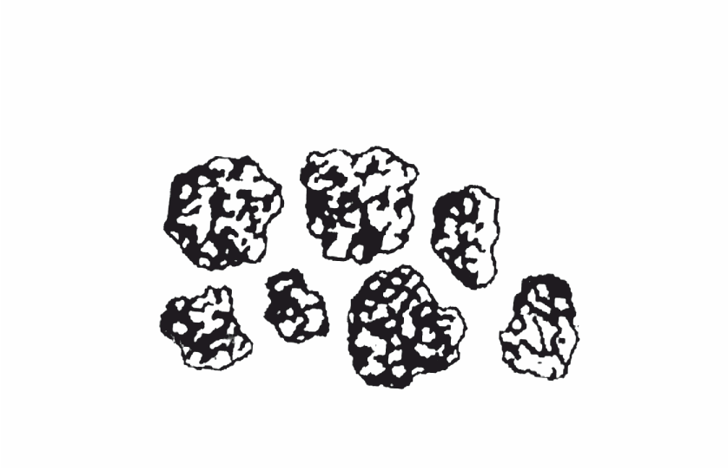

A 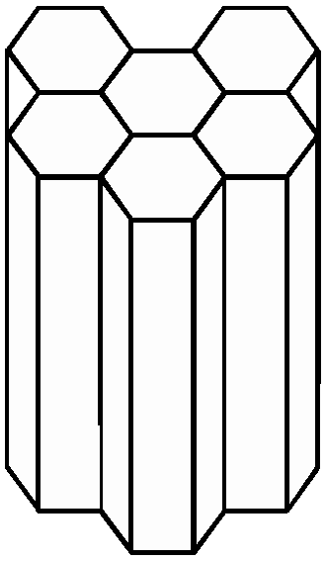

a) Identify the type of soil structures labelled. A and B. (2 marks)

...................................................................................................................................................................

................................................................................................................................................................... b) Which type of the two soil structures illustrated by the diagrams is best suited for farming. (1 mark)
................................................................................................................................................................... c) Give THREE reasons for your answer in (b) above. (3 marks)
...................................................................................................................................................................

...................................................................................................................................................................

...................................................................................................................................................................

23. The diagram below represent some weeds labelled G & H. Study them and answer the questions that follow.
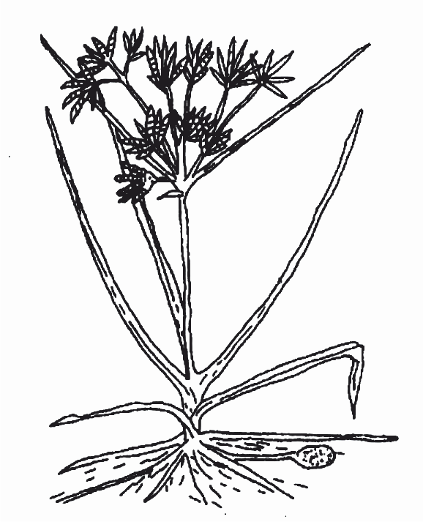

G berries

H

a) Identify the weeds. (2 marks)

G .............................................................................................................................................................. H .............................................................................................................................................................
b) Give a specific harmful effect of each weed. (2 marks) G ............................................................................................................................................................ H .............................................................................................................................................................
SECTION C
Answer any TWO questions in thus section in the spaces provided at the end of the section

24. a) Explain FIVE environmental factors that affect the effectiveness of a herbicide. (10 marks) b) Outline measures which can minimise water pollution on a farm. (6 marks) c) Describe the role of potassium in crop nutrition. (4 marks)
25. a) Explain ten factors influencing supply of a commodity in a market. (10 marks)

b) Explain the preparation of bean seeds for planting. (10 marks)

26. a) Outline the steps that farmers should follow when planning a farm business. (7 marks) b) Explain the factors determining the depth of planting. (8 marks) c) Outline FIVE contributions of agriculture to the national development. (5 marks)
...................................................................................................................................................................

...................................................................................................................................................................

...................................................................................................................................................................

...................................................................................................................................................................

...................................................................................................................................................................

...................................................................................................................................................................

...................................................................................................................................................................

...................................................................................................................................................................

...................................................................................................................................................................

...................................................................................................................................................................

...................................................................................................................................................................

...................................................................................................................................................................

...................................................................................................................................................................

...................................................................................................................................................................

...................................................................................................................................................................

...................................................................................................................................................................

...................................................................................................................................................................

...................................................................................................................................................................

...................................................................................................................................................................

...................................................................................................................................................................

...................................................................................................................................................................

...................................................................................................................................................................

...................................................................................................................................................................

...................................................................................................................................................................

...................................................................................................................................................................

...................................................................................................................................................................

...................................................................................................................................................................

...................................................................................................................................................................

...................................................................................................................................................................

...................................................................................................................................................................

...................................................................................................................................................................

...................................................................................................................................................................

...................................................................................................................................................................

...................................................................................................................................................................

...................................................................................................................................................................

...................................................................................................................................................................

...................................................................................................................................................................

...................................................................................................................................................................

...................................................................................................................................................................

...................................................................................................................................................................

...................................................................................................................................................................

...................................................................................................................................................................

...................................................................................................................................................................

...................................................................................................................................................................

...................................................................................................................................................................

...................................................................................................................................................................

...................................................................................................................................................................

...................................................................................................................................................................

...................................................................................................................................................................

...................................................................................................................................................................

...................................................................................................................................................................

...................................................................................................................................................................

...................................................................................................................................................................

...................................................................................................................................................................

...................................................................................................................................................................

...................................................................................................................................................................

...................................................................................................................................................................

...................................................................................................................................................................

...................................................................................................................................................................

...................................................................................................................................................................

...................................................................................................................................................................

...................................................................................................................................................................

...................................................................................................................................................................

...................................................................................................................................................................

...................................................................................................................................................................

...................................................................................................................................................................

...................................................................................................................................................................

...................................................................................................................................................................

...................................................................................................................................................................

...................................................................................................................................................................

...................................................................................................................................................................

...................................................................................................................................................................

...................................................................................................................................................................

...................................................................................................................................................................

...................................................................................................................................................................

...................................................................................................................................................................

...................................................................................................................................................................

...................................................................................................................................................................

...................................................................................................................................................................

...................................................................................................................................................................

...................................................................................................................................................................

...................................................................................................................................................................

...................................................................................................................................................................

...................................................................................................................................................................

...................................................................................................................................................................

...................................................................................................................................................................

...................................................................................................................................................................

...................................................................................................................................................................

...................................................................................................................................................................

...................................................................................................................................................................

...................................................................................................................................................................

...................................................................................................................................................................

...................................................................................................................................................................

...................................................................................................................................................................

...................................................................................................................................................................

