Name ............................................................................................................... Index No. ..............................

School.............................................................................................Candidate's signature ..............................

443/2

AGRICULTURE
Paper 2
Date ........................................................

Time 2 hours

K.C.SE REVISION GUIDE
AGRICULTURE
Paper - 443/2
Time: 2 hours

INSTRUCTIONS TO CANDIDATES

• This paper consists of THREE sections A, B and C
• Answer ALL questions in section A, All questions in section B and Two questions in section C.
• All answers must be written in this booklet.

EXAMINER'S USE ONLY

Section | Question | Max. score | Candidate's score
A | 1 - 18 | 30
B | 19 - 22 | 20
C | 23 - 25 | 40
Total score |  | 90

This paper consists of 11 printed pages

Candidates should check the question paper to ensure that all the printed pages are printed as indicated and no questions are missing.

SECTION A (30 marks)
Answer ALL the questions in this section in the spaces provided.

1. Name TWO attachment methods used in attaching implements onto a tractor. (1 mark)

...................................................................................................................................................................

...................................................................................................................................................................

2. Give FOUR reasons why camels are suited to living in arid areas. (2 marks)

...................................................................................................................................................................

...................................................................................................................................................................

...................................................................................................................................................................

...................................................................................................................................................................

3. Outline FOUR factors that determine nutritional requirement of cattle. (2 marks)

...................................................................................................................................................................

...................................................................................................................................................................

...................................................................................................................................................................

...................................................................................................................................................................

4. Give the function of each of the following parts of the reproductive system of a hen in egg formation. a) The funnel (infundibulum)
...................................................................................................................................................................

................................................................................................................................................................... b) Uterus (shell gland)
...................................................................................................................................................................

...................................................................................................................................................................

5. Outline FOUR functions of a gearbox in a tractor. (2 marks)

...................................................................................................................................................................

...................................................................................................................................................................

...................................................................................................................................................................

...................................................................................................................................................................

6. Give FOUR deficiency symptoms of calcium in a lactating cow. (2 marks)

...................................................................................................................................................................

...................................................................................................................................................................

...................................................................................................................................................................

...................................................................................................................................................................

...................................................................................................................................................................

8. List TWO methods of castration in beef cattle. (1 mark)

...................................................................................................................................................................

...................................................................................................................................................................

9. Name THREE zoonotic diseases in livestock. (1½ marks)

...................................................................................................................................................................

...................................................................................................................................................................

...................................................................................................................................................................

10. State FOUR construction features in a fish pond. (2 marks)

...................................................................................................................................................................

...................................................................................................................................................................

...................................................................................................................................................................

...................................................................................................................................................................

11. Give the origin of each of the following livestock breeds. (1 mark)

a) Toggenburg

...................................................................................................................................................................

b) Large white

...................................................................................................................................................................

12. List TWO farm structures used in the control of external parasites in livestock. (1 mark)

...................................................................................................................................................................

...................................................................................................................................................................

13. Mention THREE tools used to ensure that the building blocks are correctly laid during construction. (1½ marks)

...................................................................................................................................................................

...................................................................................................................................................................

...................................................................................................................................................................

15. List down FIVE signs of farrowing in livestock. (2½ marks)

...................................................................................................................................................................

...................................................................................................................................................................

...................................................................................................................................................................

...................................................................................................................................................................

...................................................................................................................................................................

16. Give THREE reasons for feeding bees. (1½ marks)

...................................................................................................................................................................

...................................................................................................................................................................

...................................................................................................................................................................

17. Give the function of each of the following farm tools and equipment. (2½ marks)

a) Teeth clipper.........................................................................................................................................

................................................................................................................................................................... b) Sledge hammer.....................................................................................................................................
................................................................................................................................................................... c) Riveting machine..................................................................................................................................
................................................................................................................................................................... d) Pruning hook ......................................................................................................................................
................................................................................................................................................................... e) Wood float ...........................................................................................................................................
...................................................................................................................................................................

18. Name FOUR categories of livestock diseases based on their causal agent. (2 marks)

...................................................................................................................................................................

...................................................................................................................................................................

...................................................................................................................................................................

...................................................................................................................................................................
SECTION B (20 marks)
Answer ALL questions in the spaces provided

19. Below is a diagram illustrating various parts of a building. Study it and use it to answer the questions below.
Ridge piece(board) B

rafter batter

Tie

Z

Rafter

Purlin

A C

Wall

a) Name the parts labelled A, B, C (1½ marks) A ............................................................................................................................................................. B ............................................................................................................................................................ C ............................................................................................................................................................
b) Give one function of part Z (1 mark)

................................................................................................................................................................... c) State TWO types of materials used to make the truss above. (2 marks)
...................................................................................................................................................................

................................................................................................................................................................... d) Give TWO factors that would be considered on choice of materials to construct a roof. (2 marks)
...................................................................................................................................................................

...................................................................................................................................................................

20. Use the diagram of a petrol engine fuel system below to answer the questions that follow.

Z engine block

X

Fuel tank

Fuel filter

throttle valve

Fuel lift pump

Y

air cleaner carburettor

a) Name the parts labelled X, Y and Z. (3 marks) X ............................................................................................................................................................. Y .............................................................................................................................................................. Z ..............................................................................................................................................................
b) Give the maintenance practice of the following parts. (2 marks)

i) Fuel tank cap .......................................................................................................................................

................................................................................................................................................................... ii) The carburettor .....................................................................................................................................
...................................................................................................................................................................

21. Below is a diagram of a sheep

C

D B
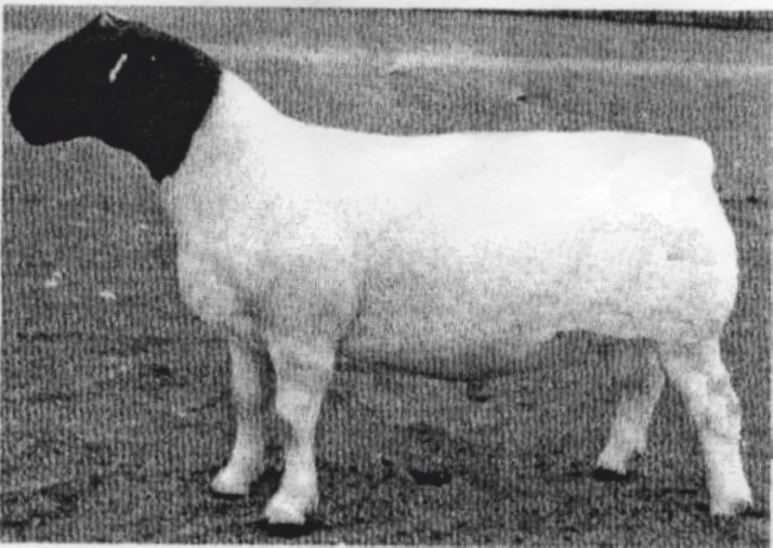

A

a) Identify the sheep breed.

................................................................................................................................................................... b) Name the part labelled A, B, C and D. (2 marks)
A .............................................................................................................................................................. B .............................................................................................................................................................. C .............................................................................................................................................................. D ..............................................................................................................................................................
c) On the diagram above, mark with letters E, F and G where the following practices are done.
E - Raddling
F - Tagging
G - Taking body temperature (1½ marks)

22. Below is a diagram of a farm implement. Study it and answer the questions that follow.

Swath stick

K
Spring
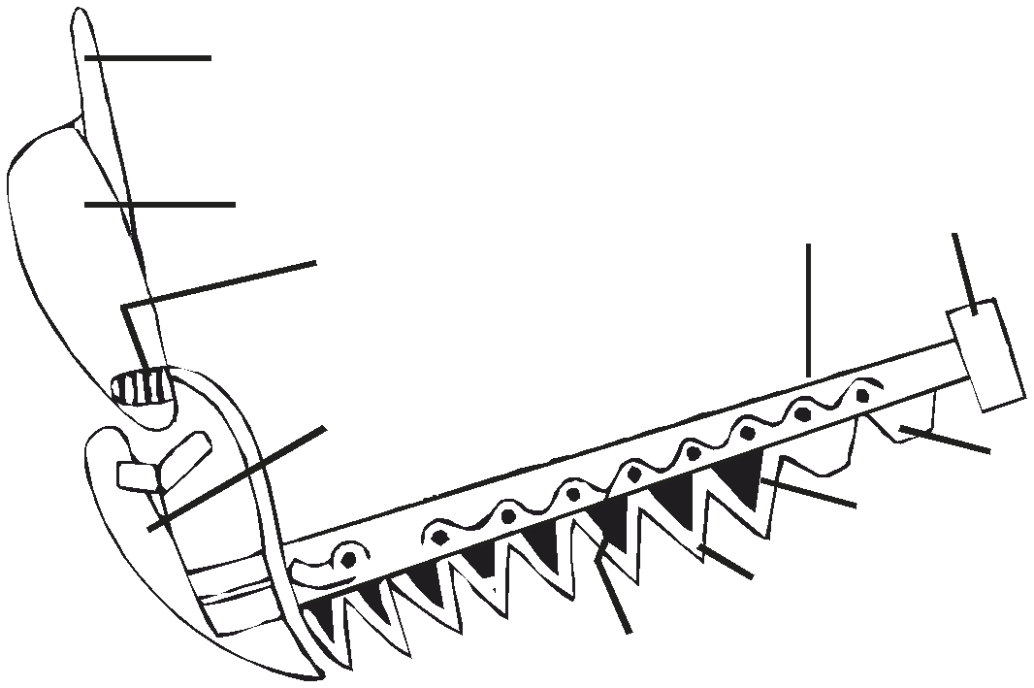

Skid plate

L Inner shoe

Knife section
Ledger plate
M

Wearing plate

a) Identify the implement. (½ mark)

................................................................................................................................................................... b) Name the parts labelled K, L, M (1½ marks)
K .............................................................................................................................................................. L .............................................................................................................................................................. M ..............................................................................................................................................................
c) Give one use of the implement on the farm. (1 mark)

...................................................................................................................................................................

................................................................................................................................................................... d) Explain any two maintenance practices carried out on the implement. (2 marks)
...................................................................................................................................................................

...................................................................................................................................................................

...................................................................................................................................................................

...................................................................................................................................................................

SECTION C (40 marks)
Answer only TWO questions from this section

23. a) Outline the symptoms of Tapeworm (Taenia spp) attack in livestock. (10 marks)

b) Describe five appropriate handling practices during routine management in livestock. (10 marks)

24. a) Explain four cultural uses of livestock (8 marks) b) Outline six advantages of the four stroke cycle engine. (5 marks) c) Describe preparation of a sow, one week before farrowing. (7 marks)
25. a) Discuss the four rules to be observed during milking in dairy cows. (8 marks)

b) Describe the process of digestion in following parts in poultry digestive system.

i) Crop (2 marks) ii) Gizzard (2 marks) iii)Caecum (2 marks)
c) Outline any six preventive measures in livestock disease control. (6 marks)

...................................................................................................................................................................

...................................................................................................................................................................

...................................................................................................................................................................

...................................................................................................................................................................

...................................................................................................................................................................

...................................................................................................................................................................

...................................................................................................................................................................

...................................................................................................................................................................

...................................................................................................................................................................

...................................................................................................................................................................

...................................................................................................................................................................

...................................................................................................................................................................

...................................................................................................................................................................

...................................................................................................................................................................

...................................................................................................................................................................

...................................................................................................................................................................

...................................................................................................................................................................

...................................................................................................................................................................

...................................................................................................................................................................

...................................................................................................................................................................

...................................................................................................................................................................

...................................................................................................................................................................

...................................................................................................................................................................

...................................................................................................................................................................

...................................................................................................................................................................

...................................................................................................................................................................

...................................................................................................................................................................

...................................................................................................................................................................

...................................................................................................................................................................

...................................................................................................................................................................

...................................................................................................................................................................

...................................................................................................................................................................

...................................................................................................................................................................

...................................................................................................................................................................

...................................................................................................................................................................

...................................................................................................................................................................

...................................................................................................................................................................

...................................................................................................................................................................

...................................................................................................................................................................

...................................................................................................................................................................

...................................................................................................................................................................

...................................................................................................................................................................

...................................................................................................................................................................

...................................................................................................................................................................

...................................................................................................................................................................

...................................................................................................................................................................

...................................................................................................................................................................

...................................................................................................................................................................

...................................................................................................................................................................

...................................................................................................................................................................

...................................................................................................................................................................

...................................................................................................................................................................

...................................................................................................................................................................

...................................................................................................................................................................

...................................................................................................................................................................

...................................................................................................................................................................

...................................................................................................................................................................

...................................................................................................................................................................

...................................................................................................................................................................

...................................................................................................................................................................

...................................................................................................................................................................

...................................................................................................................................................................

...................................................................................................................................................................

...................................................................................................................................................................

...................................................................................................................................................................

...................................................................................................................................................................

...................................................................................................................................................................

...................................................................................................................................................................

...................................................................................................................................................................

...................................................................................................................................................................

...................................................................................................................................................................

...................................................................................................................................................................

...................................................................................................................................................................

...................................................................................................................................................................

...................................................................................................................................................................

...................................................................................................................................................................

...................................................................................................................................................................

...................................................................................................................................................................

...................................................................................................................................................................

...................................................................................................................................................................

...................................................................................................................................................................

...................................................................................................................................................................

12

