TERM TWO EXAMINATION
FORM TWO CHEMISTRY
NAME………………………………………………………..ADM………CLASS

- The diagram below shows oxygen can be prepared in a laboratory. Study it and answer the questions that follow.
Water

Oxygen

Liquid X
MnO₂
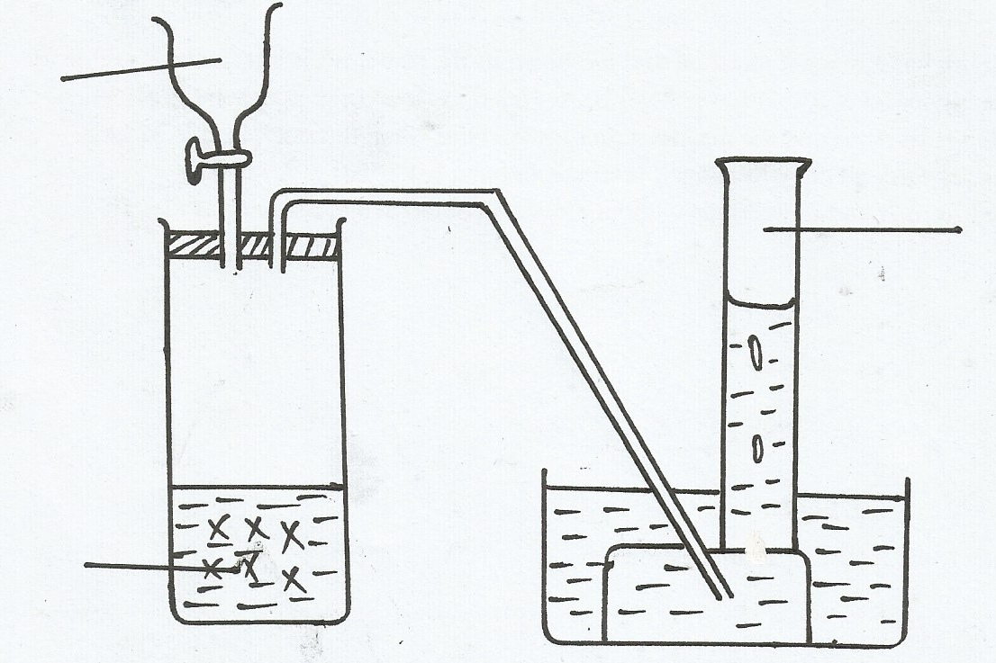

a) Name the liquid X (1mark)

b) Write a balance chemical equation to shows how oxygen is produced in the boiling tube. (1mark)

c) Give one industrial use of oxygen(1mark)

- Metal Xreacts with cold water slowly while Y does react with neither cold water nor hot water. Metal Z react with both cold water and hot water vigorously and explosively respectively. Arrange these metals in order of increasing reactivity (2mark)

c) Explain the observation made in (b) above (1mark)
- The grid below shows part of the periodic table. The letters do not represent the actual symbols of elements.
P | Q |  |  |  |  |  | X
 |  |  |  | Z |  |  | Y

(a) Compare
(i) Atomicradii ofP and Q(1mark)

(ii) Reactivity of X and Y (1mark)

(b) Write the chemical formula of a compound formed by Q after reacting with X. (1mark)

- Using dots(.) and crosses (x) show the bonding
- NH₄⁺ (1mark)

- H₂O (1mark)
- (a)Name two allotropes of carbon. (1mark)

- Explain why diamond is very hard. While graphite is very soft. (2marks)

©Carbon (II) oxide is a‘silent killer’. Explain. (2marks)

- Name the following processes;
- When anhydrous calcium chloride is left in an open beaker overnight a solution was formed. (1mk)

- When sodium carbonate decahydrate crystals are left in an open beaker for some days it turned into a powder. (1mk)

- In an experiment, two pieces of iron sheets were wrapped in each case with zinc and copper metal sheets as shown below. They were left in the open for some months.
iron

zinc copper
(I) (II)

State and explain the observations made in the experiments; (3mk)

8.Study the diagram below and answer the questions that follow.

Iron wool

wet sand gas J
heat

- Name gas J (1mk)

- Explain why its important to heat the wet sand before heating the iron wool. (1mk)

- Name the product formed in the combustion tube. (1mk)

9.Solutions can be classified as acids, bases or neutral. The table below shows solutions and their pH values
Solution | Ph – values
K | 1.5
L | 7.0
M | 14.0
- Select any pair that would react to form a solution of pH 7

(1 Mark)
- Identify two solutions that would react with aluminium hydroxide. Explain

(2 Marks)
- Oxygen gas can be prepared in the laboratory by heating potassium nitrate.
(a) Write the equation of reaction to show the decomposition of potassium nitrate (1 Mark)

(b) State two physical properties of oxygen gas (1 Mark)

- Outline one industrial use of oxygen gas (1 Mark)

11.Study the set-up below for electrolysis of molten lead(ii) bromide using grahite electrodes.
C
Switch
Cell
Bulb
Graphite electrode
Graphite electrode
Lead(ii) bromide

- Write ionic equations for reactions that took place at
I Anode (½ Mark)

II. Cathode (½ Mark)

- State the observation made at each electrode
I. Anode (½ Mark)

II. Cathode (½ Mark)

- State and explain the observations made on the electrolyte (1 Mark)

12.(a) State the role of the following parts during fractional distillation of a mixture of water and ethanol
(i) Glass beads in the fractionating column (1 Mark)

(ii) Fractionating column (1 Mark)

(b) State any one application of fractional distillation (1 Mark)

13.
Hydrogen
Lead (II) Oxide
Heat
Anhydrous
Calcium Chloride
Hydrogen flame

(i) Write an equation for the reaction that takes place in the tube (1 Mark)

(ii) What property of hydrogen makes this reaction possible? (1 Mark)

(iii) What would you expect to happen, if sodium oxide (Na₂O) was used instead of Lead (II) oxide?
(1 Mark)

14.The chromatogram of two inks and three dyes is drawn below.

Ink INK B RED BLUE YELLOW
A B DYE DYE DYE
(a) Name the colours of ink A (1 Mark)

(b) Suggest how separated components can be recovered (1 Mark)

- Suggest two reasons why separations occur in this method (1 Mark)

15.(a) Why is reaction between calcium and dilute sulphuric (VI) acid not used in preparation of hydrogen
gas
(2 Marks)

(b) Calcium is an element in period 2, what do members of the period have in common? (1 Mark)
- The sketch below shows a graph of temperature against time obtained when a gaseous substance was cooled.
Explain what happens to the gaseous substance between:
- T and U (1 mark)

U and V (1 mark)

V and W (1 mark)

17.Diamond and graphite are both allotropes of carbon. Explain why graphite is a good conductor
of electricity while diamond is not. (2 marks)

18.The figure below shows the stages in the manufacture of sodium carbonate. Study the diagram
below and use it to answer the questions that follow.
HEATING LIMESTONE
REACTION CHAMBER 2
REACTION CHAMBER 1
REACTION CHAMBER 3
Calcium chloride
Sodium carbonate
Solid V
Filtration
Liquid U
Carbon
(IV) Oxide
Ammonia
Brine

a) (i) Name three starting materials in the manufacturer of sodium carbonate.( 1¹/₂ marks)

(ii) Which substances are recycled in this process? ( 1¹/₂ marks)

(iii) Identify the chambers in which the recycled substances are regenerated.( 1¹/₂ marks)
(iv) Name the substances U and V. (1 marks)

- Give an equation for the reaction which occurs:

(i) In the reaction chamber 1 ( 1 mark)

(ii) When solid V is heated. ( 1 mark)

- In the reaction chamber 3.( 1 mark)

c) State one commercial use for
(i) Sodium carbonate. ( 1 mark)

19. The set-up below was used to prepare dry carbon (II) Oxide gas. use it to answer the questions
below it:

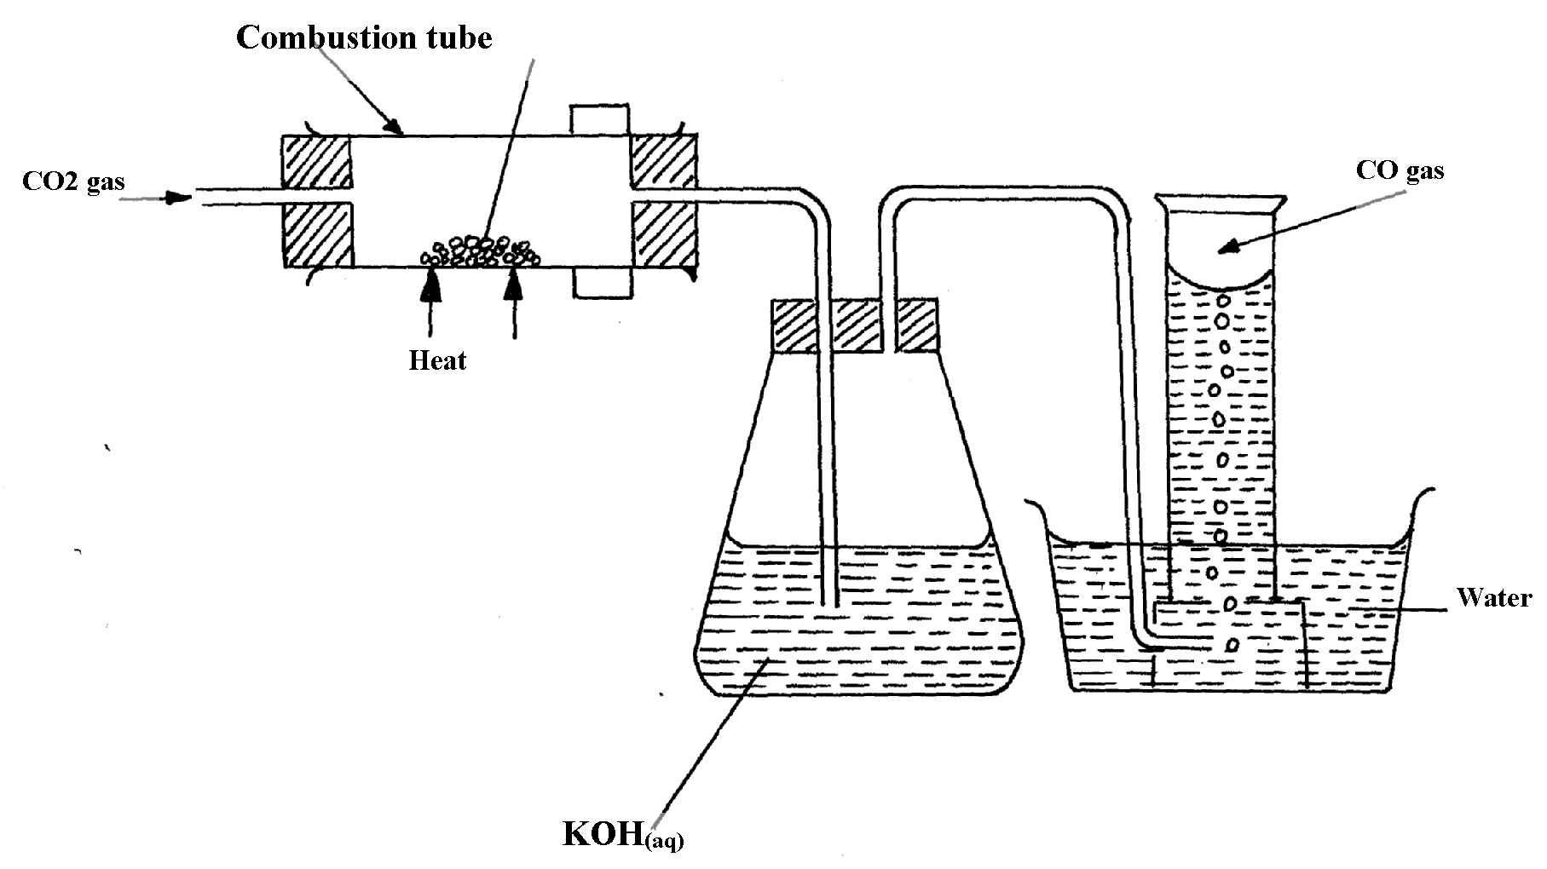
charcoal

(a) (i) State two mistakes committed in the set-up arrangement above( 2 marks)

(ii) The student produced carbon (IV) oxide gas from the reaction between Lead (II) Carbonate
and dilute hydrochloric acid. The gas was produced for a short time and the reaction came
to a stop. Explain (2 marks)

(iii) Write the equation for the reactions taking place in the combustion tube and the conical
flask: ( 2 marks)
Combustion tube:…………………………………………………………………..
Conical flask ……………………………………………………………………..

(iv) State one use of carbon (IV) Oxide gas apart from fire extinguisher(1 mark)

(v) Give two properties that make carbon (IV) Oxide to be used as fire extinguisher ( 2 mark)
(b) PbO_{(s)} + CO_{(g)} Pb_{(s)} + CO_{2(g)}

Which property of carbon (II) Oxide is demonstrated by the above equation? (1 mark)

(c) Aluminium carbonate does not exist. Give a reason ( 1 mark)

(d) Ammonium carbonate decomposes when heated. Write a chemical equation to
represent this decomposition ( 1 mark)

