NAME…………………………………………… ………………………………………………… ADM NO…………………
ANESTAR SCHOOLS JOINT EVALUATION TEST
…./80
TERM TWO 2020
233/1CHEMISTRY PAPER 1 (THEORY)
TIME 2 HOURS
INSTRUCTIONS TO CANDIDATES
- Write your name and Index Number in the spaces provided above.
- Sign and write date of examination in the spaces provided above.
- Answer ALL questions in the spaces provided.
- Mathematical tables and electronic calculators may be used.
- All workings must be clearly shown where necessary.

1. The chromatogram below shows the constituents of ink sample M using propanone spirit as solvent.
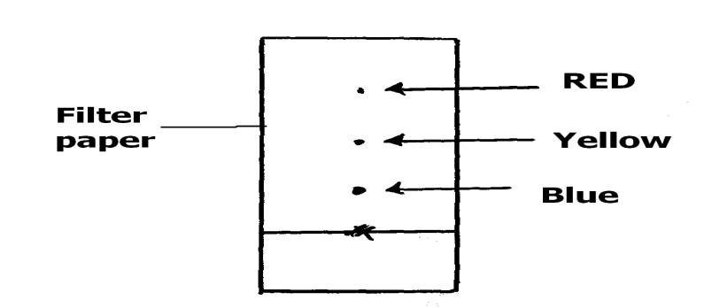
Describe how you would obtain a solid sample of the red pigment from the chromatogram above. (3mks)
……………………………………………………………………………………………………………………………………………..
……………………………………………………………………………………………………………………………………………..
……………………………………………………………………………………………………………………………………………..
……………………………………………………………………………………………………………………………………………..
……………………………………………………………………………………………………………………………………………..
……………………………………………………………………………………………………………………………………………..
2. Air was passed through several reagents shown in the flow chart below.
air
Excess heated magnesium powder
Unreacted gases
Excess heated copper turnings
Concentrated KOH solution
a) Write an equation for the reaction which takes place in the chamber with
magnesium powder(2 marks)
...........................................................................................................................................
(b) Name one gas, which escapes from the chamber containing magnesium powder.
Give a reason for your answer (1 marks).
……………………………………………………………………………………………………………………………………..
3. An ion T3⁻ has an electronic arrangement of 2.8
(a) What is the atomic number of the element. (1mk)
…………………………………………………………………………
(b) To which group and period does the element belong to;
Group___________________________________________(1mk)
Period__________________________________________ (1mk)
4. 27cm³ of a solution containing 0.1M of Sodium hydroxide was neutralized by 18cm3 of dilute Sulphuric (VI) acid. Calculate the concentration of the acid in moles per litre.
(Na = 23, O = 16, H=1) (3mks)
……………………………………………………………………………………………………………………………………..
……………………………………………………………………………………………………………………………………..
……………………………………………………………………………………………………………………………………..
……………………………………………………………………………………………………………………………………..
5. Natural gallium consists of the isotopes ⁶⁹Ga and ⁷¹Ga in the ratio 3:2 respectively. Which of the isotopes is likely to depict the relative atomic mass of gallium? Explain. (2mks)
……………………………………………………………………………………………………………………………………..
……………………………………………………………………………………………………………………………………..
6. A concentrated solution of sulphuric contains 70% H₂SO₄ and has density of 1.8g/cm³. Determine the molarity of the sulphuric acid solution. (H=1, S=32, O=16) (3mks) ……………………………………………………………………………………………………………………………………..
……………………………………………………………………………………………………………………………………..
……………………………………………………………………………………………………………………………………..
7. Identify and state the use of the apparatus represented below. (2 marks)
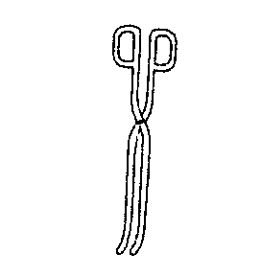
Name……………………………………………………………………
Use………………………………………………………………………
8. 3.78g of a hydrated salt of iron (II) sulphate, FeSO₄, in H₂O were heated until all the water of crystallization was driven off. The anhydrous salt left had a mass of 1.52g.
Determine the formula of the hydrated salt. (Fe = 56, S = 32, H = 1, O = 16) 3 marks
......................................................................................................................................................................
........................................................................................................................................................................
........................................................................................................................................................................
........................................................................................................................................................................
........................................................................................................................................................................
........................................................................................................................................................................
........................................................................................................................................................................
9. A set-up to investigate electrical conductivity of substances was assembled as shown below.
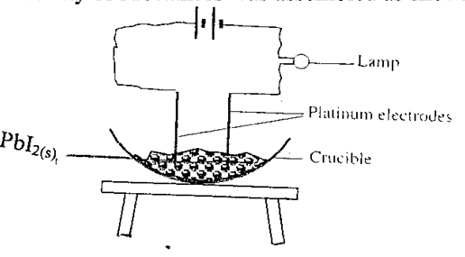
The bulb did not light.
(a) What was missing in the set-up? (1 mark)
(b) The bulb lit when the omission was corrected. Explain. (2 marks)
……………………………………………………………………………………………………
……………………………………………………………………………………………………
10. The empirical formula of a compound is C₂H₅ and it has a molecular mass of 58.
(a) What is the molecular formula of this compound? (2 mark)
……………………………………………………………………………………………………
……………………………………………………………………………………………………
(b) To which group of hydrocarbons does the compound in (a) above belong? (1/2 mark)
……………………………………………………………………………………………………
(c) Draw the structural formula of the third member of this series and give its IUPAC name
…………………………………………………………………………………………………… (1/2 mark)
……………………………………………………………………………………………………
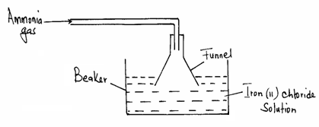
11. The diagram below is a set-up of apparatus used to react ammonia gas with iron (II) chloride solution.

(a) State the observation made in the beaker after a few minutes.(1 mark)
……………………………………………………………………………………………………
……………………………………………………………………………………………………
(b) Explain why the funnel is used to deliver the ammonia into the solution. ……………………………………………………………………………………………………
……………………………………………………………………………………………………(1 mark)

12. The diagram below shows how two gases P and Q were collected.
- Name the two methods used
(i)………………………………………………… 1mk
(ii)…………………..……………………………… 1 mk
b) How do the densities of P and Q compare? 1mk
…………………………………………………………………………………………………………………………………………………………………………………………………………………………………………………………………………………………………………
13. When Carbon (IV) oxide gas was passed through aqueous calcium hydroxide a white suspension was formed.
(a) Write an equation for the reaction that took place. (1mark)
…………………………………………………………………………………………………………………………………………………………………………………………………………………………………………………………………………………………………………
(b) State and explain the changes that took place when excess Carbon (IV) Oxide was bubbled through the white suspension . (2marks)
…………………………………………………………………………………………………………………………………………………………………………………………………………………………………………………………………………………………………………

14. The apparatus below was set up to show the catalytic oxidation of ammonia.
Jar
Conc. Ammonia solution
A
B
Hot platinum wire
- Name substances labeled A and B. 2mk
A…………………………………………B……………………………………
- State and explain two observations made in the jar. 2mk
……………………………………………………………………………………………………………………………………………………………………………………………………………………………………………………………………………………………………………………………………………………………………………………………………………………………………………………………..
15. State any three uses of sulphuric (VI) acid. 3 mks
……………………………………………………………………………………………………………………………………………………
……………………………………………………………………………………………………………………………………………………
………….…………………………………………………………………………………………………………………………………………

16. a) Chlorine is used to treat drinking water. Briefly explain how chlorine eradicates micro-organisms. ……………………………………………………………………………………………………………………………………………………(2mks)
……………………………………………………………………………………………………………………………………………………
………….…………………………………………………………………………………………………………………………………………
b) What does the term CFCs stand for? (1mk)
……………………………………………………………………………………………………………………………………………………(1mks)
17. Study the set- up below and answer the questions that follow. 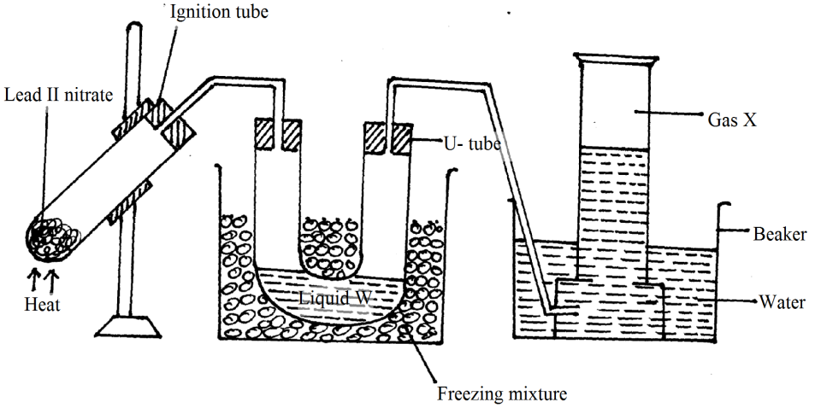
a) Identify :-
(i) Liquid W……………………………………………...( 1 mk)
(ii) Gas X ……………………………………………………….( 1 mk)

b) Write the chemical equation for the reaction taking place in the ignition tube. ……………………………………………………….……………………………………………………………………………… (1mk)
c) State any one observation made in the ignition tube after the residue formed was allowed to cool.
…………………………………..…………………………………………………………………………………………………(1mk)
18. Starting with nitric (V) acid, distilled water, lead (II) carbonate and sodium sulpahte crystals, describe how you can prepare lead (II) sulpahte crystals.(3 marks)
……………………………………………………………………………………………………………………………………………………
……………………………………………………………………………………………………………………………………………………
………….…………………………………………………………………………………………………………………………………………
………….…………………………………………………………………………………………………………………………………………
………….…………………………………………………………………………………………………………………………………………
19. The diagram below is a set up for the laboratory preparation of dry oxygen gas.
Sodium peroxide
Liquid X
Liquid Y

- Name:
I. Liquid Y……………………………………………………………….. (1 Mark)

II. Liquid X………………………………………………………………. (1 Mark)

(b) Write an equation for the reaction that took place in the flask. (1mark)
…………………………………………………………………………………………………………………………………….
(c) Complete the diagram to show how dry oxygen can be collected. (1mark)
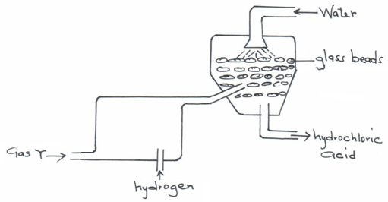
20. The diagram below represents a section of the hydrochloric acid manufacturing plant.

(a) Name Gas Y………………………………………………………………………………..(1 mark)
(b) State the role played by glass beads. (1 mark)
…………………………………………………………………………………………………………………………………….
(c) Chlorine reacts with hydrogen sulphide gas according the equation shown below:
H₂S _{(g)} + Cl_{2 (g)} → 2HCl _{(g)} + S_{(S)}
From the equation identify the oxidizing agent. (1 mark)
…………………………………………………………………………………………………………………………………….
…………………………………………………………………………………………………………………………………….
21. A form one student set-up the following apparatus to investigate the percentage of oxygen in air.

c
Sodium
Hydroxide
a
b

(a) Why is sodium hydroxide preferred to water in the above experiment? (1 Mark)
……………………………………………………………………………………………………………………………………………………………………………………………………
(b) Write an expression to show how the percentage of oxygen can be calculated (1 Mark)
…………………………………………………………………………………………………………………….………………………………………………………………………………
22. A balloon contains 80cm³ of gas at 30⁰C and 4 atmospheres. Calculate the volume of the balloon at 50⁰C and 2 atmospheres. (3 Marks)
…………………………………………………………………………………………………………………….………………………………………………………………………………
…………………………………………………………………………………………………………………….………………………………………………………………………………
…………………………………………………………………………………………………………………….………………………………………………………………………………
23 State and explain what is observed when chlorine gas is bubbled through a solution of potassium bromide solution. (2 marks)
…………………………………………………………………………………………………………………….………………………………………………………………………………
…………………………………………………………………………………………………………………….………………………………………………………………………………

(b) Write an ionic equation for the above reaction (1 mark)
…………………………………………………………………………………………………………………….………………………………………………………………………………
24. Give the systematic names of the following compounds:- (2mks)
- CH₂ = C – CH₃
Br
……………………………………………………….………………………………………….
- CH₃CH₂CH₂C = CH
……………………………………………………….…………………………………
25 The simplified flow chart shows some of the steps in the manufacture of sodium carbonate by the Solvay process
G
Ammonium Chloride
Step II
Ammonium Chloride and sodium hydrogen carbonate
BRINE
Sodium hydrogen carbonate
Carbon (IV) oxide
Step III
Sodium carbonate

- Identify substance G. (1mk)
......................................................................................................................................
- Name the process – taking place in step II (1mk)
…………………………………………………………………….………………………
- Write an equation for the reaction, which takes place in step III. (1mk)
………………………………………………………………….…………………………
26. The diagram below shows the bonding between boron chloride and ammonia
Cl H
| |
Cl – B N - H
| |
Cl H

- Name the types of bonds that exist in the molecule. (1mk)
…………………………………………………………………………..………………
- How many electrons are used for bonding in the molecule? (1mk)
……………………………………………………………………………………….…
- What makes it possible for the boron chloride molecule to bond with the ammonia molecule? (1mk)
…………………………………………………………………………………………..

27. The grid below shows part of the periodic table. The letters do not represent the actual symbols of the elements.
 |  |  |  | J
 |  |  |  | K |  |  | L
M

Select the
- Element which has the largest atomic radius (1mk)
………………………………………………………………………………………
- Most reactive metal (1mk)
………………………………………………………………..……………..………

- Most reactive non- metal (1mk)
………………………………………………………………..……………..………

