FORM THREE CHEMISTRY PAPER 2
NAME: ………………………...……………..ADM NO: …………CLASS: …….……
1.The grid below shows part of the periodic table. Use it to answer question that follow. The letters do not represent actual symbols.

S U V
P R T W
Q

- Which of the elements has the highest atomic radius? Explain (2marks)

- Identify the most reactive non- metal. Explain (2marks)

- Give the electron configuration of: (1mark)

(i)Element S
(ii)Element Q

- Compare the atomic radius of P and R. Explain (2marks)

- Given that the atomic mass of W is 40. Write down the composition of its nucleus. (1mark)

- Write the formula of compounds formed between:

(i) Element P and S (1mark)

(ii)Element R and T (1mark)

- Give the formula of one stable ion with an electron arrangement of 2.8 which is:
(i)Negatively charged (1mark)

(ii)Positively charged (1mark)

2.The diagram below shows the process of manufacturing sodium carbonate using ammonia soda
process. Study it and answer the questions that follow.
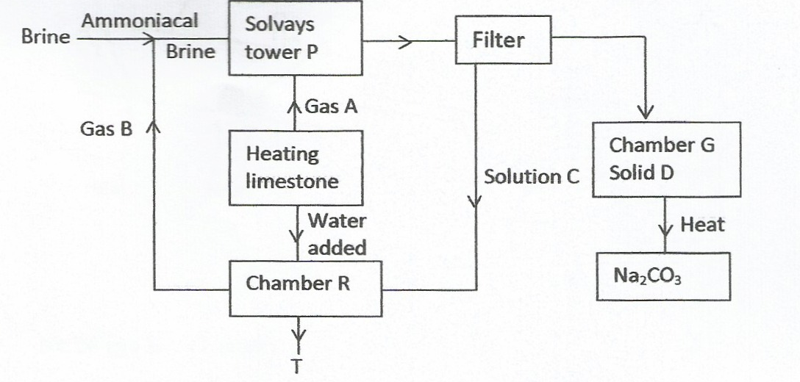

(a) Name gases A and B. (2 marks)
A
B
(b) Name liquid C and solid D. (2 marks)
C
D
(c) Write equations of the reactions in: (2 marks)
Tower P

Tower R

(d) Name the product T formed at chamber R and give one of its uses. (2 marks)
3. Air was passed through several reagents as shown in the flow chart below.
Gas p
Concentrated
Sodium hydroxide
Electrostatic
Excess heated
Copper turnings
Excess heated
Magnesium
Compressor
Fractionating column
Nitrogen
(-196⁰C)
Argon
(-186⁰C)
C (-183⁰C)
Air

(a) Name the major components of air. (2mks)

(b) Write an equation for the reaction which takes place in the chamber with:
(i) Concentrated sodium hydroxide. (1mk )
(ii) Excess heated copper turnings. (lmk)

(iii) Excess heated magnesium powder. (1mk)

(c) Name onegas which escapes from the chamber containing magnesium powder. Give a reason for your answer. (2mks)

(d) Name the substance that was eliminated by electrostatic precipitation. (l mk)

(e) Name a reagent that can be used in place of concentrated sodium hydroxide. (1 mk)

f) Name substance C. (l mk)

(g) State three uses of gas C. (3 mks)

4. a. (i) Sulphur is allotropic. What does this mean? (1 mk)

(ii) Give two differences between rhombic and monoclinic sulphur. (2 mks)

(iii) State and explain using an equation the observations made when sulphur reacts with hot concentrated nitric (v) acid. (3 mks)

Observations

Equation

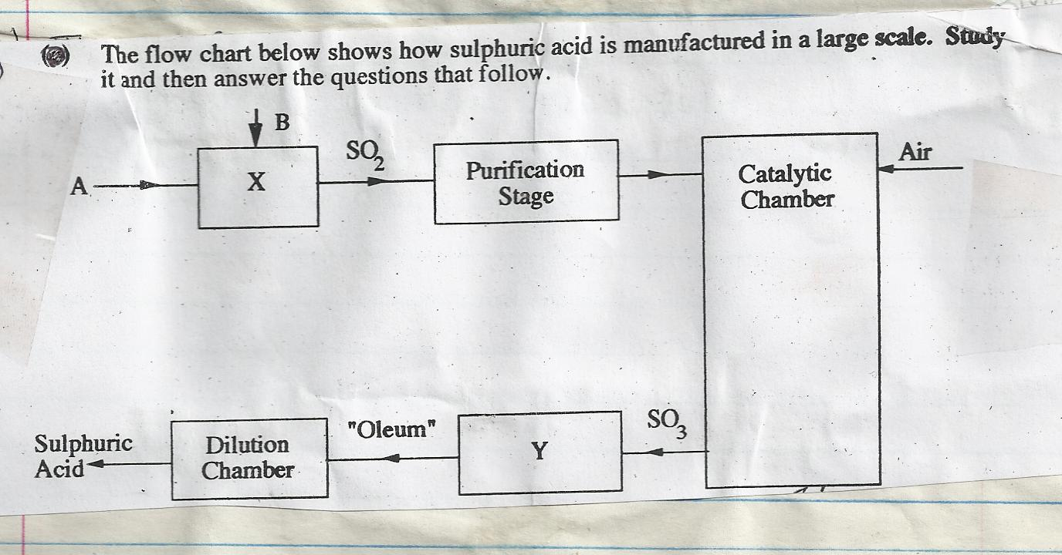

I. (i) Name the raw materials A and B. (2 mks)

A
B
(ii) Name the chambers X and Y. (2 mks)

II. (i) Name two impurities that are removed during the purification stage.(2 mks)

(ii) Why must the impurities in (i) above be removed. (1 mk)

III. (i) Name the catalyst used in this process. (1 mk)

(ii) The equation below shows what happens in the catalytic chamber.

2SO_{2(g)} + O_{2(g )} 2SO₃ ∆ H = -197KJ/Mol

(iii) State the two conditions that are necessary for maximum production of SO₃ (1 mark)

5. A student set up the apparatus as shown in the diagram below to prepare and collect
dry ammonia gas.
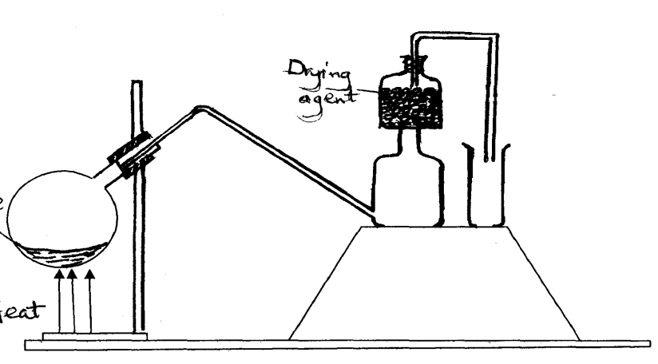
Heat
Drying agent

Mixture of Ammonium chloride and Calcium hydroxide moist

i. Identify two mistakes in the set up and give a reason for each mistake (3mks)
ii. Name a suitable drying agent for ammonia (1mk)

iii. Write an equation for the reaction that occurred when a mixture of ammonium chloride and calcium hydroxide was heated. (1mk)

iv. Describe one chemical test for ammonia gas. (2mks)

b) Ammonia gas is used in the manufacture of nitric (v) acid, as shown below.
High
temperature
Cooling chamber
Absorption tower
Ammonia
Air
Gases
A
B
Water
Unit III
Unit II
Unit I

i. This process requires the use of a catalyst. In which unit is the catalyst used? (1mk)
ii. Identify compound A and B
A (1mk)
B (1mk)
iii. Ammonia and nitric (v) acid are used in the manufacture of ammonium nitrate fertilizer. Calculate the amount of nitric (v) acid required to manufacture 1000kg ammonium nitrate using excess ammonia (3mks)
6.A mixture of magnesium powder and lead (II) Oxide will react vigorously when heated but no reaction occurs when a mixture of magnesium oxide and lead powder areheated.
a) Explain the observation above. (2mks)

b) Write an equation for the reaction between magnesium and lead (II) oxide. (1mk)

c) From (b) above, identify:
i. Oxidized substance (1mk)

ii. Oxidizing agen(1mk)

iii. What name is given to such a reaction (1mk)

d) The following data gives the pH values of solution A, B and C, use the information provided to answer the questions that follow.
Solution | pH
A | 13.9
B | 6.7
C | 1.5
i. Which solution would give pink colour after adding a few drops of phenophthalein? Give its possible identity (2 marks)
Solution
Identity
ii. Which solution would produce carbon (IV) oxide when reacted withcopper (II) carbonate?( 1 mark)

iii. Which solution would produce ammonia gas when reacted with ammonium chloride?(1 mark)

7.a) What name is given to a compound that contains carbon and hydrogen only? (1 mark)

b) Hexane is a compound containing carbon and hydrogen.
- What method is used to obtain hexane from crude oil? (1 mark)

- State one use of hexane. (1 mark)

c) Study the flow chart below and answer the questions that follow.
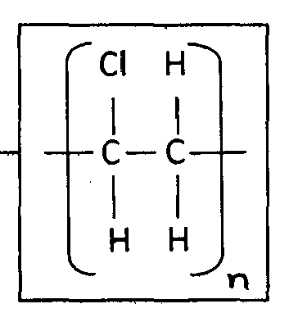
Ca(OH)₂
Step 3
Step 1
Step 2
L + H₂O
1 mole HCl
K
Gas J
Step 4
1 mole H₂

Step 6
H₂O catalyst
C₂H₄
CH₃CH₃
CH₃CH₂OH
Ni,H_{2,}150ºC
Step 5

- Identify reagent L.
(1 mark)
- Name the catalyst used in step 5. (1 mark)

- Draw the structural formula of gas J. (1 mark)

- State;
- One use of product R. (1 mark)

- A commercial application of the process which takes place in step 6. (1 mark)

