NAME………………………...............................ADM...….CLASS…..
FORM FOUR
233/1
CHEMISTRY PAPER 1 (Theory)
TIME: 2 HRS
INSTRUCTIONS.
- Answer all questions in the spaces provided.
- Mathematical tables and calculators may be used.
- All working must be clearly shown.
1. Molten sodium chloride and graphite both conduct electricity. State their difference in electrical conductivity (2mks)
……………………………………………………………………………………………………..
……………………………………………………………………………………………………..
2.20cm³ of an unknown gas Q takes 12.6 seconds to pass through a small orifice. 10cm3 of oxygen gas takes11.2 seconds to diffuse through the same orifice under he same conditions of temperature and pressure. Calculate the molecular mass of the unknown gas (O=16)

3. Study the diagram below and answer the questions that follow
HCl_{(aq)}
Ba(NO₃)_{2(aq)}
Gas Y which turns K₂Cr₂O₇ paper from orange to green
Solid X
Solution of Potassium salt

(a) Name (i)Solid X (1mk)
………………………………………………….
(ii) Gas Y (1mk)
…………………………………………………..
4. Compare the second ionization energy of magnesium with its first ionization energy. Explain your answer. (2mks)
……………………………………………………………………………………………………..
……………………………………………………………………………………………………..
……………………………………………………………………………………………………..
5.(a) Define solubility as applied in solids (1mk)
……………………………………………………………………………………………………..
……………………………………………………………………………………………………..
(b) In an experiment,36 grams of a saturated solution of a salt at 25ºC yielded 12 grams of solid when evaporated to dryness. Determine the solubility of the salt at 25ºC (2mks)

6. A cleaning agent L can be made according to the scheme below.
R
Cleaning agent L
OSO₃H+NaOH_{(aq)}
R
Conc. H₂SO₄

(a) Draw the structure of L (1mk)

(b) Give two advantages of using L as a cleaning agent. (1mk)
……………………………………………………………………………………………………..
……………………………………………………………………………………………………..
7. 25.0cm³ of a solution of hydrochloric acid reacts completely with 3.0g of Magnesium ribbon. Calculate the concentration of hydrochloric acid in mol/dm³ (Cl=35.5, Mg= 24.0, H=1.0) (3mks)

8. A hydrocarbon has 85.71% carbon by mass. Its relative molecular mass is 84. Determine the
Molecular formula of the hydrocarbon. (3 marks)

9. The figure below shows a paper that was placed horizontally across the middle of a non-luminous flame and quickly withdrawn.
Paper
Charred black
Unburnt

(a) Explain the observations (1mk)
……………………………………………………………………………………………………..
……………………………………………………………………………………………………..
(b) Why is luminous flame not used for heating in the laboratory? (1mk)
……………………………………………………………………………………………………..
……………………………………………………………………………………………………..
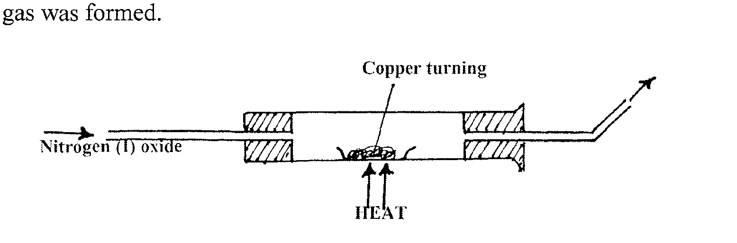
10. When nitrogen (I) oxide was passed over heated copper turnings as shown in the diagram below, Nitrogen gas was formed.

Copper turnings

(a)Write the equation for the reaction which takes place (1mk)
……………………………………………………………………………………………………..
(b) Name two uses of Nitrogen (I) oxide (2mks)
……………………………………………………………………………………………………..
……………………………………………………………………………………………………..
11. Sodium can be extracted by electrolysis of molten sodium chloride. In this process, calcium chloride is added to the sodium chloride
(a) Give the purpose of the calcium chloride (1mk)
……………………………………………………………………………………………………..
……………………………………………………………………………………………………..
(ii) Write the cathode and anode equations
Cathode (1mk)
……………………………………………………………………………………………………..
Anode (1mk)
……………………………………………………………………………………………………..
(iii) Name one use of Sodium (1mk)
……………………………………………………………………………………………………..
……………………………………………………………………………………………………..
12.Ethane reacts with chlorine gas in the presence of sunlight as shown
Sunlight
CH₃-CH₃+Cl₂ CH₃CH₂Cl+HCl
The following bond energies are shown
Cl-Cl = 242KJmol⁻¹
C-Cl = 339KJmol⁻¹
H-Cl = 431KJmol⁻¹
C-H = 413KJmol⁻¹
C-C = 400KJmol⁻¹
(a) Calculate the heat change during the reaction. (3mks)

(b) Is the reaction exothermic or endothermic? Give a reason (1mk)
……………………………………………………………………………………………………..
……………………………………………………………………………………………………..
13. Briefly explain the following
(i) Alkaline earth metals are generally less reactive than alkali metals (1mk)
……………………………………………………………………………………………………..
……………………………………………………………………………………………………..
(ii) Melting point of alkali metals decrease down the group while melting point of halogens Increases down the group (2mks)
……………………………………………………………………………………………………..
……………………………………………………………………………………………………..
(iii) Group VIII elements are gases at room temperature. (1mk)
……………………………………………………………………………………………………..
……………………………………………………………………………………………………..
14.How would you obtain a sample of pure iodine from a mixture of iodine and lead (II) sulphate(2mks) ……………………………………………………………………………………………………..
……………………………………………………………………………………………………..
……………………………………………………………………………………………………..
15. The table below indicates the PH values of solutions labeled A,B,C,D and E
Solution | A | B | C | D | E
P^{H} value | 5 | 13 | 2 | 10 | 7
Identify the solution:
(i) Containing highest concentration of hydrogen ions ( ½ mk) ……………………………………………………………………………………………………..
(ii) that is likely to be ethanoic acid. Give a reason ( 1mk)
……………………………………………………………………………………………………..
…………………………………………………………………………………………………
(iii) that is likely to be common salt solution ( ½ mk)

16.Use the information in the table below to answer the questions that follow.(Letter A,B.C,D,E and Z are not actual symbols of elements)
Oxide | A₂O | BO | C₂O₃ | DO₂ | E₂O₅ | ZO₂
P^{H} of oxide in water | 13 | 9 | x | x | 1 | 4
Melting point | 1193 | 3075 | 2045 | 1728 | 563 | -91
- Identify oxide with the following structures
(i) Giant atomic ( ½ mk)
……………………………………………………………………………………………………..
(ii) Simple molecular ( ½ mk)
……………………………………………………………………………………………………..
(b) Write another formula of the oxide formed when E and oxygen combine apart from the one given above. (1mk)
……………………………………………………………………………………………………..
……………………………………………………………………………………………………..
(c) Explain why DO₂ is a solid at room temperature and pressure while ZO₂ is a gas (2mks)
……………………………………………………………………………………………………..
……………………………………………………………………………………………………..
……………………………………………………………………………………………………..
17.An element Y has relative atomic mass 6.939 and atomic number 3. It has two isotopes with atomic 6.015 and 7.016. Calculate the relative abundance of the isotopes

18.(a) Give the name of the organic compound formed when methanol and ethanoic acid reacts in the presence of concentrated sulphuric (VI) acid (1mk)

(b) Write the structural formula of 2-methylpropane (1mk)

19. The diagram below shows how magnesium reacts with steam

Gas C
Wet cotton
Magnesium
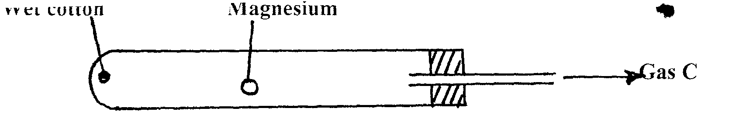
(i) Gas C would not be produced as in the set-up but when certain condition is introduced gas C is produced. On the diagram indicate the condition that was omitted (1mk)
(ii) Describe how gas C is produced after the mistake was corrected in the set-up (1mk)
……………………………………………………………………………………………………..
……………………………………………………………………………………………………..
20.Study the information in the table below and answer the questions that follow. The letter do not represent the actual symbols of the elements
Element atomic number Electronic arrangement
X 16
Y 19
(a) Complete the table by writing the electronic arrangement of the elements (1mk)
(b) Which type of bond is formed between X and Y. Explain (2mks)
……………………………………………………………………………………………………..
……………………………………………………………………………………………………..
21. Hydrogen chloride gas was passed into water as shown below
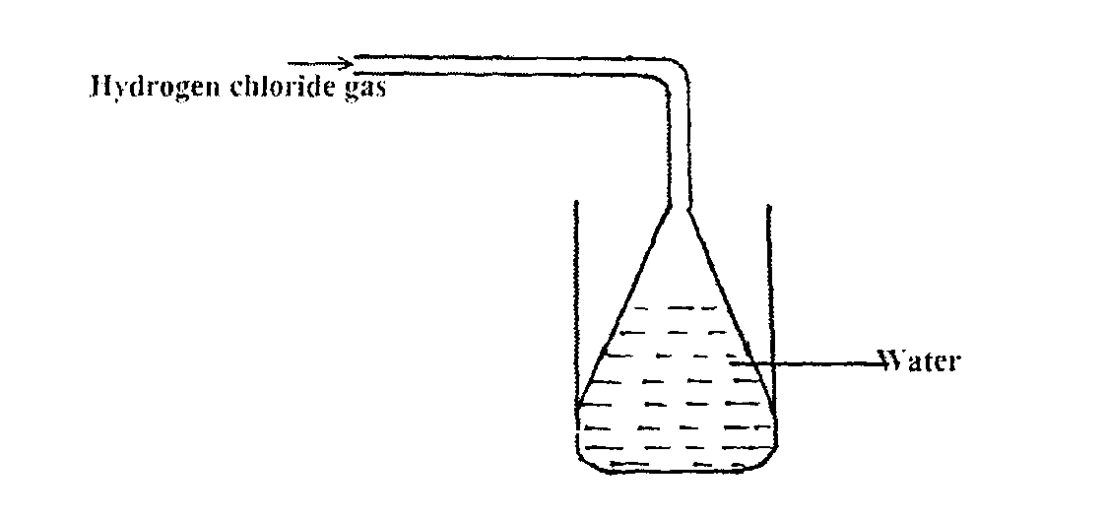
Hydrogen chloride gas

Water

(a) When a blue litmus paper was dropped into the resulting solution, it turned red. Give a reason for the observation (1mk)
……………………………………………………………………………………………………..
……………………………………………………………………………………………………..
- What is the function of the funnel? (1mk)
……………………………………………………………………………………………………..
……………………………………………………………………………………………………..
22. The paper chromatogram below shows the identification of unknown metal ions in mixture M. The reference ions X,Y and Z are also shown. The experiment was done in an ascending method.
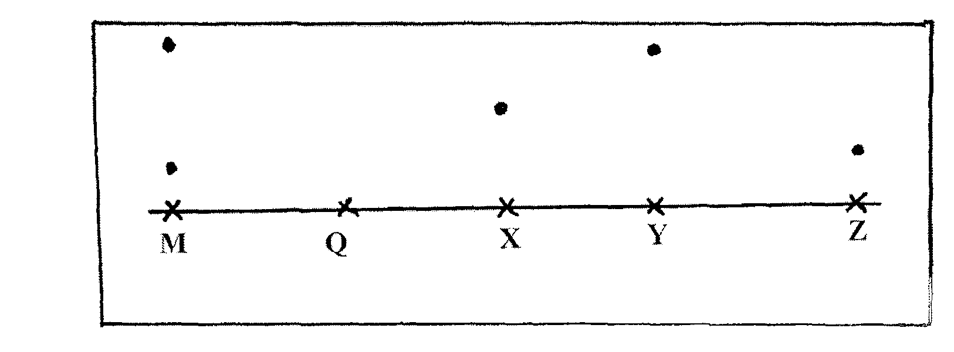
X- Vanadium (IV) ion (V⁴⁺)
Y-Chromium (III) ion (Cr³⁺)
Z- Copper (II) ion (Cu²⁺)
(a) Name the ions present in the mixture M (1mk)
……………………………………………………………………………………………………..
(b) Indicate the solvent front on the diagram (1mk)
(c) Mixture Q contains all the three ions. Show the chromatography of Q ( 1 ½ mks)
23. The set up below shows the preparation of Carbon (II) oxide
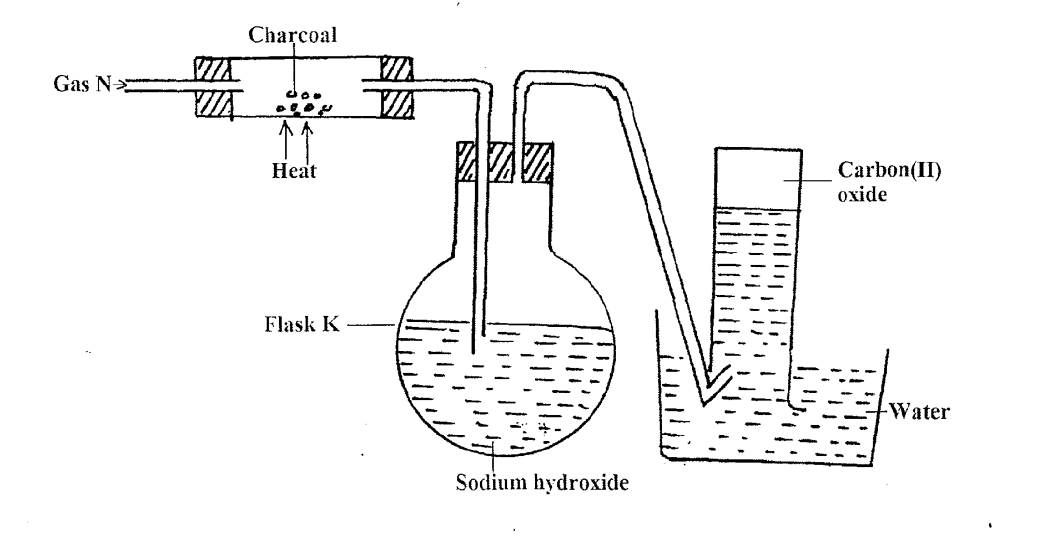
(a)Name gas N (1mk)
……………………………………..
(b) What is the purpose of sodium hydroxide in flask K? (1mk)
……………………………………………………………………………………………………..
(c) Why is it necessary to carry out this experiment in a fume cupboard? (1mk)
……………………………………………………………………………………………………..
……………………………………………………………………………………………………..
24.100g of a radioactive substance was reduced to 12.5g in 15.6 years. Calculate the half-life of the substance (2mks)

25.Using dots (•) and crosses (X), show the formation of (H₄O)²⁺; (H=1, O=8) (3mks)

26.When dry hydrogen gas was passed over a heated lead (II) oxide sample in a combustion tube and the gaseous product cooled, a colorless liquid was obtained.
(a)(i) Name the colorless liquid ( ½ mk)
……………………………………………………………………………………………………..
……………………………………………………………………………………………………..
(ii) Describe a chemical test you would use to confirm the colorless liquid in a (i) above (2mks)
……………………………………………………………………………………………………..
……………………………………………………………………………………………………..
……………………………………………………………………………………………………..
(c) Write a chemical test you would use to confirm the colorless liquid in a (i) above (2mks)
……………………………………………………………………………………………………..
27.The following is an energy level diagram for the reaction
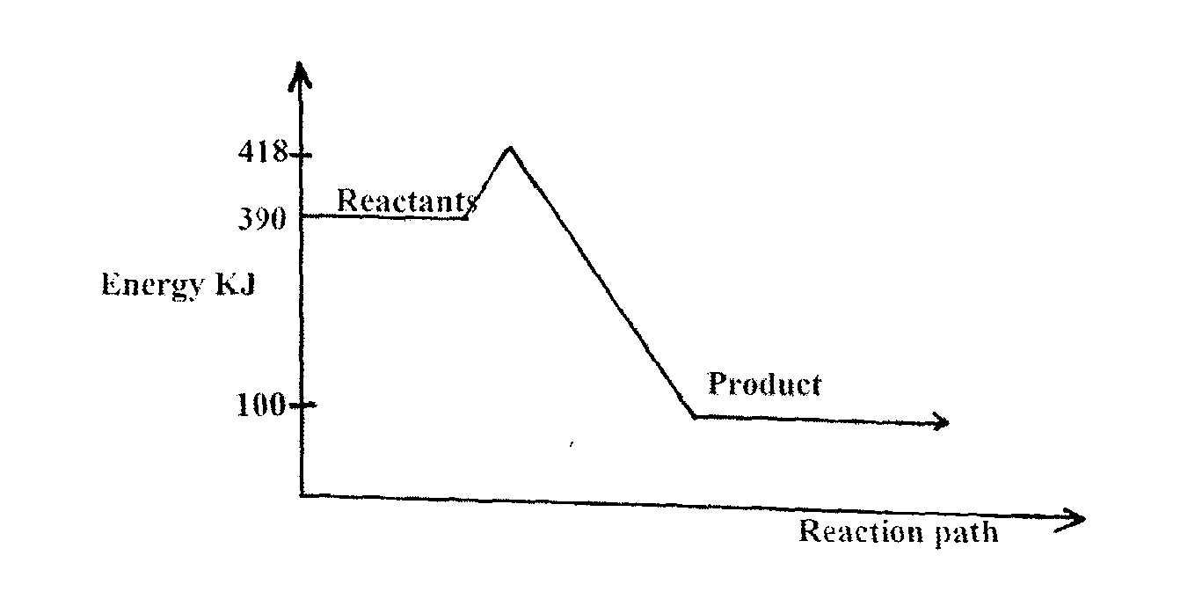
½ H_{2(g)} + ½ F_{2(g)} HF_{(g)}

(a) Calculate the activation energy of this reaction (1mk)

(b) Calculate the enthalpy change (ΔH) for this reaction. (1mk)

28.Colored flower in a jar containing gas X immediately turned colorless. A solution of gas X in water formed a white precipitate with silver nitrate solution. The precipitate was insoluble in nitric (V) acid but dissolved in excess aqueous ammonia
(a) What is the identity of gas X? (1mk)
……………………………………………………………………………………………………..
……………………………………………………………………………………………………..
(b) Write down the balanced chemical equation of the reaction that took place when:
(i) Solution of gas X in water reacted with silver Nitrate solution (1mk)
……………………………………………………………………………………………………..
……………………………………………………………………………………………………..
(ii) Aqueous ammonia was added to the resulting mixture in b(i) above (1mk)
……………………………………………………………………………………………………..
……………………………………………………………………………………………………..
29.Study the flow chart below and answer the questions that follow
Brown gas
Excess
Aqueous
NaOH
Colorless solution E
Yellow solid when cold
Solid G
Colorless solution F
Dil Nitric
acid

(a) Identify solid G (1mk)
……………………………………………………………………………………………………..
(b) Write the formula of the complex ion in solution F (1mk)
……………………………………………………………………………………………………..
……………………………………………………………………………………………………..
30. Describe how you would obtain solid sample of sodium carbonate from a mixture of lead carbonate and sodium carbonate powders. (3mks)
……………………………………………………………………………………………………..
……………………………………………………………………………………………………..
……………………………………………………………………………………………………..

