NAME………………………...............................ADM...….CLASS…..
FORM FOUR
233/2
CHEMISTRY PAPER 2 (Theory)
TIME: 2 HRS
INSTRUCTIONS.
- Answer all questions in the spaces provided.
- Mathematical tables and calculators may be used.
- All working must be clearly shown.
- (a) Crude oil is a source of many compounds that contain carbon and hydrogen only.
  - Name the process used to separate the components of crude oil. (1mk)
…………………………….……………………………………………………………
  - On what basis does separation occur? (1mk)
…………………………………………………….………………………………………………………………………………………………………………………………
(b) Under certain conditions hexane can be converted to two products one of them being butane.
(i) Write the formula of the other product. (1mk)
………………………………………………………………………………………………
(ii)Describe a simple chemical test to show the difference between the two products formed in (b) above (2mks)
………………………………………………………………………………………………………………………………………………………………………………………………………………………………………………………………………………………………………
(c)Ethyne is another compound found in Crude oil. One mole of hydrogen Chloride gas reacted with one mole of ethyne and a product P was formed.P was then reacted with excess hydrogen gas to form product Q. Draw the structures of P and Q. (2mks)
P: Q:

(d) Ethyne may be collected over water during preparation. Explain why this is possible.(1mk)
……………………………………………………………………………………………………………………………………………………………………………………………………
(e) (i) When one mole of ethyne is reacted with one mole of hydrogen the product formed may undergo addition polymerization under suitable conditions. Write an equation for the reaction, stating the conditions. (2mks)
Equation….……………………………………………………………………………………
Condition………………………………………………………………………………………
(ii) Give one disadvantage of the polymer in e (i) above (1mk)
…………………………………………………………………………………………………
(f) State one commercial use of ethyne (1mk)
………………………………………………………………………………………………
- The grid below shows part of the periodic table. Use it to answer the questions that follow.
(The letters are not the actual symbols of the elements)
 |  |  |  |  |  |  |  | E | F | G
H | I |  |  |  | J | K | L | M | N | O
W | X
a) Write the electronic configuration of the following element. (1 mk)
E………………………………………..…………………………………………………
b) Give the formula of one stable ion with an electron arrangement of 2:8 which is;
(i) Negatively charged …………………………………………………… (1 mk)
(ii) Positively charged………………………………………………….…. (1 mk)
c) The oxide of J reacts with both hydrochloric acid and sodium hydroxide to form a salt.
What is the nature of the oxide? (1 mk)
d) Identify the most reactive non – metal. Give a reason for your answer. (2 mks)
……………………………………………………………………………………………………………………………………………………………………………………………………
e) Explain the following observations in terms of structure and bonding:
(i) Element K has a higher boiling point than element N. ( 1mk)
…………………………………………………………………………………………………
(ii) Ionic radius decreases from H to J. (1 mk)
…………………………………………………………………………………………………
f) (i) When a piece of element H is placed on water, it melts and a hissing sound is produced as it moves on the surface of the water. Explain these observations. (2 mks)
…………………………………………………………………………………………………………………………………………………………………………………………………..….
(ii) Write a chemical equation for the reaction between element H and water. (1 mk)
…………………………………………………………………………………………………

3.
SO₂
SO₃
F
H₂SO_{4(l)}
G
HNO₃
C
B
NH₃
E
Air
Step 3
Step 4
H
D
Step 5
Step 6
D
A
A
A
Step 2
Step 1
H_{2(g)}
N_{2(g)}

(a) Name substances (2mks)
A…………………………………………..
B…………………………………………..
D…………………………………………..
F…………………………………………..
(b) Substance E and ammonium nitrate have one common use. State the use (1mk)
…………………………………………………………………………………………………
(c) Name the suitable catalyst in step 3 (1mk)
…………………………………………………………………………………………………
(d) Write the chemical equation in step 4 (1mk)
…………………………………………………………………………………………………
(e) Identify two gaseous environmental pollutants from the above flow chart (1mk)
…………………………………………………………………………………………………
…………………………………………………………………………………………………
(f) State the observation when potassium hydroxide is warmed with substance G (1mk)
…………………………………………………………………………………………………
(g) Calcium oxide can react with Sulphur (VI) oxide to form calcium sulphate. State the property which makes it possible for calcium oxide to react. (1mk) ………………………………………………………………………………………………
…………………………………………………………………………………………………
(h) Write a chemical equation where concentrated sulphuric (VI) acid is used as an oxidizing agent (2mks)

(i) What type of reaction is shown below?
KNO_{3(s)} + H₂SO_{4(l)} KHSO_{4(aq)} + HNO_{3(g)}
…………………………………………………………………………………………………
…………………………………………………………………………………………………
- a) In an experiment to determine how the rate of reaction of hydrogen peroxide with potassium iodide
varies with the concentration of hydrogen peroxide. The data in the table below was recorded.

Experiment |  | 1 | 2 | 3 | 4 | 5
Beaker X | Hydrogen peroxide  Water | 30  0 | 25  5 | 20  10 | 15  15 | 10  20
Beaker Y | Potassium iodide  2M Sulphuric (iv) acid  Starch | 5  5  2 | 5  5  2 | 5  5  2 | 5  5  2 | 5  5  2
 | Time (T) (seconds) | 54 | 63 | 82 | 103 | 164
 | (sec⁻¹)
Complete the table by computing (2 mks)
b) (i) Plot a graph of (vertical axis) against volume of hydrogen peroxide used.
(3 mks)
(ii) From the graph, determine the time the reaction would take if the volume of hydrogen peroxide is 28.5cm³. (2 mks)

(iii) How does the concentration of hydrogen peroxide affect its rate of reaction with potassium iodide? ………………………………………….……………………… (1 Mk)
(iv). Other than concentration, state two factors that would affect the rate of a reaction. (2 mks)
……………………………………………………………………………………………………………………………………………………………………………………………………
c) Given the equation below:
Br_{2(aq)} + H₂O_{(l)} OBr⁻_{(aq)} + Br⁻_{(aq)} + 2H⁺_{(aq)}
yellow – orange colourless
What is the effect of adding ethanoic acid to the above system in a chemical equilibrium?
(2 mks)
……………………………………………………………………………………………………………………………………………………………………………………………………
- The diagram below shows the set up of the apparatus by a student to determine the enthalpy change of combustion of ethanol. The heat produced by burning fuel warms known mass of water.
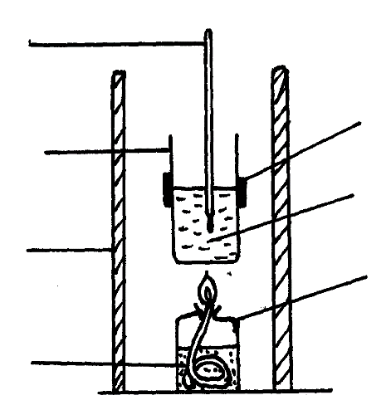
Thermometer

Metal calorimeter
Spirit burner
Water
Clamp

Draught shield
Liquid fuel

Results
Volume of water in the beaker = 500 cm³
Initial temperature of water = 12⁰C
Final temperature of water = 31.5⁰C
Mass of ethanol burnt = 1.50g
Density of water = 1 g/cm³
Specific heat capacity = 4.2 jg⁻¹K⁻¹

- Define standard heat of combustion. (1 mark)

……………………………………………………………………………………………
………………………………………………………………………………………………
Calculate the heat required to raise the temperature of the water from 12⁰C to 31.5⁰C.(2 mks)
………………………………………….………………………………………...…………
…………………………………………………..……………………………….………
…………………………………………………………...………………………………
- Find the molar enthalpy of combustion of ethanol. (2 marks)

………………………………………………………………………………………………… ………………………………………………………………………………….………………
……………………………………………………………………………….…………………
- An accurate value for ΔHC of ethanol is -1368 kJmol⁻¹. State two sources of errors for the low figure obtained. (2 marks)

…………………………………………….………………………………………………..………………………………………………………….………………………………….………………………………………………………………………………………………...……………
- Draw an energy level diagram for the combustion of ethanol. (2 marks)

- Calculate the heating value of ethanol. (C = 12, H = 1, O = 16 (2 marks)

- I. Study the flow chart for the industrial manufacture of ammonia given below and answer the questions that follow.
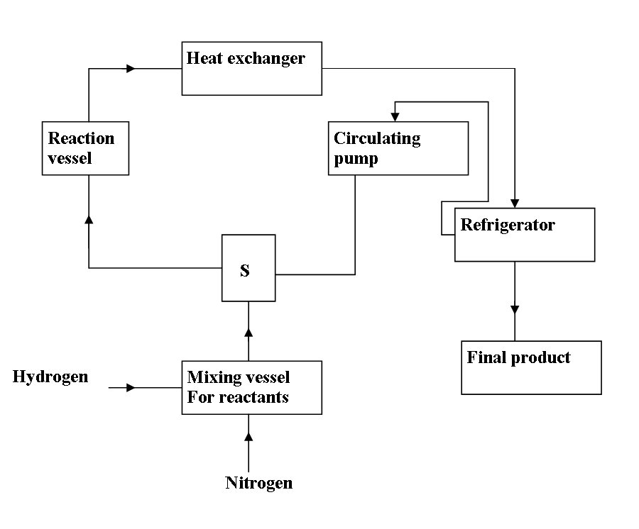

a) State the purpose of the unit labelled S. (1mk)
……………………………………………………………………………………………………………………………………………………………………………………
b) What is the function of the circulating pump? (1mk)
……………………………………………………………………………………………………………………………………………………………………………………
c) Suggest the source of the raw materials. (2mks)
……………………………………………………………………………………………………………………………………………………………………………………………………
d) Name two impurities removed during the purification of hydrogen and nitrogen. (1mk)
………………………………………………………………………………………………………………………………………..……………………………………………………………
e) In what state is the final product collected. Explain. (2mks)
……………………………………………………………………………………………………………………………………………………………………………………………………
II. Below is a set – up in the preparation of a particular salt. Study it and answer questions that follow
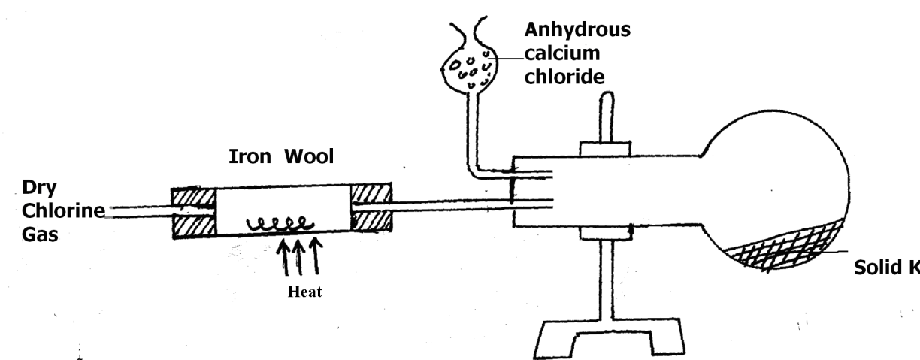

(a)Explain the observation made in the combustion tube when dry hydrogen Chloride gas is passed instead of dry chlorine. (2mks)
…………………………………………………………………………………………………………..…………………………………………………………………………………………
b). Identify solid K (1mk)
…………………………………………………………………..………………………………
c). What property makes solid K to be collected in the flask as shown above? (1mk)
………………………………………………………………………………………….……….
d) State the purpose of anhydrous calcium Chloride as shown in the set – up above. (1mk)
………………………………………………………………………………………….……….

7. The flow chart given below shows an analysis of mixture K that contains two salts .Study it and answer the question that follows.
Add excess NH _{3(aq)}
Solid M
White precipitate that dissolve
Mixture K
Metal oxide + CO_{2(g)}
Solution N.
Solution L
White ppt
White precipitate that dissolves
Add AgNO₃+HNO_{3(aq)}
Add excess NaOH (aq)
To a portion of L and warm

Add water and filter
Step 2
Add excess NaOH _{(aq)}
Add HNO_{3(aq)}

Colorless solution A+NH_{3(g)}

- Name substances (2mks)
L ……………………………………………….……M ………………………………………
- What condition is necessary for step 2 to take place? (1mk)
……………………………………………………………………………………………….…
c). State the colour changes that the metal oxide undergoes when hot and cold (1mk)
…………………………………………………………………………………………………………………………………………………………………………………….………………
- When sodium hydroxide is added to a solution N, a white precipitate is formed which later dissolves when added in excess. Give the name and formula of the complex ion formed. (1mk)
Name …………………………………………….………………………………………..
Formula………………………………………..…………….…………………………………
- Explain why it was necessary to add water to mixture K and filter. (1mk)
……………………………………………………………………………………………………………………………………………………………………………………………………
- 7 grams of a mixture of sodium carbonate and sodium chloride were dissolved in water. The solution was found to neutralize 25.0 cm³ of a solution of nitric acid containing 63g/dm³.
- Determine the molarity of the acid. (H=1,N=14,O=16) (1mk)

- The moles of sodium carbonate present in the mixture. (2mks)

- The percentage of sodium carbonate in the mixture (Na=23, C=12, O=16). (2mks)

