FORM ONE AGRICULTURE NOTES

INTRODUCTION TO AGRICULTURE
The word Agriculture is derived from two Latin words Ager which means field and cultura that means cultivation. Therefore agriculture can be defined as field cultivation.
Livestock are all the domesticated animals.
Definition of agriculture:
Agriculture is defined as the art and science of crop and livestock production.
As an art
Involves use of learned skills and performing them manually (by hand). E.g.
- Tilling of land.
- Construction of farm structures.
- Measuring distances.
- Machine operations.
- Harvesting of crops.
- Feeding and handling animals.
- Marketing of Agricultural produce.
As a science
It involves experimentation and application of scientific knowledge e.g. in areas such as:
- Soil science (pedology) ---study of soil.
- Crop pathology—Study of crop diseases.
- Entomology--- Study of insects and their control.
- Agricultural Engineering--- soil and water conservation and farm power.
- Genetics—Plant and animal breeding.
Production --- Are activities that increase the quality and quantity of something.
Crop production activities include: land preparation, planting, fertilizer and manure application, weeding, pest control, disease control and harvesting.
Livestock production activities include:
- Selection and breeding.
- Feeding.
- Rearing the young stock.
- Parasite and disease control.
- Housing.
- Obtaining products from animals.
Branches of agriculture
- Crop production: e.g. Field crop farming, pomology, Floriculture, olericulture.etc.
- Livestock production: e.g. Apiculture, Poultry keeping, aquaculture.etc.
- Soil science.
- Agricultural Economics.
- Agricultural Engineering.
Crop farming or Arable farming: Is the cultivation of crops on cultivated land. E.g. In pure stands (monocropping) or mixed stands (intercropping).
Include:
- Field crops: Are crops grown on large areas of land. Are either Annual crops like cereals and pulses or perennial crops e.g. coffee, tea, sisal, cane etc.
- Horticultural crops: Are perishable crops and are exported to earn foreign exchange. Include:
- Floriculture: Growing of flowers e.g. tuber rose, roses, and carnations.
- Olericulture: Growing of vegetables e.g. French beans, cabbages, tomatoes.etc..
- Pomology: Growing of fruits e.g. avocado, mangoes and citrus.
Livestock farming: Include:
- Pastoralism (mammalian livestock farming). Is the rearing of farm animals on pastures. E.g. cattle, goats, pigs, sheep, camels and rabbits.
- Fish farming (Aquaculture); Is the rearing of fish in fish ponds. Fish is a cheap source of proteins.
- Bee keeping: ( Apiculture); Is the rearing of bees in bee hives. Bees provide ; Honey and Wax, income, Medicine, pollination of flowers.etc.
- Poultry keeping; Is the rearing of birds for meat and eggs, manure, income. Etc. Include classes of birds such as chicken ( most common), Ducks, geese, Ostrich, pigeon and Turkeys etc.
Agricultural Economics: Deals with utilization of scarce resources i.e. of land, labour, capital and management. It aims at maximizing output while minimizing costs.
Agricultural Engineering; Deals with use and maintenance of farm tools and equipment, farm machinery and farm structures.

FARMING SYSTEMS
A farming system is an organization of the farm and all the enterprises in relation to each other.
It can be extensive or intensive.
Extensive system
Characteristics
- Large tracts of land.
- Low capital investment per unit area.
- Low labour per unit area.
- Low yields per unit area.
Intensive system
Characteristics
- Small tracts of land.
- High capital per unit area.
- High labour investment per unit area.
- High yields per unit area.
Extensive or intensive farming can be carried out on small or large scale of land.
The scale of production depends on:
- Level of technology.
- Land availability.
- Capital availability.
- Skilled labour available.
- Large Scale Farming
Characteristics
- Large tracts of land.
- Heavy capital investment.
- Skilled labour and qualified man power.
- High level of management.
- It’s for commercial purpose.
- Low operation costs per unit of production since it makes use of economies of scale.
- Depends on efficient transport.
- Requires good market system.
- Most of the work is mechanized.
- Provides more employment.
It includes plantation farming and Ranching.
- Plantation farming.
Characteristics
- Large tracts of land.
- Production of only one crop.e.g. Tea plantations in Kiambu and Kericho, Coffee in Kiambu, Sugarcane in Muhoroni, Sisal in Mombasa, Pineapple in Thika.
- Ranching : Is the keeping of livestock ( beef animals) in marginal range areas.
It is an improved pastoral-nomadism because:
- Animals are enclosed in an area.
- Diseases are controlled.
- Pastures are improved.
- Supplementary feeds and water are provided.
- Pests and parasites are controlled.
- There is provision of extension staff.
N.B The livestock carrying capacity is low because of limited pasture.
Ranching is becoming more and more common in Kenya because of:
- High meat demand.
- High population pressure on high potential areas.
- Arable farming is becoming smaller.
- Small Scale Farming
Characteristics
- Small piece of land.
- Use of improved technology.
- Production of crops and livestock is spread throughout the year.
- Goods are produced for subsistence or commercial purpose I,e sale of surplus goods..
- Does not require heavy capital investment.
Advantages
- Little capital is required.
- Source of livelihood to small scale farmers.
Methods of Farming
- Mixed Farming
- This is the growing of crops and rearing of animals on the same farm.
Advantages
- It is a method of diversification whereby should one enterprise fail, the farmer can benefit from the other.
- There is mutual benefit between the crops and livestock where crops provide feed for livestock and animals provide them with farm yard manure.
- There is maximum utilization of resources.
Disadvantages
- Labour intensive.
- High initial capital required.
- Farmer’s attention is divided.
- Nomadic Pastoralism
Pastoralism: This is the practice of rearing livestock on natural pastures.
Nomadism: This is the practice of moving from one place to another.
- Pastoral –nomadism is therefore the moving of animals from one place to another in search of pasture and water.
- This is common in the arid and semi-arid areas.
- Shifting Cultivation
- Farming on a piece of land continuously until it is exhausted after which the farmer moves to a new more fertile land.
- It is applicable where;
  - Land is abundant
  - Population is sparse
  - Number of livestock per unit area is low.
  - Land is communally owned.
Advantages of shifting cultivation
- It has low capital requirement
- There is no pests and diseases build-up
- Soil structure is maintained
- No land disputes as land ownership is not individualized.
Disadvantages of shifting cultivation
- Total yields per unit are is low
- Farmers have no incentive to develop land and conserve water and soil
- A lot of time is wasted when the farmer is shifting and building structures.
- Not applicable in areas of high population density or where there is high population increase.
iv) Agroforestry
Agroforestry - Involves growing of trees and crops and keeping of animals on the same piece of land at the same time.
Suitable tree species for agroforestry
- Leucaena leucocephala
- Gravillea robusta
- Calliandra catothrysus
- Mangifera indica
- Sesbania sesban
- Lantana camara
- Cajanus cajan
Advantages of Agroforestry
- Saves labour since some operations can be done at once for both plants and trees
- Gives higher combined yield
- Provide wide variety of agricultural produce
- Reduces the risks of total failure
- Crops benefit from nitrogen fixing trees.
- Trees help in holding the soil firmly
- Some trees act as livestock fodder.
- Provides a wider variety of agricultural produce.
Disadvantages of Agroforestry
- Mechanization is difficult.
- Use of pesticides and fertilizer may be difficult.
- Productivity may suffer because the skills for managing the different trees

FACTORS INFLUENCING AGRICULTURE
- HUMAN FACTORS.
They are factors in human beings or the way human beings do things.
The following is a list of human factors that influence agricultural production.
- Levels of education and technology
- This is translated as the ability of a producer who is a farmer to apply appropriate methods and techniques in production using available resources for example, Farmer weighing livestock food to ensure efficiency
- Good education level makes a farmer able to understand and translate technical language in farming.
- Health of the farmers
- A healthy nation is a productive nation
- The following are some of the diseases that contribute to lowering agricultural productivity
  - Malaria,
  - Tuberculosis,
  - Typhoid,
  - Pneumonia and HIV/AIDS
Effects of HIV/AIDS on farming
  - Loss of skilled labour
  - Time spent caring for the infected
  - Money spent on treatment
- State of economic development
- The capital earned from economic activities such as farming is used to raise economic growth in the country.
- Transport and communication network
- Good and efficient infrastructure is important for the smooth flow of farm produce from the farm to the consumer.
- The improvement of technology in communication has improved farmers access to important information from the research stations and other fellow farmers
- Government policy on agricultural input and produce taxation
- The government of Kenya, through different ministries formulates guidelines to be followed by producers of different products. After the guidelines and proposals are legislated they become policies
- Availability of storage facilities
- Cultural and religious beliefs.
- Local and International market forces
Human Factors which improve production
- Good health of the farmer
- Availability of money
- High taxation on imported agricultural produce
- Availability of ready market for agricultural produce
- Availability of storage facilities
- Liberalized market
Human Factors which lower production
- Restrictive cultural and religious beliefs
- Poor road network
- BIOTIC FACTORS.
- These are living organisms that affect agricultural production.
- Biotic factors influencing agriculture can be divided into the following classes.
  - Crop pests: stalk borer damaging maize in the field
  - Decomposers: Cause rotting of organic matter there by releasing nutrients for crop growth.
They help in improving soil structure through incorporating organic matter into the soil.
  - Nitrogen fixing Bacteria: Nitrogen fixing bacteria are found in root nodules of leguminous plants. Improve crop production through increasing soil nitrogen content which crops require for proper growth.
  - Livestock parasites: suck blood and transmit diseases to animals
  - Pollinators: Bee pollinating maize flower. Pollination in crop production increases yields and viability of seeds.
  - Predators: Eagles can eat chicken, rabbits among other livestock. Eagle can also eat insects and pests for example rats, moles and birds which destroy crops.
  - Pathogens: Causes diseases in livestock and crops thereby lowering quality of produce. Increase cost of production when control measures are implemented. Introduce toxic substances into agricultural products thereby lowering the quality of the produce. Can cause death to crops and animals.

Effects of Biotic Factors on Agricultural Production
1. Pests
- Feed on crops thereby lowering quantity of agricultural produce.
- Feed on grains thereby affecting viability of the seeds
- Act as disease vectors
- Lower palatability of crop produce
- Increase cost of production when control methods are applied
- Create entry points for disease causing organisms
2. Parasites
- Irritate livestock
- Causes anemia in livestock
- Some block alimentary canal
- Lower rate of production in livestock
- Increase cost of production when controlled
- Some lower quality of hides and skins
- Some absorb food meant for the livestock thereby lowering the level of production.
- Some for example ticks transmit disease causing organisms.
- CLIMATIC FACTORS.
Climatic factors include:
- Rainfall
- Poor rainfall distribution results to wilting of crops
- Excess rainfall can cause soil erosion
- Excess rainfall can result to crop failure due to flooding.
The four aspects of rainfall which affect agricultural production include:-
- Rainfall Amount
Rainfall amount refers to quantity of rainfall received in a given area for a period of one year. Rainfall amount is measured using a rain gauge in millimeters per annum. The amount of rainfall determines the crops grown in an area.
- Rainfall distribution
This refers to the spread of rainfall over the year. Rainfall distribution is very poor in Kenya and therefore irrigation is necessary to supplement the short supply.
- Rainfall reliability
This refers to the certainty with which a given amount of rain is expected in a given place in the year.
- Rainfall Intensity
This refers to the strength with which rain falls; it is therefore measured in terms of amount per hour.
Rainfall of low intensity is preferred as it improves water infiltration into the soil and causes less soil erosion.
- Temperature
- Temperature is the coldness or hotness of a place.
- Temperature is measured in degrees Celsius using a thermometer.
- Temperature is influenced by altitude and topography.
- Temperature decreases with increase in altitude, such that for every 300 meters rise in altitude above sea level temperature decreases by1.7-2.2 degrees Celsius.
- Each crop has a temperature range within which it can grow referred to as the cardinal range of temperature.
- For crops to grow well and produce high yields, they require a narrow temperature range within the cardinal range referred to as optimum range of temperature
Effects of temperature on agriculture
Low temperature
- Slow growth rate.
- High incidences of disease such as CDB in coffee.
- Improvement of quality in crops such as tea and pyrethrum.
High temperature
- High evaporation rate hence wilting in crops.
- Hasten the rate of maturity due to increased growth rate.
- Improvement of quality in crops such as pineapples and oranges.
- Increase incidences of diseases such as leaf rust in coffee.
- Increased incidences of pest infestation such as aphids in vegetables.

Effects of altitude on agriculture
- Kenya is divided into three ecological zones which include;
- Low altitude zone o - 1500 meters above sea level
- Medium altitude zone 1500 - 2500 meters above sea level
- High altitude zone above 2500 meters above sea level
Crops perform differently when grown in each of these ecological zones and therefore each crop has its most suitable zone for maximum performance as illustrated below.
- Wind
Wind refers to air in motion.
- Below is a list of effects of strong wind on agricultural production.
- Blowing and bringing rain bearing clouds
- Destruction of farm structures
- Strong wind may course lodging in weak plants.
- Wind erosion on bare land
- Increases rate of moisture evaporation
- Increase spread of pests and diseases
- Agent of dispersal.
- Pollination in crops.
- Light
  - Light is the source of energy which plants require for photosynthesis.
  - During photosynthesis, plants manufacture food using water and carbon dioxide in the presence of sunlight and chlorophyll.
Aspects of light that influence agriculture
i). Light intensity.
- This is the strength with which light hits the surface of the earth.
ii) Light duration
- This is the period of time the plants are exposed to light recorded using a Campbell sunshine recorder
Photoperiodism
- This is the response of plants toward light duration.
Long day plants
- These are plants which require more than 12 hours of lighting to flower and produce fruits or seeds e.g. some wheat varieties
Short day plants
- These are plants which require less than 12 hours of lighting to flower and produce e.g Maize
Day neutral plants
- These are plants which produce flowers regardless of the duration of lighting they have been exposed to e.g Tobacco.
iii) Light wavelength:
- This refers to the type or quality of light. A wavelength is the distance between two corresponding points of a light wave.
- Chlorophyll absorbs certain wavelengths of light which are not present in artificial light unless it is ultra violet or infra red.
NB/ Green houses can be used to control the temperature, relative humidity and light duration and intensity.
- Relative Humidity.
- This is the amount of water vapour held by air at a given temperature.
- At high humidity the rate of evaporation is low and vice versa.
- EDAPHIC/SOIL FACTORS
- Soil is a mixture of weathered rock and decayed organic matter.
- It supports plant growth by providing anchorage nutrients and water.
- Topsoil covers most of the earth and it contains minerals, organic matter, air, water and living organisms.
Soil Formation
- Soil is formed through the process of weathering.
- Weathering is the breakdown and alteration of the parent rock near the earth’s surface.
- Parent rock is first broken into smaller fragments and eventually into individual constituent minerals.
- The individual minerals combine to form the soil.
- Weathering is a continuous process and it takes hundreds of years to form a centimeter of the soil.
- Weathering involves breakdown (disintegration) and building up (synthesis).
- Weathering process is influenced by the following factors.
- Climate.
- Parent material.
- Topography.
- Living organisms.
- Time.
Agents of The Weathering Process.
- Physical agents.
- In this case no chemical changes are involved.
- These include wind, water, moving ice and temperature.
- Strong winds carry materials which hit against each other and break into smaller fragments.
- Raindrops hit the ground with some force causing soil erosion.
- Moving ice causes rocks to disintegrate.
- High temperatures in the arid areas cause the rocks to at different rates. During the night, temperatures drop making the rock to contract. The rock surface contracts faster than the inside. This unequal contraction causes the rocks to disintegrate.
- In places with very low temperature, water gets into the cracks, freezes and becomes ice. As water turns into ice, it increases in volume pushing the rock apart hence disintegration.
- Biological agents.
- This involves living organisms.
- Large animals like elephants and cattle exert pressure on rocks as they move causing them to break.
- Mans activities such as mining, quarrying, road construction and earth moving breaks rocks into smaller fragments.
- Bacteria and fungi help in the breakdown of plant and animal tissues (decomposition). These materials are incorporated into the soil.
- Termites and moles bring to the surface large quantities of fine materials. This promotes weathering by aerating lower layers of the rocks.
- Roots of plants force their way through rocks making them to disintegrate. They also produce acids during respiration which dissolves rock minerals. Decayed roots may mix with water forming organic acids which dissolves rock minerals.
- Chemical agents.
- This is the decay or decomposition of the rocks. It involves the following processes.
- Carbonation.
- As the rain falls through the atmosphere, it dissolves some Co₂ forming weak carbonic acid.
- Over time this acid reacts with the rock minerals particularly calcium carbonate causing decomposition.
Rain water + carbon (iv) oxide Carbonic acid.
Carbonic acid + Limestone Calcium bicarbonate
- The calcium bicarbonate formed in this reaction is soluble in water causing water to eventually dissolve the entire rock.
- Oxidation.
- Oxygen reacts with many elements found in rocks causing them to disintegrate.
- Solution.
- Hydrolysis.
- Hydration.
Factors Influencing Soil Formation
- Parent rock material
- This influences the physical and chemical properties of the soil such as
- The texture of the soil e.g. granite gives coarse grained soil.
- Mineral composition of the soil e.g. rocks containing calcite, feldspar and ferro-magnesium minerals produce deep heavy soils rich in nutrients.
- The rate of soil formation e.g. limestone is easily weathered in warm humid regions and the carbonates are easily soluble.
- Since the parent material influences the physical and chemical properties of the soil, it therefore controls the type of vegetation in an area.
- Climate
- High temperature speed up the rate of chemical reactions.
- Wind acts as a transport agent and carries the weathered materials from one place to another. Where a lot of weathered materials are deposited, the soils are deep and rich in nutrients.
- Rainfall provides water which is an important reagent during the weathering process. A lot of rain may cause rocks to break hastening the weathering process.
- Topography(Relief)
- This is the shape of the land in relation to the underlying rock of the earth’s surface.
- It may quicken or slow the weathering process.
- The slope affects the depth of the soil and kind of vegetation growing in an area.
- Soils found in flat land and low lying areas tend to be more fertile than those found on higher slopes. Such areas have deeper soils.
- On a steep slope, erosion is high and such areas have shallow soils.
- Living organisms(Biotic factors)
- The presence of the various agents of biological weathering speeds up the process of soil formation.
- Time.
- The process of soil formation is very slow and takes a lot of time.
- Deep mature soils are found where soil forming processes have taken place over a long period.
- If the parent material is resistant to weathering agents, more time is required for the soil to mature.
- Areas with severe soil erosion have a poorly differentiated soil profile.

SOIL PROFILE
- This is the vertical arrangement of the soil horizons (layers).
- The horizons show soil layers at different stages of development.
- Soil forming processes are continuous and the soil develops in depth resulting in the formation of the distinct sequence of soil layers.
- The layers differ from each other in terms of colour, organic matter content, chemical composition, porosity, depth and the arrangement of soil particles.
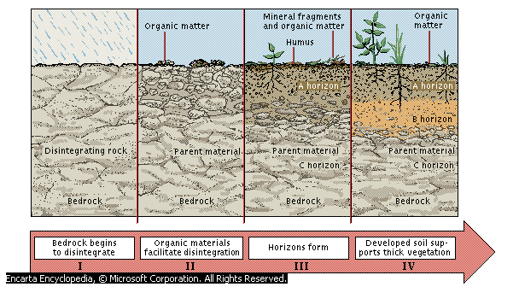
The horizons are;
- Superficial layer.
- It’s a thin layer consisting of dead decaying and decayed organic matter covering the soil.
- Top soil (Horizon A).
- It lies beneath the superficial layer.
- It contains a lot of humus hence it’s darker than the other layers.
- It’s well aerated and contains active living organisms.
- It’s well drained and rich in plant nutrients.
- Most of the roots are found here.
- Sub soil (Horizon B).
- Found beneath the top soil.
- More compacted and less aerated than top soil.
- May contain an impermeable layer called the hard pan which may prevent drainage and root penetration.
- Minerals leached from top soil accumulate here hence this layer is referred to as the layer of accumulation.
- It has clay deposits.
- Substratum/weathered rock (Horizon C).
- Made up of partly weathered rocks.
- Has no humus.
- Hard and impermeable to water.
- Roots of big trees may reach this layer and draw water from it during the dry season.
- Parent rock/Bed rock (Horizon D).
- It’s found beneath the weathered rock. Soil is formed from this rock. It may contain ponds of water.
NB/ . Between any two bordering soil layers, there is a transitional zone whereby one layer gradually merges into the next one in the series.
The soil profile influences agriculture in the following ways.
- Topsoil contains most of the soil nutrients, well aerated and has soil microorganisms.
- A well developed profile holds more moisture for plant use than a shallow one.
- Loosely packed subsoil allows easy root penetration, drainage and aeration.
- Nature and composition of the bedrock determines the mineral components of the whole soil.
SOIL CONSTITUENTS
- Mineral matter.
- The mineral composition of the parent rock determines the mineral constituents of the soil.
- The mineral matter makes the framework of the soil.
- It holds the roots firmly in the soil giving anchorage to plants.
- Between the particles are spaces which are filled with water and air.
Diagram
- Organic matter.
- When the dead materials rot, they are decomposed by bacteria and fungi to form the soil organic matter.
- Humus is dead organic matter which is in the state of continuous chemical decomposition, transformation and construction.
- Humus in the soil improves the soil structure.
- Humus contains plant nutrients such as sulphates, nitrates, phosphates, calcium, magnesium, potassium etc.
- Air.
- The soil contains all the gases such as nitrogen, oxygen, Co₂ and the rare gases.
- Availability of air in the soil is influenced by the type of the soil and amount of water in the soil.
- Oxygen is needed by plants during respiration. It is also required by microorganisms in the soil during decomposition and nitrogen fixation.
- Excess Co₂ in the soil is poisonous to plants and microorganisms.
- For best crop performance, a balance of soil water and soil air has to be maintained.
- Water.
- Soil contains water. Soil water exists in three forms;
- Superfluous water.
- This is water occupying large air spaces (macro pores).
- This water is loosely held by the soil and therefore easily lost.
- The water is readily available to plants but not useful because excess water in the soil brings about poor aeration.
- A lot of water in the soil causes leaching of nutrients.
- Capillary water.
- This is water occupying small pores (microspores).
- It is held with grater force by soil particles.
- It is available to plants and acts as a solvent for plant nutrients.
- It is also referred to as available water.
- It leaves most of the macro pores empty allowing aeration of the soil.
- Hygroscopic water.
- This is water that forms a thin film around the soil particles.
- It is firmly held by soil particles making it not available to plants.
- Clay particles have a lot of hygroscopic water but sandy soils contain very little hygroscopic water because sandy particles have weaker forces.
Importance of water to plants
- A solvent for plant nutrients.
- Raw materials for photosynthesis.
- During transpiration plants lose a lot of water hence a cooling effect on them.
- Water makes plant cells turgid hence support.
- Living organisms (biotic factors)
- They are important in the soil in the process of decomposition.
- They are divided into ;
- Soil microorganisms
- They include bacteria, fungi and protozoa. They help in decomposition process.
- Some bacteria e.g. Rhizobium spp helps in nitrogen fixation in legumes.
- Some microorganisms are harmful because they cause diseases.
- Soil macro organisms
- They are larger organisms found in the soil such as moles, earthworms, termites, ants and plant roots.
- They burrow in the soil aerating the soil and making it loose..
PHYSICAL PROPERTIES OF THE SOIL
- Soil structure
- This refers to the physical appearance of soil according to how the individual soil particles are arranged, packed or aggregated.
- The soil structure type is determined by the general shape of the aggregates.
- Soil structure class is determined by the size of the aggregates.
- The soil structure grade is determined by the stability or cohesiveness of the aggregates.

Types of soil structures
- Single grained structure.
- There is no aggregation at all.
- Particles are not cemented together. The particles are non-porous and spherical.
- Mostly found in the top soil of sandy soils, arid climates and alkaline soils.
- Crumby soil structure.
- The aggregates are small, soft and porous irregular in shape.
- Aggregates are not closely fitted together.
- Granular soil structure.
- The aggregates have irregular shape called granules.
- Soil is very porous when wet.
- Structure is found in the topsoil of cultivated soils and in the subsoil of soils under grass or bush.
- Prismatic soil structure.
- Aggregate are arranged vertically.
- The vertical axis of each aggregate is longer than the horizontal axis.
- When the tops are rounded, they are said to be columnar and when they have flat ends they are prismatic.
- Platy soil structure.
- The aggregates are arranged on top of one another in thin horizontal plates.
- The structure has poor permeability, drainage and root penetration.
- Structure is mostly found in top horizon of soils in the forest and in clay soils.
- Blocky soil structure.
- Aggregates are arranged in rectangular blocks.
- Aggregates easily fit together along vertical edges.
Importance of Soil Structure on Crop Production
Soil structure influences:
- Soil aeration.
- Soil drainage and water holding capacity.
- Plants root penetrability and anchorage.
- Microbial activities in the soil.
- Circulation of gases in the soil.
The following farming practices improve the soil structure
- Application of inorganic manure into the soil.
- Tilling the land at the right moisture content.
- Crop rotation.
- Minimum tillage.
- Cover cropping.
- Mulching.
Soil texture
- It refers to the relative proportion of the various sizes of the mineral particles of soil.
- Also defined as the coarseness or fineness of the soil when felt between the fingers.
- Different soil particles have different sizes as shown below.
Particle | Size (Diameter) in mm
Stones (Gravel) | Above 2.00 mm
Coarse sand | Between 0.20 – 2.00 mm
Fine sand | Between 0.02 – 0.20 mm
Silt | Between 0.002 – 0.02mm
Clay | Below 0.002 mm
Determination of Soil Texture
This can be done through;
- Mechanical analysis.
- Chemical analysis.
Mechanical analysis
Apparatus
Garden soil, sieves of different measured mesh diameter, containers and weighing balance.
Procedure
- Put a known amount of soil sample into a container.
- Crush the soil lumps without breaking the particles.
- Pass the soil through the sieve with the largest mesh diameter (2.00 mm) and shake vigorously.
- Weigh the soil that remains on the sieve and record.
- Repeat the process using other sieves with mesh diameters of 0.2mm, 0.02mm and 0.002mm always using the soil that passes through the previous sieve.
Observation
- Soil particles left on first sieve of mesh diameter 2.00mm are called gravel.
- From the second sieve of 0.20mm; coarse sand particles.
- From the third sieve (0.02 mm); fine sand particles.
- From the fourth sieve (0.002 mm); silt particles.
- All the particles that pass through the fourth sieve are clay particles.
Importance of soil texture on crop production
- Influences soil fertility.
- Affects the organic matter content.
- Influences the drainage of the soil.
- Influences soil aeration.
- Influences water holding capacity
- Influences the capillarity or movement of water in the soil.
NB/ Based on texture, soil can be classified as;
- Sandy soil. (50-80% sand, 20-50% silt and clay and 0.1-3% organic matter).
- Are made up of largely sand particles (coarse textured).
- Have large air spaces hence poor in water retention.
- Easy to till (light soils)
- Low fertility due to leaching of minerals.
- Easily eroded.
- Free draining.
- These soils can be improved by addition of organic matter and fertilizers.
- Silty loam (20-30% sand, 70-80% silt and clay and 0.1-4% organic matter).
- Fine textured
- Well drained
- Good water holding capacity.
- Moderately fertile and aerated.
- Area acidic to moderate pH.
- Clayey loam soils. (20-50% sand, 20-60% silt and clay and 0.1 - 6% organic matter).
- Poorly drained and aerated
- Fine textured
- High capillarity and water holding capacity.
- Slightly acidic to slightly alkaline.
- Rich in plant nutrients.
- Difficult to work on when dry or wet.
- Are suitable for flood irrigation of crops like rice.
- Clayey soils. ( > 40% clay content)
- Made up of largely clay particles.
- Have small pore spaces hence good in moisture retention.
- Difficult to till (heavy soils)
- Poorly drained.
- Expand when wet, crack when dry.
- High capillarity.
- Rich in plant nutrients.
- Are suitable for flood irrigation.
- They can be improved by drainage.
- Loamy soils. (30-50% sand, 50-70% silt and clay and 0.1 - 4% organic matter).
- Moderately textured and drained.
- Slightly acidic.
- Do not erode easily.
- Easy to work on.
- Have a good water holding capacity.
- They are the most suitable for crop production since they contain good amounts of plant nutrients and organic matter.
- They can be improved further by planting cover crops to maintain fertility and by adding manures and fertilizers.
Soil Colour
- This depends on the mineral composition of the rock and the organic matter content.
- Soils containing a lot of iron are brownish, yellowish or reddish in colour.
- Soils with a lot of silica are white.
- Soils with a lot of humus are dark or grey.
- Soil colour influences the soil temperature.
- Dark soils absorb and retain more heat than light coloured soils.
- Relatively high temperatures in the soil enhance microbial activity.
Soil pH
- This refers to the acidity or alkalinity of the soil solution.
- It is determined by the concentration of hydrogen ions (H⁺) or the hydroxyl ions (H⁻) in the soils solution.
- pH is measured using the pH scale which ranges from 1-14.
- A pH of less than 7 means that the soil solution is acidic.
- A pH of more than 7 means that the soil is alkaline.
- pH of 7 is neutral.
- As the hydroxyl ions in the soil increase, the soil becomes more alkaline and vice versa.
Influence of Soil pH on Crop Growth
- Determines the type of crop to grown in a particular area.
- Affects the type of fertilizer to be used.
- Affects the availability of some nutrients e.g. at low pH phosphorous and molybdenum are less available while high pH makes manganese, potassium, iron, boron and zinc less available.
- Very acidic or very alkaline conditions affect activities of soil microorganisms.
Modifying Soil pH
The following are applied to the soil in order to lower its pH (Increase soil acidity)
- Application of sulphur.
- Application of acidic fertilizers such as sulphate of ammonia.
In raising its pH (increase alkalinity) the following is done.
- Application of lime which is a basic compound which raises the soil pH after some time.
- Application of basic fertilizers.

Agricultural Economics
- Agricultural economics is defined as an applied science that aims at maximizing output while minimizing costs, by combining the limited resources of land, capital, labour and management to produce goods and services for use by the society over a period of time.
Basic Economic Concepts
- Scarcity.
- The factors of production such as land, capital, labour and management are scarce or limited.
- The farmer therefore must decide on how to allocate the few/scarce resources to the many competing production needs.
- Preference and Choice
- Since the available resources are limited and production needs are many, a farmer has to make a choice of how to allocate these resources.
- A farmer therefore has to choose one or several enterprises from very many.
- The choice made is determined by factors such as needs of the society, farmer’s preference and ecological conditions.
- Opportunity Cost
- Since a choice has to be made from very many competing enterprises, some revenue has to be foregone. For example, a piece of land may be suitable for the production of maize and wheat.
- If a farmer chooses o grow maize, the returns that the farmer would have obtained from wheat is foregone.
- The foregone returns are called the opportunity cost. Opportunity cost is the revenue foregone from the best alternative.
Farm Records
- These are documents kept in the farm showing farm activities over a period of time.
- They should be neat, concise and complete showing actual amounts, weights, measurements or dates.

Uses of farm records to a farmer
- Help to determine the value of the farm/ determine assets and liabilities.
- Provide history of the farm.
- Assist in planning and budgeting in various fields.
- Helps to detect losses or theft in the farm.
- Assists when sharing losses or profits (dividends) for communal owned farms/ partnership.
- Help to settle disputes in the farm among heirs.
- Help to support insurance claim e.g. against fire and theft.
- Provide labour information like terminal benefits, NSSF due, Sacco dues for all employees.
- Help to compare the performance of different enterprises within a farm or other farms.
- Help in the assessment of income tax to avoid over or under taxation.
- Records help to show whether the farm business is making profit or losses. This information helps in obtaining credit.
Types of Farm Records
- Production Records
- They show the total yield and the yield per unit of each enterprise such as the total number of litres of milk from the whole herd and from each cow.
Name /No.  of cow | Days in the month |  |  |  |  |  |  | TOTALS
 | 1 |  | 2 |  | 3 |  | etc
 | AM | P.M | A.M | PM | AM | PM
1
2
3
4
etc
Totals

- Inventory records
- They show all the assets on the farm e.g. livestock, machinery, buildings, crops etc.
- They are divided into two;
- Consumable goods such as animal feeds, fertilizers, fuel, pesticides etc.
- Permanent goods such as machinery, farm tools and equipment, buildings etc.
Consumable Goods Inventory

Receipts |  |  | Issues
Date | Commodity/Item | Quantity | Date | Issued to | Quantity | Balance in Stock
Permanent goods Inventory

Date | Commodity/Item | Quantity | Written off | Balance in Stock | Comment
- Field Operations Records
- They show all the activities being carried in the field such as date of ploughing, planting, fertilizer used etc.
- They help to work out the cost of production for each field at the end of the season.
- Breeding Records
- They are kept to show the breeding activities and programmes for various animals on the farm.
- There are different breeding records depending on the animals being reared.
- Feeding Records
- They show the type and amounts of feeds used to feed the animals.

Daily feeding record for the month of…………………………………………………………
Enterprise ……………………………………………………………………………………...
Type of feed…………………………………………………………………………………….
Date | No. of Animals | Amount Received  (kg) | Amount Used  (Kg) | Balance in Stock  (Kg) | Remarks
- Health Records
- They show the health conditions of the animals. They show when actions such as vaccinations and deworming are to be done.
- They help in the selection of the breeding stock. They also help in calculating the cost of treatment.
Date | Disease symptom | Animal(s) affected | Drugs used | Cost of treatment | Remarks
- Marketing Records
- They show the commodity, quantity, amount sold, date, rate per unit of the commodity, total value and where sold.
Commodity……………………………………………………………
Date | Amount sold | Price per unit  (kshs) | Total Value  (ksh) | Where sold | Remarks
- Labour Records
- They show the type of labour, date of employment, rate of payment, skilled and unskilled labour.
- They are divided into two;
- Muster Roll – this checks the number of days worked for and therefore determine how much to be paid to a worker.
- This record shows the name of the worker, payroll number, days worked for, rate of payment, the amount of salary and signature.
Muster Roll
Name of  Person | Pay Roll  No. | Days |  |  |  |  | Days  Worked | Rate of  Pay (kshs) | Total  Pay (Kshs) | Signature of  Workers.
 |  | 1 | 2 | 3 | 4 | 5
Mr. X | 08 |  |  |  |  |  |  | 25 | @100/- | 2,500/-
Mr. Y | 09 |  |  |  |  |  |  | 25 | @100/- | 2,500/-
-Labour Utilisation Analysis. They show how labour is utilized on the farm and helps to determine labour allocation; labour requirement for the purpose of budgeting when labour is in peak demand or when to lay off unproductive labour.

No of hours  Worked | Livestock  Production | Crop  Production | Machinery  Maintenance | Date of  Working | Remarks
Total cost

CROP PRODUCTION 1
LAND PREPARATION
Land preparation involves all the activities that make land suitable for planting such as
- –ploughing/digging
- -harrowing
- -ridging
- -rolling etc
A piece of land that has been prepared for planting is called seedbed. In a seedbed the planting materials germinate and grow to maturity and are harvested from same place.
IMPORTANCE OF LAND PREPARATION
- -To kill the weeds.
- -Encourage water infiltration into the soil.
- -To aerate the soil.
- -Incorporate manure and other organic matter into the soil.
- -To destroy stages of crop pests such as eggs, larvae, pupa or adults burying them, exposing them to the suns heat or predators and starving them.
- -To encourage root penetration into the soil.
- -To make subsequent operations possible e.g. planting, fertilizer application, rolling and ridging.
OPERATIONS IN LAND PREPARATIONS
They include;
- Land clearing.
- Primary cultivation.
- Secondary cultivation.
- Tertiary operations.
- LAND CLEARING
This is the removal of vegetation cover from the surface before tillage. This is done to prepare land for cultivation and as method of land reclamation. Land clearing is necessary under the following conditions.
- When opening up a virgin land.
- Where a stalk growing crop was previously planted such as maize.
- Where land was left fallow for long time.
- Where the interval between primary and secondary cultivation is long such that the land has reverted to the original virgin state.
Methods of Land Clearing
- Tree felling. Axes, pangas and power saws are used to cut down trees. Bulldozers and root rakers are used in felling trees on a large scale. Removal of stumps and trash later follows.
- Burning. The vegetation cover is set ablaze. The method should be discouraged as it destroys the soil organic matter, soil micro organisms and plant nutrients.
- Slashing. This is done to cut small bushes and grasses using slashers, pangas or tractor drawn mowers.
- Use of chemicals. Chemicals used to kill weeds are called herbicides.
- Primary Cultivation
This follows land clearing,
- Small scale farmers use jembes or fork jembes during hand digging.
- In Large scale framing ploughing is done using mouldboard or disc plough.
- Other farmers use ox ploughs.
- Primary cultivation should be done before the onset of the rains. This ensures that all other subsequent operations are done in good time.
Importance of Primary Cultivation
- To remove weeds.
- To bury organic matter for easy decomposition.
- To facilitate water infiltration and aeration.
- To destroy soil borne pests by exposing them to predators and the sun.
- To make planting easy.
Methods of Primary Cultivation
- Hand digging. This is done by use of jembes, mattocks and fork jembes to cut and turn the soil slices.
- Mechanical cultivation. This is the use of tractor drawn implements such as mouldboard and disc ploughs. Subsoilers, cultivators and chisel ploughs are used to break the hard pan. Subsoiling is the process of cultivating the soil with the purpose of breaking up the hard pan. Hard pans may be formed due to continuous use of heavy machinery on the land.
Importance of subsoiling
- Breaking up the hard pan hence improving drainage.
- Improving soil aeration.
- Bringing to the surface leached minerals.
- Improve root penetration.
- Use of an oxplough. This is the use of ploughs drawn by oxen, donkeys or camels. The method is faster and more efficient than hand cultivation. It’s common in areas where land is fairly flat.
The following aspects should be considered when carrying out primary cultivation.
- Time of Cultivation
Land should be prepared before the onset of the rains so as to;
- Give enough time for the weeds to dry up and decompose into organic matter.
- To allow CO₂ and other gases to diffuse out of the soil while being replaced by oxygen.
- Give enough time for subsequent operations to be done hence giving way to early planting.
- Depth of Cultivation
This is determined by;
- Type of crop to be planted. Shallow rooted crops do not deep cultivation. Deep rooted crops require deep cultivation.
- Type of the soil. Heavy soils are hard when dry making jembes and fork-jembes to dig shallowly.
- The implements available. Tractor drawn implements give deeper depth than hand operated tools.
- Choice of the Correct Implements
This is determined by:
- Condition of the land. If the land has a lot of stones and stumps, a disc plough is preferred because it rolls over the obstacles without braking.
- Type of the tilth required. Very fine tilth requires different types of implements.
- Depth of cultivation. When deep cultivation is required heavy implements are used. Light implements are used when shallow cultivation is needed.
- Topography of the land. Tractor drawn implements cannot be used where the slope is very steep.
- Implements available. A farmer can only use what is locally available.
- Shape of the land. Some land shapes may not allow tractor drawn implements to be used efficiently e.g. where there are acute corners.
- Size of the land.
- Secondary Cultivation
- This follows primary tillage.
- This involves the refinement of the seedbed before planting.
- It is also referred to as harrowing.
- Small scale farmers can use pangas, jembes, fork-jembes, and garden rakes to break the soil clods and pulverize the soil.
- Large scale farmers use factors drawn harrows such as disc harrows, spike toothed harrows, spring tine harrows.
IMPORTANCE OF SECONDARY CULTIVATION
- To remove any weeds that might have germinated immediately after primary cultivation.
- To break the soil clods into small pieces for easy planting.
- To level the field so as to obtain the uniform depth of planting.
- Incorporate organic matter into the soil in order to encourage decomposition before planting.
Factors determining the number of times secondary cultivation is done.
- Size of the planting materials. Small seeds require a fine tilth than large seeds.
- Slope of the land. If the land is hilly, less number of secondary cultivations are preferred to discourage soil erosion.
- Moisture content of the soil. in dry soils less operations are preferred so as to conserve the soil moisture.
- Condition of the land after primary cultivation. If after primary cultivation, a lot of trash is left, more harrowing operations should be carried out so as to incorporate the trash into the soil.
- Tertiary Operations
- They are carried out to meet the needs of certain crops.
- They are conducted after land clearing, primary and secondary cultivations. They include;
- Ridging
- This is the process of digging soil in a continuous line and heaping it on one side to form a ridge (bund) and a furrow.
- These ridges are used in planting crops such as Irish potatoes, cassava, groundnuts etc.
- Ridges facilitate tuber expansion and easy harvesting of the root crops.
- Furrows are made when planting sugarcane.
- They help to conserve soil and water.
- Rolling
- This is done to compact the soil which is loose or of fine tilth.
- This is done to prevent small seeds from being blown away by the wind and to prevent soil erosion.
- This also increase seed soil contact.
- Heavy rollers are used in large scale.
- Leveling
- This is making the soil surface flat and uniform to promote easy germination of small seeded crops.
- Rolling ensures uniform germination of seeds.
MINIMUM TILLAGE
This is the use of a combination of farming practices that disturb soil the least. These farming practices include;
- Application of herbicides in controlling weeds.
- Timing cultivation/timely weeding of the previous crop.
- Mulching. Mulch prevents weeds from growing.
- Restricting cultivation to the area where seeds are to be planted. Weeds in the rest of the field are controlled by slashing.
- Establishing a cover crop on the field.
- Uprooting or slashing weeds in perennial crops.
Reasons for carrying out minimum tillage
- Reduce the cost of cultivation. By reducing the number of operations.
- To control soil erosion.
- To maintain soil structure.
- To conserve soil moisture. Continuous cultivation exposes the soil to sun’s heat hence evaporation of soil moisture.
- To prevent root and underground structures disturbance.
- To prevent exposure of humus to adverse conditions such as sun’s heat that cause volatilization of nitrogen
Soil Fertility I: (Organic Manures)
Soil Fertility: This is the ability of the soil to provide the crops with the required nutrients in proper proportions for high production.
Characteristics of Fertile Soils
- Good Depth: Deep soil gives plants greater volume to obtain nutrients and also provide anchorage.
- Good water holding capacity: This ensures that water is retained well for plant use.
- Proper drainage: Well drained soils are well aerated facilitating healthy root development.
- Correct soil pH. Different crops have different nutrient requirements.
- Adequate nutrient supply. It should supply the crops with the nutrients they require in adequate amounts.
- Free from excessive infestation of soil borne pests and diseases.
How Soil Loses Fertility
- Leaching. Soluble minerals are carried to lower horizons beyond the reach of plant roots.
- Mono cropping. Growing one type of crop continuously for a long time leads to the exhaustion of certain minerals that the plant uses.
- Change of soil pH. Changes in the soil pH affect the activity of the soil microorganisms and the availability of certain soil nutrients. Use of some fertilizers can change the soil pH.
- Continuous cropping. Crops take up a lot of nutrients during their growth which are never returned to the soil. This makes the soil deficient of these plant nutrients.
- Burning of vegetation cover. This destroys the organic matter hence destruction of the soil structure.
- Soil erosion. When the fertile top soil is carried away, the soil loses its fertility.
- Accumulation of salts. This is as result of irregular rainfall and insufficient removal of salts from the soil especially in the arid and semi arid areas. Accumulation of salts is called salinisation
Maintenance of Soil Fertility
- Control of soil erosion to enhance soil infiltration onto the soil and reduce surface run off.
- Weed control to prevent competition for nutrients. Water space and light with crops. It also reduces pests and diseases.
- Carrying out crop rotation, this helps to control accumulation of crop pests and diseases on the farm. It also helps to ensure maximum utilization of nutrients.
- Use of inorganic fertilizers helps to add nutrients to the soil e.g. CAN, DAP, Urea etc..
- Use of organic manure helps to supply organic matter to the soil.
- Minimum tillage which helps to maintain soil structure and prevent soil erosion.
- Intercropping (Mixed cropping) of leguminous and non- leguminous crops fix nutrients and improve fertility.
- Proper drainage by breaking hard pans or creation of water channels this ensures proper aeration.
- Control of pH to almost neutral to ensure proper functioning of micro-organisms which help in decomposition of organic matter.
Organic Manures
They are obtained from plant and an animal remains after decomposition.
Role/ Importance of Organic Matter Improves soil structure – aeration, drainage absorption and retention.
- Improve water holding capacity of the soil.
- Increases soil fertility e.g. carbon nitrogen etc.
- It provides food and shelter to soil microorganisms.
- Help to keep PH of soil stable (Buffers soil pH).
- Reduces toxicity of plant poisons that have build up in the soil as a result of continuous use of pesticides and fungicides etc.
- Humus gives soil dark appearance making the soil to absorb heat. This moderates soil temperature.
Problems Associated with the use of Organic Manures
- Bulkiness – they have low nutritive value per unit volume hence required in large volumes.
- Laborious in application and transportation – this is due to their bulkiness.
- They spread diseases, pests and weeds – i.e. if they are made from materials that are contaminated.
- Losses of Nutrients – if they are poorly stored, soluble nutrients are easily leached and some become volatilized when exposed to the hot sun.
- If used when not fully decomposed the plant does not benefit from them.
Types of Organic Manures
They are of three types:
- Green Manure.
- Farm Yard Manure (FYM)
- Compost Manure.
Green Manure
- It is made of green plants which are left to grow until flowering and then are incorporated into the soil through ploughing. The crops used include; cowpeas, groundnuts, Lucerne, beans, sunflower etc.

Characteristics of Plants used as Green Manure
- Should be leafy or highly vegetative.
- Should have high nitrogen content hence leguminous ones are preferred.
- Should have a fast growth.
- Must be capable of rotting quickly.
- Should be hardy i.e. Capable of growing in poor conditions.
Reasons Why Green Manure is not Commonly Used
- Most crops used for green manure are food crops
- Takes time for the manure to decompose delaying planting
- Most of the nutrients are used up by micro-organisms in the process of decomposing the green manure
- Green manure might use most of the soil moisture and leave very little for the next crop
Farm Yard Manure (FYM)
- This is mixture of animal waste (urine and dung) and crop remains used as animal beddings.
- The quality of Farm Yard Manure is determined by the following factors.
- Type of the animal used –
- Dung from fattening animals has a high level of nutrients than that from a dairy cow.
- Non ruminants such as hens and pigs give very rich dung in terms of nutrients.
- Type of food eaten - nutritious feedstuffs give manure with more nutrients.
- Type of litter used – wood shavings and sawdust are slow to decompose and contain very little nutrients as compared to leguminous ones which give manure rich in nutrients.
- Method of storage – for manure to retain its nutritive status, it must be stored in place with a leak proof roof and a concrete floor.
- Age of the farm yard manure –well rotten manure is rich in nutrients and is easy to apply.
Preparation of the farm Yard Manure
- Provide materials such as grass or wood shavings in the animal house to serve as bedding.
- Animals deposit their droppings and urine on the bedding and mix them by trampling.
- After some time Collect the used animal bedding/litter and other rotten plant residues;
- Store collected materials under roof/shed to prevent leaching and oxidization of nutrients;
- Turnover the materials regularly;
- Sprinkle water if dry;
- Leave the material to rot completely before use
Compost Manure
- This is a type of manure made from decomposed materials such as kitchen refuse, plant and animal remains.
- The following factors are considered when selecting the site for making compost manure.
- Well drained place – this avoids waterlogging which may cause leaching of nutrients.
- Direction the prevailing wind – this aims at preventing bad smells from being blown to the homestead.
- Size of the Farm –the site should be centrally placed on the farm.
- Accessibility – this makes transportation of the manure possible.
Preparation of Compost Manure
- There are two methods of preparing compost manure;
  - Indore Method (pit Method)
  - Four Heap System (Stack Method).
Indore Method (pit Method)
- A pit 1.2m long by 1.2m wide and 1.2m deep is made.
- Te materials to be composted are placed in layers in the following order;
- Fibrous materials such as maize stalks form the foundation.
- They are followed by a layer of grass, leaves or any kitchen refuse material.
- A layer of well rotten manure is then applied to provide nutrients for the microorganisms.
- A thin layer of wood ash is applied to improve the level of phosphorous and potassium in the manure.
- A layer of top soil is then added to introduce microorganisms that are required to decompose the organic materials..
- The above sequence of layers is repeated until the pit is full.
- A layer of soil is added to cover the pit.
- During the dry season, the materials should be kept moist by adding water.

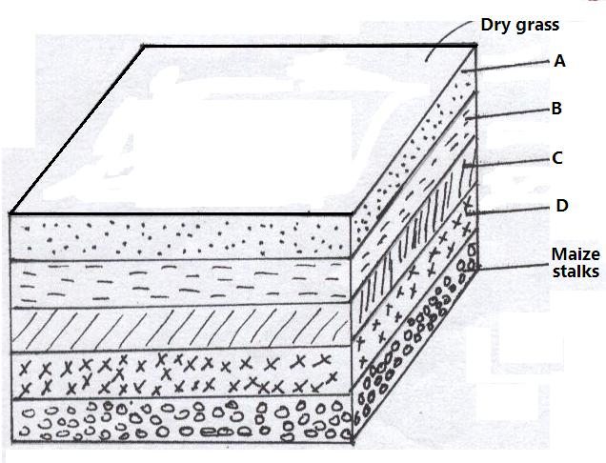

Grass, Leaves, Refuse etc.
Ash
Manure
Top Soil
- Five pits are dug in series and materials filled as follows:
- Pits I, II, III and IV are filled with the materials as described above.
- After 3-4 weeks, the materials in pit IV are transferred to pit V, materials in pit III to IV, in pit II to pit III and in pit I to pit II.
- Process is repeated until the materials are well rotten then taken to the filed as compost manure.

Pit I | Pit II | Pit III | Pit IV | Pit V
Four Heap System (Stack Method)
- In this method four heaps are used.
- The materials used are similar to those used in the pit method.
Construction
- Vegetation is cleared from the ground.
- Posts 2m high are fixed at a spacing of 1.2 by 1.2m forming the corners of the heap.
- Wood planks are fixed on the sides to form the walls and materials are arranged as in the Indore method.
- Materials are placed in the heaps labeled X and after 3-4 weeks they are transferred to pit Y.
- After another 3-4 weeks, the compost materials are transferred to pit Z where they stay for some 3-4 weeks before they become ready to be taken to the field.
- The manure should be turned occasionally to facilitate air circulation.
- A stick is driven into the stack an angle to check the temperature.
- If the temperature inside is high, it is corrected by adding water.
Diagrams

X
Y
X
Z
FIELD

WATER SUPPLY, IRRIGATION AND DRAINAGE
WATER SUPPLY
The Hydrological Cycle
- Water from the surface evaporates up the atmosphere, cools and condenses to form clouds.
- Saturated clouds fall down to the earth as precipitation in form of rain.
- This water returns back to the atmospheres through the process of evapo-transpiration.
- The circulation of water from the earth’s surface to the atmosphere and back again is called the
Hydrological Cycle
Sources of Water
- They include; surface water sources, underground water sources and rain.
- Surface water sources
They include;
- Rivers, streams and dams.
- Lakes
- Underground water sources
They include:
- Springs.
- Wells.
- Boreholes.
Assignment.
Make short notes on the various sources of surface and underground water.
- Rain water.
This is collected from rooftops and stored in tanks. Ponds cal also be dug to collect the runoff. Rain water is very pure compared to the other sources.
Water Collection and Storage
- Dams.
- A dam is a barrier constructed to store water. Dams can be made of earth or concrete.
- Grass should be planted on the embankment to prevent soil erosion.
- Weirs.
- Weirs are used to raise the water level in a river to facilitate pumping.
- Water tanks.
These are made of concrete, stone, metal sheets, plastic or rubber. They should be covered to prevent water contamination.

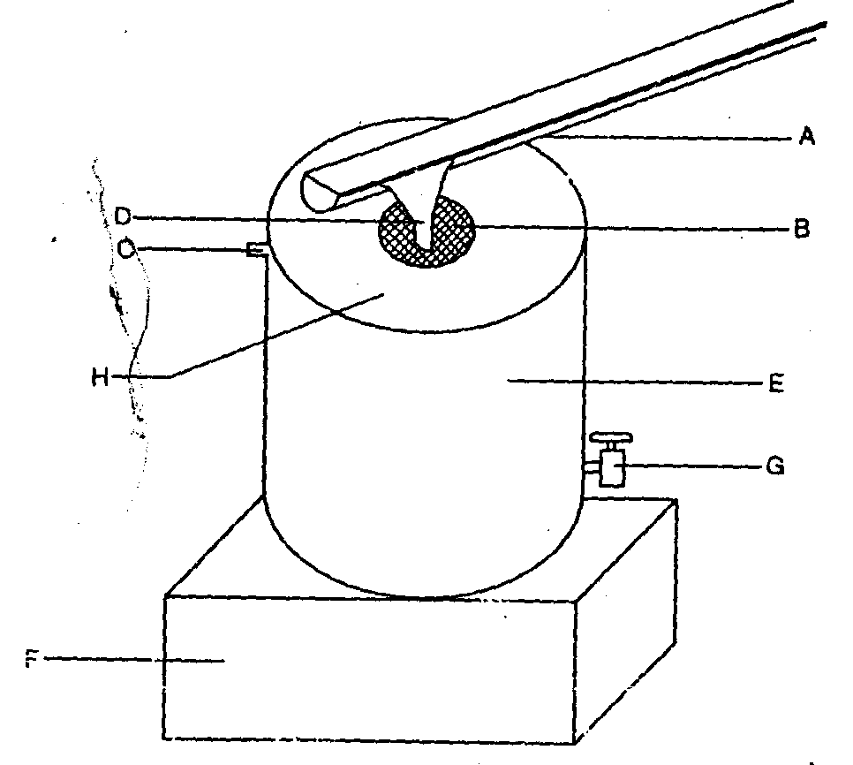

Pumps and Pumping of Water
- Pumping is the lifting of water from one point to another by use of mechanical force.
Types of water pumps
- Centrifugal/rotardynamic pumps.
- Piston/reciprocating pumps.
- Semi-rotary pumps.
- Hydram.
Conveyance of Water
- This is the process of moving water from one point (source or storage point) to where it will be used or stored. This can be done through;
- Piping
- In this case water moves through pipes.
Types and choices of pipes
- Metal pipes
These are expensive but durable. They also can withstand high pressure.
- Plastic pipes
They are cheap and easy to install. However they can burst under high water pressure, can break when exposed to the sun and can be gnawed by rodents such as moles.
- Hose pipes
They are either made of rubber or plastic. Rubber ones are more expensive and more durable than the plastic ones.
- Use of containers
Containers such as jerry cans, drums and pots are used to draw water and are carried by various means such as bicycles and animals.

- Use of canals
Water is conveyed from a high point to a lower point along a slope especially for irrigation purposes.
General Uses of Water on the Farm
- Domestic use – cooking, drinking, washing
- Cooling animals
- Rearing fish
- Watering/ irrigation plants
- Cleaning calf pens, milking sheds
- Watering livestock / drinking
- Diluting / dissolving chemical used to control pests, parasites and weeds
- Mixing concrete in construction
- Cooling and running machine engines
- Processing farm produce eg coffee hides, carrots
- Recreation eg swimming pools

WATER TREATMENT
Importance of Water Treatment
- Kill disease causing microorganisms.
- Remove chemical impurities such as excess fluoride.
- Remove bad smells and bad tastes.
- Remove sediments of solid particles such as soil and sand.
Process of Water Treatment
Stage I: Filtration of water intake.
- Water from Source River is made to pass through a series of sieves.
- Large particles of impurities are trapped by the sieves.
- Water then enters into the large pipe to be directed to the mixing chamber.
Stage II: Softening of the water
- Water circulates in the mixing chamber and doses of soda ash to soften the water.
Stage III: Coagulation and sedimentation
- Water is passed through coagulation tank where fresh air enters to remove bad smell/ chloride of lime used.
- Water stays for 36 hours thus solid particles settle and bilharzias causing organisms killed.
- Alum is added to coagulate solid particles which settle at the bottom.
Stage IV: Filtration
- Water is passed through filtration tank with layers of sand and gravel to filter it.
- Water leaving the filtration tank is clean.
Stage V: Chlorination
- Water is passed through chlorination tank where chlorine is added.
- Micro-organisms in the water are killed by chlorine.
Stage VI: Storage - The treated water is stored in large overhead tanks before distribution and use.

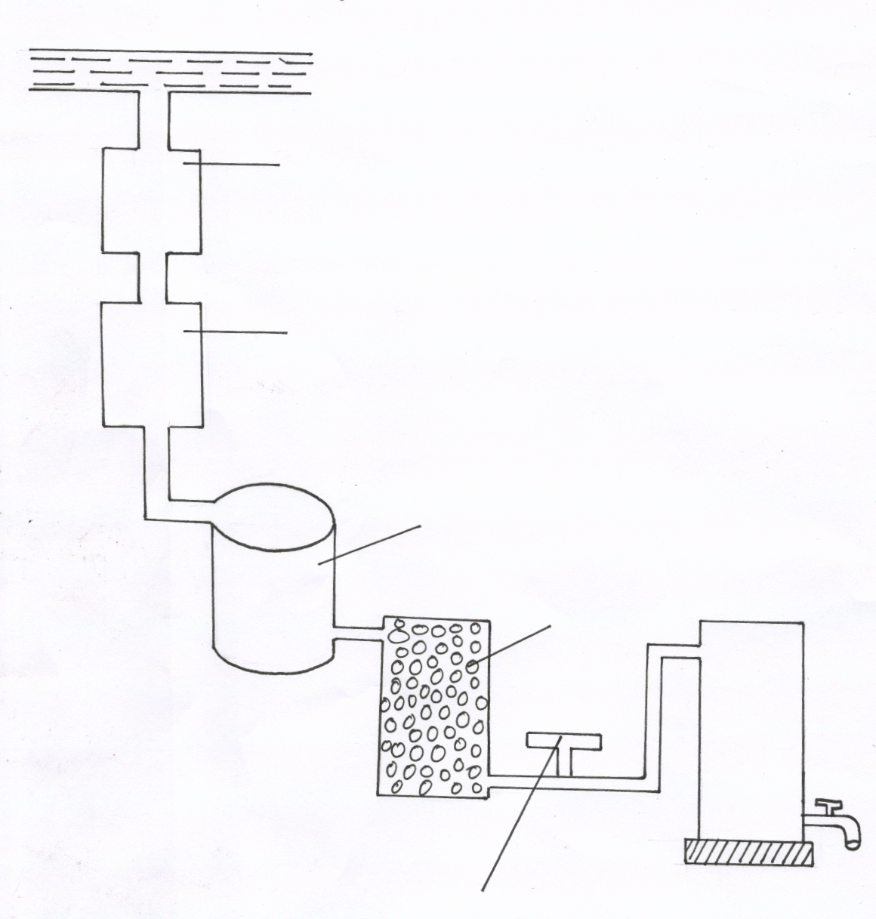
Diagram
A
B
C
D
E

Water Treatment by Boiling
- Boiling kills germs in water such as those causing bilharzias, cholera and typhoid.

IRRIGATION
- This is the artificial application of water to the soil to supply crops with sufficient moisture for growth.
- It is usually practiced;
- In dry areas.
- During dry periods.
- In the growing of paddy rice.
General importance’s of Irrigation.
- Enable crop production during dry season
- Reclaim arid and semi arid land for farming
- Supplement rainfall in crop production
- Help provides enough water to crops that require a lot of water like rice
- Creates favourable temperature for proper plant growth
- Enable supply of fertilizer in irrigation water
- Make possible to grow crops in special structures like green house
Types of Irrigation
Factors considered when choosing type of irrigation system
- Capital availability- this determines the type of irrigation systems to be used. Drip and overhead irrigation systems require high capital for installation and maintenance
- Topography- Surface irrigation requires flat areas
- Water availability- Surface irrigation requires a lot of water. Drip and overhead irrigation requires less water
- The type of soil- Surface irrigation is best suited for clay soils because they retain water for a long time.
- The type of crop / value of the crop / benefit analysis. Crop to be irrigated should be of high value to justify the irrigation cost
- The availability of clean water – drip and overhead irrigation requires clean water to prevent blockage of the systems
- Surface Irrigation
- Water is brought to the crop fields from the source by use of canals or furrows. The following method are used here; Flood Irrigation, Furrow Irrigation and Basin Irrigation.
- The following factors are considered when choosing the method to use in surface irrigation.
- Topography- Surface irrigation requires flat areas
- Water availability- Surface irrigation requires a lot of water.
- The type of soil- Surface irrigation is best suited for clay soils because they retain water for a long time.
Flood Irrigation
- The entire field is flooded with water.
- The method is cheap to establish and maintain but there is uneven distribution of water to crops and a lot of water is wasted.
Furrow Irrigation
- Irrigation water flows from canals into furrows..
- Furrows should be maintained by repairing when eroded or worn out, removing the weeds and silt.
Advantages
- Cheap to establish and maintain.
- Requires little skill to maintain.
- Reduces fungal diseases such as blight since there is no wetness on the leaves.
Disadvantages
- Soil erosion may occur.
- A lot of water is lost through evaporation and seepage.
Basin Irrigation
- An area enclosed by walls called embankments/levees is flooded. The method is common in the rice growing areas. Such as Mwea Tebere, Ahero, Bunyala etc.
- Sub-Surface Irrigation and Drip/Trickle Irrigation
- This involves laying perforated pipes underground to allow water to pass out through tiny holes and wet the soil around the zones of the crop.
Advantages
- Minimizes labour requirement especially in changing of water pipes.
- Minimizes possible theft of water pipes.
- Economizes on the use of water.
- Can be practiced on both sloppy and flat land.
- There is no soil erosion.
- No growth of weed between the rows.
- Water under low pressure can be used as long as it can flow along the pipes.
- Controls fungal diseases such as blight because water does not accumulate on the leaves.
- There is no need of constructing dykes, leveling or making
Disadvantages
- Expensive to install.
- Pipes can be broken during weeding or land preparation.
- Nozzles can get blocked making irrigation inefficient hence the method requires clean water.
- Overhead/Sprinkler Irrigation
- In this case water is applied to the plants in form of spray using sprinklers or watering cans.
- The sprinklers and pipes used must be maintained as follows.
- Lubricating the rotating parts to reduce friction.
- Repairing any broken parts.
- Cleaning to unblock the nozzles.
Advantages of sprinkler irrigation
- There is even distribution of water over the area required
- Less water is required / less water wastage
- Can be practiced on sloppy land
- It is possible to apply foliar fertilizers with irrigation water / fertigation
- Irrigation pipes / sprinklers can easily be moved from one area to another
- Irrigation water cleans off dust from plant leaves for better functioning
- Helps to control aphids.
Disadvantages
- Expensive to install.
- Encourages fungal diseases such as blight and coffee berry disease due to wetting of the leaves.
- Can cause soil erosion if not well controlled especially on sloppy ground.
- May require the establishment of a wind break.
- Maintenance is expensive as it requires a lot of skill
Factors considered in choosing irrigation water pipes
- Durability- Shown by the quality of the materials the pipes are made of
- Length of the pipes- This is determined by the size of the farm and the source of water / water supply point.
- Diameter of the pipe- Determines the volume of water to be conveyed in the pipes
- Water pressure- High water pressure requires strong pipes to prevent bursting
- Resistance to heat from the sun- Pipes crack and become brittles if exposed to the sun
- Resistance to pest damage- Plastic pipes are easily damaged / gnawed by rodents
- Cost of the pipes- Aluminium pipes may be expensive when used for irrigation
Drainage
- This is the removal of excess water from waterlogged land. It is done to reclaim marshy areas for agricultural production.
Importance of Drainage
- To increase soil aeration. When excess water is removed from the soil, plant roots get enough air for growth.
- Increase soil volume. Drainage increases the amount of soil around the root zone making it possible for plants to obtain nutrients.
- Raise soil temperature. Drainage improves the arte at which the soil becomes warm for maximum plant growth.
- Increase microbial activities. Proper aeration as a result of drainage increases the number of microorganisms in the soil.
- Reduce soil erosion. Well drained soils have high water holding capacity which helps to reduce surface run-off increasing the infiltration rate.
- Remove toxic substances. When there is water-logging, salts accumulate to toxic levels in the soil. Drainage removes such salts from the soil.
Methods of drainage
- Use of open ditches/channels/furrows.
    - Ditches are dug for water to flow by gravity lowering the water table.
- Use of underground pipes
    - Perforated pipes are laid underground and water seeps into them, then flows to a water way. The pipes are made of plastic, metal (steel) or clay.
- French drains
    - Ditches are dug and filed with stones and gravel and then covered with soil.
    - Water from the surrounding area seeps into tem the flows to a water way.
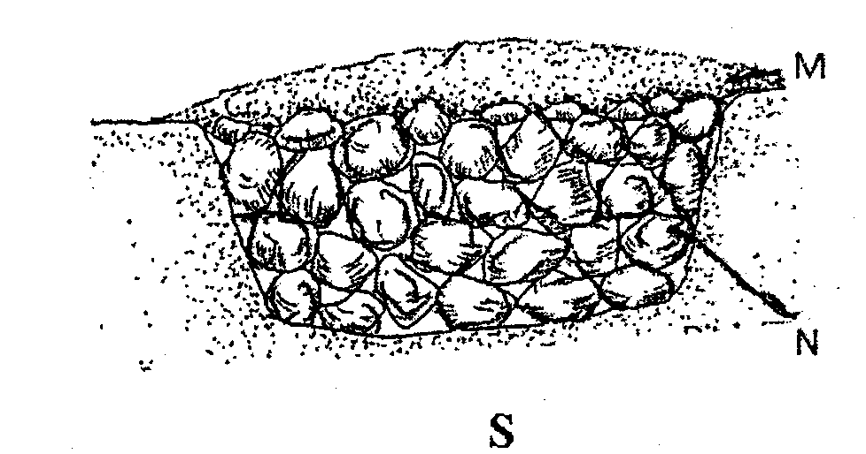

Soil

Stones

- Cambered beds
    - Raised beds are constructed in combination with ditches in the poorly drained soil such as the black cotton soil.
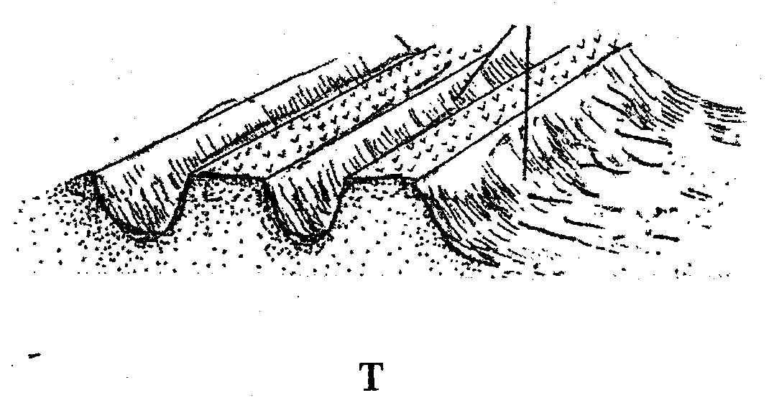
Raised beds planted with crops.
Ditches for water drainage

- Mechanically pumping
    - In the low lying areas where the other methods of drainage cannot be practiced, water is mechanically pumped out of the soil.
- Planting of Trees
    - Trees such as eucalyptus can be planted in water logged areas as they lose a lot of water through transpiration.
Water Pollution
This is the introduction of harmful substances into the water.
Agricultural Practices that Pollute Water
- Use of inorganic fertilizers
Fertilizers used get leached through the soil and are carried to water bodies.
- Use of pesticides
Excess pesticides seep into the soil and find their way to the water bodies causing pollution.
- Poor cultivation practices. These practices include:
    - Over cultivation. This causes soil erosion hence siltation in water bodies.
    - Overgrazing. This also causes soil erosion hence pollution in water bodies.
    - Cultivation along the riverbanks. Also causes soil erosion hence siltation in water bodies.
Methods of Preventing water Pollution
- Soil conservation measures to minimize soil erosion.
- Fencing of water sources to minimize pollution by animals.
- Enforcing integrated ways of controlling pest and weeds that do not use chemicals such organic farming.
- Planting vegetation along the river banks to avoid siltation.
- Using adequate storm control methods in the areas experiencing heavy rains.
FARM TOOLS AND EQUIPMENT REVISION QUESTIONS
1 The diagrams below are of farm tools and equipment. Study them and answer the questions that follow
i) Identify the tools 1 mk
ii) Give one functional difference between the tools above. 1 mk
2. The diagram below show farm equipment. Use them to answer the questions that follow.
a) Identify the equipments M and L. (1mk)
b) State the functional difference between M and L. (2mks)
c) State TWO common maintenance practices carried out on both M and L. (2mks)
3. The diagram below shows a farm equipment study it and answers the questions that follow.

[a] Identify the equipment. [1mk]
[b] Name the parts labeled. [2mks]
W; X ; Y; Z
[c] What is the function of the part labelled Z. [1mk]
4. Study the diagrams below and answer the questions that follow.
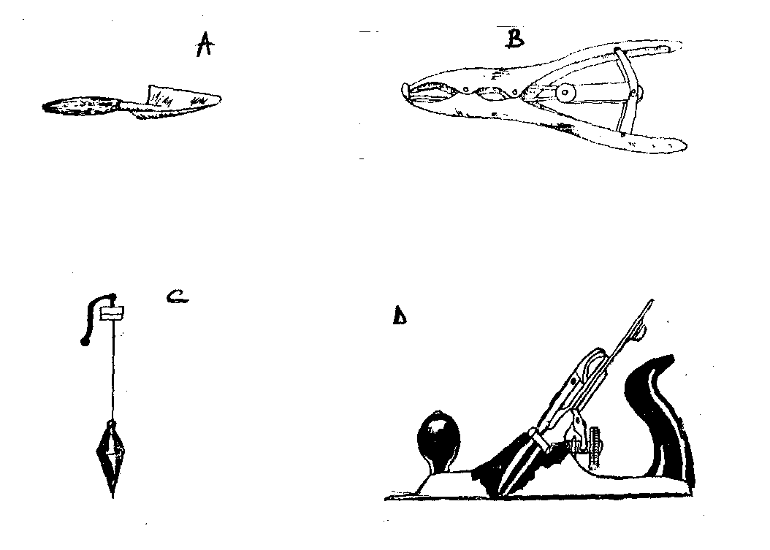
(a) Identify the tools. A-B-C-D (2mks)
(b) State the correct use of each of the tools above. (2mks)
(c) Give two maintenance practices carried out on tool D for efficient use. (1mk)
5 (a) Name four types of tools used in smoothing wood. (2mks)
(b) Give three reasons why farm tools and equipment should be well maintained. (1¹/₂mk)
6. Below is a diagram of farm equipment. Use it to answer the questions that follow.
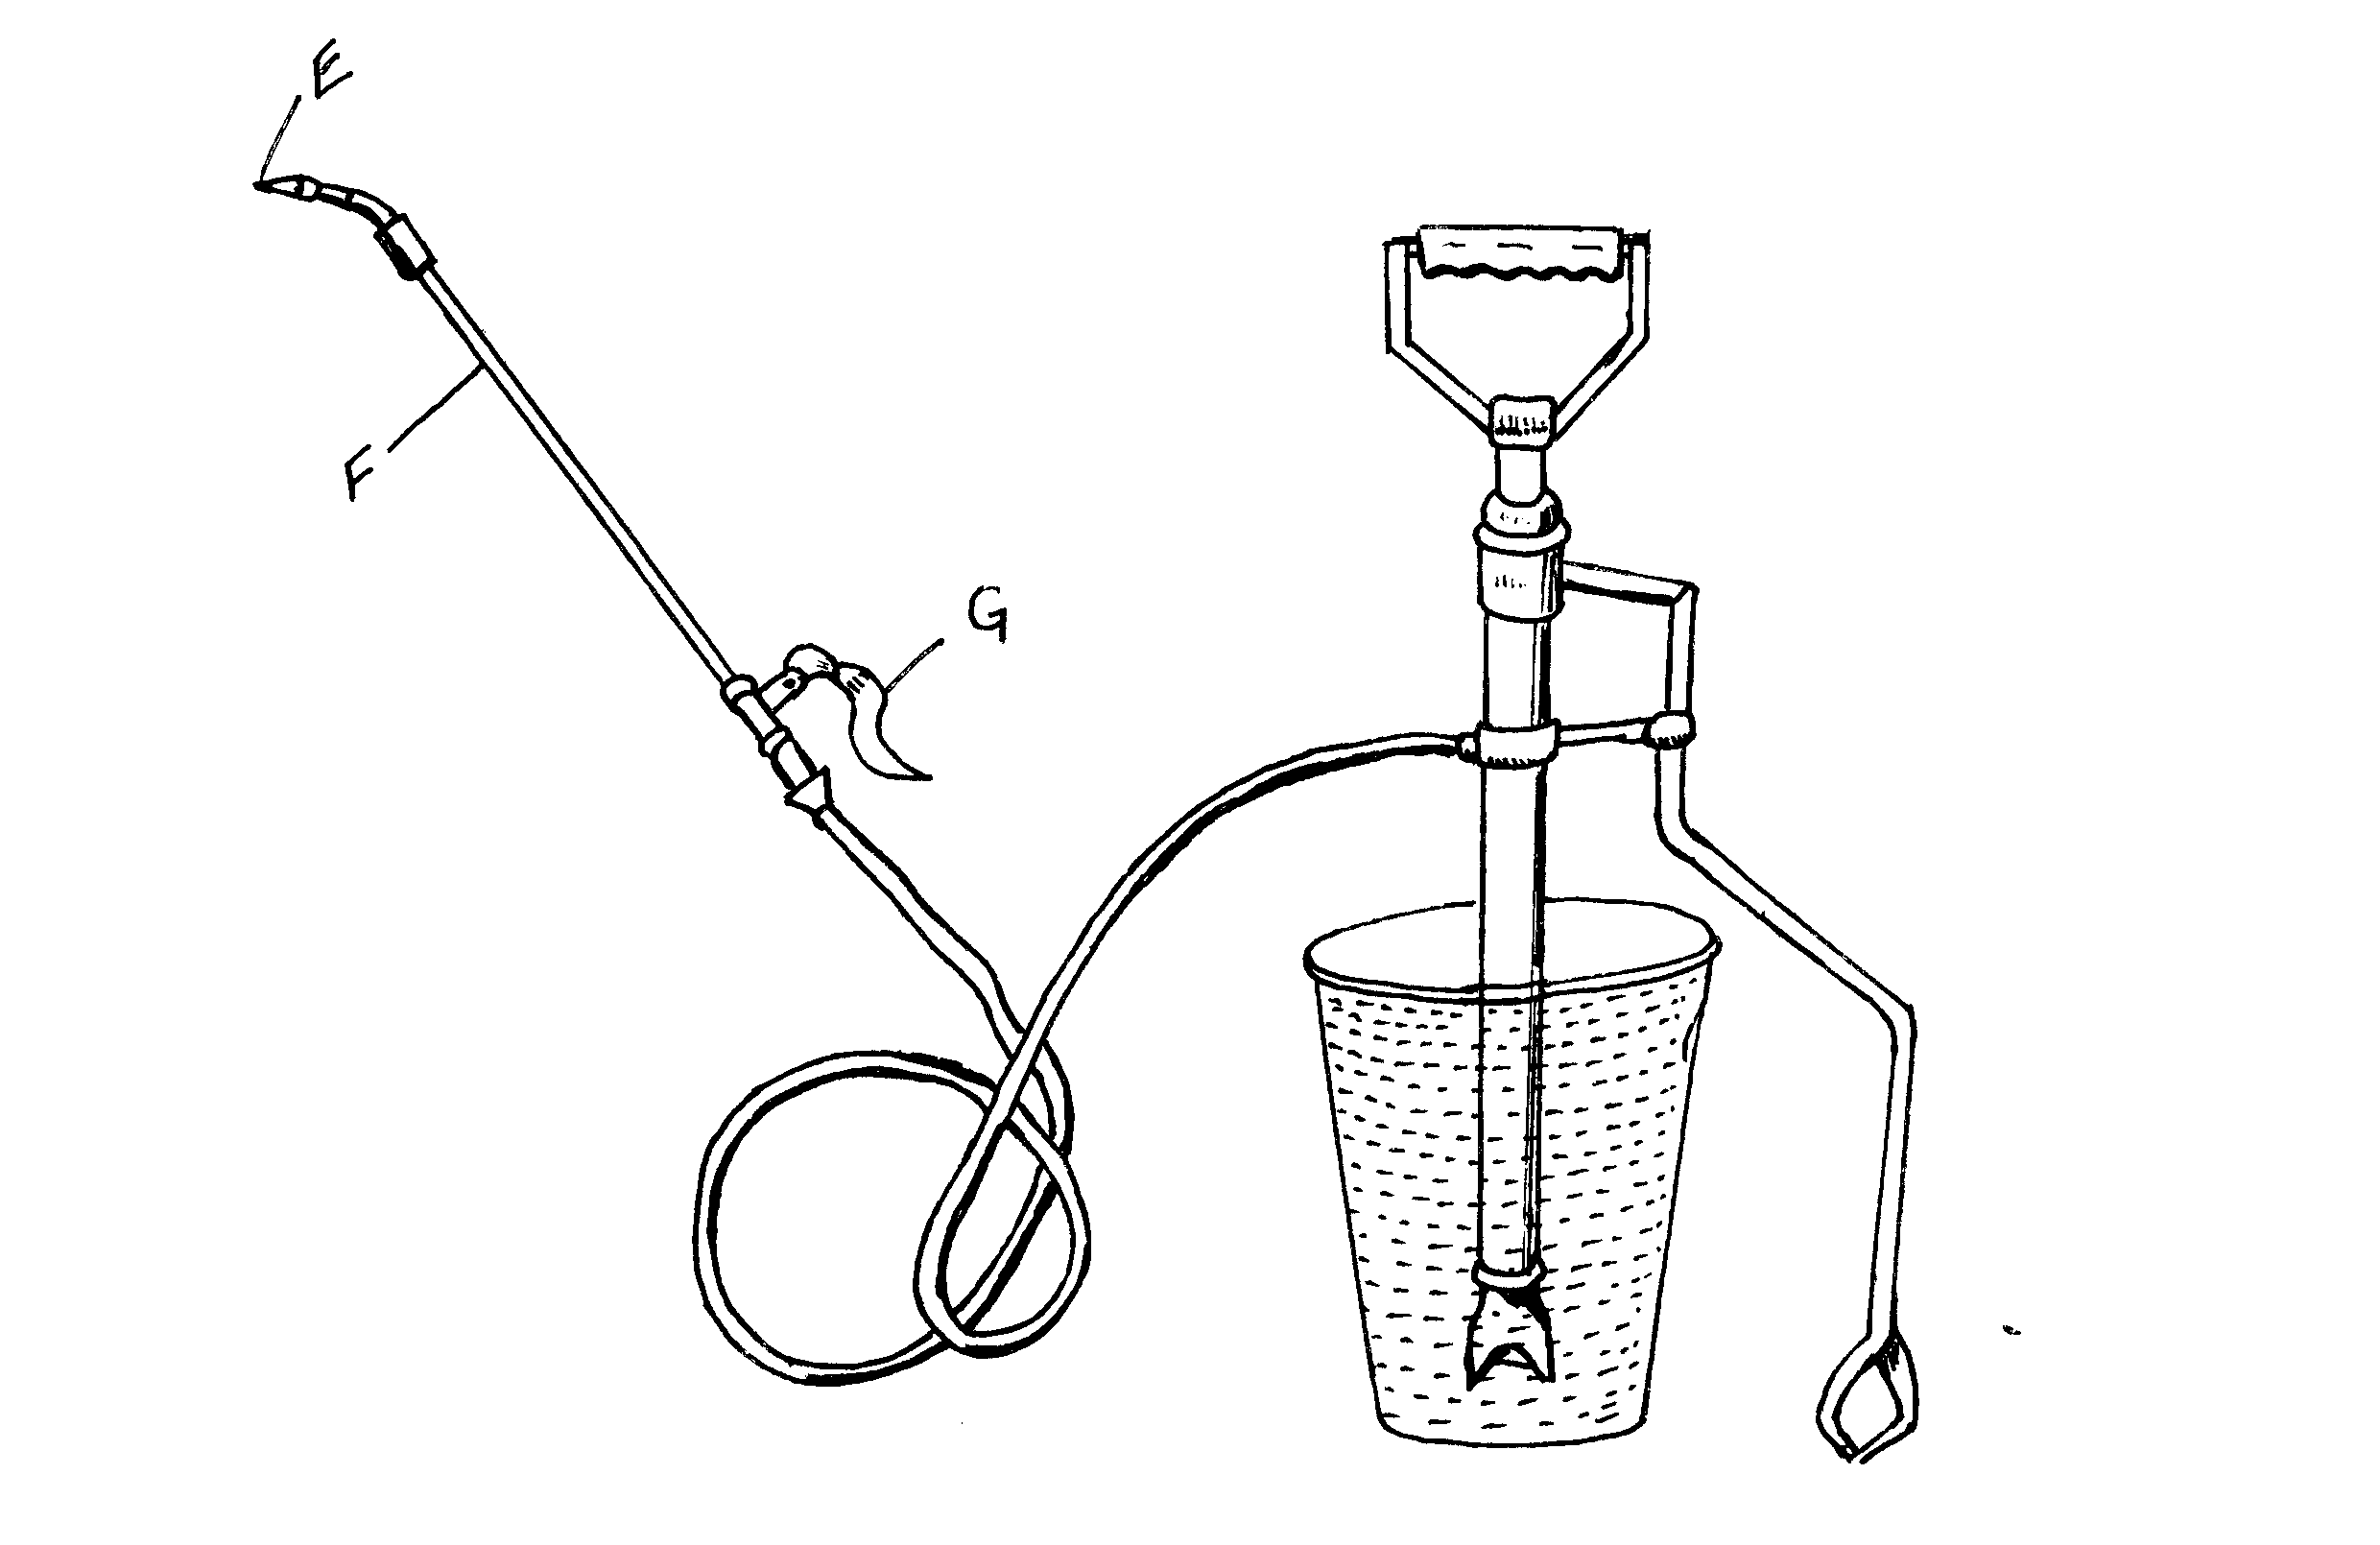
a) Identify the equipment. ( ½ mk)
(b) State two reasons for your choice in (a) above (1mk)
b) State the use of the equipment (1mk)
c) Name the parts labelled G,E and F. (1 ½ mks)
d) Identify two draw backs in using this equipment compared to others that may be used for the same purpose. (2mks)
7. Identify the farm tool and equipment illustrated in the diagram labeled k and L and give one use of each equipment.
Equipment identity Use
(a) K ..................................... ......................................................................
L ..................................... .......................................................................
(b) Give the care and maintenance of L (1mk
8. Observe the tools X and Y illustrated below and answer the questions that follow:-
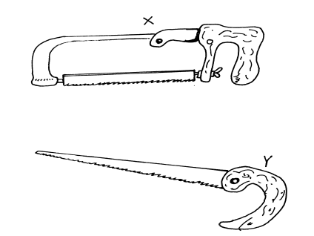
a) Identify the tools. X ; Y (2 mks)
b) State one use of each of the following tools. X;Y (2 mks)
c) State three maintenance practices carried out on tool X. (3 mks)
9. The diagram below illustrate a workshop tool
- Identify the tool…………………………………………………………………......(1mk)
- Name the parts labeled S, T and U (3mks)
- State the use of the tool (1mk)
10. Study the diagrams of livestock production tools below and answer questions that follow.
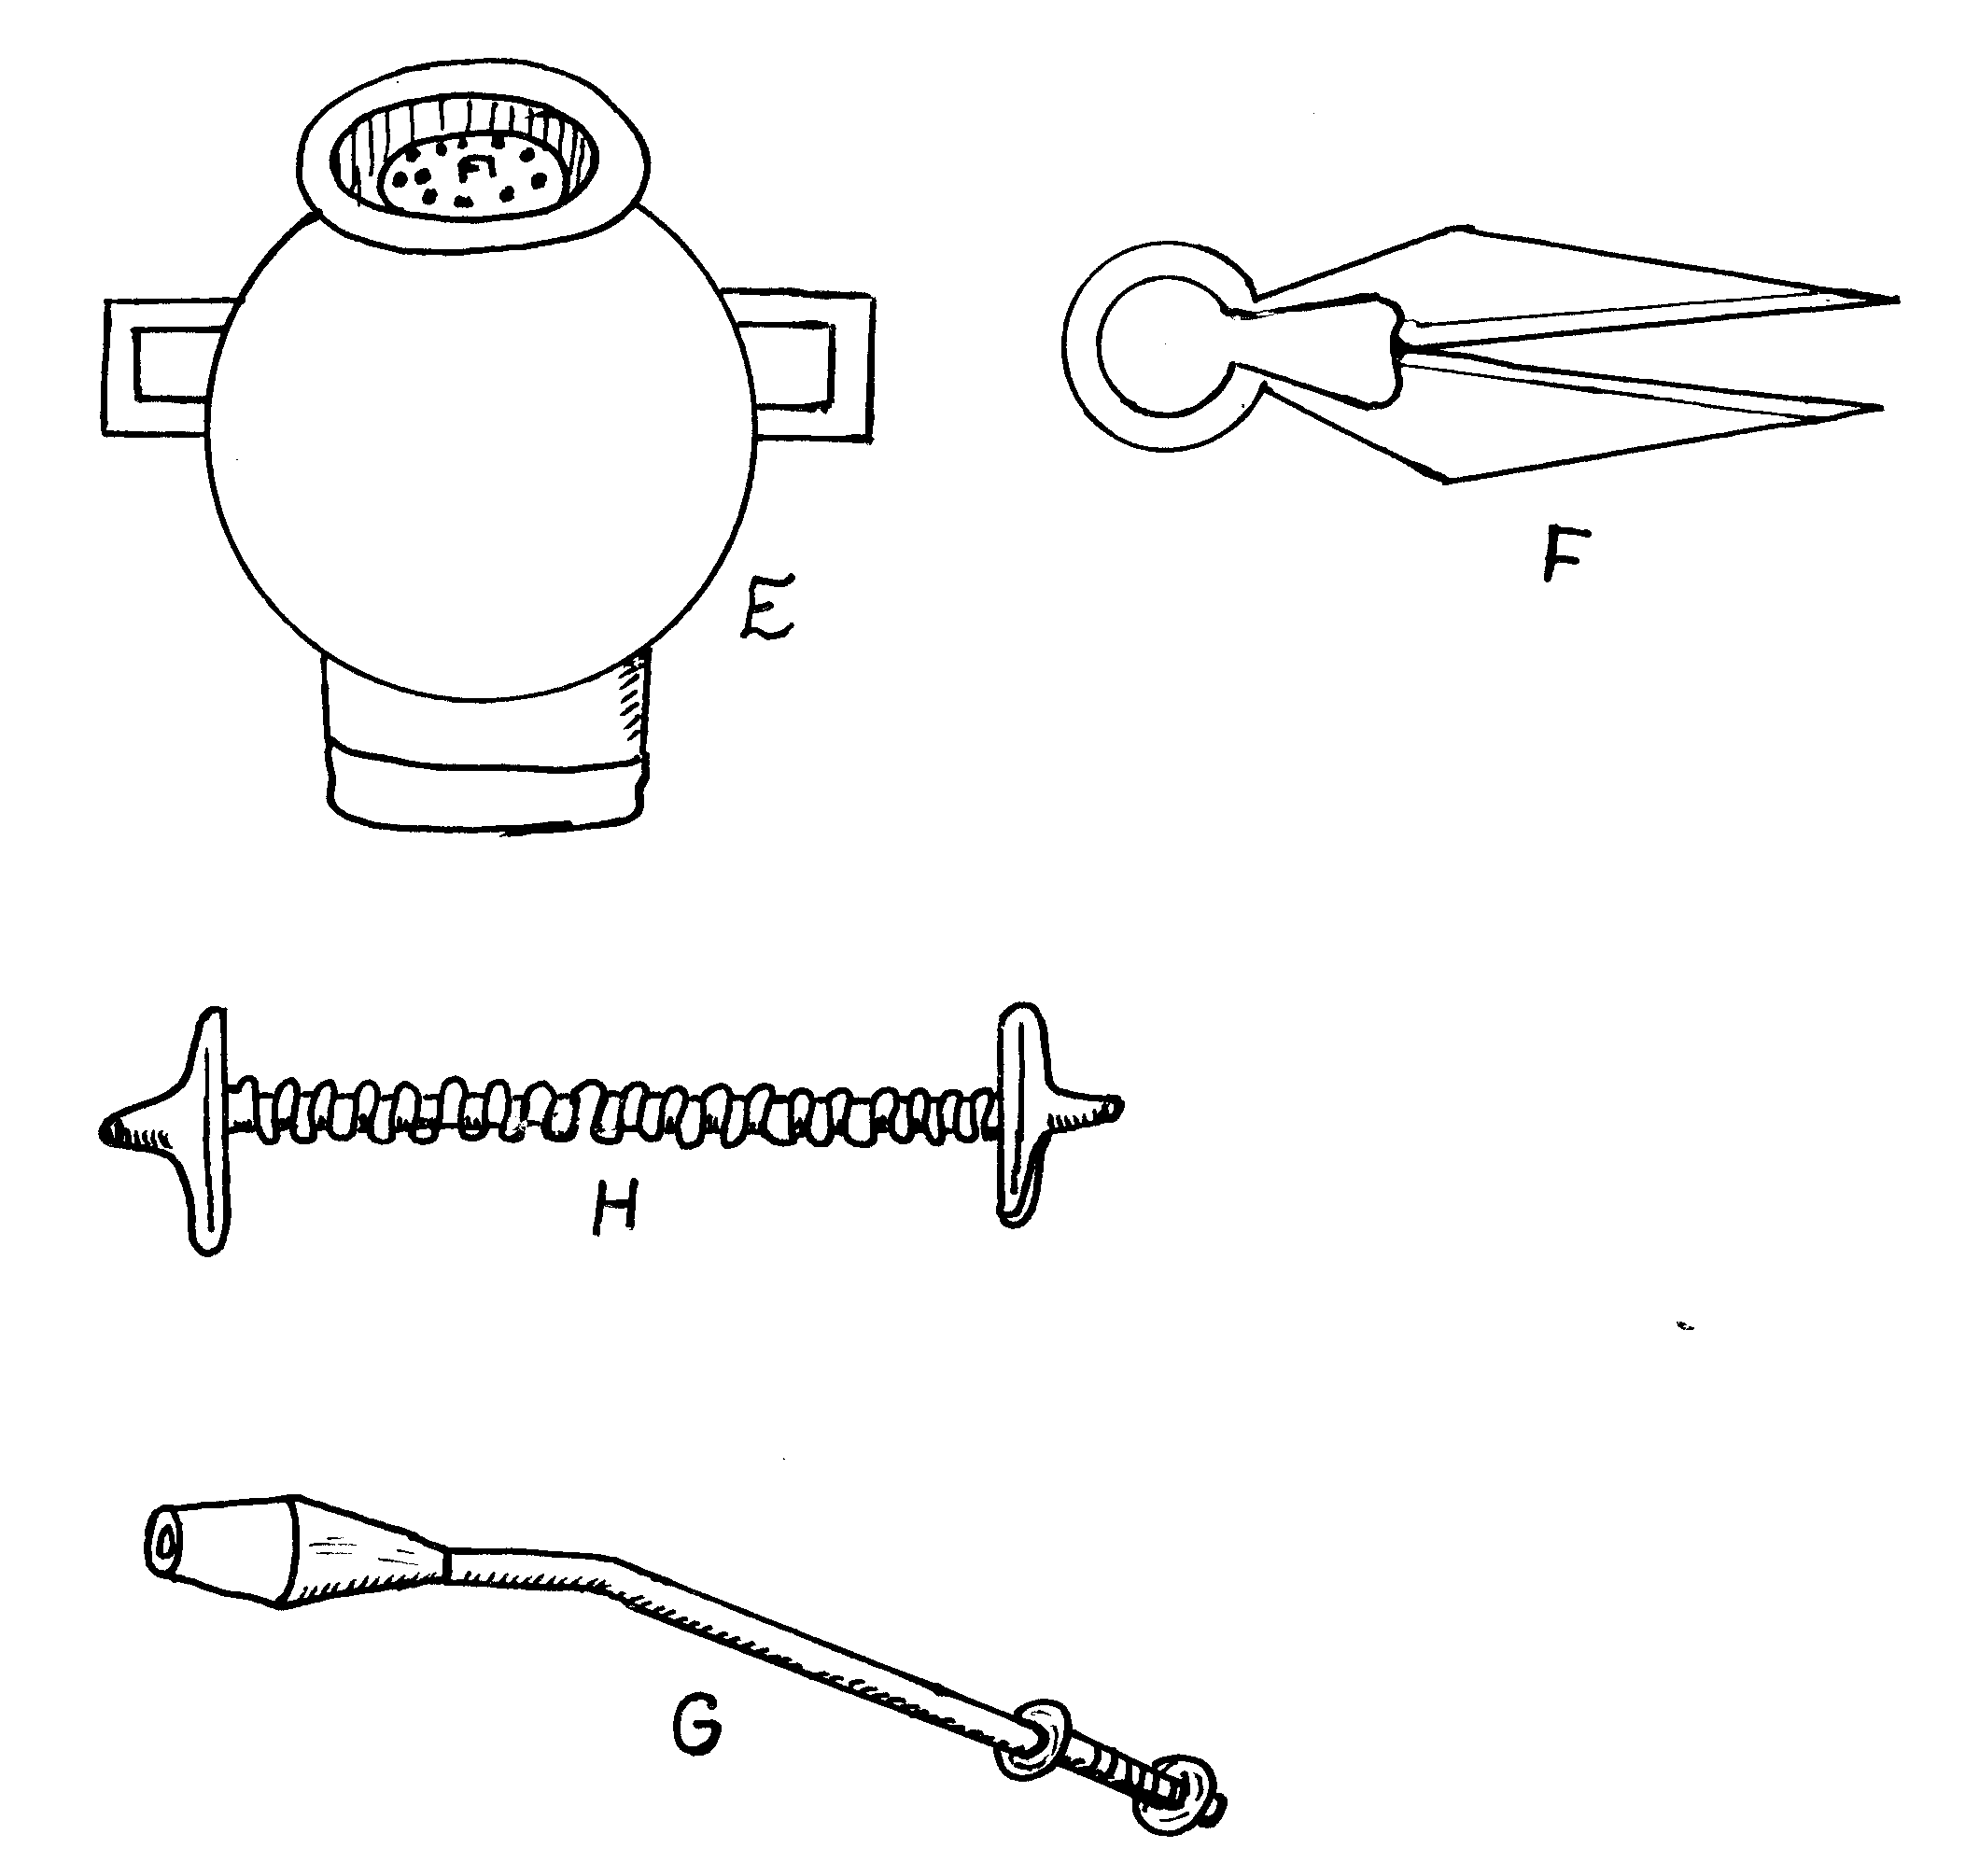
a) Identify the tools E, F, G and H. (4mks)
b) State two maintenance practice of the equipment E. (2mks)
11. Below are diagrams of workshop tools.
(iii)
(i)
(ii)
(iv)

State the functions of tools. (4mks)
(i)………………………………………………………………………
(ii)……………………………………………………………………………
(iii)……………………………………………………………………………
(iv)……………………………………………………………………………
b) What is the name given to the metallic brush which is used to clean out wood chippings from tool (i) above.
- Study the diagrams of garden tools shown below and answer the question that follo
(i) State two field conditions under which tool A would be more suitable for use in crop
Production (2mks)
(ii) Give the function of the tool labelled C. (1mk)
(iii) State two maintenance practices of the tool labelled B. (2mks)
13. Study the diagrams below labeled P,Q,R and S representing some workshop tools and then answer the questions that follow.

a) identify the tools 2mks
Tool Name
P ………………………………………….
Q …………………………………………
R …………………………………………
S …………………………………………
b) Give one use of tools P and R in the construction of a wooden feed trough.1mk
P ………………………………………
R ……………………………………….
c) How would the tool labelled Q be used in the construction of a calf pen? ½ mk
d) Give two maintenance practices carried out on tool S. 1mk
14. Study the diagram below of farm tools and equipment and answer questions that follow.
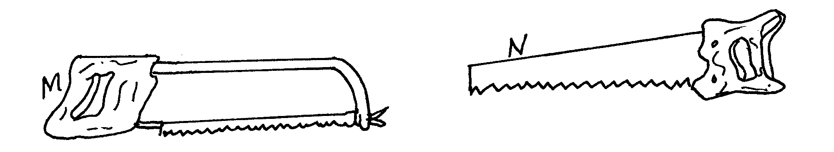

(i) Identify tool M and N (1mk)
M……………………………………………………..
N………………………………………………………
(ii) State one functional difference between M and N (1mk)
(iii) State two maintenance practices of tool M. (1mk)
FARM TOOLS ANSWERS
1 A)
Tenon / back saw
Cross – cut saw/ rip saw/ hand saw (1 mk)
b) Tenon saw- For cutting tenon joints / fine sawing reject cutting joints alone
Cross cut- saw cutting across the grains of wood (2 mks)
2 a) M – milking bucket / pail (reject milk bucket / pail)
L- Milk churn / can (reject milking churn) 2 x ½ = 1mks
b) M – used for holding milk during milking 2 x 1 = 2mks
L – Used for holding milk during transportation
c) i) Washing thoroughly with hot water 2 x 1= 2mks
ii) Sterilizing using recommended detergent
4 .(a) A-garden trowel
B-elastrator
C- Plumb bob/ plumb line
D- Jack plane (½ x 4)
(b)
Tool | use
A | -for lifting seedlings from the nursery during transplanting.
B | -for applying/ fixing the rubber ring during castration docking or dehorning
C | -checks the vertical straightness of a stone wall during castration.
D | -for smoothening rough wood surfaces.
(c)
- Sharpening the blades regularly
- Replacing broken handles and knob
- Tightening loose parts ( screws)
- Adjusting appropriately the lever cap. ( ½ x 2)
6. a) - Stir-up pump. √½
b) - Spraying livestock √1
c) - E-Trigger √½
- F-Nozzle √½
- G-(Brass) lance. √½ 1 ½mk
d) - Need two people to operate. √1
- Not easy to carry about during operation. √1 1 x 2=2mk
Equipment | Identify | Use
K ………………….. | - Hypodermic  syringe / syringe  And needle | - Inject  Animals to introduce  Drug or vaccine
L | - Adjustable spanner | - Holding different sizes of nuts and bolts  ( Accept tightening / loosening )

9. (i) Auger bit (1 x 1 = 1mk)
(ii) S – shank
T-Twist threads
U-Spur (3 x 1 = 3mks)
(iii)Making holes (boring holes on the wood ( 1mk)
12 (i) Conditions under which tool labeled A is used
- Hard ground/ soils
- A stony field
- Field with rhizomes/stolons/ roots
- A field with sticky soils(2x1 =2mks)
(ii) Functions of the tool labeled C
- Cutting pruning undesirable branches/ stems of trees/fruits/coffee/
- Cutting pruning excessive vegetative parts(1x1 =1mk)
(iii) Maintenance practices of tool labeled B
- Clean /remove soil/trash after use
- Straighten the prongs if bend
- Replace the handle if broken
- Fix the handle firmly on the rake(2x1 =2mks)
13.a)
Tool | Name
P | Try square
Q | Spirit level
R | Tenon saw/back saw
S | Cold chisel
½ x 4=2 MKS
- Use of tools P and R in the construction of a wooden feed trough
P-Measuring angles/ layout of angles/ measuring lengths
R- Cutting timber to make joints/ used for joinery work
-Fine cutting/ sawing
½ x1=1/2mk
- Use of Q in the construction of a calf pen
To determine if the floor level/ the walls are vertical.
½ x1= ½ mk
- Maintenance practices on tool S
-Sharpening the cutting edge
-Removing the mushroom head
½ x2=2mks
- i) M- hack saw
N- hand saw
ii) Functional differences between M and N
- hack saw (M) is used for cutting metal rods and plates while (N) hand saw is used for cutting wood/timber (1x1=1mk)
iii) maintenance practices
              - tighten loose screws and nuts (ref.bolt)
              - replace worn out blade
              - regular cleaning
              - hang properly to avoid possible damage
              - maintain correct tension of the blade

OTHER REVISION QUESTIONS
- a). What is Agriculture?
b). State the roles played by agriculture in national development
d). i) Briefly outline the problems that have hindered agricultural development
in Kenya.
ii) Suggest ways in which these problems can be alleviated
- a) i) What are the characteristics of shifting cultivation?
ii) State the problems associated with shifting cultivation.
- What is pastoralism?
- State the factors to consider in choosing a type of farm
- What is arable farming?
- i) State the advantages of mixed farming
ii) State the limitations of mixed farming
- i) Give the types of farming practised by small scale farmers
- Name the types of large scale farming
- Why does the Kenya government put a lot of emphasis on ranching?
- State the common features of ranching as a farming system:
- i) State the advantages of plantation farming
- State the disadvantages of plantations.
- State the major characteristics of plantation farming.
- a) List the ecological factors affecting agriculture.
- Mention the aspects of rainfall which are important in crop production
- i) What is optimal temperature?
ii) State the effects of high temperature on crop production.
- State the negative effects of wind to crops.
- a). i. Define the term soil
ii). Name the ways in which soil is important to growing plants.
b). i) State the factors which influence the soil forming process
ii). What biological agents influence the speed of the soil forming process?
- i) Define the term soil Profile
ii) How does soil profile influence plant growth?
- i) List the constituents of a fertile soil.
ii) What role do micro-organisms play in soil?
- i) What is soil structure?
ii) State the farming practices that improve soil structure.
iii) Why is a good soil structure desireable for growing crops.
- i) What is soil texture?
- State the properties of soil that are influenced by its texture.
- Give the types of soil based on texture.
- a) State the advantages of using farm tools.
- List the factors that determine a farmer’s choice of tools and equipment.
- i) Why should tools and equipment to maintained well?
ii) How should tools and equipment be maintained?
- List the safety precautions necessary for tools and equipment
- Name the categories of farm tools and equipment.
- a) State the importance of land preparation.
b) i) What is primary cultivation?
ii) Which factors influence choice of tools for primary cultivation.
- i) What is secondary cultivation?
ii) Give reasons for secondary cultivation?
- i) Define minimum tillage
iii) State reasons for practising minimum tillage.
- Name the factors that determine the number of tillage operations during seedbed preparation.
- a) List the sources of water on the farm.
- How is water conveyed from one point to another?
- i) Name the types of water pipes.
iii) What features are considered when buying plastic pipes?
- Name the types of water pumps to be used on the farm.
- i) Why should water be treated before use?
ii) State the methods of treating water on the farm.
iii) How is water used on the farm?
- a) i) What is irrigation?
ii) List the factors to consider in deciding to irrigate crops.
b) List the major types of irrigation
- a) i) What are the uses of farm records
- List types of records kept on mixed farms.
- List types of records kept by crop farmers.
- , goat, pigs, bees, fish, donkey, camel
10 b) i) Explain the role of livestock in human life
ii) List factors that affect livestock industry in Kenya.
c) i) List dairy breeds of cattle
ii) State their characteristics.
- i) Name beef cattle breeds.
ii) What are the characteristics of beef cattle.
- Name the important rabbit breeds in Kenya.
- Name the major breeds of sheep in Kenya and indicate the purpose they are kept for
- Name important goat breeds and their uses
- Name important pig breeds kept in Kenya.
- i) Give the meanings of exotic and to indigenous breeds.
- State the characteristics of exotic cattle that make them better suited to marginal areas than exotic cattle breeds.
- What are the advantages of keeping a Jersey cow instead of Friesian for production of milk?
- i) State the general characteristics of exotic cattle breeds.
ii) Give the characteristics of indigenous cattle
11. Below is a diagram of a nursery for raising the seedlings.
(a) State two advantages of having the part labeled J (2mks)*Nrk*
(b) State any 3 management practices that should be carried out on the nursery from the time seedlings emerge to the stage of transplanting 3mks)*Nrk
12. a) i) What is soil fertility?
- State the characteristics of a fertile soil.
- How can a fertile soil loss its fertility
iv). State the ways of maintaining or improving soil fertility
- i) What are plant nutrients?
ii) Name the major plant nutrients (macro-nutrients)
- State the roles and deficiency of the following nutrients in plants.
i) Nitrogen uses
- Deficiency.

Excessive supply
- Phosphorous used.

Deficiency
- Potassium uses.
Deficiency.
- i) What is soil sampling?
- List the methods of soil sampling.
- State the reasons for soil testing:
- Explain the procedure of soil sampling:
- State precautions necessary during soils sampling
- Name the methods of detecting nutrient deficiency in crops:
- State the importance of soil PH to a crop:
13 a) i) Differentiate between manure and fertilizer:
- List the common organic manures
b). i) What is organic matter?
- State the importance of organic matter
- How can organic matter be added to soil?
c) i) Describe how to make farm Yard manure:
ii) State the factors determining quality of farm yard manure
iii) Give the advantages of using Farm Yard Manure over fertilizer:
- Give the disadvantages of using farm yard manure
d) i) State the factors to consider when citing a compost pit.
- Describe how to make compost manure
- i) How is green manuring done on the farm?
- List the characteristics of green manure crops:
- What are the advantages of green manuring?
14a) Classify fertilizers by nutrient content.
b) i) Name the common nitrogenous fertilizers.
- State properties of nitrogenous fertilizers/ (characteristics)
- When are they applied and why at that time?
c) i) Name the common phosphatic fertilizers:
- When are they applied and why at the time?
- i) Name the common potassic fertilizers
- Characteristics:
- i) What is fertilizer application?
- List the methods of fertilizer application:
- What is top dressing?
- i) Calculate the amount of K₂O (potassium chloride) contained in 400 kg of a compound fertilizer 25:10:5 – 5kg of K₂O is contained in 100kg of 25:10:5
- A farmer is to apply a compound fertilizer 20:30:10 on a vegetable plot measuring 5 metres long by 4 metres wide, at the rate of 200kg per hectare.
- Calculate the amount of the fertilizer the farmer would require for the plot. (show your working)
- What do the figures 20, 30 and 10 in the fertilizer stand for
- How much of a fertilizer labeled (20:20:10) should be applied to a plot which requires 30 kg P₂O₅?
15. a) i) State the importance of the nitrogen cycle
- Describe the nitrogen cycle:
- What happens to nitrogen in the soil?
b) i) State the importance of carbon cycle
- Describe the carbon cycle
- How is carbon lost?
- How can carbon be restored to the atmosphere?
16. a) i) Define crop propagation.
- What are the methods of crop propagation?
b) i) List the different methods of vegetative propagation:
- State advantages of vegetative propagation.
- State its disadvantages.
- i) What are the advantages of seed propagation
- State the disadvantages of seed propagation
- i) Give the advantages of early planting
- State the factors to consider when selecting seeds or other planting materials for planting
- What are the reasons for seed selection?
- What practices are carried out for seeds to ensure that they germinate?
- i) List the methods of planting
- State the advantages of row planting.
- State the factors which influence planting depth.
- What factors determine crop spacing?
- State the advantages of correct spacing
- Why is correct plant population necessary?
- Name the treatments necessary on planting materials before planting?
17a) What is a nursery?
- State the reasons for using a nursery.
- State the nurseries management practices.
- Explain the following nursery practices.
i) Pricking out.
- Hardening off.
- Rogueing.

